Animation(Gaming)!!!

**“B”**

-motion

-collision ( at least two tests )

- user interface

-Pong ( 2D motion, 3 test collision-ball and paddle, mousemove- paddle)

**“A”**

-several objects moving in several directions (Frogger, Space Invaders, etc.)

-higher order of collision testing (one moving object colliding with another moving object-4 tests)

- save top score(s)

Possible Forms:

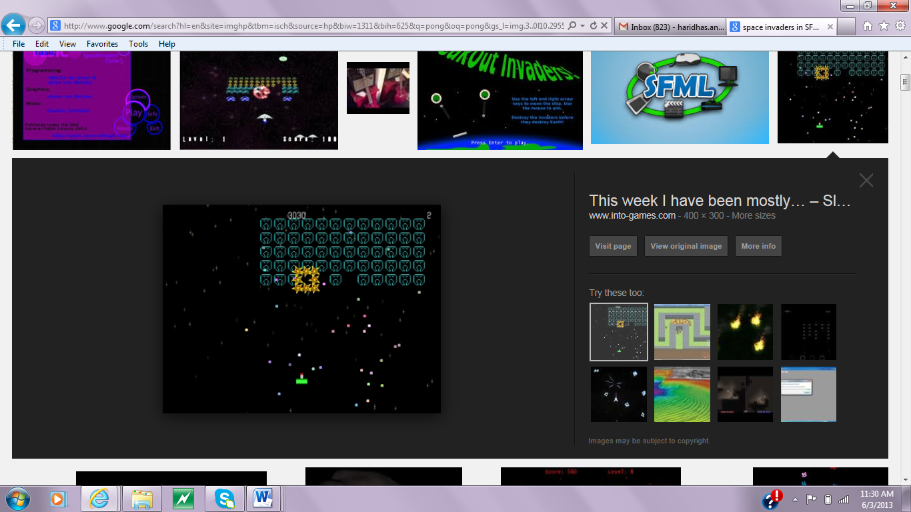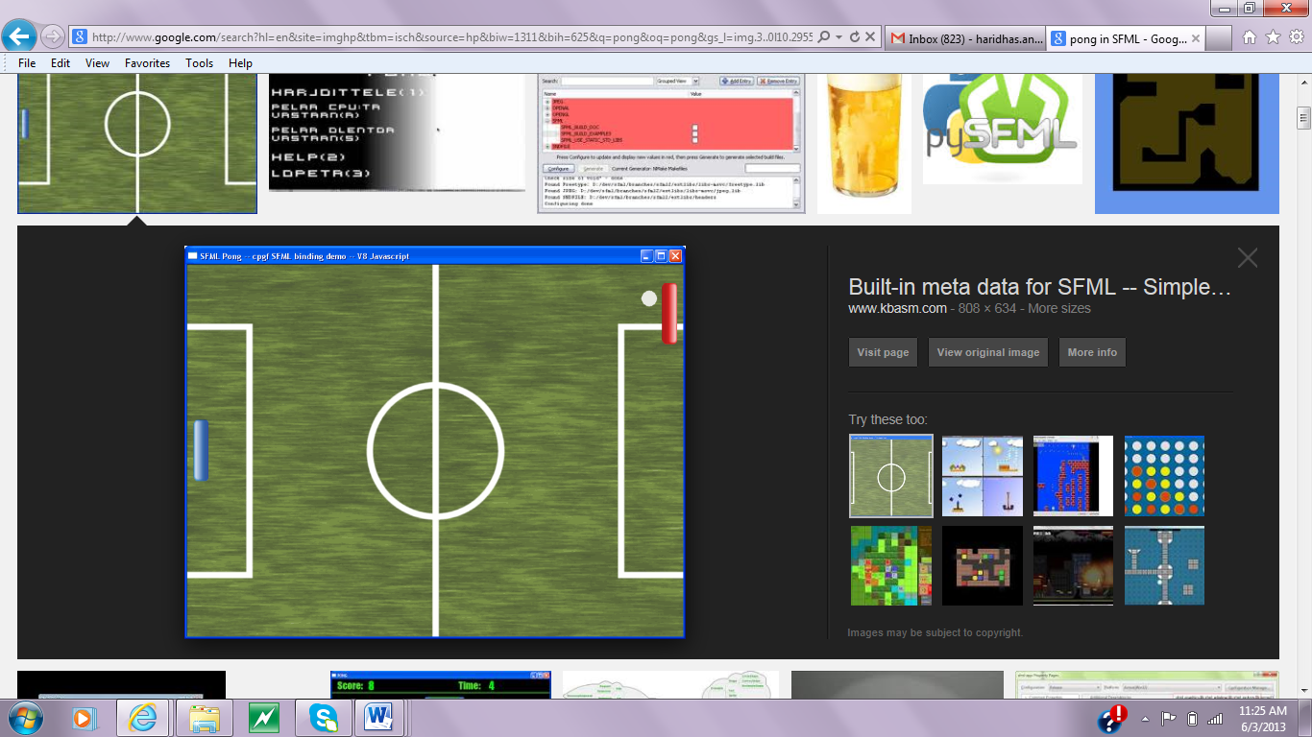

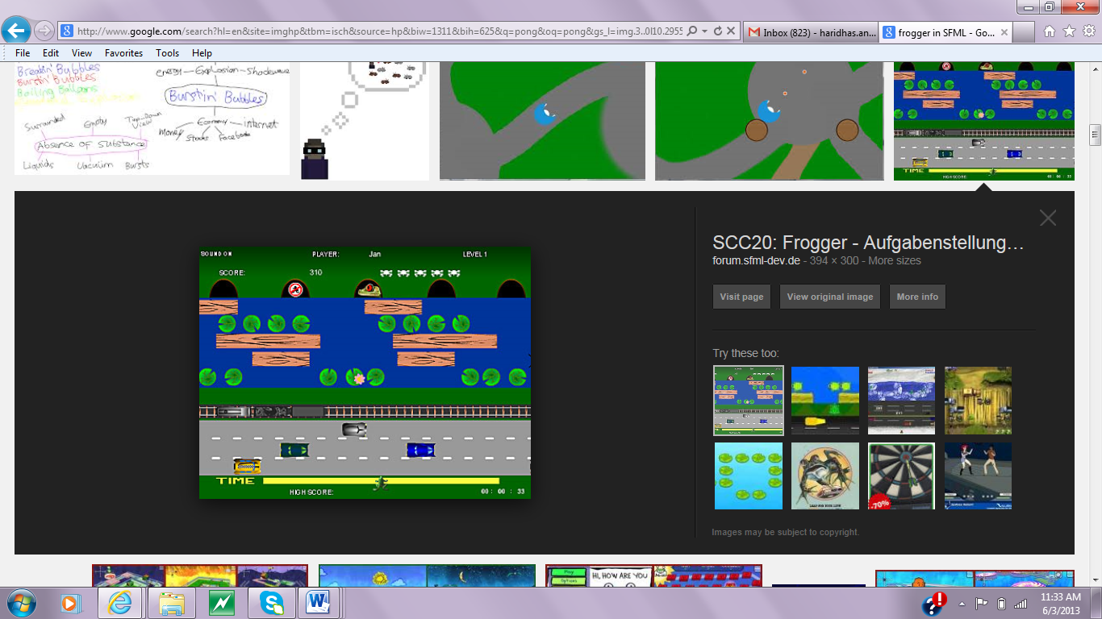

Space Invaders

Pong

Frogger