Calculator
Program Description:
Create a program which can do mathematical operations. Insert two numbers into two different text boxes and then compute the answer into a label box made to look like a text box. All math operations should be command boxes. Clear output and quit command boxes should be included. Colors and pictures (graphics) are for the A.

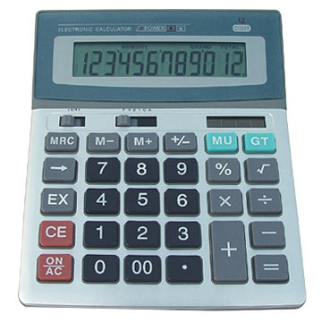
Rubric:
“B”
- 5 functions

“A”
-8 functions

-graphics

Sample output:

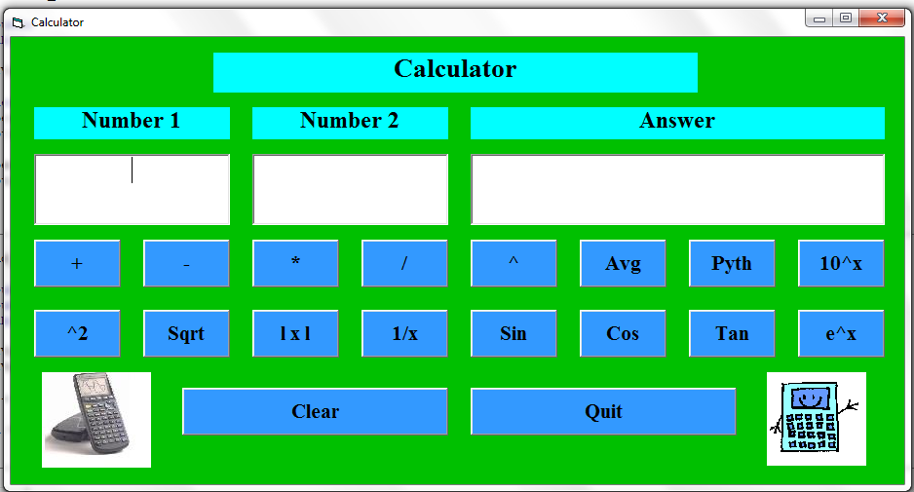

Example of gui needed for A++

5 Standard Operations:
Addition: 1+ (-1.5) = -.5
Subtraction: 1- 2 = -1
Multiplication: 1*-2 = -2
Division: 2/.5 = 4
Power: 2^(-2) = .25

Possible Other Operations: Average, Pythagorean, Log, Sin, Cos, Tan

