Tic-Tac-Toe
Program Description:
Create a program which allows the user to play multiple games of Tic-Tac-Toe. The program should tell who wins as well as give a running total of the number of wins a person has accumulated. The A goes towards whoever can create a better game (animation, graphics etc.)

Rubric:
“B”
- running total - who wins - plays multiple games

“A”
-properly Disable form -ai -animation; flashing lines - graphics

Sample output:
1. Gui before any input: 2. Gui while game is being played:
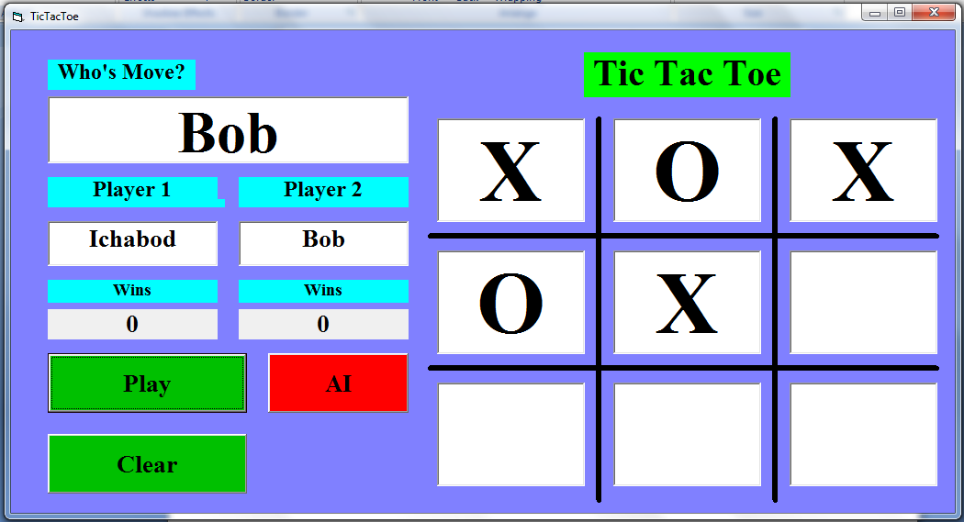
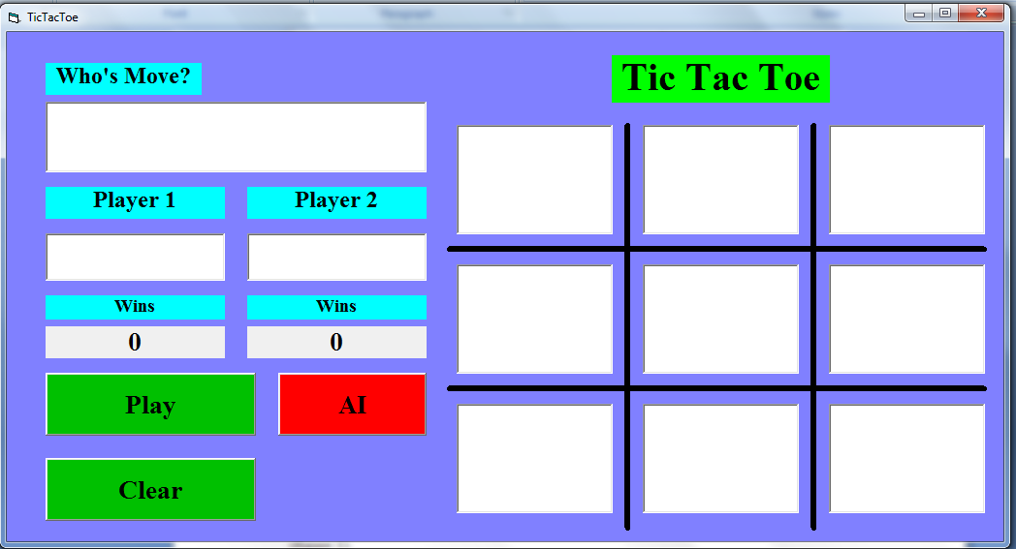

3. Gui at end of game: * 4. Gui if rematch is played:*
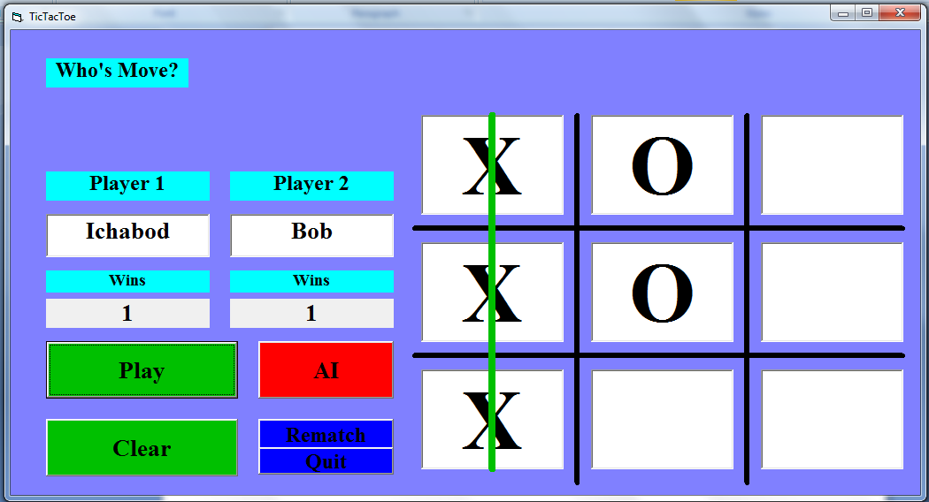
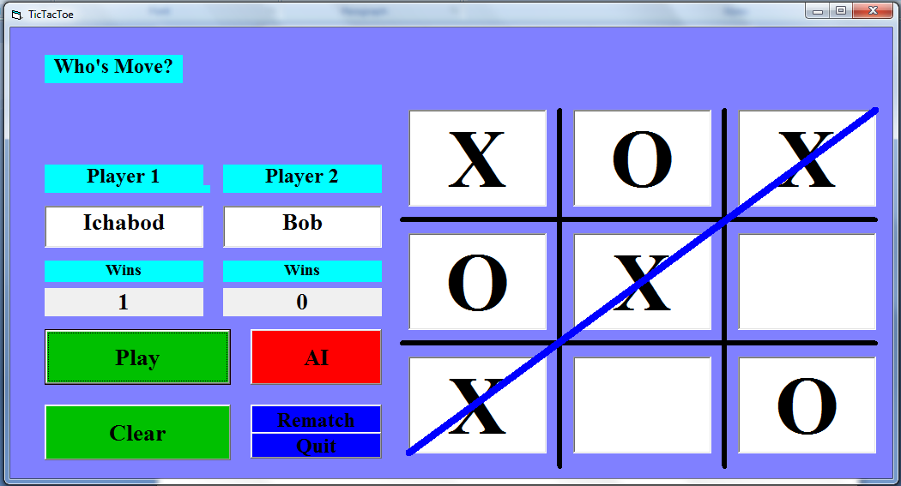

If clear is pressed the program should go back to the way it was in figure 1.
Notice that in figure 4 Ichabod’s win is still kept
* Who’s move and Tic Tac Toe label boxes don’t show because they are flashing when the game is played

