Triangle
Program Description:
Create a program which will test whether three inputted sides will form a triangle. If a triangle is formed output the area, perimeter and type of triangle into label boxes. Adding extra

Rubric:
“B”
- area - perimeter - type of triangle, e.g., Right, Isosceles etc.

“A”
-graphics -calculated angles -animation

Sample output:
1. Gui before any input: 2. Gui if triangle doesn’t exist:

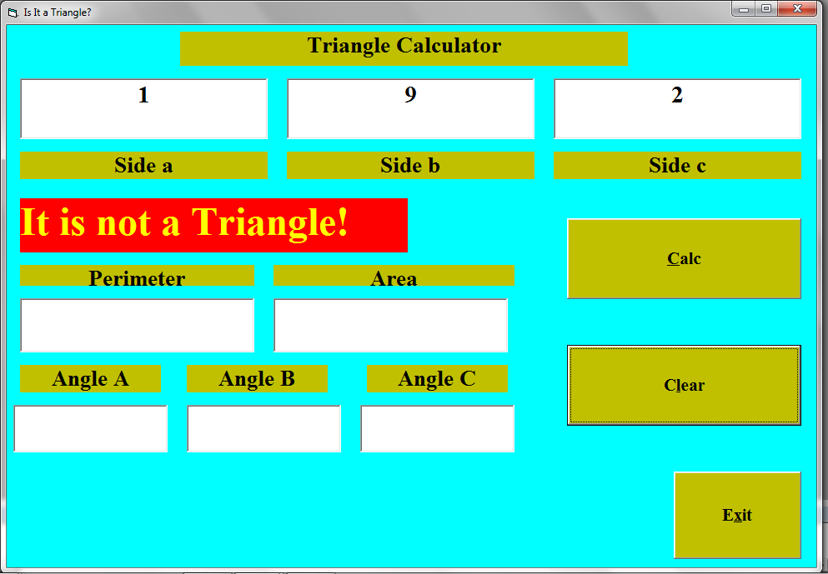
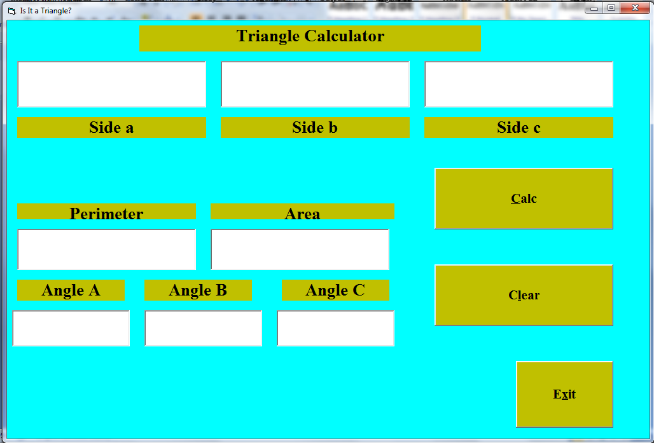

3. Gui if triangle exists:
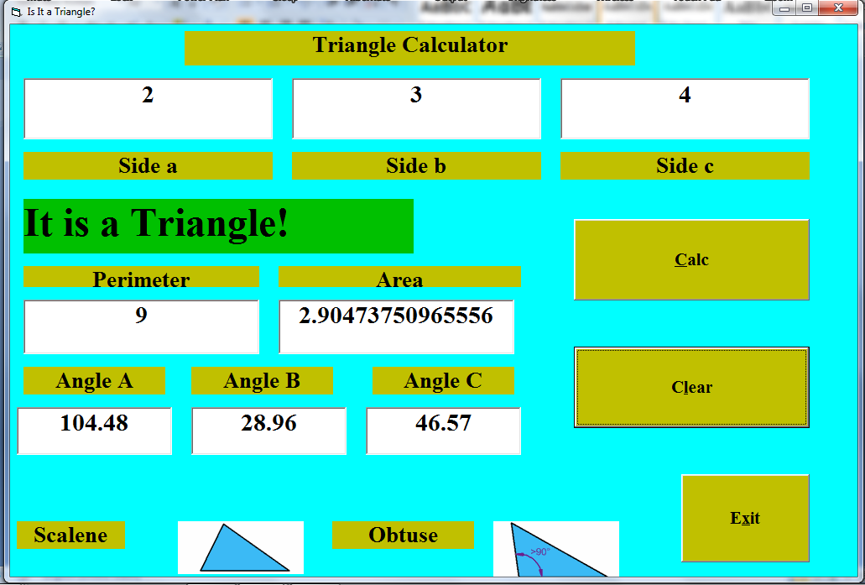
The clear button should bring the entire gui back to the state it was in before any input (figure 1).
Remember to tabstop the commands so that tabbing moves smoothly

