SICTC FRAMES
Technical Documentation
Blake Bruken & Landon Meuth
Setup
Setup Static IP Address on your Pi
Clone Repository
Run the Bash File
Innerworkings
The HTML
The HTML file, called ‘home.html’ is located under the ‘frames’ folder. It’s job is to display the Frames to the user and import the JSON, Script, and Styling files.
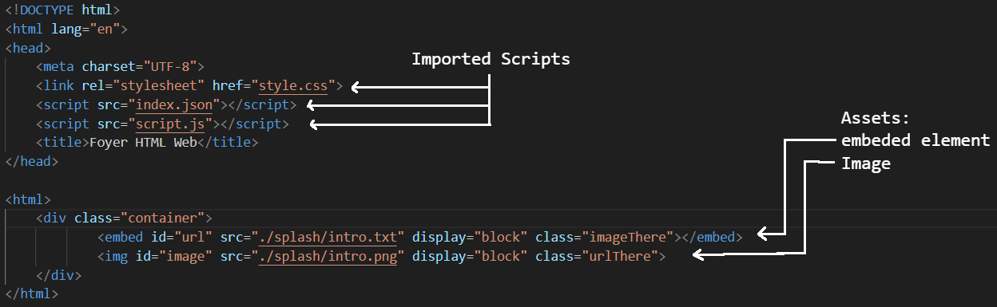
The two assets in the file has 4 inline stylings:
- id: The way this HTML tag is called inside the Script file.
- src: The source file for the tag.
  - For embed, this could be a website, image, text file, etc.
  - For img it supports image types.
- display: the display property controls if an element is present on the page.
  - “block” = show element. (I know, its confusing.)
  - “none” = hide element.
- class: tells the CSS file to format the tag based on what class it posseses.
  - Example: embed has the class “imageThere”, this tells the CSS file to make the embed tag share room with the image tag. This work in conjunction with the “display” inline styling. When a new frame is loaded and the frame has no image, the Script sets display to “none” and class to “imageGone”. Now Embed is allowed to take up the entire screen.

The JSON
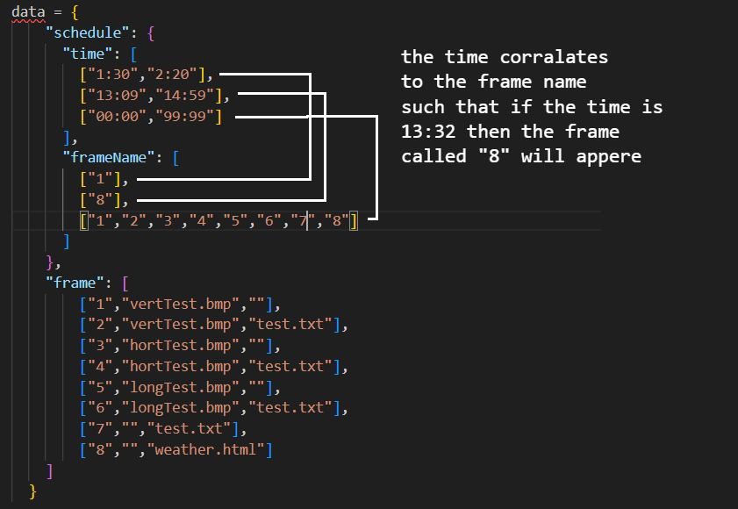
The Script

The Style

The Folders

