Assignment 1 - Programming Linear Algebra

CS2300 Section 1 Spring 2022

Landon Bunker

# Project Description

The problem that we are addressing is creating matrices from peoples first and last names. Then once the matrices are created you will add every possible combination of the first five that you have created. Then after addition you will multiply every combination and if they can not be added or multiplied then you print an error message to the console.

# Approach

The approach I had to the problem was to create a class for each matrix. From each matrix you can add a starting value or a step value between indexes. From this class you can also access various methods such as add or multiply. On the outside of the class, you will have arrays of input files and You will also have to open each file and write a script for the first part. In the first part there will be more logic in main as compared to parts 2 and 3. In the second and third parts there will be almost no logic in main because you will be calling methods which will call others from the matrix class.

# Detailed Design

## Programming Language

The programming language I am using is Java. There are a couple features from Java that are important to the design. The implementation of classes and the use of array lists allow for an expandable array without knowing the size of the array. The reason that these features are important is because you have an object that has methods that are incredibly helpful to the assignment. The array lists are helpful also just because you can find the rows and columns from a data structure without having to know the size beforehand.

## Modules

Part1: The first module of the program was just the first part. The main includes scripts so that you can enter the first and last name for the first, second and third matrices. The fourth and fifth matrices were scripted also and were a set size and had set values. Then at the end I wrote the results of the matrices to files for the second and third parts.

Part2: The second module was very small and only contains an array of strings and then that array of strings is then passed to a method which will test every single combination of the first matrices added. If the matrices can’t be added it will print an error message.

Part3: The third module was also very small and contains the same array of strings that include file names which is then passed to a test method and tests every single combination of multiplication between the first five matrices. If the matrices can’t be multiplied it will also print an error message.

## Flowcharts

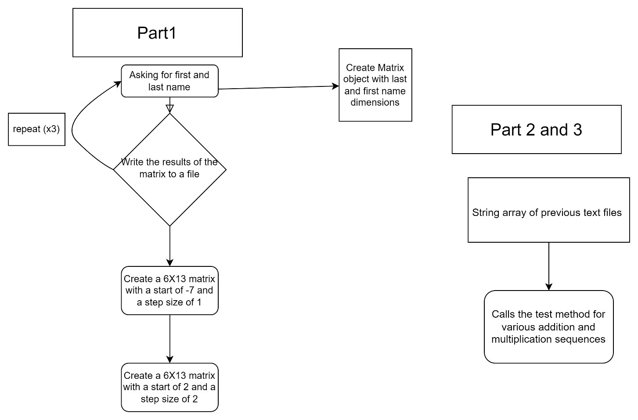

## Key Data Structures

The key data structures that I used in the programs were array lists and arrays. The array lists were mostly used to find the rows and columns of a matrix because you could load the values into an array list of an array list and get the dimensions for the matrix.

## Test Description

The test files I used for the first part was just the console because it gives direct input and output to the program and to the user. For the second part I used the first parts matrices to test the second parts addition. The results were then written to files in the file for the assignment. The third part was similar in that I used the first parts matrices for the test files and then writing the results back out to the same file.