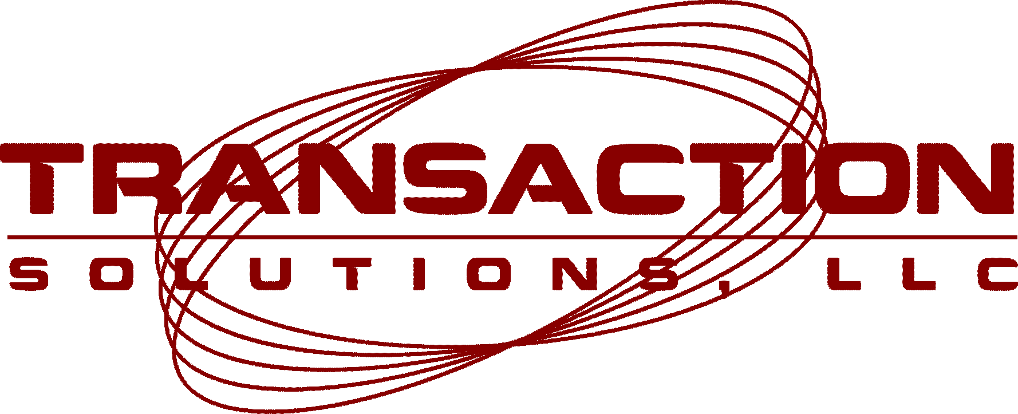

Stan Guidroz
Jalou – Cash Magic Casino’s
1869 Mills Hwy.
Breaux Bridge, LA 70517

Dear Stan,

It was good speaking with you. I have enclosed all of the necessary forms that we will need in order to activate your merchant account for credit card processing. As requested we will be happy to enable your POS system to accept Visa, MasterCard, American Express, Discover, debit, Voyager, and Wright Express. If there are other cards needed please let us know and we will be happy to help add them.

Enclosed please find the bankcard agreement and attached forms. Please fill out the YELLOW highlighted areas. Also please include one copy of a voided check and a copy of your current business license. You need to write your existing American Express (AMEX) ID# on the application where highlighted, as well as your Discover ID#. If you need to obtain new AMEX and Discover merchant ID#’s, you may call AMEX at (800) 528-5800, and Discover at (800) 347-6673 and they will issue you these numbers over the phone.

Please fax the completed applications to us, the location matrix, a copy of a voided check, and copy of business license to 928-752-7259. Once the fax is received, we’ll get your MID#’s issued and begin the set-up process. Please fax ALL PAGES (including small print) to us as soon as possible so we can get moving on the set-up process.

If you should need to ask any questions, please contact us, and we look forward to working with you! The minute we receive the fax we’ll get to work. As Forrest Van Camp will be managing the set-up process of all of your locations, please take down his cell phone number which is 850-232-0594. He will be contacting you after receipt of the paperwork and will closely monitor the activation process. Thanks again and we look forward to serving you!

Best regards,

Jason C. Godin, Petroleum Sales Director
Transaction Solutions
17255 Carroway Lane
Punta Gorda, FL 33955
850.554.0997 cell
928.752.7259 fax

