Exploring Operational Improvements to Long-Term Weather Forecasting Using Teleconnection Pattern Analysis

Everstream Analytics
MET 431/531
Spring Semester 2026

Exploring Operational Improvements to Long-Term Weather Forecasting Using Teleconnection Pattern Analysis

Project Team: |  | Tyson Stewart  Landon Moeller  Matthew Woods  Owen Cutinello
Project Advisor: |  | Dr. Haberlie
Company Sponsor: |  | Everstream Analytics.  San Marcos, California
Company Advisors: |  | Logan Bundy

MET 431/531
Spring Semester 2026

Department of Earth, Atmosphere, and Environment
Northern Illinois University
DeKalb, IL 60115

1. Introduction 4
a. Role of Everstream Analytics 4
b. Problem Statement 4
c. Introduction to Teleconnections 6
2. Methodology 8
a. Regions of Study 8
b. Data 9
c. Correlation Analysis 10
d. Statistical Model Design 11
e. Machine Learning Model Design 13
3. Results 15
a. Regional Correlations 15
b. Intra-annual Variability 24
4. Discussion 32
1.0-5. Future Work 33
a. Statistical Model Refinement 33
c. ML Model Refinement 34
6. Conclusion 34
7. References 34
Appendix A – Additional Tables 36

1. Introduction

a. Role of Everstream Analytics
Everstream Analytics is an analytics company that provides insights, forecasts, and assessments to maximize efficiency and profitability for their partners. Everstream provides services for a variety of private sector industries including the agriculture, commercial goods, and energy sectors (Everstream Analytics 2026). These sectors are particularly vulnerable to long-term changes to weather, such as temperature and precipitation. Therefore, Everstream needs a reliable means to forecast potential weather conditions beyond 2-3 weeks. Additionally, because of Everstream’s worldwide reach, any forecast method needs to be able to accommodate different global regions and their differing major industries and primary concerns and threats to said industries. To assist in this operational need, it has been requested that the potential to utilize teleconnection data in addition to numerical weather modeling and Everstream’s internal products be investigated. This report, and the information that follows, is a preliminary summary of the problem at hand, analysis of different teleconnection indices per forecast region, an experimented solution utilizing multiple modeling methods, and results/reccomendations regarding said solution.

b. Problem Statement
Long-term forecasting is an essential part of operations for a variety of industry sectors and companies. Supply chain operations and economics often hinge on decisions and events that happen months in advance. An example of this can be seen with the grounding of the container ship Ever Given in March of 2021. The ship, travelling through the Suez Canal, ran aground in the southernmost stretch of the Canal, completely blocking sea travel along the Suez for six days (Gerson 2023). This grounding not just affected shipments on the ship itself, but also the backlog of hundreds of ships waiting to travel through the canal, and the ships that needed to reroute along longer routes to avoid the blockage. Overall, the economic impacts expanded far beyond the millions of dollars' worth of goods on the ship itself (Gerson 2023).
The incident involving the Ever Given container ship highlights both the interconnected nature of the supply chain as well as how singular events can ripple into much larger consequences spanning long beyond the initial timeframe. The same applies to meteorological events and as such, it is of great importance to companies and industries that accurate and reliable long-term forecasts of weather and climate are available. Such forecasts are critical in allowing companies and industries to prepare resources ahead of time to mitigate losses. However, this need for long-term forecasts often runs into conflict with the short-term nature of computational weather modeling. Many popular numerical weather models (GFS, HRRR, NAM, etc.) are designed to operate in one-to-ten-day intervals. Longer term numerical models do exist (such as CanSIPS, NMME, and ECMFW Monthly) but are limited in scope and use cases. As a result, it can be incredibly challenging to create actionable weather and climate forecasts for companies and industry and often involve a considerable amount of time and resources. In addition, different regions often have different predominant industries which can add an additional layer of complexity. Meteorological concerns for agriculture-dominant regions, such as the Midwest United States and eastern Europe (Huston and Dastrup 2020) will differ to that of oil and energy sector dominant regions. There are, however, additional tools that can potentially be used to make generating regional, longer-term forecasts easier, one of which being the analysis of “teleconnection” patterns.

c. Introduction to Teleconnections
Teleconnection patterns, broadly speaking, are climatological patterns that can create different regional effects downstream of the initial pattern. An example of such a pattern is the infamous “El Nino-Southern Oscillation” (ENSO) teleconnection. ENSO is primarily driven by long term changes to sea surface temperature in the Pacific that then in turn effects the predominant atmospheric pressure and weather patterns globally. As such, understanding what the current state of ENSO is can be critical to determining what long-term conditions in each region can be (Fig. 1).
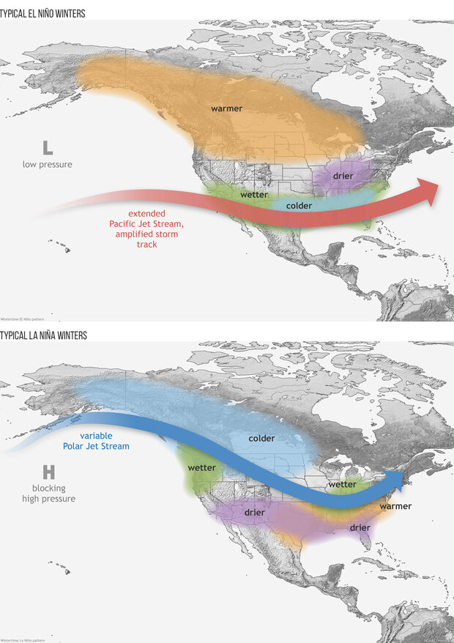
Figure 1: Map of North America with wintertime ENSO phase effects overlayed (referred to in the figure as El Nino and La Nina Winters). Figure from NOAA (2025).
Teleconnection Index Name | Abbreviation | Domain
El Nino-Southern Oscillation | ENSO 3.4 | Global
Multivariate ENSO Index | MEI | Global
Quasi-Biennial Oscillation | QBO | Global
Indian Ocean Dipole | IOD | Global
ENSO Modoki Index | EMI | Global
Interdecadal Pacific Oscillation | IPO | Global
Globally Averaged Angular Momentum | AAM-ANOM | Global
North Atlantic Oscillation | NAO | Northern Hemisphere
Arctic Oscillation | AO | Northern Hemisphere
Western Pacific Oscillation | WPO | Northern Hemisphere
Eastern Pacific Oscillation | EPO | Northern Hemisphere
Pacific North American Pattern | PNA | Northern Hemisphere
Pacific Decadal Oscillation | PDO | Northern Hemisphere
Atlantic Multidecadal Oscillation | AMO | Northern Hemisphere
Tropical North Atlantic Index | TNA | Northern Hemisphere
West Pacific Pattern | WP | Northern Hemisphere
East Atlantic Pattern | EA | Northern Hemisphere
Scandinavian Pattern | SCA | Northern Hemisphere
Polar/Eurasia Pattern | POL | Northern Hemisphere
East Atlantic/West Russia Pattern | EAWR | Northern Hemisphere
East Pacific/North Pacific Oscillation | EPNP | Northern Hemisphere
Northern Oscillation Index | NOI | Northern Hemisphere
Arctic Dipole Index | ADI | Northern Hemisphere
Southern Oscillation Index | SOI | Southern Hemisphere
Tropical Southern Atlantic Index | TSA | Southern Hemisphere
Antarctic Oscillation | AAO | Southern Hemisphere
Southern Atlantic Ocean Dipole | SAOD | Southern Hemisphere
Southern Pacific Ocean Dipole | SPOD | Southern Hemisphere
Trans-Polar Index | TPI | Southern Hemisphere

Table 1: Table of major teleconnection indices, their common abbreviations, and domain area. Note that this table is not meant to be all encompassing, as there are other indices not mentioned herein. Table created by authors from documentation provided by Everstream.
While ENSO is perhaps the most notorious example of teleconnections within popular culture, it is by no means the only pattern. A wide variety of teleconnections are present not just on a global scale, but also on a hemispheric level (Table 1). Each of these teleconnections has the potential to be a useful tool in long-term forecasting of future climatic conditions. Past research has highlighted the value of teleconnections for many use-cases including analyzing regional precipitation trends (González-Pérez et al. 2022; Goodrich and Walker 2011), agricultural risk forecasting (Zhang et al. 2021), and seasonal temperature forecasting (Rust et al. 2015). As such, the potential for teleconnection analysis to be used in an operational setting, especially as an aid for regional long-term forecasting, is an enticing prospect. Therefore, this research seeks to explore the creation of an operational model/framework for integrating teleconnection analyses into actionable climate forecasts.

2. Methodology

a. Regions of Study
Everstream Analytics is interested in 13 regions across the globe, situated in North America, South America, Europe, Asia, and Australia (Fig. 2). The eight regions in the Northern Hemisphere are the Midwest U.S., Northeast U.S., Southern Plains U.S., Eastern Europe, Western Europe, the Black Sea Region, India, and East Asia. The five regions located in the Southern Hemisphere are Northern Brazil, Southern Brazil, Argentina, Eastern Australia, and Western Australia. Regions do not have specific longitude and latitude bounds but are broadly defined by the company advisor. Examining these areas for different prospects, whether for agriculture, energy, or supply chain concerns, is important for the insights that Everstream hopes to provide to clients.
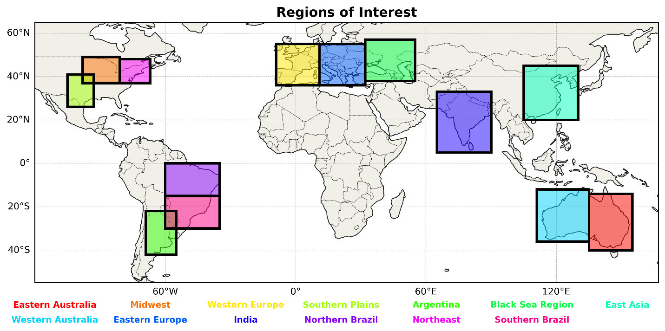
Figure 2. Thirteen regions of interest in North America, South America, Europe, Asia, and Australia.

b. Data
Two sets of monthly data from 1950 to 2024, for a total of 900 months, are used in this project. All data was downloaded in Comma-Separated Values (CSV) form as 42 individual files. Data for 29 teleconnection indices (16 with influence in the Northern Hemisphere, six in the Southern Hemisphere, and seven across the globe) was obtained from the National Oceanic and Atmospheric Administration (NOAA). Each month contains a mean index value for all teleconnections, where a positive (negative) value indicates a positive (negative) phase, except for ENSO3.4, which additionally contains a neutral phase between -0.5 and 0.5. Climate anomaly data was retrieved from European Centre for Medium-Range Weather Forecasts Reanalysis v5 (ERA5; Hersbach et al. 2020). The monthly value represents the spatial mean in each region. The variables downloaded were 2-meter air temperature (T2M) and total precipitation (TP). The baseline period of 1980-2010 was used to calculate temperature anomaly (T2M_Anom), precipitation anomaly (TP_Anom), standardized temperature anomaly (T2M_Std), and standardized precipitation anomaly (TP_Std).
These climate anomalies were detrended to remove low-frequency variability associated with long-term climate trends. Without detrending, time series are inherently nonlinear and contain natural trends (Wu et al. 2007). To pull out more accurate representations in the climate anomalies, the detrending was conducted to separate any long-term trends from the variability components. This ensures that the climate data being used for correlation analysis and model input properly reflects interannual and decadal variability.

c. Correlation Analysis
Monthly teleconnection index values were aligned with the corresponding ERA5 climate anomaly values from the CSV files into Network Common Data Form (netCDF) files for comparison by hemisphere. Pearson correlation (r) was calculated for each region using both global teleconnections and relevant hemisphere teleconnections with temperature and precipitation standardized anomaly data. In this study, correlation strengths are arbitrarily defined as weak (r < 0.30), moderate (0.30 $≤$r < 0.50), and strong (r $≥$ 0.50). Initial analysis was mostly conducted amongst all months, but there was some exploration of intra-annual variations. R-Squared ($R^{2}$) was also calculated for each instance to show the proportion of variance in a dependent variable explained by independent variables through a regression model. To perform a statistical analysis, the Pearson p-value was calculated for each. Correlations with a p-value less than 0.05 were deemed to be statistically significant, and a p-value less than 0.01 as very statistically significant. The Pearson r and p-values are used to determine which teleconnection indices may prove useful in the prediction of climate anomalies in a model. In each region, the top ten warmest and coldest (wettest and driest) months for temperature anomaly (precipitation anomaly) for each teleconnection index are also highlighted for further reference and investigation.

d. Statistical Model Design
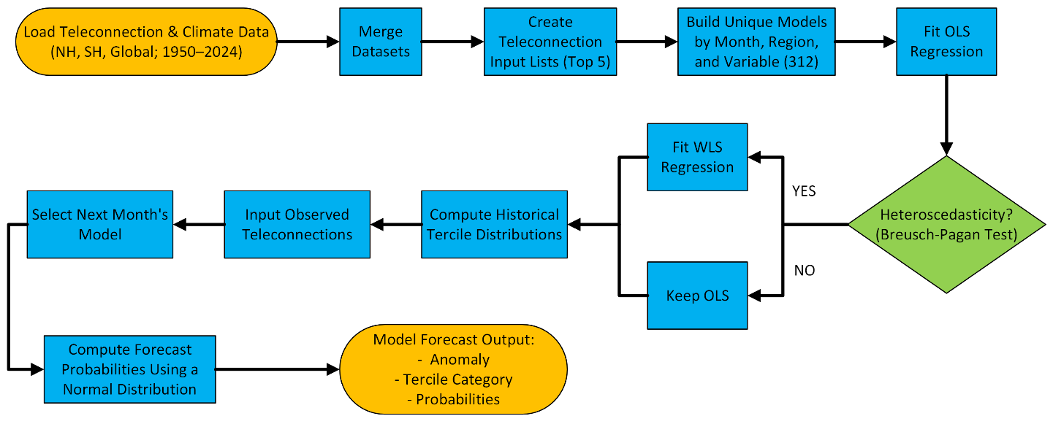
Figure 3. Workflow for building multi-linear regression models.
To predict monthly climate anomalies in each region, a multiple linear regression (MLR) model framework was developed to account for complimentary influences of several teleconnections. MLR analysis considers the input of several predictors to develop a relationship with and produce a prediction of a continuous response variable (Alexopoulos 2010). In the context of this project, the predictors are the teleconnection indices, and the response variable is the resulting T2M or TP anomaly. Given the wide-ranging intra-annual variability that exists amongst teleconnection correlations with climate anomalies, a month-specific approach will be needed to manage such discrepancies. Lag time for teleconnection correlations are both difficult to determine and incorporate into these models, but assuming that observed teleconnections are used as input, it is reasonable to produce output based on the next month’s historical correlations. This does not perfectly capture lag time, but it incorporates some amount of delay in climate anomaly response to teleconnection indices. Building this framework required separating observed correlations by month, region, and variable to best capture intricate relationships. This breakup resulted in 312 unique multi-linear regression models (12 months, 13 regions, 2 variables) with up to 75 data points for each (Fig. 3).
Similar to the correlation analysis explained in the previous section, this MLR model will take monthly teleconnection values and T2M_Std and TP_Std data for each region. This time, all teleconnections will be considered together as predictors of the monthly climate anomaly. The models were built using the statsmodels package in Python to fit with ordinary least squares (OLS). To ensure that heteroscedasticity was properly accounted for, the Breusch-Pagan test (Breusch and Pagan 1979) was ran for each configuration. Models that failed this test were instead fit with weighted least squares (WLS).
To properly inform these models, the previously calculated correlations were analyzed to identify ideal model input for each region and variable. For correlations averaged across all months, the five teleconnections with the strongest influence in each region, determined amongst both local hemisphere and global indices, were constructed into 26 model input lists. Running of these predictions is designed to take manually input observed values. The user also specifies the current month in which the teleconnection values come from. After the unique model configurations were built, historical tercile distributions (above normal, normal, and below normal) were produced using thresholds of -/+ 1 standard deviation for below/above normal. These observed tercile frequencies provide an estimate of the climatological likelihood of these categories occurring. To produce uncertainty metrics in the output of these predictions, probabilities of above/below/near normal conditions being met in the following month are calculated by taking the predicted T2M_Std and TP_Std and using them as the means of a Gaussian predictive probability distribution. These probabilities are then determined by finding the total probability of exceeding or falling below the fixed tercile thresholds previously defined.
The output of this model is predicted T2M_Std, TP_Std, T2M ($℃$), and TP (mm) for the next month in each region. Additionally, the most likely category (above/normal/below) is provided alongside the probability of each category being realized. The output is in a table-like format.

e. Machine Learning Model Design
In an effort to compare the ability of the MLR model to predict temperature and precipitation anomalies for each region to other potential methodologies, a similar but distinct model has been designed utilizing machine learning as opposed to a more statistically based model. The objective of this model remains the same as the statistical variant, regressively predict anomaly values for a given region using teleconnection indices. However, the second model, referred to herein as the “ML model”, utilizes random forests (RF) to create such predictions. RF leverages the use of decision trees to analyze multiple input variables and how they collectively contribute towards the output variable being predicted. In addition to modeling a similar analytical approach to one that a human may take through individual decision trees, RF uses a collective of many trees to make an ultimate prediction (Fig. 4). This means that connections between input variables, that may not otherwise be immediately noticeable, can be factored into predictions, potentially improving performance.
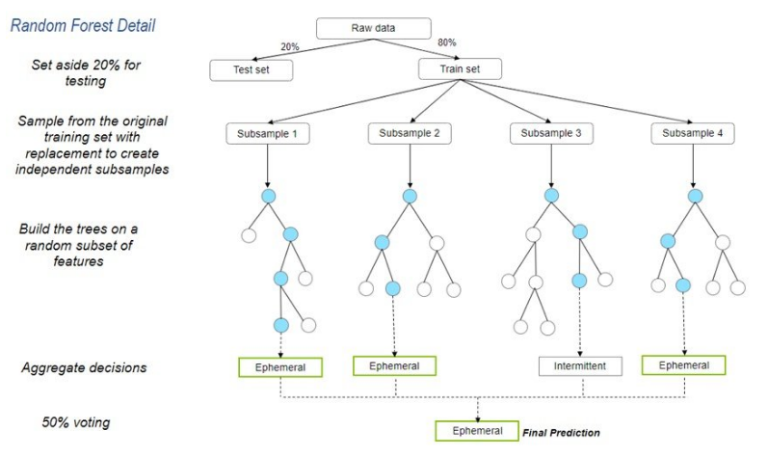
Figure 4. Diagram of a hypothetical random forest model. From each dataset subsample, exists a decision tree of branches and nodes, where each branch represents an individual indicator from the input data that can be used to predict the output variable. Once all trees are generated, predictions are run through and counted from the collection of trees, with the category with the most predictions being used as the final prediction. Figure from EPA (2025).
Such an ML model has been shown to be effective in meteorological use cases numerous times, including showing promising results in severe weather forecasting (Hill et al. 2020). Therefore, it serves as a promising starting point when developing a ML-centric prediction model. To implement RF into a prediction model, a starting workflow like that of the MLR model was utilized. Teleconnection and anomaly data were merged into a single, tabular dataset, and teleconnections were filtered into the top five performing indices based on the prior correlation analysis. However, in contrast to the MLR model, indices across all months were analyzed as opposed to models split per month. A main reason for this is the ability to pass the month variable as an input in addition to the teleconnection indices, though models remain split based on region and variable. From here, the dataset is filtered to exclude months with any null values and randomly split into training and testing pools based on the year. This is done to ensure that the data used to test the model is separated from the data used to train it, thereby ensuring correct accuracy of metrics. The decision to split the data by year is also to ensure that monthly data is consistent within the year, thereby accounting for any intra-annual variability. Finally, once this filtered dataset is compiled, it is then passed into RF model training, with the teleconnection indices and month variable as inputs, and the regional variable anomaly passed as the output.
Both the RF model training and subsequent model evaluation are utilized via the “Yggdrasil Decision Forests” (YDF) Python package. This package was created by Google Research as an offshoot of the popular TensorFlow ML package. Therefore, it offers a variety of advantages that are particularly useful for this project and its future development. These advantages include “checkpoints” for long-duration model training, many options for model revision and expansion, the ability to save pre-trained models as a file for future use, and streamlined syntax with minimal boilerplate code. For the sake of simplicity, we have opted for a simplified model configuration using a mostly default configuration and hyperparameter tuner, to ensure reasonably optimal performance.

3. Results

a. Regional Correlations
The three regions of focus within the United States are the Midwest, the southern Great Plains, and the Northeast. Starting with the Midwest using Northern Hemisphere temperature teleconnection data, the EPNP pattern has the strongest correlation with a Pearson value of –0.4467. Along with a p-value of < 0.01, this marks it as being very statistically significant. The East Pacific Oscillation (EPO) and Arctic Oscillation (AO) come next, both being very statistically significant. Following these are the WPO and the NAO. Regarding the most significant global teleconnections, the EMI is the most statistically significant and has a Pearson value of –0.0974.
The Southern Plains’ most significant teleconnection correlation with temperature is the EPNP with a Pearson value of –0.2783. Following that, the PDO, EPO, and AO are among the most significant teleconnections. The global teleconnection that holds the most significance for the Southern Plains is the IPO.
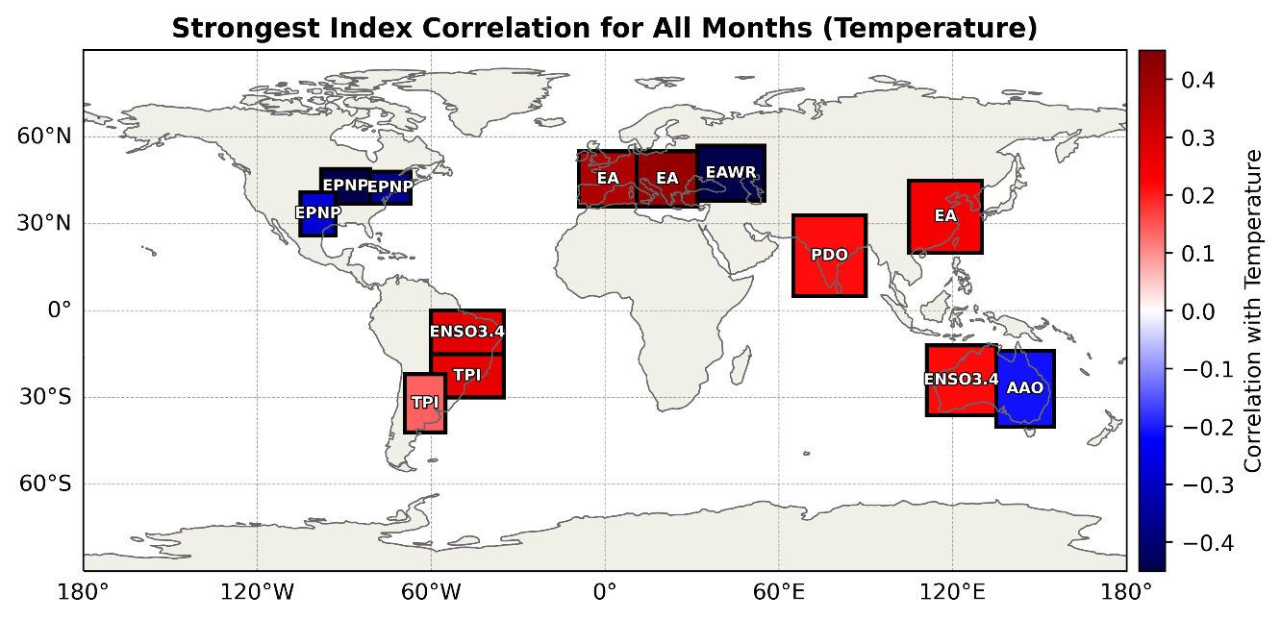
In the Northeastern U.S., the topmost teleconnection regarding temperature anomalies is the EPNP with a Pearson value of –0.3636. The EPNP correlation for this region is moderately significant. The EPO is next with this one being very statistically significant. Following that are the AMO, the AO, and last, the PDO. The top global teleconnection for the Northeast is the EMI with a Pearson value of –0.1240. Overall, the commonality in the United States is that teleconnections in the East Pacific, such as EPNP and EPO, have the strongest correlations with temperature departures (Fig. 5).
Figure 5. The strongest index by Pearson correlation across all months for T2M_Std by region.
When examining precipitation across all months from 1950-2024, and using Northern Hemisphere teleconnections, the Midwest is most influenced by the PNA with a Pearson value of –0.1951 and is very statistically significant. PNA is followed by the AMO, TNA, and SCA, which are all very statistically significant. The EAWR is also statistically significant. Out of the global teleconnections, the Midwest is most influenced by the Multivariate ENSO Index (MEI) with a Pearson value of 0.0888 and is very statistically significant. In addition to the top five most influential teleconnections, the Midwest is also statistically significantly influenced by the EPNP, PDO, AO, and NOI.
The Southern Plains is most influenced by the PDO with a Pearson value of 0.1819 and is very statistically significant. Following the PDO are the AMO and EAWR, which are both very statistically significant. Then there is the TNA and PNA, which are both statistically significant. The most impactful global teleconnection is the MEI with a Pearson value of 0.1877 and is very statistically significant. IPO, ENSO 3.4, AAM, and EMI are all also very statistically significant as far as global teleconnections go.
In the Northeast, NAO is the most influential teleconnection with a Pearson value of 0.0776. Following NAO, the EPNP, PNA, AMO, and SCA complete the top five most influential teleconnections. The most influential global teleconnection is the IOD with a Pearson value of 0.0248.
Concerning South America, the main regions of focus are Northern Brazil, Southern Brazil, and Argentina. Starting with Northern Brazil, the top temperature teleconnection is the SOI with a Pearson value of –0.1990. Following the SOI teleconnection is the TSA, TPI, AAO, and the SPOD. The most significant Global temperature teleconnection is the ENSO 34 for Northern Brazil with a Pearson value of 0.2743.
In Southern Brazil, the topmost significant temperature teleconnection is the TPI with a Pearson value of 0.2685. Following the TPI are the SOI, SPOD, TSA, and the AAO. These teleconnections show relatively lower correlations, and none are considered very statistically significant. Concerning Southern Brazil, the top global teleconnection is the ENSO 34 with a Pearson value of 0.1925.
In Argentina, the temperature teleconnection with the highest statistical significance is the TPI with a Pearson value of 0.1403. The SOI, AAO, SPOD, and the TSA teleconnections all follow the TPI, all being statistically significant. Regarding the top global temperature teleconnection, the MEI is the most statistically significant with a Pearson value of –0.0498. The MEI teleconnection for Argentina has a much weaker correlation strength in comparison to other teleconnections.
When examining precipitation in South America using southern hemisphere teleconnections, Northern Brazil is most impacted by the AAO with a Pearson value of 0.0524. After AAO, TPI, SAOD, TSA, and SPOD have the most impact on the precipitation in the region. The most impactful global teleconnection is AAM with a Pearson value of 0.1288 and is very statistically significant. IOD and ENSO 3.4 are also statistically significant teleconnections for the region.
Southern Brazil is most impacted by SPOD with a Pearson value of 0.2098 and is very statistically significant (Fig. 6). Following SPOD is TPI which is very statistically significant, and SAOD which is statistically significant. Rounding off the top five are SOI and AAO. MEI is the most influential global teleconnection with a Pearson value of 0.2444 and is very statistically significant. Other very statistically significant global teleconnections are IPO, ENSO 3.4, and AAM.
In Argentina, SOI is the most impactful teleconnection with a Pearson value of –0.1603 with SPOD not far behind. Both are very statistically significant. After SOI and SPOD, TSA, AAO, and SAOD are the next three most influential teleconnections in the region. The most influential global teleconnection is MEI with a Pearson value of 0.2438 and is very statistically significant. IPO, ENSO 3.4, and EMI are all also very statistically significant, and IOD is statistically significant.
Figure 6. Correlation of the SPOD with TP_Std across all months in Southern Brazil. The black line denotes the line of best fit. Pearson r and $R^{2}$ values are printed in the top left.
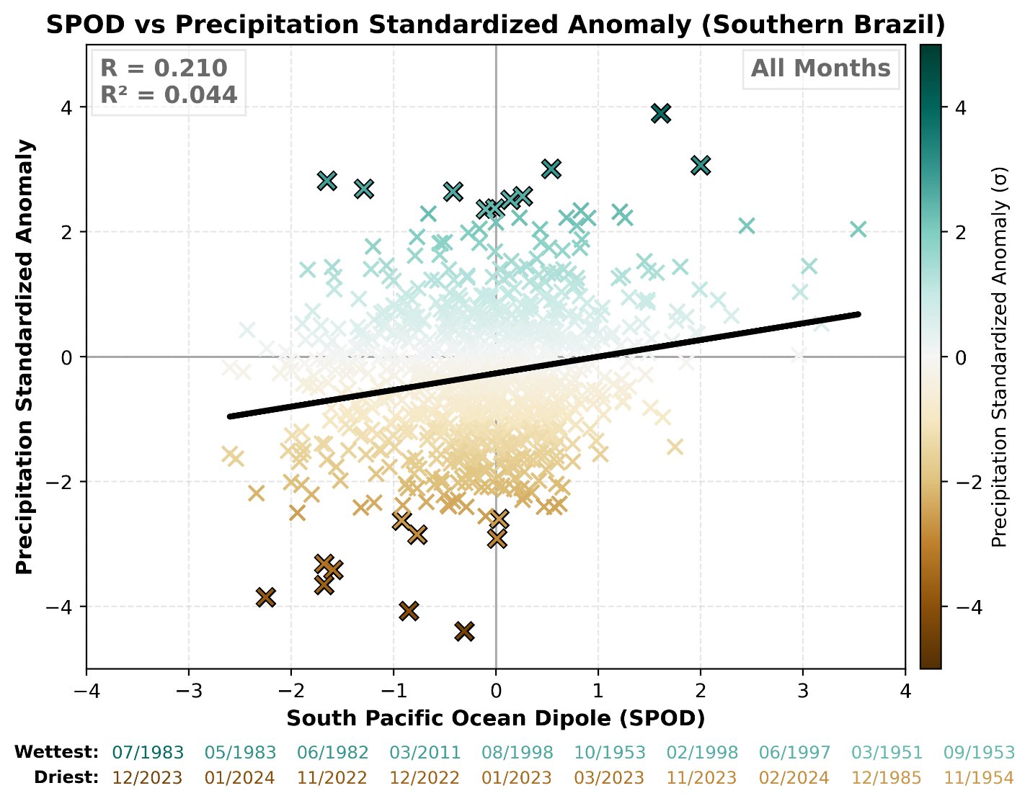
The main regions of focus within Europe are Western Europe, Eastern Europe, and the Black Sea. Starting with Western Europe, the most statistically significant temperature anomaly teleconnection is the EA with a Pearson value of 0.3659. This teleconnection is very statistically significant for Western Europe. Following the EA is the AO, which is also very statistically significant. The teleconnections following the AO are the EAWR, NAO, and AMO. The dominant global teleconnection for Western Europe is the IOD with a p value of 0.0619.
Figure 5. Correlation of the SPOD with TP_Std across all months in Southern Brazil. The black line denotes the line of best fit. Pearson r and $R^{2}$ values are printed in the top left.
For Eastern Europe, the dominant temperature anomaly teleconnection is the EA with a p value of 0.4082. This teleconnection for Eastern Europe has a relatively strong correlation strength and holds high statistical significance. The AO and the AMO are next, both being very statistically significant. Eastern Europe is also influenced by the PDO and the EAWR regarding temperature anomalies, both showing lower but still relevant statistical significance. The topmost influential global teleconnection for Eastern Europe is the AAM with a p value of –0.0928.
Regarding the Black Sea Region for temperature anomalies, the EAWR stands out as the most statistically significant with a Pearson value of –0.4686. This teleconnection has moderate correlation strength, indicating that it is very statistically significant. Following the EAWR is the SCA with a Pearson value of –0.2057. The AMO, PDO, and the NAO teleconnections are all statistically significant, but show slightly weaker correlation strength. The top global teleconnection concerning temperature anomalies is the AAM with a Pearson value of -0.1076 being statistically significant.
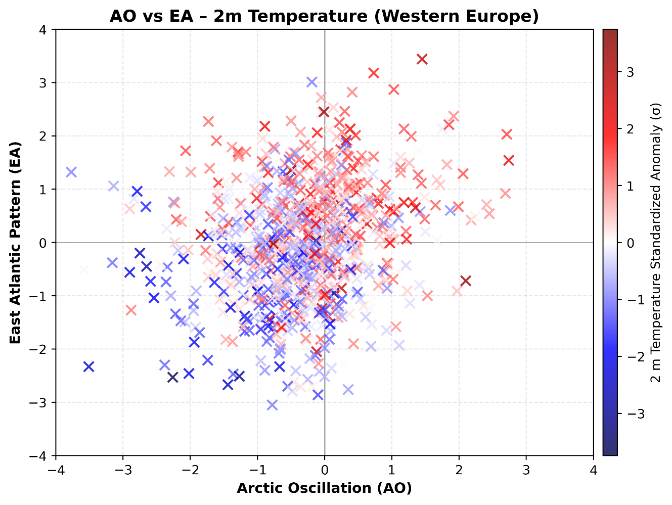
Figure 6. Figure 7. AO and EA with T2M_Std in Western Europe across all months.
The dominant teleconnection within the Northern Hemisphere correlated to precipitation in Western Europe is the Arctic Oscillation (AO) with a Pearson value of –0.2906, weak correlation strength, and is very statistically significant. After the AO, the SCA, NAO, EA, and EAWR complete the top five most influential teleconnections for Western Europe and are all very statistically significant. The most impactful global teleconnection is the IPO with a Pearson value of 0.1267 and is very statistically significant. In addition to the top five most impactful teleconnections, Western Europe is influenced by the PDO, EPNP ADI, NOI, and AMO, which are all very statistically significant, and EPO, and WPO, which are all statistically significant. When combining two teleconnections with at least moderately strong correlation in a region, additional conclusions can be made. For example, examining both the AO and EA in Western Europe shows that when both are negative (positive), below (above) average temperatures are favored in the region (Fig. 7).
Looking at precipitation, Eastern Europe is most influenced by the AO with a Pearson value of –0.3663 and the EAWR, which both have moderate correlation strength and are very statistically significant. Following those two, Eastern Europe is impacted by the EA, NAO, and PDO, which are all very statistically significant as well. The most influential global teleconnection that impacts Eastern Europe is the IPO with a Pearson value of 0.0481. In addition to the top five teleconnections, Eastern Europe is influenced by ADI, POL, and SCA which are all very statistically significant, and the WPO, AMO, and EPO which are all statistically significant.
Within the Black Sea Region, EAWR is the most impactful teleconnection with a Pearson value of 0.2634 and is very statistically significant for precipitation. Following this, the PDO, AMO, EA, and POL are the most influential and are all very statistically significant. On the global scale, the MEI is the most impactful with a Pearson value of 0.1938 and is very statistically significant. Along with the top five, other impactful hemisphere teleconnections are SCA, AO, and NOI, which are all very statistically significant. Of interesting note, in Western Europe and Eastern Europe, the strongest correlation (AO) is negative while the strongest correlation in the Black Sea Region (EAWR) is positive (Fig. 8). Other impactful global teleconnections are the AAM, IPO, EMI, and ENSO 3.4 which are all very statistically significant.
Figure 7. The strongest index by Pearson correlation across all months for TP_Std by region.
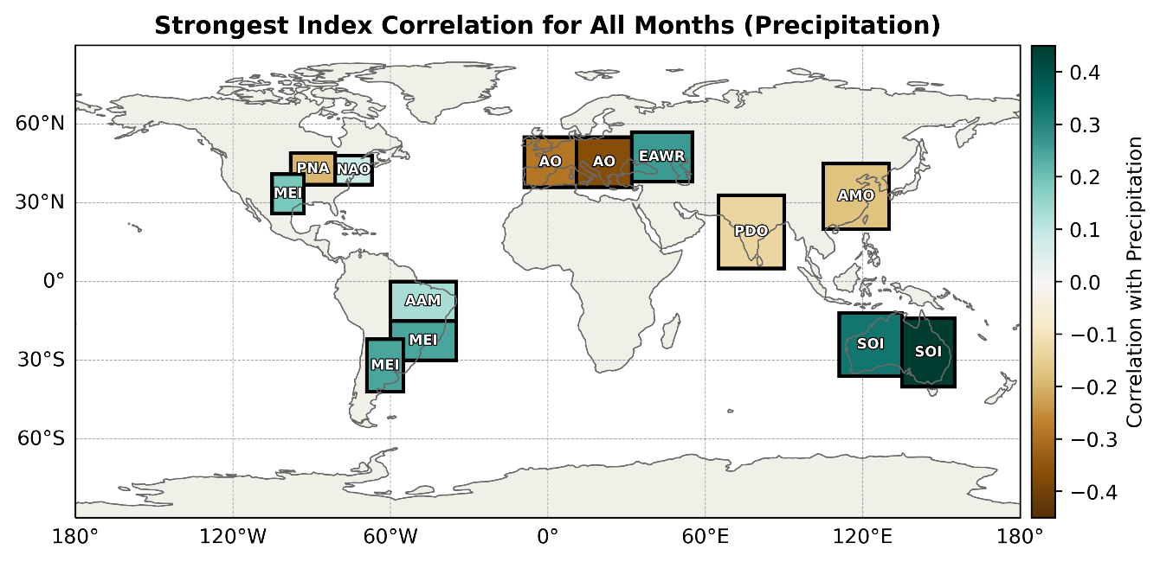
The regions of focus are India and East Asia. Starting with India, the top teleconnection regarding temperature anomalies is the PDO with a Pearson value of 0.2116. Following the PDO are the ADI, WPO, WP, and PNA teleconnections. All these teleconnections show statistical significance. The most significant global teleconnection for India is the IPO with a p value of 0.2028 and holds statistical significance.
Figure 8. The strongest index by Pearson correlation across all months for TP_Std by region.
Getting into detail about temperature anomaly teleconnections for East Asia, the topmost teleconnection for this region is the EA with a p value of 0.2363. The next most relevant teleconnection for East Asia regarding temperature anomalies is the AMO with a p value of 0.1784 and also is statistically significant. The next three dominant teleconnections for India are the PDO, EAWR, and the NOI. The most influential global teleconnection for East Asia regarding temperature anomalies is the IPO with a Pearson value of –0.1033.
For Precipitation, In India, the most influential teleconnection is PDO with a Pearson value of –0.1311 and is very statistically significant. Following the PDO are the AMO, NOI and AO which are all statistically very significant. The fifth and final most influential teleconnection is EPO which is statistically significant. The most influential global teleconnection is IPO with a Pearson value of –0.1286 and is very statistically significant. MEI and AAM are also very statistically significant and ENSO 3.4 is statistically significant.
East Asia is most impacted by the AMO for precipitation, with a Pearson value of -0.1756 and is very statistically significant. After AMO, NAO, PDO. TNA, and ADI have the most influence and are all very statistically significant. The next most impactful is the SCA and AO, which are both statistically significant. The most influential global teleconnection is MEI with a Pearson value of 0.1560 and is very statistically significant. Other teleconnections include IPO and ENSO 3.4, both very statistically significant and EMI, which is statistically significant.
Australia is divided into two regions, Eastern and Western Australia. Starting with western Australia concerning temperature anomalies, the dominant teleconnection is the AAO with a Pearson number of –0.2145. The next top teleconnections for western Australia are the SOI, TSA, SPOD, and the SAOD. All these teleconnections show statistical significance but are not highly statistically significant. The dominant global teleconnection for western Australia is the ENSO 34 with a Pearson number of 0.2163 being statistically significant.
Eastern Australia’s top teleconnection concerning temperature anomalies is the AAO with a Pearson value of –0.2085. The next most influential teleconnections for Eastern Australia are the SOI, TPI, SPOD, and the TSA, with most being statistically significant. The topmost global teleconnection for Eastern Australia is the ENSO 34 with a p number of 0.1829.
For precipitation, Eastern Australia is most influenced by SOI with a Pearson value of 0.4518 and AAO which are both very statistically significant. SOI has a moderate correlations strength. Then there is SPOD which is statistically significant, TPI and TSA. Eastern Australia is most influenced by the ENSO global teleconnection with a Pearson value of –0.2791 and is very statistically significant. After ENSO, EMI, MEI, IPO, and IOD are all very statistically significant and AAM is statistically significant.
Sticking with precipitation, Western Australia is most influenced by the SOI with a Pearson value of 0.3292 and is very statistically significant along with a moderate correlation strength. After SOI is AAO which is very statistically significant, then TPI, SPOD, and TSA. The most influential global teleconnection is ENSO with a Pearson value of –0.2201 and is very statistically significant. Following ENSO are MEI, EMI, IOD, and IPO which are all very statistically significant.

b. Intra-annual Variability
Looking at Figure 9, there is a clear image that ENSO is more impactful in the Southern Hemisphere than it is in the Northern Hemisphere. Most of the Northern Hemisphere has a correlation variation between 0.17 and 0.3, while the Southern Hemisphere has a correlation variation anywhere from 0.35 to 0.55. The two notable regions in the northern hemisphere that have seen higher correlation variation are Eastern Europe and India. Argentina has the lowest correlation variation concerning ENSO sitting at 0.243. The months of November, March, and December tend to see the strongest correlation variation in the majority of the Southern Hemisphere regions. 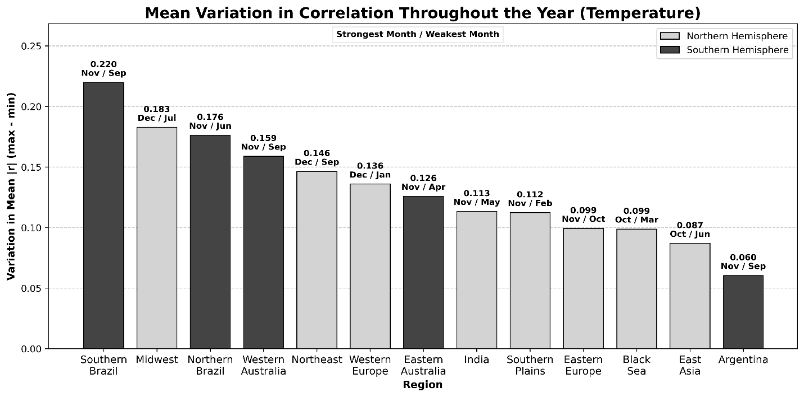
Figure 9. Intra-annual variation (maximum – minimum) in absolute Pearson r correlation strength for T2M_Std with local and global teleconnections by region. Southern Hemisphere regions are represented by the dark gray bars while Northern Hemisphere regions are in the light gray bars. The variation and the month with the strongest and weakest absolute correlation are printed above each bar.

Due to seasonal changes and shifts in weather patterns, strength and direct correlation between regions and their respective indices will fluctuate and will have different indices taking the title of most influential. Precipitation is impacted by the correlation between ENSO 3.4 and the specific regions, and how it can be very influential to one region and have little impact on other regions during the same month (Fig. 10). The Southern Plains and the Northeast are good examples of this. During the month of December, ENSO has its biggest impact on precipitation for the Southern Plains, while the Northeast is the least impacted by ENSO as it will be all year.
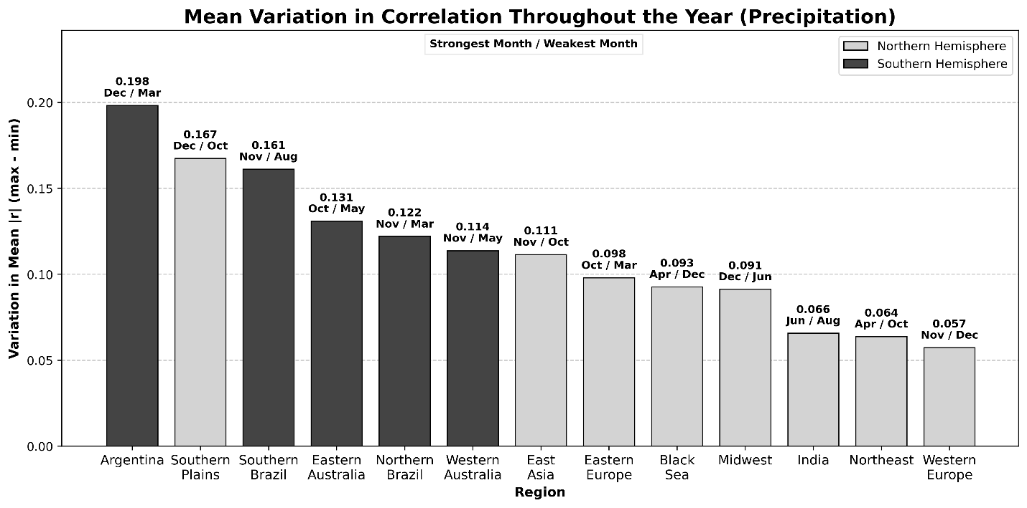
To examine an example of intra-annual variability, each Southern Hemisphere and global teleconnection’s correlation with precipitation in Argentina is plotted throughout the year (Fig. 11). It is easy to see a teleconnection such as TPI have a high correlation in January but have a low correlation throughout the rest of the year. Many indices such as the IPO, which remains around a Pearson r value of 0.2 - 0.4 throughout the year, have a large jump exceeding a 0.6 correlation value as it gets closer to the end of the year. The main takeaway is that correlation strengths both increase and diverge towards summer in Argentina. A similar analysis can be done for each region to show varying intra-annual trends.
Figure 10. Same as in Figure 8, but for TP_Std.

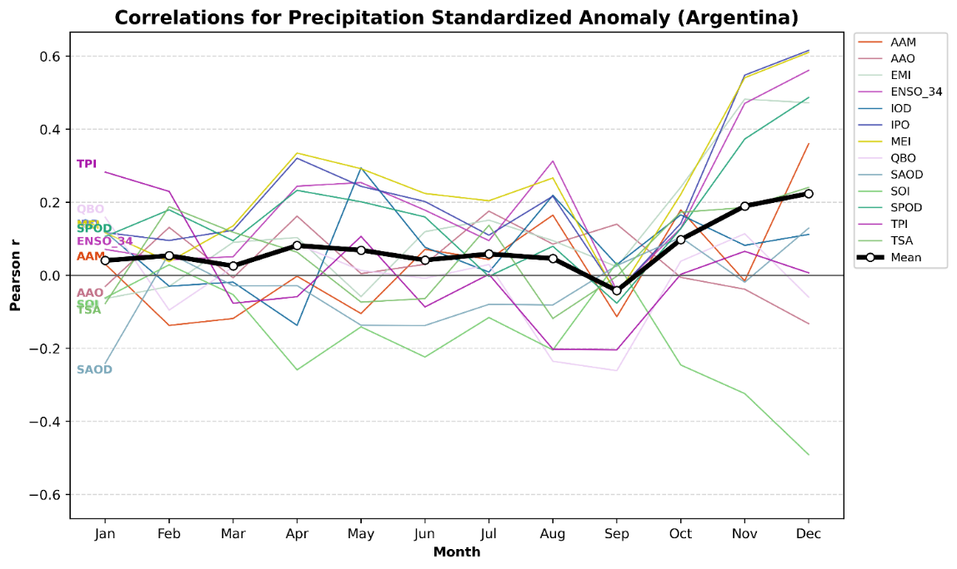
Figure 11. Correlation between TP_Std and the six Southern Hemisphere teleconnections and the seven global teleconnections plotted by month in Argentina. The mean of all 13 teleconnections is plotted in thick black.

c. Statistical Model Evaluation
The performance of the multi-linear regression models used in this project was evaluated with the use of in-sample validation across all regions, variables, and months. For each region and variable, performance metrics were computed by comparing the predicted standardized anomalies to the corresponding observed detrended standardized anomalies. The metrics used for model evaluation include the coefficient of determination (R²), the Pearson correlation coefficient (r), and the root-mean-square error (RMSE). These measures offer insights into various aspects of model skill, such as explained variance, linear association, and error, respectively. Regional performance summaries were separated by variable types to highlight differences in predictive skill and error between temperature and precipitation (Table 2).
It was found that correlations generally exceed the corresponding R² values in magnitude, indicating that the models often correctly capture the sign and timing of variability better than its amplitude. Overall, r tended to decrease in tandem with R². For temperature, RMSE values are typically below 1 $σ$ in all regions except for Northern Brazil. Precipitation RMSE values are slightly higher and more variable amongst the regions. This is consistent with lower overall predictability of precipitation anomalies. Regions in the southern hemisphere performed consistently worse than most northern hemisphere regions across all three evaluation metrics, except for East Asia and India. The best performing regions are in Europe and the United States, with relatively high R², r, and low RMSE. A notable variability exists between the European and U.S. regions, however. Western and Eastern Europe were extremely consistent in predictive skill amongst both temperature and precipitation. In the U.S., the Midwest, Northeast, and Southern Plains exhibited notably higher performance for temperatures than for precipitation. This indicates that precipitation patterns were more difficult to predict in the U.S. than for temperature. The opposite is true in Australia, where precipitation was easier to predict than temperature was. This shows how variable predictions are across the different regions of interest.
Region | T2M R² | TP R² | T2M r | TP r | T2M RMSE ($σ$) | TP RMSE ($σ$)
Black Sea | 0.447 | 0.213 | 0.663 | 0.450 | 0.783 | 0.971
Western Europe | 0.378 | 0.388 | 0.606 | 0.609 | 0.807 | 0.788
Midwest | 0.358 | 0.138 | 0.577 | 0.355 | 0.809 | 0.960
Eastern Europe | 0.324 | 0.336 | 0.561 | 0.570 | 0.860 | 0.861
Northeast | 0.260 | 0.085 | 0.495 | 0.286 | 0.880 | 0.941
Southern Brazil | 0.255 | 0.176 | 0.497 | 0.395 | 0.934 | 0.969
Southern Plains | 0.239 | 0.126 | 0.478 | 0.350 | 0.976 | 0.946
Northern Brazil | 0.217 | 0.095 | 0.460 | 0.293 | 1.096 | 1.094
East Asia | 0.215 | 0.181 | 0.453 | 0.418 | 0.980 | 0.985
Eastern Australia | 0.183 | 0.288 | 0.417 | 0.529 | 0.977 | 0.830
Western Australia | 0.173 | 0.197 | 0.404 | 0.437 | 0.934 | 0.908
India | 0.163 | 0.129 | 0.387 | 0.336 | 0.977 | 1.073
Argentina | 0.142 | 0.133 | 0.360 | 0.332 | 0.954 | 0.949

Table 2: Performance of the multi-linear regression model by region and variable for R², r, and RMSE across all months. Regions with better performance are higher up in the table.
Seasonal variability in model performance is also evident from this evaluation. When averaged across all regions and variables, model skill varies by month, with higher R² values typically observed during fall and early winter (Fig. 12). This seasonal dependency likely reflects changes in the strength or prevalence of large-scale teleconnection patterns, which tend to be stronger and more consistent during these months. Thus, this performance matches expectations and is rather promising. On the other hand, RMSE showed little seasonal variability in a similar assessment, indicating rather consistent error throughout the year.
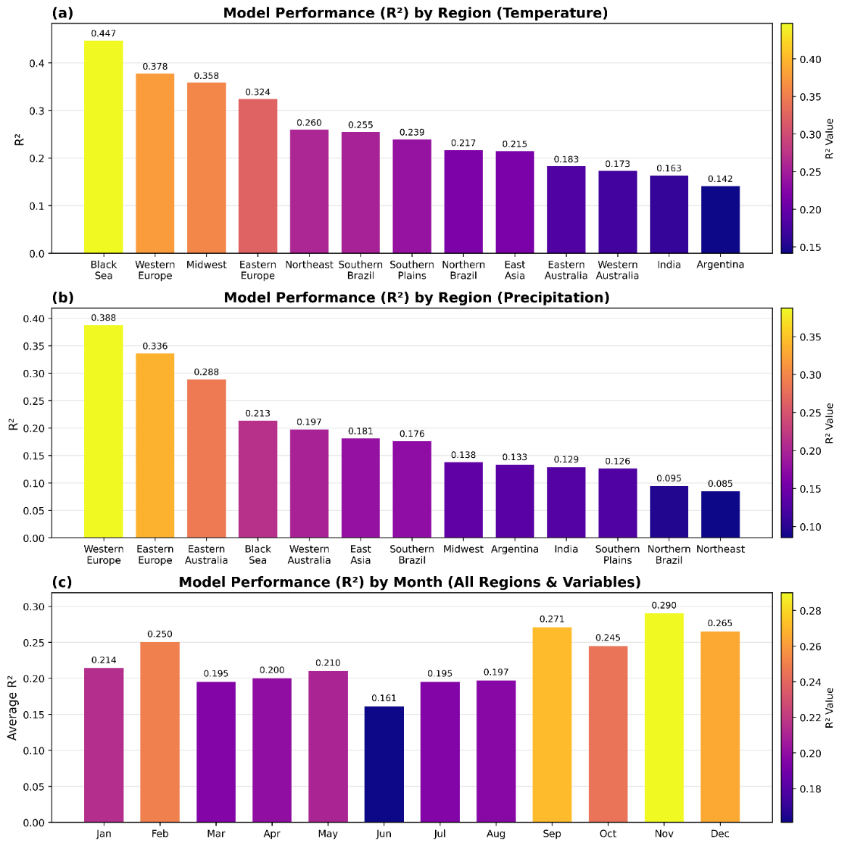
Figure 12. Performance (R²) of the multi-linear regression model for (a) T2M_Std in each region, (b) TP_Std in each region, and (c) for all variables and regions in each month.
Additional assessments were conducted for various configurations to determine the reasonability of output. As an example, we know that several teleconnections have a notable correlation with temperature in October in the Midwest. EPNP has a strong negative correlation, while NAO, AO, EPO, and WPO have moderately positive correlation. Reasonably strong values with a magnitude of 2 were solely input into the model in September for each of these teleconnections, respectively, with EPNP being negative and the rest positive. The output for October resulted in a strong signal for above normal temperatures, with a predicted T2M_Std of 2.24 $σ$ and T2M of 2.63$℃$. Alongside the expected category being determined as above normal came supportive probabilities of 85.5%, 14.2%, and 0.3% for above normal, normal, and below normal conditions, respectively.

d. ML Model Evaluation
Similarly to the statistical MLR model, the random forest model showed some promise but had significant errors. When comparing the RMSE of each region and variable for all months, we find that the models showed similar errors to each other, with RMSE scores anywhere from 0.85 to over 1.33 standard deviations (Fig. 13)
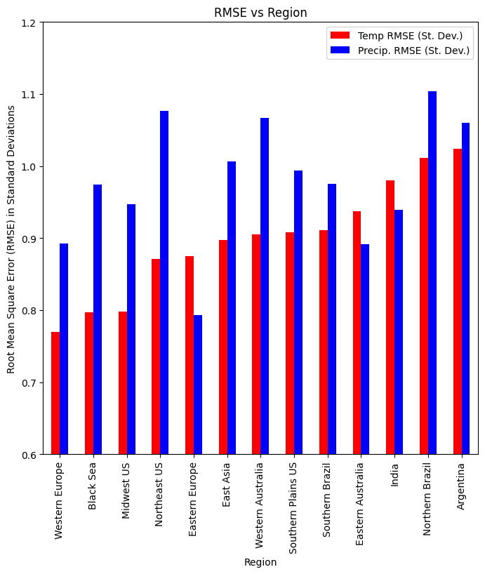
Figure 13. Plot of the Root Mean Square Error (RMSE) as a value of the standard deviation (St. Dev.) of each region and variable anomaly pair. RMSE of the regional temperature anomalies are shown in red, and RMSE of the regional precipitation anomalies are shown in blue. Figure generated by authors.
Since the standard deviation for temperature and precipitation anomalies were around 1.0-1.3 units, and the range of anomaly values often stayed within one standard deviation, given the normal distribution of each anomaly variable, this error is not low enough to imply reliable operational use in forecasting the anomaly value. Still, many of the general trends assessed in the statistical model appear to be replicated here as well. RMSE scores appear to be regionalized to an extent, with European and United States regions tending to have better RMSE scores than regions such as those in the Southern Hemisphere.
When further examining ML model predictions compared to the “ground truth”, actual anomaly values we begin to understand where specifically the source of error appears to be coming from. Throughout even our lowest RMSE regions, predicted values fail to fully represent the relationship at hand (Fig. 14). Furthermore, it appears that anomalies closer to zero (thereby representing an ideal “normal” temperature or precipitation value), have better performance than those at the extremes (Fig. 14).
Figure 14. Plot of the predicted temperature (left) and precipitation (right) anomalies for Eastern Europe by the random forest model. Note that while both predictions (shown by the orange line) increasingly stray from the ground truth (shown as the dotted blue line), there is still a positive relationship like the ground truth line. Illustrating some skill by the model to evaluate the teleconnection correlations. Figures generated by author using YDF evaluation tool output.
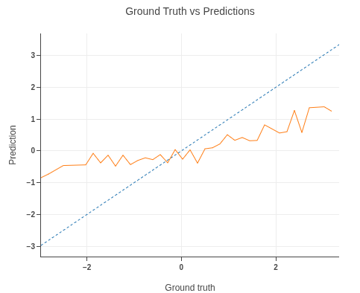 | 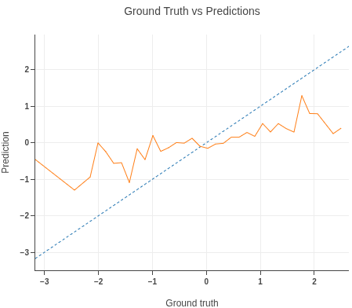

4. Discussion
The results of this project highlight the utility of large-scale teleconnection patterns for the prediction of regional climate anomalies. At the same time, there are some limitations in the means of making these predictions. With the combination of historical correlation analysis, a statistical and machine learning model, and probabilistic forecasting, the framework of this project offers insight into which teleconnections are useful for explaining relationships and how these can be used for prediction. An important thing to note from this is that there are regionally dependent correlations that can differ significantly between temperature and precipitation. Additionally, intra-annual variability results in different relationships from month-to-month in each region. Some regions demonstrate higher consistency and stronger relationships than others, as has been found to especially be the case with the European regions in this project.
The multi-linear regression framework used also displays these findings. It captures a meaningful portion of this variability, especially for temperature. As expected, precipitation patterns are more difficult to predict, are historically more variable, and are often associated with weaker correlations. The models created here often capture the sign and timing of interannual variability, but the amplitude of anomalies is not captured quite as well. With an average RMSE around 0.9 $σ$, these smaller predicted amplitudes might result in a slightly higher chance of the predicted tercile category being incorrect, especially in configurations with weak historical teleconnection correlations. The probabilities of the tercile categories in the statistical model output attempt to highlight this uncertainty, especially in these weaker scenarios. A potential limitation of the statistical model is the assumption to only use the top 5 strongest teleconnections, though the goal here is to avoid over fitting and keep it simple without mixing signals. Regardless, the current framework shows promise and some skill in predicting climate anomalies using observed teleconnection indices.
Similar optimism and caveats are shared with the machine learning model. In a similar respect to the statistical model, the ML model showed undesirably high RMSE values but did show model predictions somewhat following the trend shared by the testing values. However, model error seemed to be focused on the extreme ends of the temperature and precipitation anomaly, with differences in predicted and actual values increasing as the actual values increased (Fig. 14). This would suggest that the ML model for each variable and region combination is encountering a phenomenon known as “underfitting”. Underfitting describes a situation in machine learning models where the model does not capture the underlying relationship at hand, often over-simplifying correlation trends (Mucci n.d.). In our case, the model is underfitting along the extremes, assuming that the data trend near the normal values applies for the extremes.
The source of the underfitting can be a variety of different factors. There is of course the intrinsic possibility that our RF model is too simplified for the task that we are asking of it. It is possible that, given the variety of teleconnection indices that we are seeking to analyze, each with different varying degrees of correlation with regional temperature and precipitation trends, a random forest approach may not be robust enough to predict anomaly values. Another potential source of error is with the data sample size itself. As previously alluded to, given the normal distribution of temperature and precipitation anomalies, there are going to be vastly different quantities of above and below average anomalies compared to the normal range. Because of this, it is possible that the model needs to be trained on more abnormally high and low anomaly values so that it can better understand the relationship between all the various teleconnection patterns.

5. Future Work

a. Statistical Model Refinement
The multi-linear regression models could be further refined to include 312 input lists instead of the current 26 to potentially increase the performance in individual months, given that we have found that intra-annual variability in teleconnection correlation strength and even direction can be significant. This would give each of the model configurations their own, more specific input, rather than relying on average correlations throughout the year.

b. A “Proxy-Year” Product
While we were unable to produce a product that highlights proxy years with observed teleconnection indices, this is something that could be easily done in future efforts. Ideally, this product would identify the year that is the best match based on historical indices for the month in which it is run, as well as other closely matching years. The simplest form of this would just look at the historical teleconnections in the current month, but a more useful version could consider the past several months of teleconnections. The prospect of this product is that it can serve to highlight similar years so that Everstream can go back and examine these years more closely as analogs for the upcoming year, meaning it is ideally run towards the start of the year. Knowing similar past years, especially those that featured significant temperature and precipitation anomalies (and associated risk), can allow Everstream to offer a further warning to customers. The current data framework should allow for the easy creation of this product.

c. ML Model Refinement
As previously mentioned, the primary sources of error with the ML model are along two main sources, those being the ML model complexity and the sample size of the teleconnection/anomaly dataset. If improved ML model performance is desired, it is likely best that future work begins by addressing these major areas of concern. Regarding model complexity, a potential starting point could be to emulate the approach used in the statistical, MLR model and split models into not just region/variable pairs, but also by individual month. Doing this may allow for further diagnosis in determining which months are easier to forecast compared to others. Another way to introduce complexity in the model could be to add additional, non-teleconnection variables, into the model. Doing so may allow the model to better contextualize the physical relationship between teleconnections and meteorological anomaly indices. One way this could theoretically be done is by passing a previous month’s temperature or precipitation anomaly as an input. This could allow the model to account for not just how teleconnection indices affect regional temperature and precipitation, but also how said trends lag in time from month to month. Due to time-constraints, this research was unable to test said adjustments, however given the tabular nature of the data, said process should be straight forward to experiment within the future.
As for the issue regarding sample size, this is difficult to resolve. Given that teleconnection indices are often expressed in the form of monthly data, isn’t viable to increase the time resolution to a sub-monthly time frame. Therefore, to expand the sample size, teleconnection index data for earlier time periods would need to be acquired. This could in theory be obtained from direct observational data or through the use of model reanalysis datasets, similarly to how the regional temperature and precipitation anomalies were calculated. Said process could be possible, given that many teleconnection indices are calculated numerically from atmospheric data but lie outside the scope of this research. Finally, in addition to adding more data, data could be weighed such that anomaly extremes appear as a larger percentage of the training dataset. Much care would need to be taken to ensure that the datasets remain realistic, which influenced the decision to avoid it for this research, but this remains possible nonetheless.

6. Conclusion
In conclusion, this research sought to analyze and assess the practicality of creating a modeling framework for forecasting changes to temperature and precipitation across select regions around the world. The goal of said modeling framework was to use teleconnection indices to generate actionable long-term forecasts for Everstream and its clients. The research group successfully analyzed a wide range of teleconnection indices, and how said indices correlate to changes in temperature and precipitation. However, creating a prediction model framework to turn said correlations into actionable forecasts, yielded mixed results. In both statistical and machine learning models, observed error was found to be too great to yield reliable results. As such, neither of the models are accurate enough to be implemented in an operational setting.
However, both of the models present opportunities for improvement, as well promising prospects towards to a future model existing that can be utilized for medium-range climate forecast. Should improvements in regards to complexity, sample size, and configuration be utilized, it is entirely possible that a model could be created that fulfills the requirements targeted in this research. It is therefore the belief of this research group that future work regarding this subject is needed, and that the models and methodology presented herein can be used as a foundation for said future work.

7. References
Breusch, T. S., and A. R. Pagan, 1979: A Simple Test for Heteroscedasticity and Random Coefficient Variation. Econometrica, 47, 1287, https://doi.org/10.2307/1911963.
Everstream Analytics, 2026: Everstream Analytics. https://www.everstream.ai/.
EPA, 2024: Random Forest Modeling. United States Environmental Protection Agency, https://www.epa.gov/streamflow-duration-assessment/random-forest-modeling.
Gerson, A., 2023: Stranding of the Mega-Ship Ever Given in the Suez Canal: Causes, Consequences, and Lessons to Be Learned. The Suez Canal: Past Lessons and Future Challenges, C. Lutmar and Z. Rubinovitz, Eds, Palgrave Studies in Maritime Politics and Security, Springer International Publishing, 231–252, https://doi.org/10.1007/978-3-031-15670-0_12.
González-Pérez, A., R. Álvarez-Esteban, A. Penas, and S. Del Río, 2022: Analysis of recent rainfall trends and links to teleconnection patterns in California (U.S.). Journal of Hydrology, 612, 128211, https://doi.org/10.1016/j.jhydrol.2022.128211.
Goodrich, G. B., and J. M. Walker, 2011: The Influence of the PDO on Winter Precipitation During High- and Low-Index ENSO Conditions in the Eastern United States. Physical Geography, 32, 295–312, https://doi.org/10.2747/0272-3646.32.4.295.
Helali, J., M. Nouri, M. Mohammadi Ghaleni, S. A. Hosseni, F. Safarpour, A. Shirdeli, P. Paymard, and Z. Kalantari, 2023: Forecasting precipitation based on teleconnections using machine learning approaches across different precipitation regimes. Environ Earth Sci, 82, 495, https://doi.org/10.1007/s12665-023-11191-9.
Hersbach, H., and Coauthors, 2020: The ERA5 global reanalysis. Quart J Royal Meteoro Soc, 146, 1999–2049, https://doi.org/10.1002/qj.3803.
Hill, A. J., G. R. Herman, and R.S. Schumacher, 2020: Forecasting Severe Weather with Random Forests. Monthly Weather Review, 148, 2135-2161, https://doi.org/10.1175/mwr-d-19-0344.1.
Huston, R., and A. Dastrup, 2020: People, Places, and Cultures. J. Holmes, Ed. Tulsa Community College, https://open.library.okstate.edu/culturalgeography/chapter/5-3-2/.
Mucci, Ti., Overfitting vs. Underfitting. IBM Think, https://www.ibm.com/think/topics/overfitting-vs-underfitting.
NOAA, 2025: El Niño & La Niña (El Niño-Southern Oscillation). Climate.gov, https://www.climate.gov/enso.
Rust, H. W., A. Richling, P. Bissolli, and U. Ulbrich, 2015: Linking teleconnection patterns to European temperature – a multiple linear regression model. metz, 24, 411–423, https://doi.org/10.1127/metz/2015/0642.
Wu, Z., N. E. Huang, S. R. Long, and C.-K. Peng, 2007: On the trend, detrending, and variability of nonlinear and nonstationary time series. Proc. Natl. Acad. Sci. U.S.A., 104, 14889–14894, https://doi.org/10.1073/pnas.0701020104.
Zhang, N., T. B. Pathak, L. E. Parker, and S. M. Ostoja, 2021: Impacts of large-scale teleconnection indices on chill accumulation for specialty crops in California. Science of The Total Environment, 791, 148025, https://doi.org/10.1016/j.scitotenv.2021.148025.

Appendix A – Additional Tables
Region | Relevant Hemisphere | Global
Eastern EU | EA: 0.4082 | AAM: -0.0928
Western EU | EA: 0.3659 | IOD: 0.0619
Black Sea Region | EAWR: -0.4686 | AAM: -0.1076
Midwest US | EPNP: -0.4467 | EMI: -0.0974
Northeast US | EPNP: -0.3636 | EMI: -0.1240
East Asia | EA: 0.2363 | IPO: -0.1033
Southern Brazil | TPI: 0.2685 | ENSO3.4: 0.1925
Southern Plains US | EPNP: -0.2783 | IPO: -0.2130
Northern Brazil | SOI: -0.1990 | ENSO3.4: 0.2743
Western AU | AAO: -0.2145 | ENSO3.4: 0.2163
India | PDO: 0.2116 | IPO: 0.2028
Eastern AU | AAO: -0.2085 | ENSO3.4: 0.1829
Argentina | TPI: 0.1403 | MEI: -0.0498
Table A1. Strongest relevant hemisphere and global teleconnection correlation with Pearson r by region for T2M_Std across all months.
Region | Relevant Hemisphere | Global
Eastern AU | SOI: 0.4518 | ENSO: -0.2791
Eastern EU | AO: -0.3663 | IPO: 0.0481
Western AU | SOI: 0.3292 | ENSO: -0.2201
Western EU | AO: -0.2906 | IPO: 0.1267
Black Sea Region | EAWR: 0.2634 | MEI: 0.1938
Southern Brazil | SPOD: 0.2098 | MEI: 0.2444
East Asia | AMO: -0.1756 | MEI: 0.1560
Argentina | SOI: -0.1603 | MEI: 0.2438
Midwest US | PNA: -0.1951 | MEI: 0.0888
Southern Plains US | PDO: 0.1819 | MEI: 0.1871
India | PDO: -0.1311 | IPO: -0.1286
Northeast US | NAO: 0.0776 | IOD: 0.0248
Northern Brazil | AAO: 0.0524 | AAM: 0.1288
Table A2. As in Table A1, but for TP_Std.

