Six-Layer Enterprise Agent Architecture
A scalable operating model for secure, consistent and faster AI-assisted software delivery
Audience: Engineering, technology, security and business leaders
Purpose: Explain how each layer adds control, flexibility and enterprise value
Prepared: August 30, 2026
Document status: Business-shareable architecture overview

Executive message: The six-layer architecture gives every engineering team a dependable enterprise foundation while allowing controlled adaptation to technologies, repositories and delivery contexts. Each layer adds capability without weakening the controls beneath it.

Why enterprises need a layered model
AI coding agents can improve engineering productivity, but value depends on predictable behavior, trusted evidence and alignment with each repository. A single universal rulebook creates friction; fully independent configurations create inconsistency and risk. The layered model resolves that tension by separating what must be common from what should vary.
The result is a governed platform capability: teams can move quickly within clear boundaries, security and quality controls remain visible, and business leaders can scale adoption without treating every repository as a new policy exercise.

Enterprise outcomes
- Security by default through consistent handling of secrets, dependencies, evidence and authorization boundaries.
- Quality at scale through repeatable planning, testing, documentation and verification expectations.
- Faster delivery through reusable setup, stack-aware guidance and fewer reinventions across teams.
- Measurable value through traceable controls, governed exceptions and a common adoption model.

Architecture at a glance
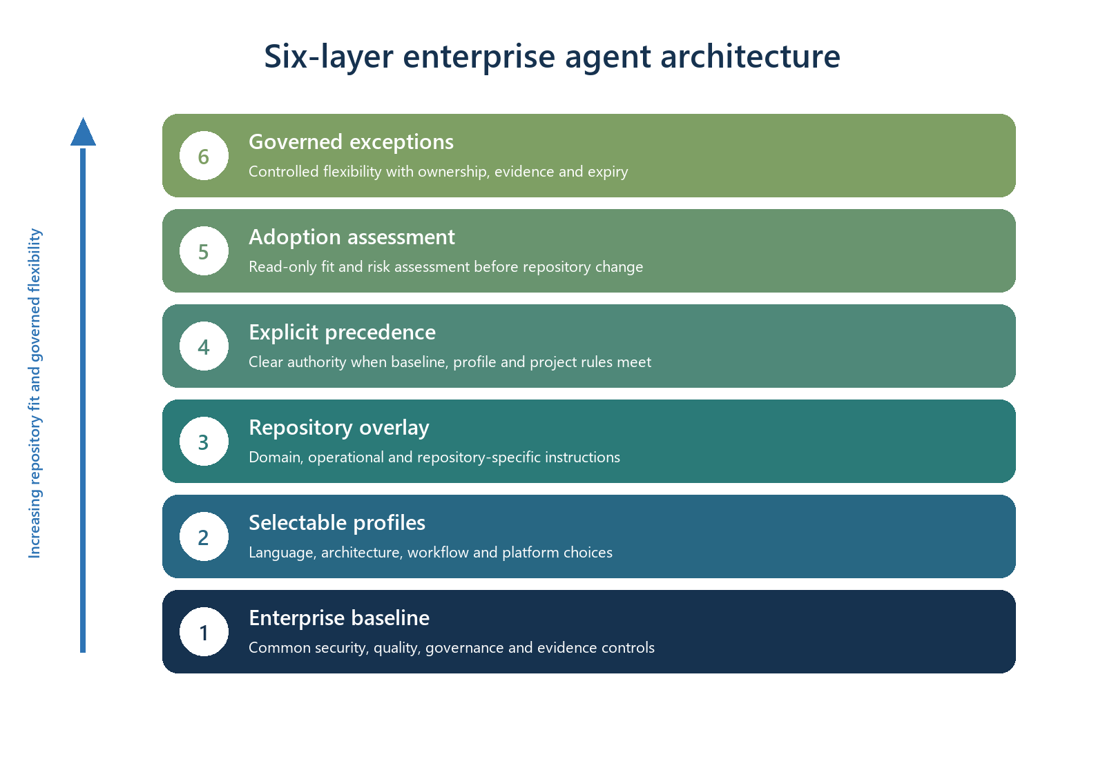
The lower layers establish consistency and assurance. The upper layers add repository fit and controlled flexibility. Because every upper layer depends on the controls below it, local adaptation remains visible and governed.

How the layers work together
- Establish a common enterprise baseline for every participating repository.
- Select profiles that match the technology, architecture, workflow and hosting platform.
- Add repository-specific domain and operational instructions.
- Apply explicit precedence so conflicting instructions have a predictable outcome.
- Assess each repository before adoption to confirm fit, impact and migration needs.
- Use governed exceptions when a justified, temporary departure is necessary.

The six layers

Layer 1 — Enterprise baseline
Purpose: Set the minimum operating contract that every participating engineering repository follows.
Core functionality
- Common agent workflow, ownership, documentation and completion expectations.
- Deterministic verification for tests, dependency integrity and required evidence.
- Provider-neutral governance with controlled platform-specific enforcement.
Enterprise outcome | How this layer contributes
Security | Creates consistent minimum safeguards and clear authorization boundaries.
Quality | Defines a common standard of done and evidence for every team.
Delivery speed | Removes repeated setup and policy interpretation from individual repositories.
Enterprise value | Provides a scalable, auditable foundation for responsible agent adoption.

Layer 2 — Selectable profiles
Purpose: Adapt the baseline to approved technologies and delivery patterns without creating separate standards.
Core functionality
- Language and framework guidance.
- Architecture and deployment topology choices.
- Workflow, CI platform, security and supply-chain profiles.
Enterprise outcome | How this layer contributes
Security | Applies controls in the native mechanisms of each approved platform.
Quality | Uses stack-appropriate linting, typing and test expectations.
Delivery speed | Gives teams ready-made paths instead of bespoke configuration work.
Enterprise value | Supports portfolio diversity while retaining one governance model.

Layer 3 — Repository overlay
Purpose: Capture the business domain, operational context and engineering conventions unique to a repository.
Core functionality
- Domain terminology, invariants and critical business rules.
- Repository-specific commands, directories, deployment constraints and runbooks.
- Local skills and instructions that complement the enterprise baseline.
Enterprise outcome | How this layer contributes
Security | Adds repository-specific trust boundaries, data handling and operational risks.
Quality | Aligns agent behavior with the codebase's actual conventions and acceptance criteria.
Delivery speed | Reduces rework by giving agents precise local context at the point of change.
Enterprise value | Preserves team expertise and domain knowledge within a shared operating model.

Layer 4 — Explicit precedence
Purpose: Define which instruction wins when enterprise, profile and repository guidance overlap.
Core functionality
- Protected enterprise controls that cannot be silently weakened.
- Clear rules for profile specialization and repository-specific additions.
- Traceable instruction provenance for reviewers and auditors.
Enterprise outcome | How this layer contributes
Security | Prevents local rules from unintentionally bypassing protected controls.
Quality | Eliminates ambiguous or contradictory direction to agents.
Delivery speed | Reduces escalation and review time caused by unclear authority.
Enterprise value | Makes distributed governance predictable and defensible.

Layer 5 — Adoption assessment
Purpose: Evaluate fit and impact before the standard changes an existing repository.
Core functionality
- Read-only discovery of technology, workflows, tests, documentation and existing agent rules.
- Compatibility and ownership report showing what will be preserved, merged or introduced.
- Explicit confirmation of ambiguous architecture and operational choices.
Enterprise outcome | How this layer contributes
Security | Surfaces incompatible controls, sensitive boundaries and migration risks early.
Quality | Maps the standard to the repository's real verification and documentation model.
Delivery speed | Avoids failed installations and shortens adoption planning.
Enterprise value | Enables portfolio rollout based on evidence rather than assumptions.

Layer 6 — Governed exceptions
Purpose: Allow justified, temporary departures without turning flexibility into uncontrolled drift.
Core functionality
- Named control, owner, reason, scope, evidence and expiration.
- Automatic expiry and visibility in local and CI verification.
- Clear classification of configurable, waivable and non-waivable controls.
Enterprise outcome | How this layer contributes
Security | Makes risk acceptance explicit, bounded and reviewable.
Quality | Prevents permanent informal workarounds from becoming hidden policy.
Delivery speed | Allows work to proceed when a legitimate constraint cannot be resolved immediately.
Enterprise value | Balances governance with delivery realities while creating evidence for improvement.

Enterprise value chain
Value stage | Enabled by | Enterprise result
Consistent foundation | Baseline + profiles | Teams begin from approved controls and technology patterns.
Repository fit | Overlay + precedence | Agents receive relevant local context without losing enterprise guardrails.
Safe scale | Assessment + exceptions | Adoption and deviations are evidence-based, bounded and reviewable.
Business outcome | All six layers | Higher engineering throughput with stronger assurance and less duplicated governance work.

A staged enterprise operating model
The architecture is designed for incremental delivery. An enterprise can establish the baseline first, add approved profiles next, and introduce repository overlays and automated assessments as adoption expands. Precedence and exceptions provide governance maturity without requiring every capability on day one.
- Foundation: publish the enterprise baseline and ownership model.
- Enablement: offer supported profiles for the most common engineering paths.
- Scale: add repository overlays, precedence and repeatable assessments.
- Optimization: use exception and adoption evidence to improve the standard over time.

Measures of success
• Adoption lead time and percentage of repositories completing verification on the first attempt.
• Change failure, escaped defect and security finding rates for participating repositories.
• Time saved in repository setup, policy interpretation, review and documentation maintenance.
• Number, age and recurrence of governed exceptions.
• Developer confidence, agent usefulness and reviewer trust in generated changes.
Key takeaway: The six layers are not six separate standards. They are a single enterprise control system that combines consistency at the foundation with increasingly specific, governed context at the repository edge.

