----------> https://appraw.com/apk/food-street-apk-download-jjrzk <------------

-------> https://apkpure.com/food-restaurant-manager-game/com.food.restaurant.cook.free <------

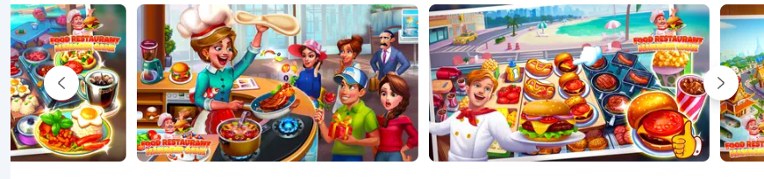
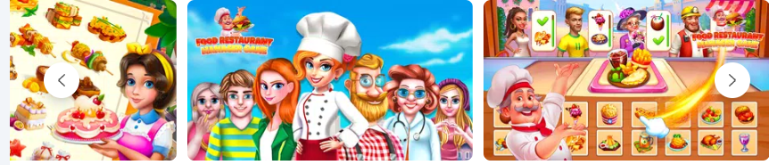

About Food Restaurant Manager
Matching Game For Food Street Fan, Enjoy Food Restaurant Manager Game Now!
Food Restaurant Manager Game is a happy place where the kitchen never closes, the waiter always has a big smile on his face and the food is so great you should probably play with a bib on.

Open your restaurant, give it a name and decorate it to your taste! Then start cooking world cuisines and serving customers! Your place will soon become so popular you'll have to make it bigger!

Cook & serve as Chef in your own cafe diner restaurant city or bakery story in Food Street Game!

You are the master chef of your own cooking business, kitchen, diner and restaurant story. You can even adopt fun and cute pets to attract diners in this food game!

Renovate your own bakery, cafe, diner, or food truck! Serve and cook tasty food for customers in my cafe land!

Farm your own tasty ingredients in your garden, cook delicious recipes in a fun 3D restaurant and cooking town cafeland filled with fun.

Master tasty cooking and restaurant management skills in this restaurant management game with endless cooking! Fans of food games, cafe games, diner games and farm games will love managing their own restaurant!

FEATURES:

🏘️ Build & Design Your Restaurants!

🌾 Farm Your Own Ingredients!

👩‍🍳 Cook Amazing Food!

😃 Serve Your Customers!

🌶️ Restaurant Management Story!

Realise your dream of becoming a Culinary Master, Restaurant Manager! Your fellow chef games gourmands are counting on you, and as in the best dash games, there’s no time to waste: get cooking right now in a delicious restaurant game and recipe game!

---------> https://play.google.com/store/apps/details?id=com.ministone.game.cookingarena <----------
This is online game

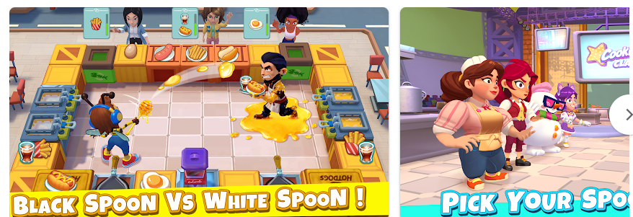
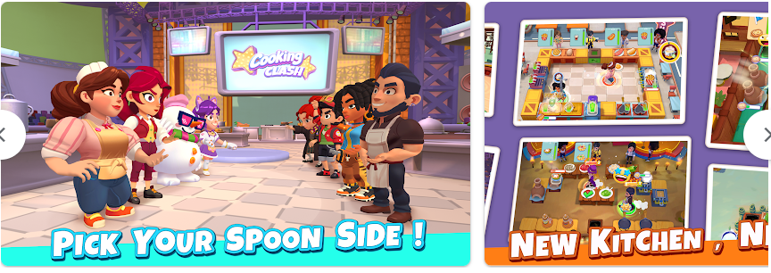
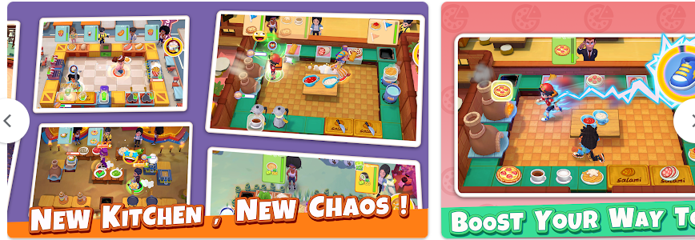
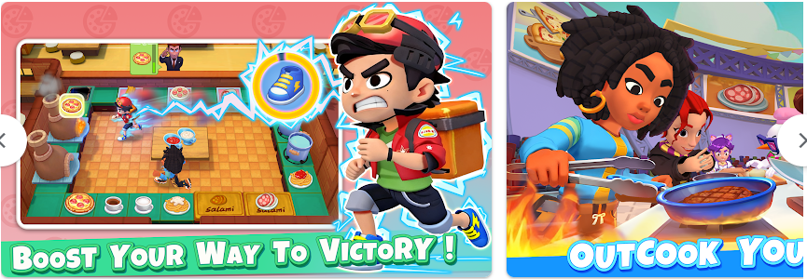
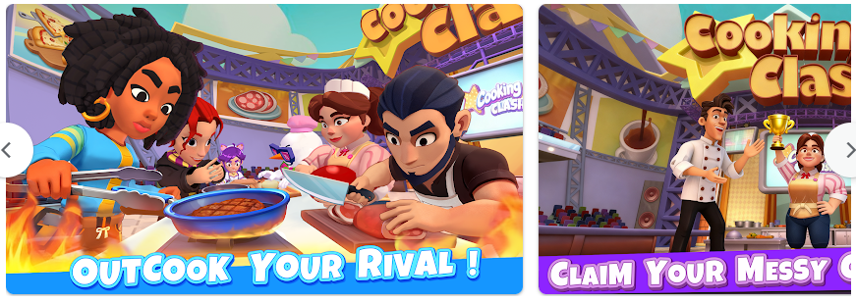

Welcome to Cooking Clash, a real-time online cooking game where teamwork, speed, and strategy decide every kitchen battle. Team up with another player through random matchmaking, cook together in exciting co-op levels, or challenge rivals in fast-paced PvP cook-offs.

Step into chaotic shared kitchens, coordinate your moves, complete customer orders, and use powerful chef skills to become the ultimate cooking star.

Why You’ll Love It

* Co-op Cooking Battles: Team up with another player and clear exciting two-player cooking levels together.

* Random Matchmaking: Quickly find a teammate and jump into co-op challenges anytime.

* Real-Time PvP Cook-Offs: Face rivals in fast-paced online cooking battles where every second counts.

* Team-Based Strategy: Coordinate stations, timing, roles, and hero skills to complete orders faster.

* High-Speed Gameplay: Fast, strategic, and unpredictable kitchen action keeps every match exciting.

* A World of Recipes: Master everything from street bites to gourmet plates.

* Always Fresh: Seasonal ranks, trophies, events, and new challenges keep every kitchen war thrilling.

Cook Together in Co-op Mode

Cooking is better with a teammate. Enter shared two-player kitchens, match with another player, and work together to complete orders before time runs out.

No friend online? No problem. Random matchmaking helps you quickly find a teammate and start your next co-op challenge.

Share tasks, manage busy cooking stations, build combos, and combine hero skills at the perfect moment. Every co-op level is a test of teamwork, timing, and smart kitchen strategy.

Challenge Rivals in PvP

Want a real cooking showdown? Enter real-time PvP cook-offs and compete head-to-head against other players. Steal the lead, outserve your rival, and prove who is the faster chef in the kitchen arena.

Your Journey Begins

Choose your mentor and enter the ultimate Culinary Class War. Whether you cook side by side in co-op mode or fight solo in PvP, your mentor will shape your path to victory.

White Mentor — a Michelin-style master of gourmet cuisine, focused on precision, timing, and elegant teamwork.

Black Mentor — a street-food superstar, built around bold flavors, fast hands, and explosive kitchen battles.

How to Play

1. Pick a mentor — White Mentor or Black Mentor.

2. Team up with another player through random matchmaking.

3. Cook dishes using your heroes’ unique skills while managing the clock.

4. Coordinate with your teammate to complete orders, build combos, and clear co-op levels.

5. Challenge rivals in real-time PvP when you want a head-to-head cooking battle.

6. Win matches to earn Golden Spoons, climb the ladder, and claim trophies.

Master Thrilling Game Modes

Prove your culinary skills across co-op challenges and competitive PvP battles:

* Dish Duel: A frantic cooking race where speed and teamwork decide the result.

* Cash Clash: Earn the most money before time runs out.

* Heart Dash: Win customers’ hearts and claim the highest score.

* Order Dash: Complete full customer orders as efficiently as possible.

* Combo Rush: Chain perfect serves with your teammate to dominate the kitchen.

Build Your Ultimate Chef Squad

* Hero-Driven Progression: Unlock and collect unique chefs with powerful skills.

* Upgrade & Customize: Level up your heroes and equip gear to boost their strengths.

* Team Strategy Matters: Mix classes, roles, and abilities to create the perfect co-op duo or PvP lineup.

Climb the Global Ranks

Battle in online PvP duels, co-op leagues, and global tournaments. Master timing, coordination, and execution to win trophies, earn rewards, and prove your class.

If you love cooking games, team-based co-op, random matchmaking, and real-time PvP kitchen battles, join Cooking Clash today.

Download now — match with a teammate, cook together, and compete fiercely in the ultimate cooking clash!

-------->https://play.google.com/store/apps/details?id=playte.energetics.ai <---------------
This is online game

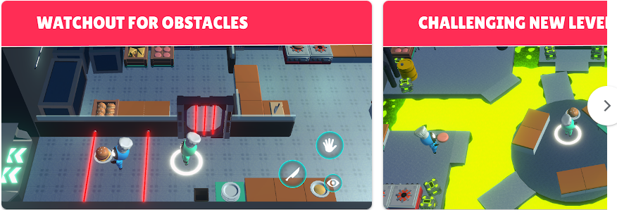
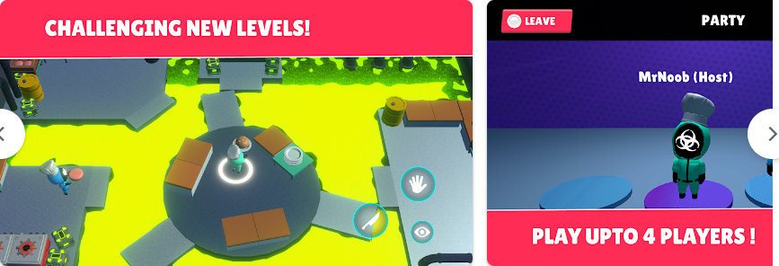
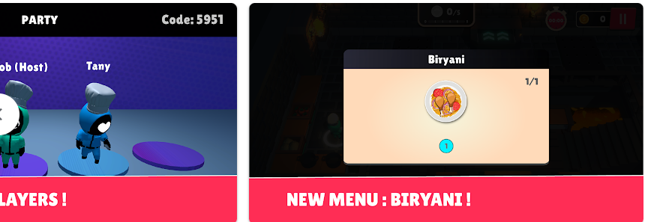

Cook & serve as Chef in your own cafe land restaurant city or bakery story in Food Street Game!

You are the master chef of your own cooking business, kitchen, diner, cafeland and restaurant story. You can even adopt fun and cute pets to attract diners in this food game!

Renovate your own bakery, cafe, diner, or food truck! Serve and cook tasty food for customers in my cafe land!

Farm your own tasty ingredients in your garden, cook delicious recipes in a fun 3D restaurant and cooking town cafeland filled with fun.

Master tasty cooking and restaurant management skills in this restaurant management game with endless cooking! Fans of food games, cafe games, diner games and farm games will love managing their own restaurant!

Build & Design Your Restaurants!
- Build your restaurant and garden from the ground up!
- Expand your kitchen, diner, cafe with new stations for different foods.
- Design your restaurants with unique themed staff uniforms in waitress games
- Decorate unique and cool restaurants in this food game, styling each as a cafe, diner, food truck or bakery, by purchasing fun decorations.
- Raise your own cute pets to attract customers, build a cafe or diner dash and adopt dogs, horses, pigs and more

Farm Your Own Ingredients!
- Farm for ingredients in your own garden and cook them in all of your food dishes!
- Farm and build more plots to grow more ingredients for food games!

Cook Amazing Food!
- Cooking and baking with simple gameplay and fun characters in this cafe world.

Serve Your Customers!
- In this cooking food game you’re the Head Chef! Start cooking food for your customers.
- Serving games let you cook food for free in this fun restaurant cafe game with stunning 3D graphics!

Restaurant Management Game!
- Create multiple restaurant layouts to promote your business in a fast-growing tasty town.
- Decorate your cafe restaurants using Food Street’s restaurant and food cooking upgrades!
- Experience fun and exciting cooking restaurant management games without the pressure of a time limit.

Online Food Management Cafe!
- Manage your cafe restaurants story like no other food games: Collaborate in restaurant Food Clubs to compete in friendly competitions.
- Play food games and cafe games in online Food Clubs where you and your friends trade recipes and cook together.
- Participate in restaurant games with your chef friends!

Please note: Food Street - Restaurant Game is free to download. Purchases can be made in the game for real money. If you don’t want to use this feature, please disable in-app purchases in your device settings and play your food games for free. A network connection is required to play.

Our friendly Food Street - Restaurant Game games team is ready to help you run your tasty town and enjoy your food games for free at support@supersolid.com

--------> https://play.google.com/store/apps/details?id=com.tychemobile.cookingclash <-------------
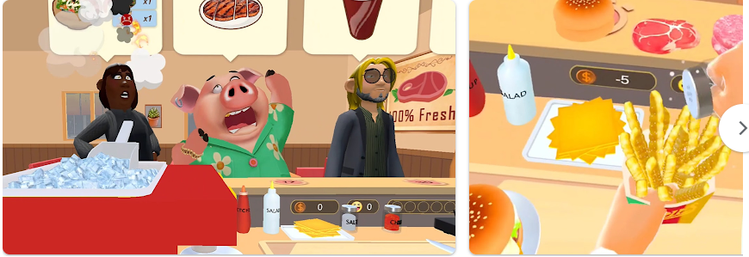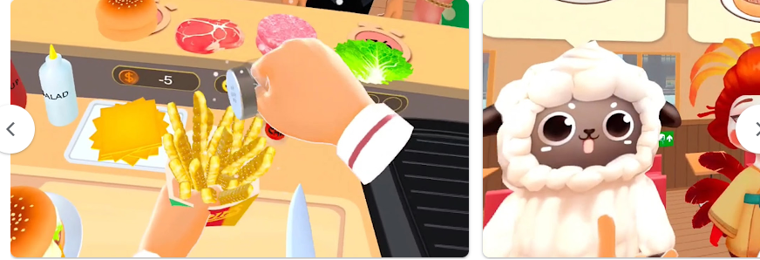
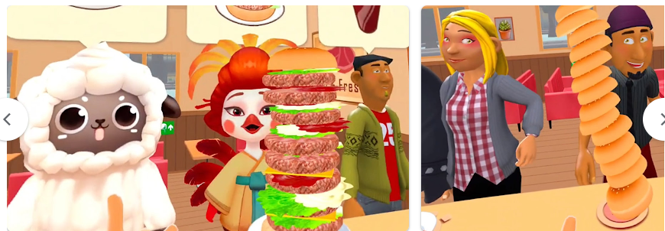
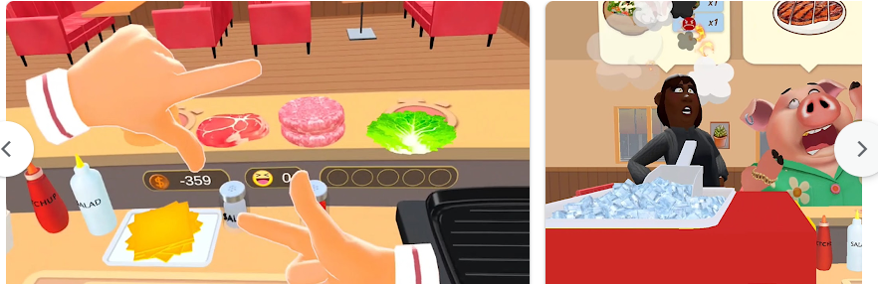

Think you’ve mastered all the usual cooking games? Cooking Clash takes it to a whole new level of kitchen madness—where hilarious customers, wild recipes, and unexpected challenges turn every shift into pure comedy.

🍳 Cook & Experiment
This isn’t about following boring recipes. In Cooking Clash, your kitchen is a playground. Mix and match ingredients to create outrageous meals that surprise your guests and keep the tip jar overflowing in this fast-paced food game.

🐒 Quirky Customers, Quirky Problems
Here, your diners aren’t just faceless NPCs. They have attitudes, demands, and sometimes very sticky fingers. From picky eaters to sneaky tip-snatchers, every customer keeps you guessing—and laughing.

💸 Guard Your Hard-Earned Cash
Cooking isn’t the only challenge. Stay sharp or watch your hard-earned tips disappear faster than a free dessert. Managing customers is just as important as managing the stove.

🎉 Why You’ll Love It
A fun twist on classic cooking games with extra chaos and humor
Endless ingredient combos for creative dishes
Wacky customer interactions that keep every round unpredictable
Easy to pick up, impossible to put down—a true cooking craze

Cooking Clash isn’t just about food—it’s about fun, laughter, and a little bit of chaos. Ready to cook up trouble? Download now and join the clash!

------>https://play.google.com/store/apps/details?id=com.kitchentogether&hl=en<--------------

we can play with users. This is online game
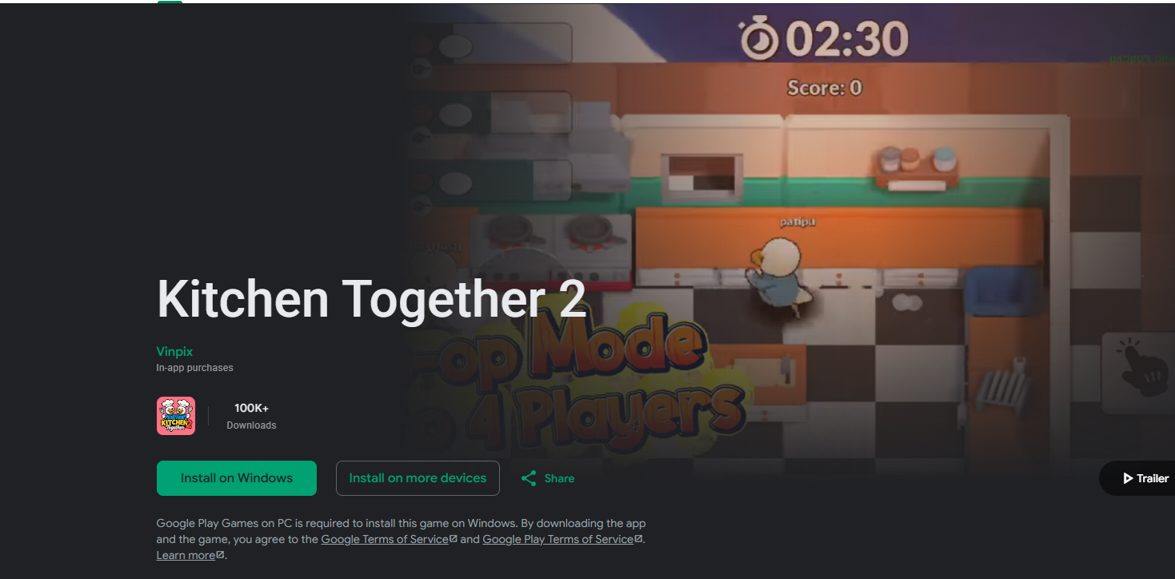
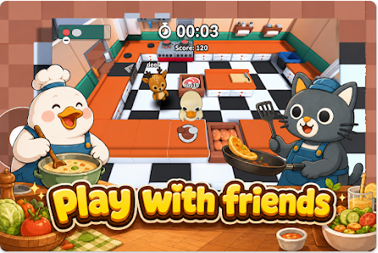
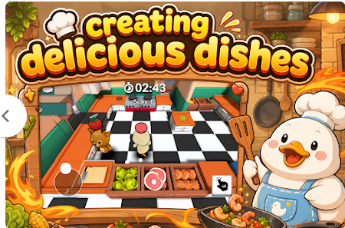
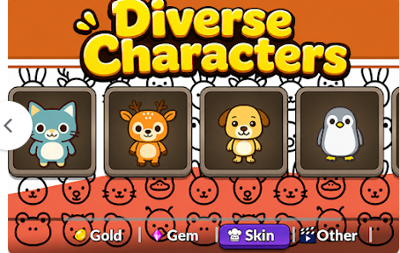

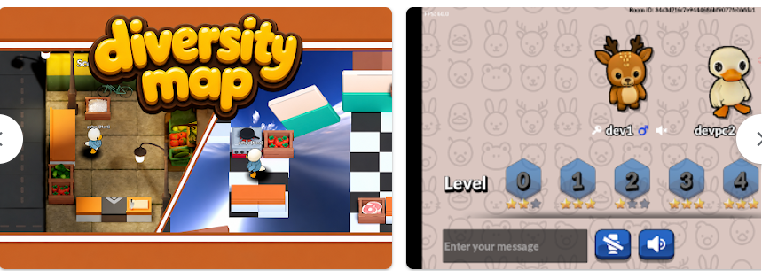

-------->https://play.google.com/store/apps/details?id=com.magicgame.kitchencrush&hl=en<-----

