Instructions for Unpacking and Testing Extension

Written by Landry Baudouin

-To begin with, thank you so much for taking the time to test our extension and work! The team looks forward to what results you find and hopes everything is smooth sailing.

-The instructions for unpacking a Google Chrome extension are straight-forward luckily. Included with this document will be a .zip file containing the necessary code for the extension. This document serves to aid the user with pictures and specific instructions on what we are looking for in this first round of user testing.

-Instructions on what to deliver are located at the bottom of this document and throughout it as well.

Starting off:

1. Open Google Chrome and navigate to the three dots at the top right corner of the window. Click the more tools options and then click on extensions. The page below will appear.
   1. The red squares indicate necessary items on the page. First navigate to the top right and click the developer mode button. Make sure it is blue and turned on.
   2. Second, click on load unpacked. This is where we will locate the extension files and give Chrome access to them.

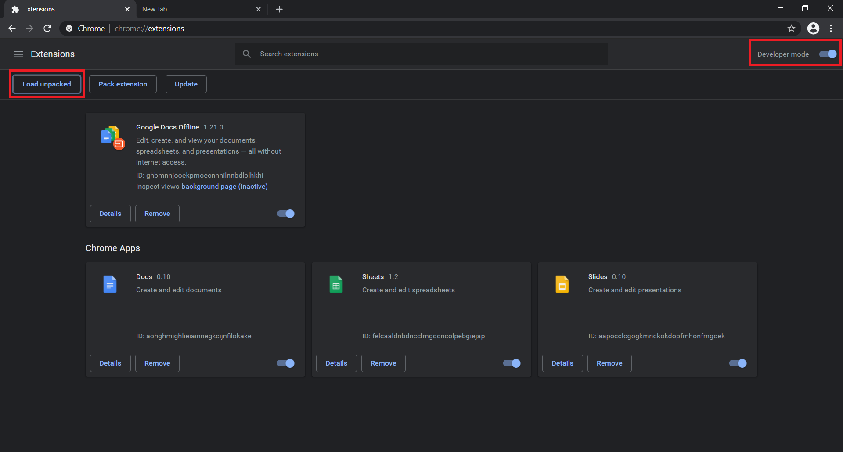

1. From there, a popup box will appear. We want to make sure that we are picking the right folder, otherwise Chrome will complain and reject the extension. Within the overall **extracted** folder from the .zip file (which should be entitled something along the lines of “SeniorDesign-Main”), perform one click on the folder entitled “CapstoneProject” and click “Select Folder” at the bottom right.

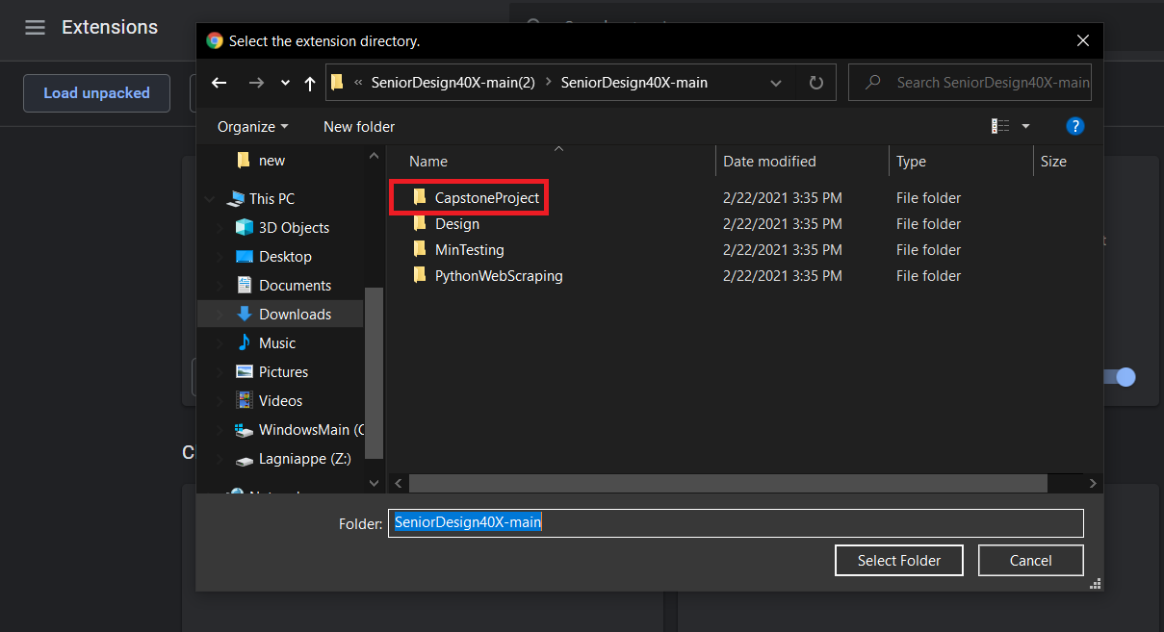

* 1. Now the extensions page should appear as below, with the “Kill the Phish” project now having its own little square.

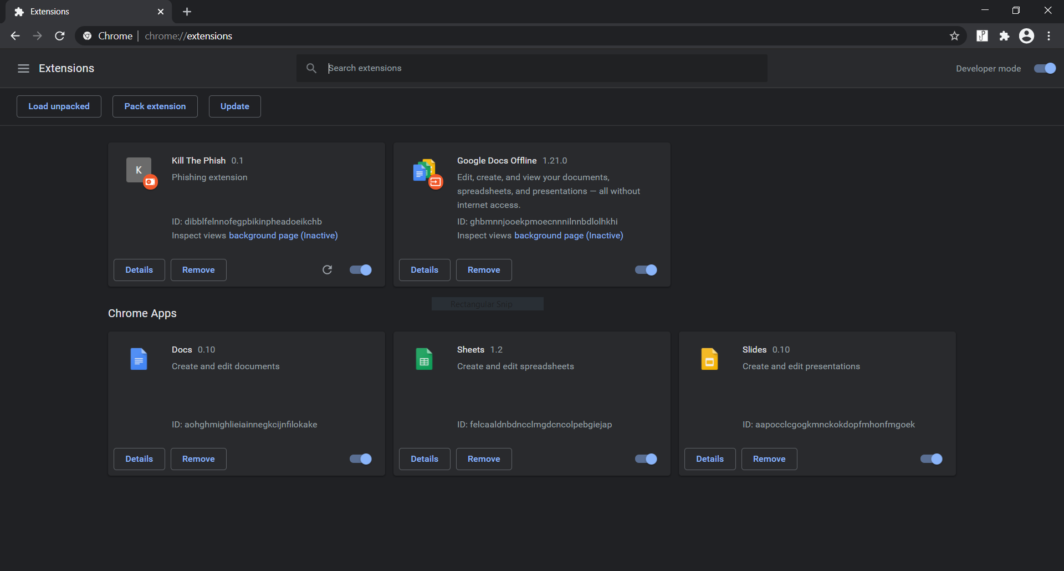

1. From here, now we can begin testing. Make a quick google search on some topic (I just did one on Wikipedia) and then navigate back to the three dots at the top right hand corner. Click on more tools and then Developer Tools. From there, the console should appear.
   1. **Important:** I would highly recommend refreshing the page at this instance with the console open to ensure the code runs and all outputs can hopefully be witnessed.
   2. Once that is done, you should see the output as below.

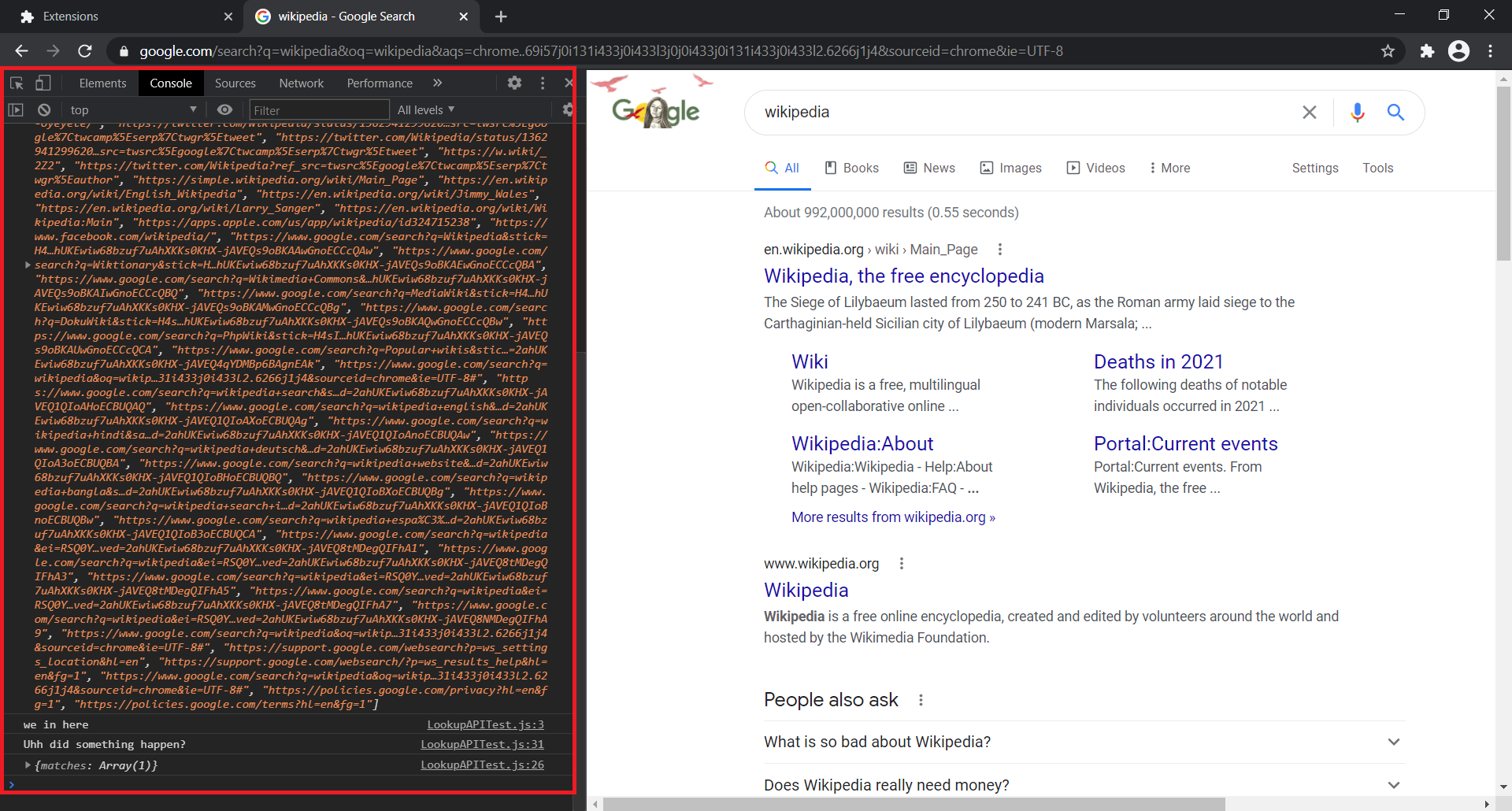

* 1. As you can see, there is a large array of websites, some console.log() outputs of random messages to myself that I used for testing, and then a “matches: Array(1)” output. These are all critical elements of the code so far; please take a **screenshot** of whatever appears here in the console.
  2. **Note:** sometimes the large array of websites will appear as just an Array(x) output, which will have a drop down exposing all the different website elements. I believe this did not occur in this example case because it did not generate enough to warrant doing that. In any case, be on the lookout for that - that is not a bug and is ok to be included in a screenshot if it appears that way or is more convenient.

1. Next are the hovering links and alert box. You can screenshot these if possible, but simply noting whether they showed up is sufficient as well. When hovering over a link, a status will appear denoting either safety (green box) or danger (red box) with an icon as well. These are temporary placeholders and do not indicate the true status of the link. They look like the pictures below.
   1. The hover boxes will alternate between green and red when you take your mouse off a link. This is also intentional for the time being.
   2. When you click a link that is currently green, the link will go through to the new site.
   3. When you click a link that is red though, an alert box will appear at the center-top that will say the site is dangerous and if you are sure you want to continue to it. This is also intentional and serves as a temporary placeholder for the warning page functionality that will come down the road. Either option on the box will make it go away.

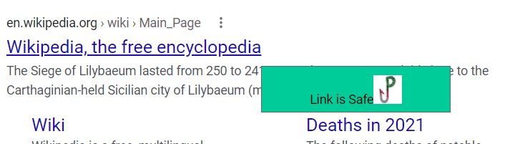

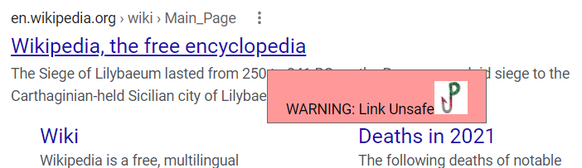

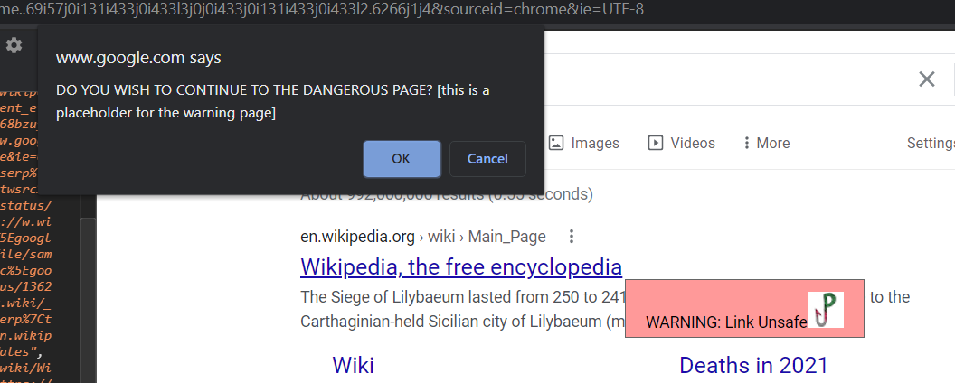

1. Finally, the options page is the last thing to test. If the Kill the Phish “hook” icon is not present on the tool bar at the top right, click on the puzzle piece at the top right and find the Kill the Phish extension with a thumbtack next to it. Click that, and the icon will appear on the toolbar.
   1. Right click on the hook icon and then press options. You should be brought to a page that looks like the picture below.

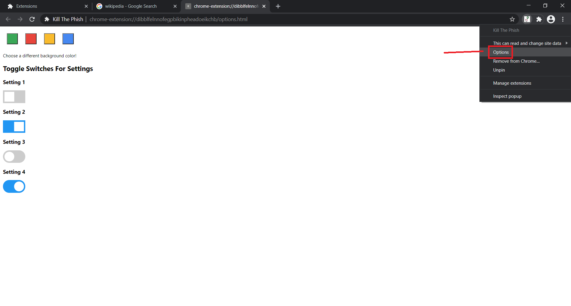

* 1. Currently this page can only change the color setting for a background script elsewhere, but that is non-essential for testing right now. Just getting here is a good sign – please take a screenshot, of which only **one** will be necessary.

1. In conclusion, to remove the extension once you are done testing, you can simply return to the extensions page we navigated to at the beginning and click “Remove”. This will delete the extension from Chrome. From there, you are free to do whatever with the local files as you like.

Some necessities in terms of results:

1. Please take screenshots for the console outputs and go to five different sites. That should result in **five** different screenshots for this section.
2. The hovering mouse links and alert box can be screenshotted (I pulled up snipping tool and then pressed “Ctrl+print screen button” to capture them since they would disappear) or you could simply state whether you saw them and they functioned as described.
3. Please take a **single** screenshot of the options page

-This all totals up to 6+ screenshots and some statements of what you saw and experienced.

-Please either .zip all text and screenshots together or send them all in a folder back to me at:

lsb036@latech.edu or [landryb02@gmail.com](mailto:landryb02@gmail.com)

-Once again, thanks for taking the time to test and gather some information for us!