The Circuits

Receiving

LCD Screen

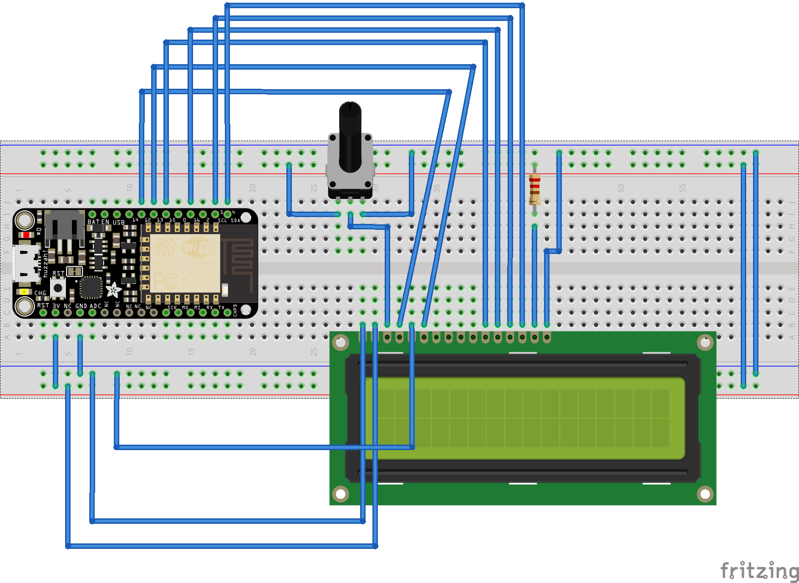

Pump Controller

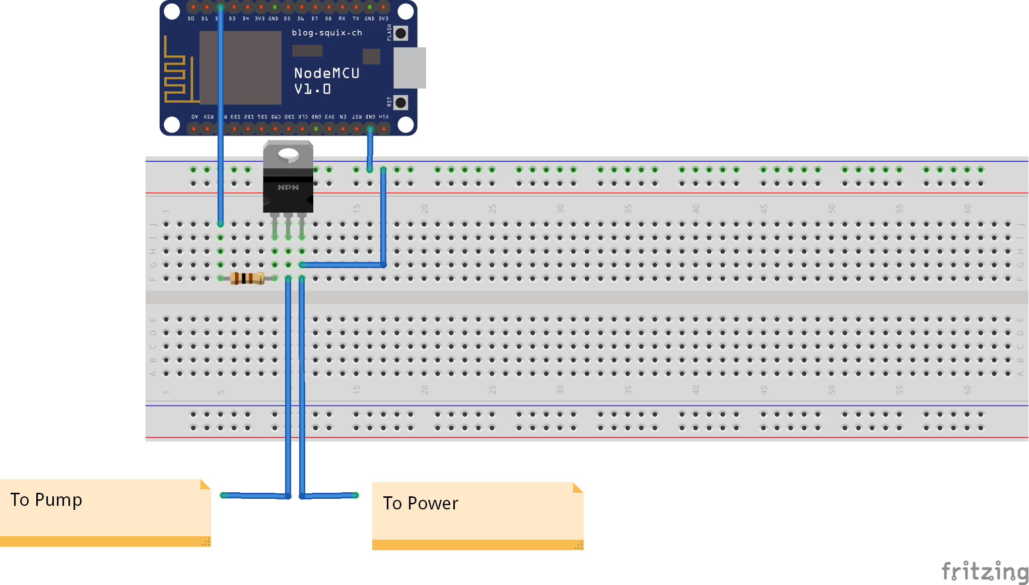

Array of Lights
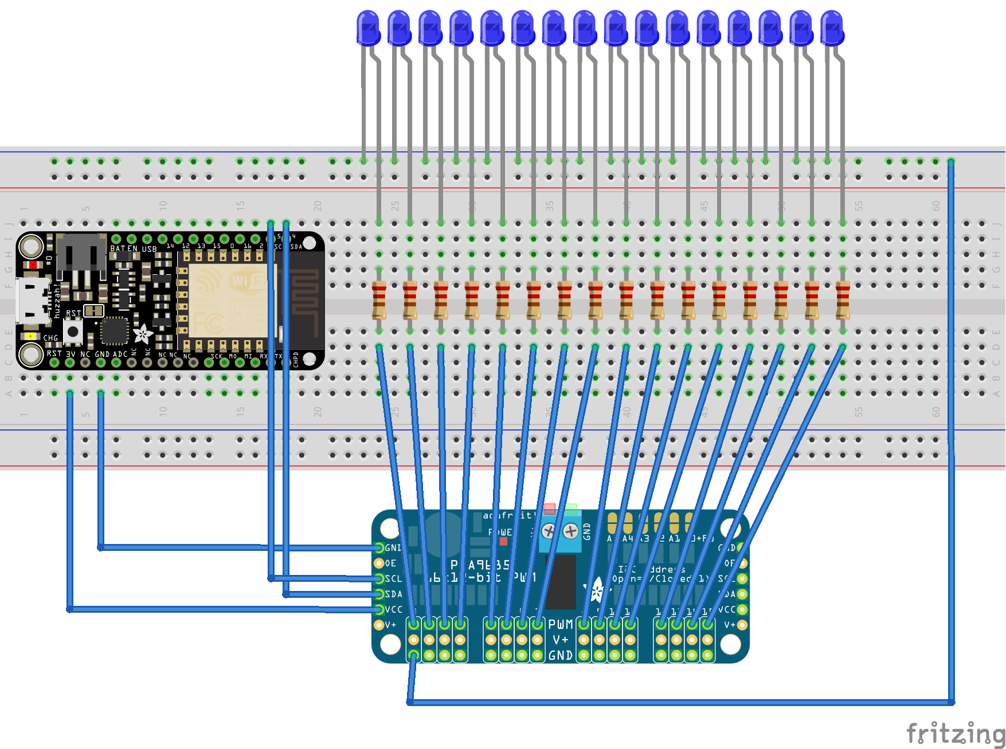
Sending

Light Sensor

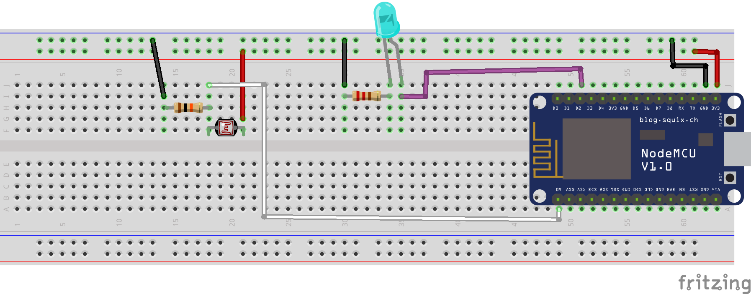

Button
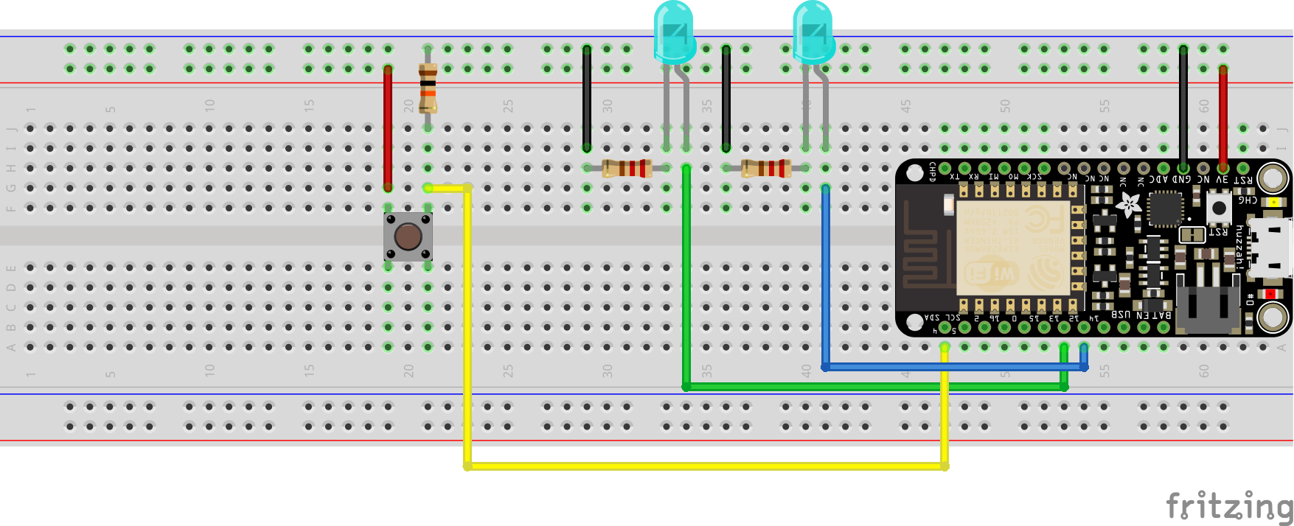

Ultrasonic Distance Sensor
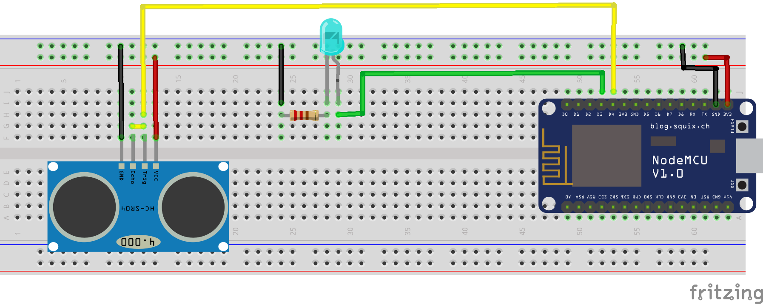

Useful Resources

Arduino – Website with lots of information on the Arduino micro-controller.
Instructables – Tutorials on a wide range of subjects.
Stack Overflow – Technical Programming Q+A
Processing – Reference for the Processing programming language.
OpenFrameworks – Reference for the OpenFrameworks library.
Python – Reference for the Python Programming language.
Github – Repository for code.
Unity – Reference for the Unity program.
OpenCV – Reference for the OpenCV library.
SparkFun – Learning resources for electronics.
Adafruit – Learning resources for electronics.

Short Glossary

Internet of Things: The phenomenon of objects with embedded electronics becoming connected to the internet.

Arduino: An easy to use micro-controller, an IDE and a website.

Micro-controller: A very basic computer which can only run one program at a time. Used to control circuits.

IDE (Intergrated Developer Environment): Software used to develop programs

C/C++: A family of low-level, fast programming languages used (among many other things) to program most micro-controllers.

Processing: A programming language made for artists and designers. Orientated around 2D graphics and based on Java.

Python: An easy to use, but relatively slow, scripting language.

OpenFrameworks: A collection of libraries for C++ enabling 2D/3D graphics, communication, Computer Vision and more.

Unity: The easiest way to create 3D applications.

NodeMCU: a Micro-controller incorporating the ESP-8266 WiFi chip. Marginally more complicated than wireless variations of Arduino, but MUCH cheaper.

Adafruit Feather: Also uses the ESP-8266. More expensive, but more options.

LDR: Light Dependent Resistor. Used in circuits to detect light brightness.

PIR: Passive Infra Red Sensor. Used to detect motion.

Ultrasonic Sensor: Used to detect proximity. Faster and more responsive than IR.

Infra Red LED: Invisible light. Can be used in combination with an IR sensor to create “laser-trip-wires”

LED: Light Emitting Diodes. Very common low voltage lights that come in many varieties.

Relay: To control high voltage circuits with a low voltage circuit, you can use a relay.

Transistor: (Short description) Works like an electrically controlled switch. Turn things on and off by sending the transistor a signal.

Resistor: Reduces voltage in a circuit. Many more complicated applications.

Capacitor (short description): Stores charge in a circuit, sort of like a battery. Many applications, including smoothing electric signals.

Capacitive Touch: Using the human body’s ability to store electric charge to detect touch in circuits.

DC Motor: A simple motor used when accuracy isn’t a concern.

Stepper Motor: A more complicated motor used when you need fine control of heavy loads.

Servo Motor: A more complicated motor used when you need fine control at higher speeds.

Piezo: Can be used as a buzzer which generates different tones, or as a vibration sensor.

