

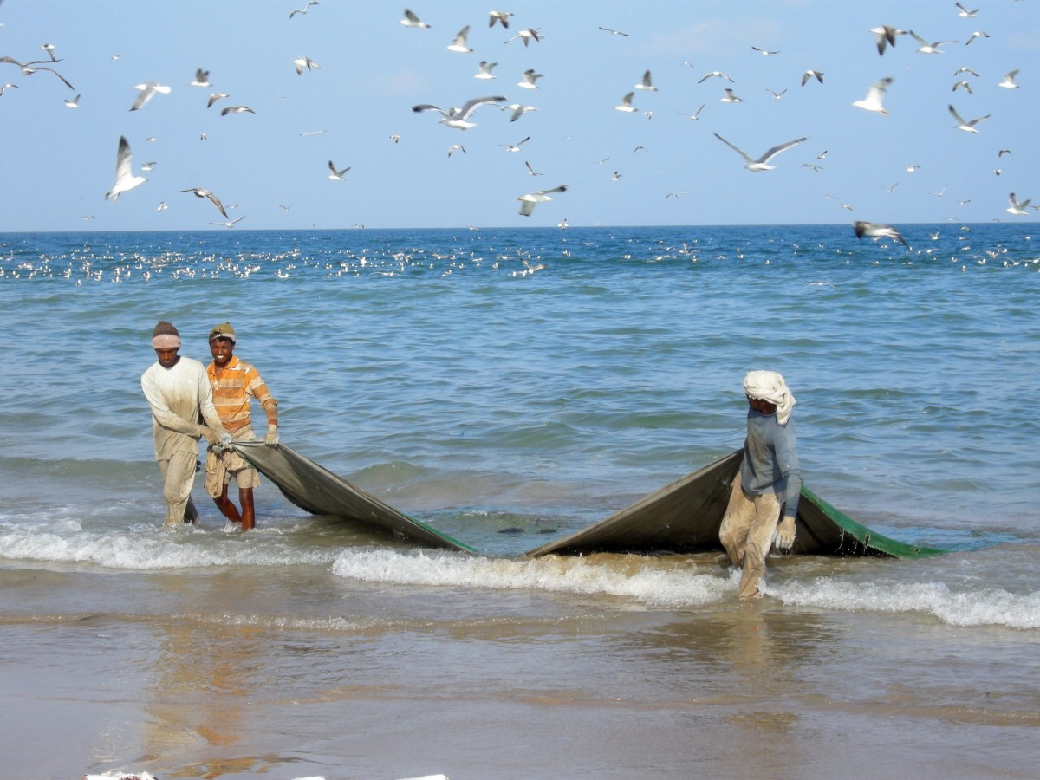

**2018**

(303) - 555 – 5555 | www.ceibatrade.com

**SEAFOOD CATALOG**

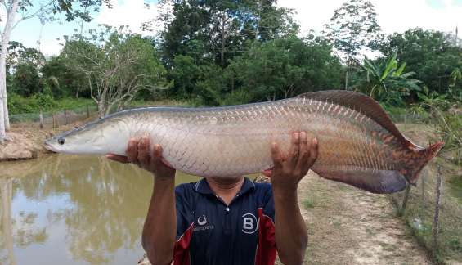**Variety/Type Descriptions**

**Arapaima Gigas–** The species is among the largest known freshwater fish, commonly measuring 200 centimetres (7 ft) and exceptionally reaching lengths of up to 450 centimetres (15 ft). Adults may weigh up to 200 kilograms or 440 pounds.

|  |  |  |  |  |  |  |  |  |  |  |  |  |
| --- | --- | --- | --- | --- | --- | --- | --- | --- | --- | --- | --- | --- |
|  | Jan | Feb | Mar | Apr | May | Jun | Jul | Aug | Sep | Oct | Nov | Dec |
|  |  |  |  |  |  |  |  |  |  |  |  |  |

**Product Availability**

**\*PRODUCT FOR CEIBA ONE CONTAINER PER MONTH ALL YEAR**

**Origin of Product**

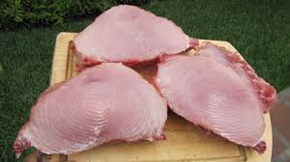Sucumbios Province.

**Ordering Specifications**

Common Packaging:

Boxes X 20 kg. Frozen

Grades:

Tenderloin Steaks

**Storing and Handling**

**Temperature/humidity recommendations:**

The storage temperature must not be less than-30 °C -22 °F

**Shipping Port**

Guayaquil

**\*Call for quote at your destination**

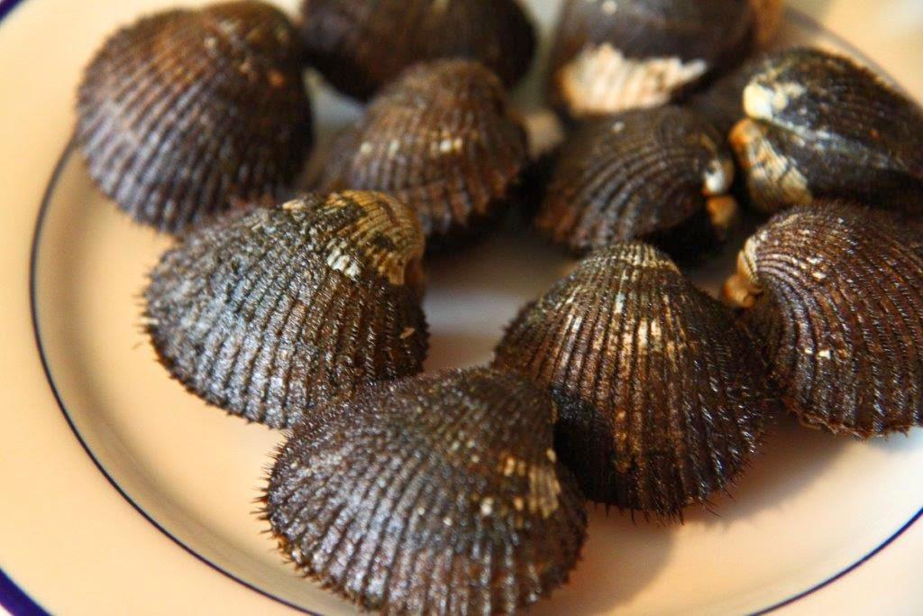

**Variety/Type Descriptions**

**Mytilus Edulis –** a dark-fleshed shellfish that makes a dark inky sauce for the ceviche. black clams that are roasted or broiled until they open; they are delicious when squeezed with fresh lime juice

**Product Availability**

|  |  |  |  |  |  |  |  |  |  |  |  |  |
| --- | --- | --- | --- | --- | --- | --- | --- | --- | --- | --- | --- | --- |
|  | Jan | Feb | Mar | Apr | May | Jun | Jul | Aug | Sep | Oct | Nov | Dec |
|  |  |  |  |  |  |  |  |  |  |  |  |  |

**Origin of Product**

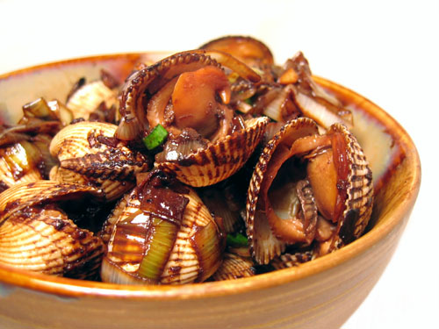Esmeraldas, Manabi and Guayas Provinces.

**Ordering Specifications**

Common Packaging:

Boxes X 25 kg.

Grades:

Fresh Selected

**Storing and Handling**

**Temperature/humidity recommendations:**

Fresh . Storage at -20 °C / -4 °F

**Shipping Port**

Guayaquil

**\*Call for quote at your destination**

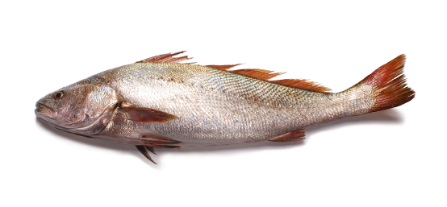**Variety/Type Descriptions**

**Argirosomus Regius** is a saltwater fish. Its body is blue-grey on top, silvery overall with small scales, and is elongated and somewhat compressed in shape. It has a large mouth and a dorsal fin that is deeply notched between spiny and soft parts. It reaches 40 cm (16 in) or more. The corvina has a white and flaky texture and a mild, sweet taste. Cooking methods include grilled, baked, fried, and sushi.

|  |  |  |  |  |  |  |  |  |  |  |  |  |
| --- | --- | --- | --- | --- | --- | --- | --- | --- | --- | --- | --- | --- |
|  | Jan | Feb | Mar | Apr | May | Jun | Jul | Aug | Sep | Oct | Nov | Dec |
|  |  |  |  |  |  |  |  |  |  |  |  |  |

**Product Availability**

**Origin of Product**

Esmeraldas, Manabi and Guayas Provinces.

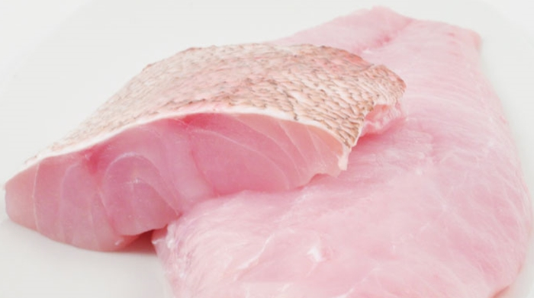Common Packaging:

Boxes X 25 kg

Grades:

Fresh Selected

**Storing and Handling**

**Temperature/humidity recommendations:**

**Ordering Specifications**

Fresh . Storage at 10 °C / 50°F

**Shipping Port**

Guayaquil

**\*Call for quote at your destination**

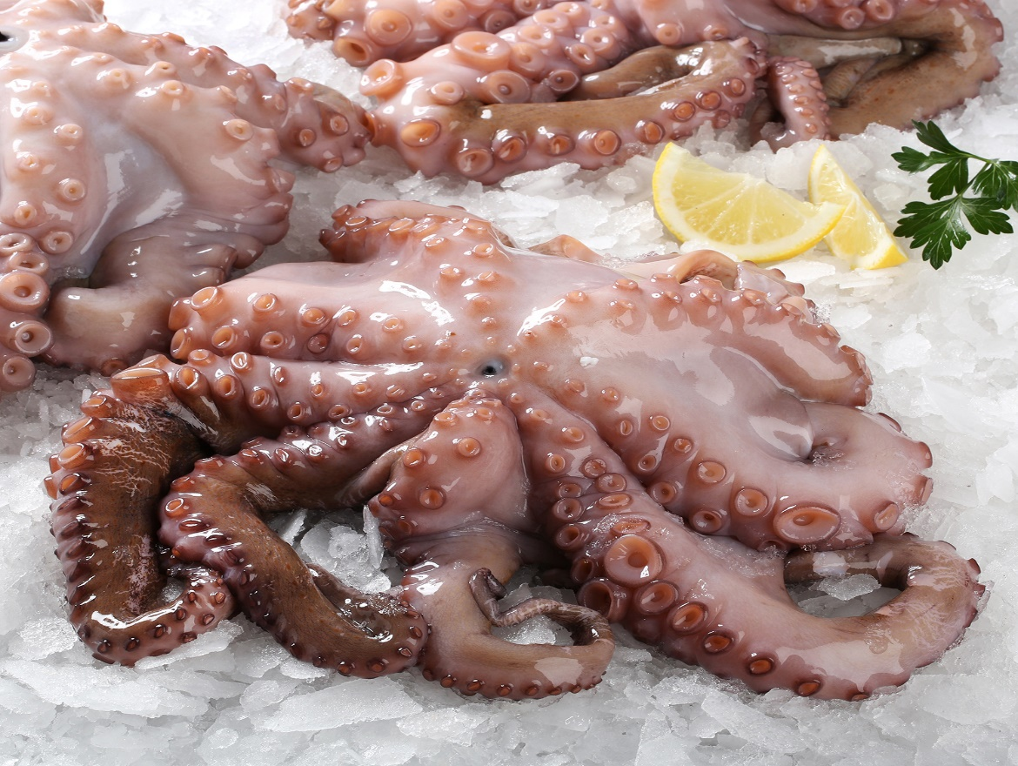

**Variety/Type Descriptions**

**Octopus** is full of vitamins and is low in fat and high in iron. Octopus can be prepared by blanching it in boiling water and then baking it, as well as boiling, grilling, or poaching. Because octopus evolves in taste depending on what ingredients are used when cooking, many prefer to eat it raw.

**Product Availability**

|  |  |  |  |  |  |  |  |  |  |  |  |  |
| --- | --- | --- | --- | --- | --- | --- | --- | --- | --- | --- | --- | --- |
|  | Jan | Feb | Mar | Apr | May | Jun | Jul | Aug | Sep | Oct | Nov | Dec |
|  |  |  |  |  |  |  |  |  |  |  |  |  |

**Origin of Product**

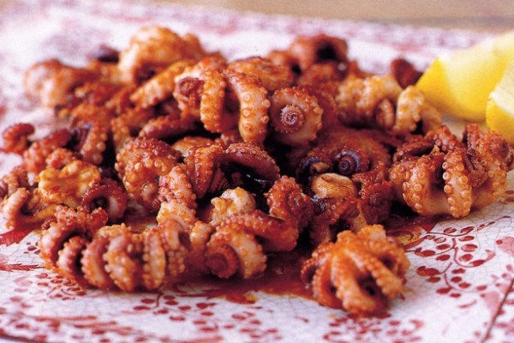Esmeraldas, Manabi and Guayas Provinces.

Common Packaging:

Boxes X 25 kg

Grades:

Fresh Selected

**Storing and Handling**

**Temperature/humidity recommendations:**

**Ordering Specifications**

Fresh . Storage at -20 °C / -4 °F

**Shipping Port**

Guayaquil

**\*Call for quote at your destination**

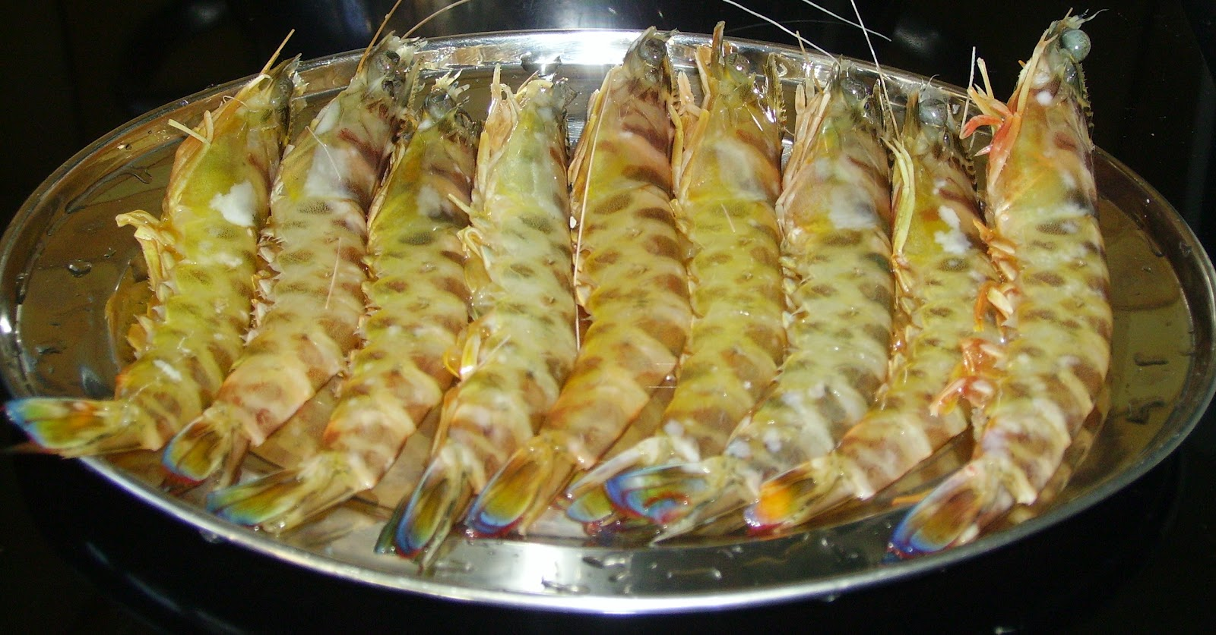**Variety/Type Descriptions**

**Denbrobranchiata** Prawns are crustaceans similar in appearance to shrimps, but they can be distinguished by the gill structure which is branching in prawns and not in shrimp. They are high in protein, iron, zinc and vitamin E. Prawns also contain heart-friendly omega-3.

|  |  |  |  |  |  |  |  |  |  |  |  |  |
| --- | --- | --- | --- | --- | --- | --- | --- | --- | --- | --- | --- | --- |
|  | Jan | Feb | Mar | Apr | May | Jun | Jul | Aug | Sep | Oct | Nov | Dec |
|  |  |  |  |  |  |  |  |  |  |  |  |  |

**Product Availability**

**Origin of Product**

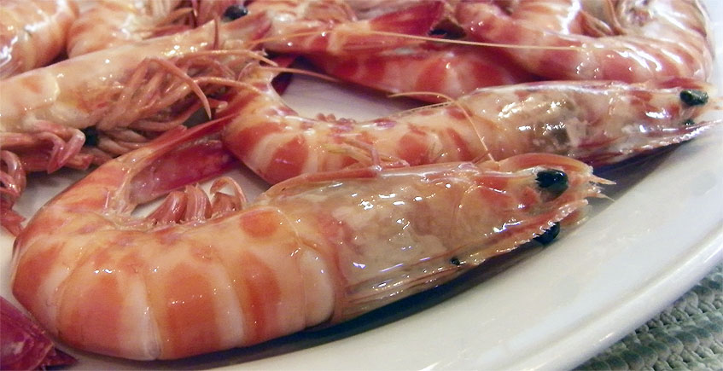Esmeraldas, Manabi and Guayas Provinces.

Common Packaging:

Boxes X 25 kg

Grades:

Fresh Selected

**Storing and Handling**

**Temperature/humidity recommendations:**

**Ordering Specifications**

Fresh . Storage at -20 °C / -4 °F

**Shipping Port**

Guayaquil

**\*Call for quote at your destination**

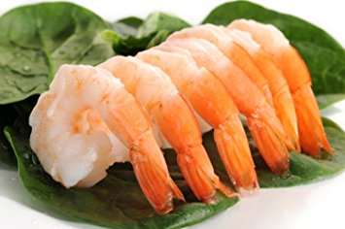**Variety/Type Descriptions**

**Caridea** are swimming, decapod crustaceans, characterized by a body that is compressed from side to side, long antennae and legs, thin and semitransparent exoskeleton, lamellar gills, and fan-like tail. They are found widely around the world in both fresh and salt water. Shrimp is high in calcium and protein. Shrimp are marketed according to size (albeit with regional variance), with general categories commonly including: 33, 34-45, 46-55, 56-66, 67-88, 89-110, 111-132, 133-154 and 154 sizes.

|  |  |  |  |  |  |  |  |  |  |  |  |  |
| --- | --- | --- | --- | --- | --- | --- | --- | --- | --- | --- | --- | --- |
|  | Jan | Feb | Mar | Apr | May | Jun | Jul | Aug | Sep | Oct | Nov | Dec |
|  |  |  |  |  |  |  |  |  |  |  |  |  |

**Product Availability**

**Origin of Product**

Esmeraldas, Manabi and Guayas Provinces.

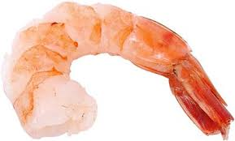Common Packaging:

Boxes X 25 kg

Grades:

According to size

**Storing and Handling**

**Temperature/humidity recommendations:**

**Ordering Specifications**

Fresh . Storage at -20 °C / -4 °F

**Shipping Port**

Guayaquil

**\*Call for quote at your destination**

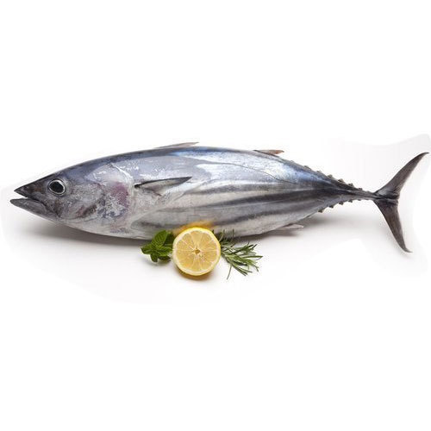

**Variety/Type Descriptions**

**Thunnus** the tuna has a sleek, streamlined body, and is among the fastest-swimming pelagic fish. It’s a type of saltwater fish that belongs to the same family as mackerel fish and bonito fish. The meat of the tuna fish is often sold frozen, fresh or canned. Tuna fish is high in protein but low in calories, also, is packed with antioxidant-rich in selenium.

|  |  |  |  |  |  |  |  |  |  |  |  |  |
| --- | --- | --- | --- | --- | --- | --- | --- | --- | --- | --- | --- | --- |
|  | Jan | Feb | Mar | Apr | May | Jun | Jul | Aug | Sep | Oct | Nov | Dec |
|  |  |  |  |  |  |  |  |  |  |  |  |  |

**Product Availability**

*PRODUCT FOR CEIBA ONE CONTAINER PER MONTH ALL YEAR

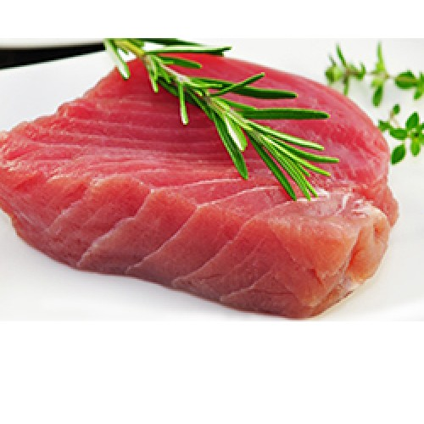**Origin of Product**

Manabi Province

Common Packaging:

Boxes X 15 kg. Frozen

Grades:

Tenderloin steaks or canned

**Storing and Handling**

**Temperature/humidity recommendations:**

**Ordering Specifications**

Fresh . Storage at -30 °C -22 °F

**Shipping Port**

Guayaquil

**\*Call for quote at your destination**