IAM SECURITY TRAINING
Active Directory Home Lab
IAM Security Engineer Training Documentation

Paraday Home Lab | paraday.home.lab.ad | March 2026

Table of Contents

1. Lab Overview ..... 3
2. Virtual Machine Setup ..... 4
3. Network Topology ..... 5
4. Domain and Forest Configuration ..... 6
5. Organizational Unit Structure ..... 7
6. Security Groups and RBAC ..... 8
7. User Management ..... 9
8. Group Policy Objects ..... 10
9. PowerShell Scripts ..... 16
10. Errors and Troubleshooting ..... 18
11. Key Terminology ..... 20
12. What is Next ..... 22

1. Lab Overview

This documentation covers everything built and practiced in the Active Directory home lab. The whole point of this lab is to get hands on experience with identity and access management to work toward becoming an IAM security engineer. Instead of just reading about Active Directory and group policies the goal was to actually build it, break it, and fix it so the concepts really stick.
The lab simulates a real enterprise environment with a domain controller, a client machine, 1000 users across multiple departments, security groups, organizational units, and group policies. Every step in here is something done and documented as a personal reference for rebuilding the lab from scratch or reviewing for interviews.

What this lab covers
- Setting up Windows Server 2019 as a domain controller
- Configuring Active Directory Domain Services
- Creating and organizing users, groups, and OUs
- Writing PowerShell scripts to automate IAM tasks
- Configuring Group Policy Objects to enforce security standards
- Auditing and reporting within Active Directory using Event Viewer
- Practicing the identity lifecycle: Joiner, Mover, Leaver

2. Virtual Machine Setup

The lab runs entirely on VirtualBox. Two virtual machines make up the environment, one acting as the server and domain controller and the other acting as a client workstation that joins the domain.

Virtual machine summary
VM Name | Operating System | Role | Username | Password
DC (Server19) | Windows Server 2019 | Domain Controller | Administrator | Fuckthe305!
Client1 (Win10) | Windows 10 | Client Workstation | user | No password

Software used
Software | Purpose
VirtualBox | Virtualization platform to run both VMs
Windows Server 2019 ISO | Operating system for the domain controller
Windows 10 ISO | Operating system for the client workstation

3. Network Topology

The domain controller has two network adapters. The first connects to the internet through NAT. The second is set to internal network mode so the DC and client VM communicate privately.

Domain controller network configuration
Adapter | Type | IP Address | Subnet Mask | Gateway | DNS
NIC 1 | Internet (NAT) | 10.0.2.15 (DHCP) | 255.255.255.0 | 10.0.2.2 | 10.0.2.3
NIC 2 | Internal Network | 172.16.0.1 (Static) | 255.255.255.0 | Empty | 127.0.0.1

Client machine network configuration
Adapter | Type | IP Range | Subnet Mask | Gateway | DNS
NIC 1 | Internal Network | 172.16.0.100 to 172.16.0.200 | 255.255.255.0 | 172.168.0.1 | 172.16.0.1

DHCP scope
Setting | Value
Scope Range | 172.16.0.100 to 172.16.0.200
Subnet Mask | 255.255.255.0
Default Gateway | 172.168.0.1
DNS Server | 172.16.0.1

SCREENSHOT PLACEHOLDER: Network topology diagram screenshot from VirtualBox NIC configuration

4. Domain and Forest Configuration

Setting | Value
Forest Name | paraday.home.lab.AD
Domain Name (FQDN) | paraday.home.lab.ad
NetBIOS Name | PARADAY
Domain Controller Name | DC
Domain Controller IP | 172.16.0.1

Services running on the domain controller
Service | Purpose
Active Directory Domain Services | Core identity and directory service
DNS Server | Resolves domain names so clients can find the DC
DHCP Server | Automatically assigns IP addresses to client machines
RAS / NAT | Allows internal VMs to access the internet through the DC

5. Organizational Unit Structure

Organizational units organize users, computers, and groups inside Active Directory. They look like folders in ADUC but are always called OUs not folders. GPOs get attached to OUs so whatever policy is linked applies to everything inside automatically.

OU Name | Parent OU | Purpose
_DEPARTMENTS | paraday.home.lab.ad | Top level container holding all department OUs
_USERS | _DEPARTMENTS | Original container where 1000 users were bulk created
HR | _DEPARTMENTS | Holds all HR department users and security groups
IT | _DEPARTMENTS | Holds all IT department users and security groups
Finance | _DEPARTMENTS | Holds all Finance department users and security groups
Sales | _DEPARTMENTS | Holds all Sales department users and security groups
Marketing | _DEPARTMENTS | Holds all Marketing department users and security groups
ADMINS | paraday.home.lab.ad | Holds administrator accounts separate from regular users

SCREENSHOT PLACEHOLDER: ADUC screenshot showing full OU structure with all departments visible in left tree

6. Security Groups and RBAC

Security groups are how access gets assigned in Active Directory. Permissions are assigned to groups not individual users. This is the foundation of role based access control. The golden rule is to never assign permissions directly to a user.

Group Name | Department | Access Level | Group Scope | Group Type
HR-ReadOnly | HR | Read only access | Global | Security
HR-FullAccess | HR | Full read and write access | Global | Security
IT-ReadOnly | IT | Read only access | Global | Security
IT-FullAccess | IT | Full read and write access | Global | Security
IT-Admins | IT | Administrative elevated access | Global | Security
Finance-ReadOnly | Finance | Read only access | Global | Security
Finance-FullAccess | Finance | Full read and write access | Global | Security
Sales-ReadOnly | Sales | Read only access | Global | Security
Sales-FullAccess | Sales | Full read and write access | Global | Security
Marketing-ReadOnly | Marketing | Read only access | Global | Security
Marketing-FullAccess | Marketing | Full read and write access | Global | Security

SCREENSHOT PLACEHOLDER: ADUC screenshot showing a user properties Member Of tab with security group memberships

7. User Management

1000 fake users were created using a PowerShell script. After the OU structure and security groups were in place those users were distributed across the 5 department OUs and assigned to their security groups. 10 users per department were manually added to ReadOnly groups and 2 per department to FullAccess groups to practice the manual process. The rest were bulk assigned via PowerShell.

Department | Approximate Users | Security Groups Available
HR | ~200 | HR-ReadOnly, HR-FullAccess
IT | ~200 | IT-ReadOnly, IT-FullAccess, IT-Admins
Finance | ~200 | Finance-ReadOnly, Finance-FullAccess
Sales | ~200 | Sales-ReadOnly, Sales-FullAccess
Marketing | ~200 | Marketing-ReadOnly, Marketing-FullAccess

8. Group Policy Objects

Group Policy Objects enforce security settings across the entire domain automatically. Each GPO is created and linked to an OU and every object inside that OU receives the settings without any manual configuration per machine or user. Five GPOs were configured and verified working in this lab.

GPO Name | Linked To | Configuration Type | Status
Password-Policy | _DEPARTMENTS | Computer Configuration | Configured and verified
Screen-Lock-Policy | _DEPARTMENTS | User Configuration | Configured and verified
Control-Panel-Restriction | _DEPARTMENTS | User Configuration | Configured and verified
USB-Storage-Restriction | _DEPARTMENTS | Computer Configuration | Configured and verified
Audit-Policy | _DEPARTMENTS | Computer Configuration | Configured and verified

SCREENSHOT PLACEHOLDER: Group Policy Management screenshot showing all 5 GPOs linked to _DEPARTMENTS

GPO 1: Password Policy
The password policy enforces strong password requirements across all domain users. It was linked to _DEPARTMENTS so every user in every department automatically has these rules enforced. Users cannot bypass these requirements even if they try to change settings manually.

Setting | Value | Why This Value
Enforce password history | 10 passwords | Prevents users from cycling back to old passwords
Maximum password age | 90 days | Forces regular password rotation to limit exposure window
Minimum password age | 1 day | Prevents cycling through history in one sitting
Minimum password length | 12 characters | Longer passwords are exponentially harder to crack
Password complexity | Enabled | Forces mix of uppercase, lowercase, numbers, and symbols
Reversible encryption | Disabled | Ensures passwords are stored as one way hashes not plain text
Account lockout threshold | 5 attempts | Stops brute force attacks by locking after 5 wrong attempts
Account lockout duration | 30 minutes | Long enough to deter attackers, short enough not to frustrate users
Reset lockout counter after | 30 minutes | Resets failed attempt count after 30 minutes of no activity

SCREENSHOT PLACEHOLDER: Password Policy GPO settings screenshot showing all configured values
SCREENSHOT PLACEHOLDER: Account Lockout Policy GPO settings screenshot showing threshold and duration

GPO 2: Screen Lock Policy
The screen lock policy automatically locks the computer screen after 10 minutes of inactivity and requires a domain password to unlock. This prevents unauthorized physical access to an unattended machine. This is a requirement in SOC 2 and ISO 27001 compliance frameworks.

Setting | Value | Why This Value
Enable screen saver | Enabled | Master switch that activates the screen lock functionality
Password protect the screen saver | Enabled | Requires domain password to unlock. Without this anyone can just move the mouse and get in
Screen saver timeout | 600 seconds | 10 minutes is the industry standard balance between security and usability
Force specific screen saver | scrnsave.scr | Forces a blank black screen which is the most professional and reliable option

SCREENSHOT PLACEHOLDER: Screen Lock Policy GPO settings screenshot showing all 4 personalization settings
SCREENSHOT PLACEHOLDER: Client VM screenshot showing the locked screen after Windows key L was pressed

GPO 3: Control Panel Restriction
This GPO completely removes access to Control Panel and Windows Settings for all standard users. Regular employees have no business changing system settings on work computers. Without this restriction users could change network settings, uninstall software, or disable security features enforced by other GPOs.

GPO setting configured
Setting | Value | Location in GPO Editor
Prohibit access to Control Panel and PC Settings | Enabled | User Configuration > Policies > Administrative Templates > Control Panel

Below is the GPO editor showing the Control Panel Restriction settings with Prohibit access to Control Panel and PC Settings set to Enabled:

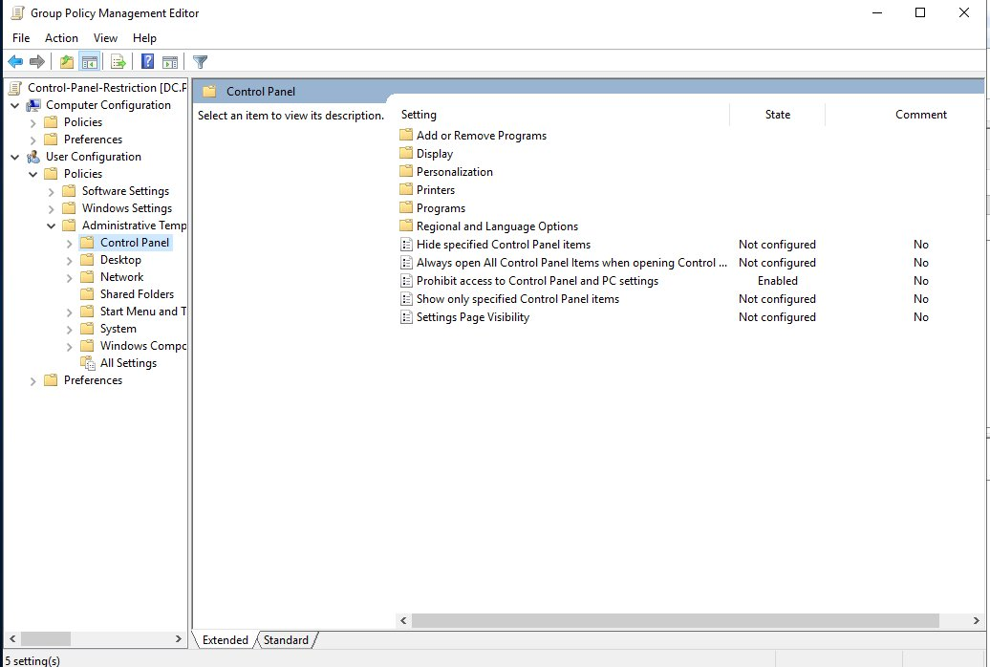
Control Panel Restriction GPO settings showing Prohibit access to Control Panel and PC Settings set to Enabled

Below is what the domain user sees on the client VM when they try to open Control Panel. This confirms the policy is working correctly:

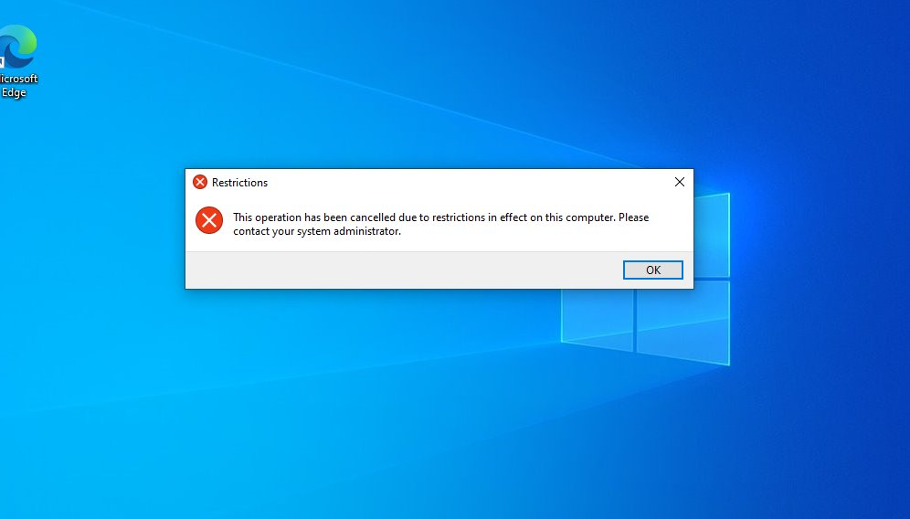
Client VM showing the restriction error when a domain user attempts to open Control Panel

GPO 4: USB Storage Restriction
This GPO blocks all USB storage devices from being used on domain machines. This prevents data theft where someone could plug in a USB drive and walk out with company data, and also prevents malware being introduced through a malicious USB device. This is a critical data loss prevention control.

Setting | Value | Why It Matters
All Removable Storage classes: Deny all access | Enabled | Master block covering every type of removable storage device
Removable Disks: Deny read access | Enabled | Specifically blocks reading data off any plugged in USB device
Removable Disks: Deny write access | Enabled | Specifically blocks copying data onto any USB device

Below is the USB Storage Restriction GPO settings showing all three restrictions enabled under Removable Storage Access:

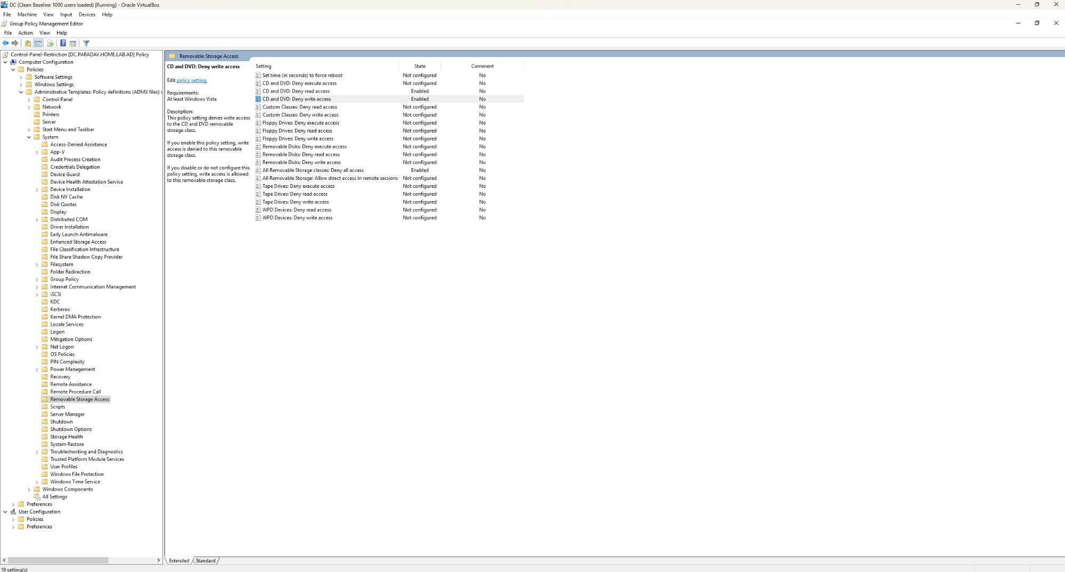
USB Storage Restriction GPO settings showing All Removable Storage classes Deny all access and Removable Disks restrictions enabled

Below is the result on the client VM when domain user acastleberry tried to access a USB drive passed through from the host machine. The E: drive is visible but completely blocked:

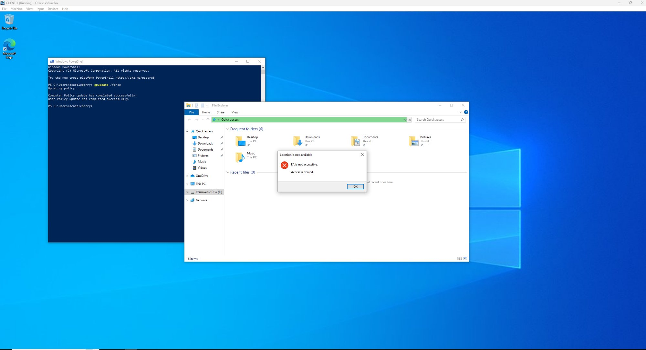
Client VM showing E: is not accessible Access is denied when domain user attempts to open a USB drive

GPO 5: Audit Policy
The Audit Policy is the most important GPO from a pure IAM security perspective. Everything else enforces security controls. This GPO creates the security camera system that records everything happening in the environment. Without auditing there are no logs and no way to investigate incidents or prove compliance.

Audit Category | Setting | Events Logged
Account Logon | Audit Credential Validation | Success and Failure
Account Management | Audit Security Group Management | Success and Failure
Account Management | Audit User Account Management | Success and Failure
Logon/Logoff | Audit Logon | Success and Failure
Logon/Logoff | Audit Account Lockout | Success and Failure
Policy Change | Audit Audit Policy Change | Success and Failure
Privilege Use | Audit Sensitive Privilege Use | Success and Failure

Account Logon settings showing Credential Validation set to Success and Failure:

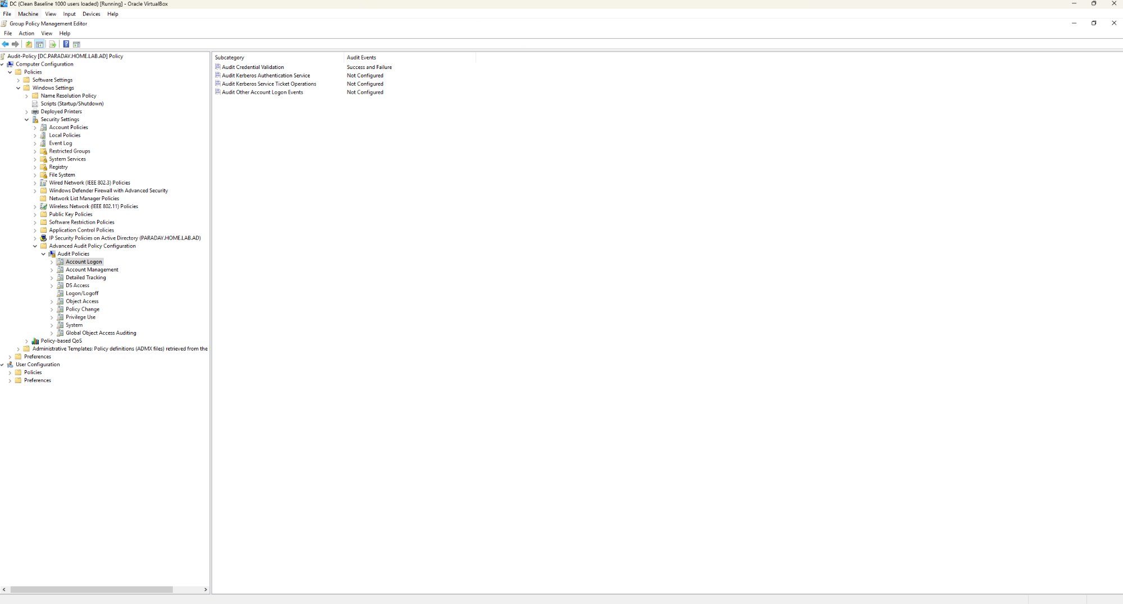
Audit Policy: Account Logon settings showing Audit Credential Validation set to Success and Failure

Account Management settings showing Security Group Management and User Account Management both set to Success and Failure:

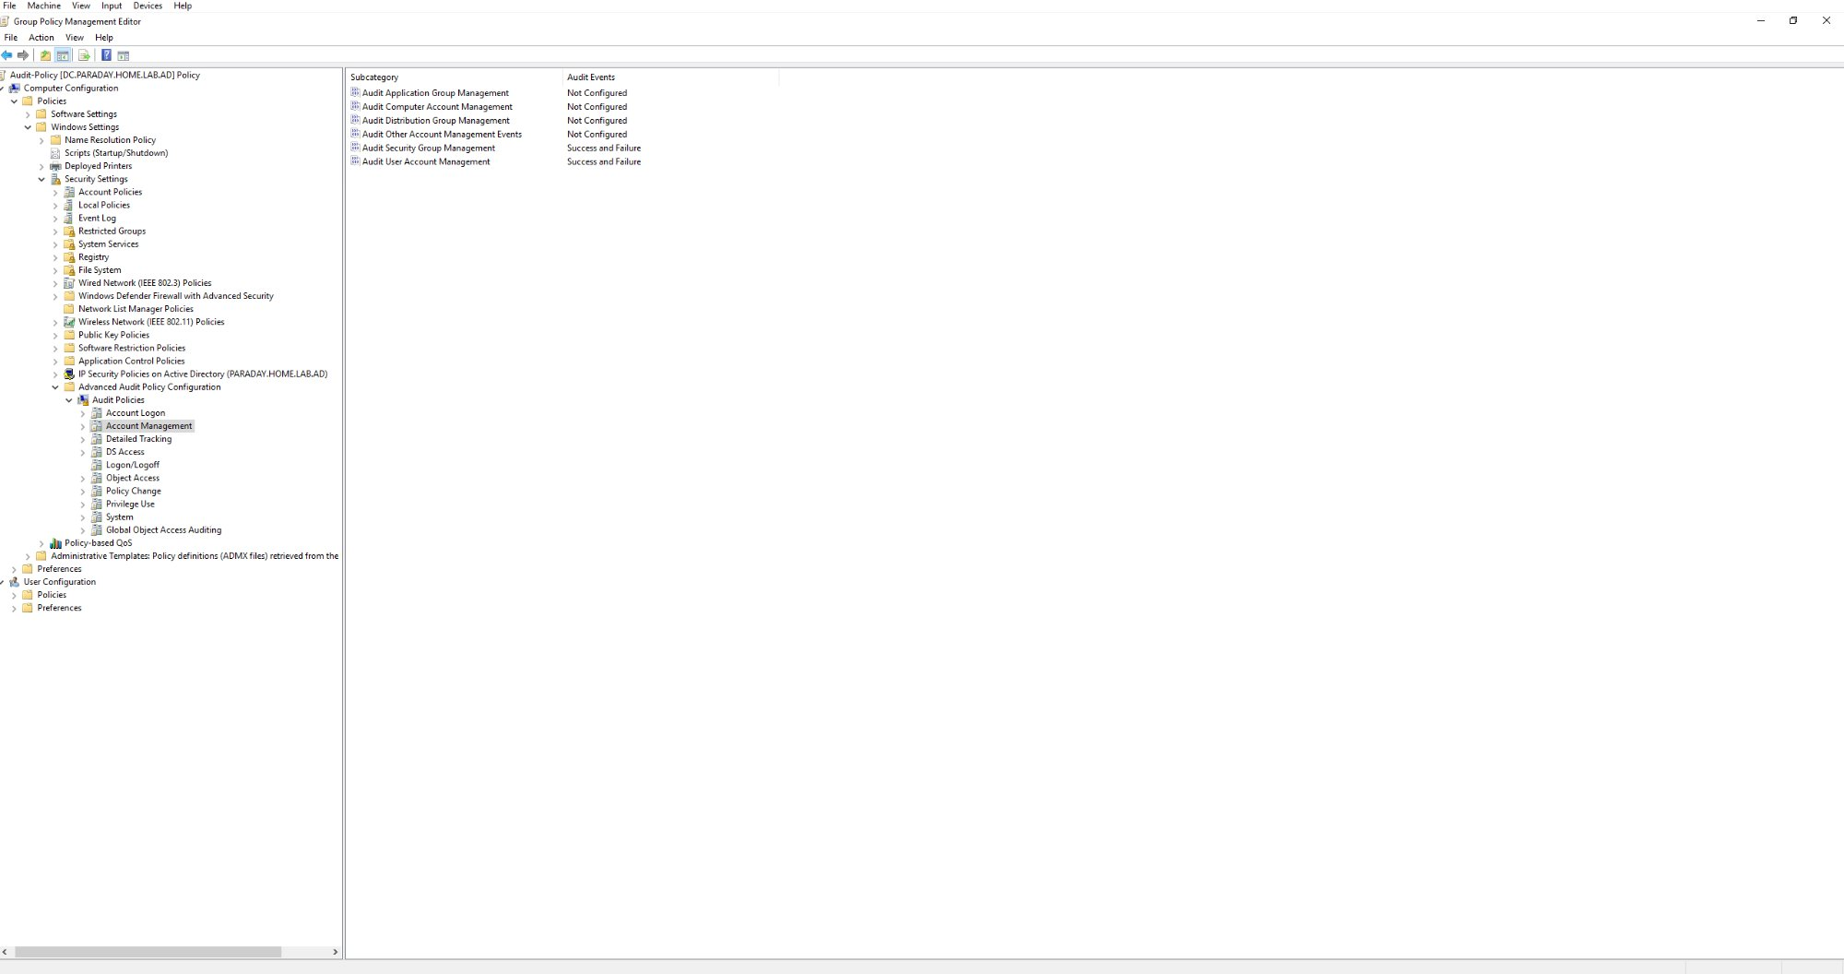
Audit Policy: Account Management settings showing Security Group and User Account Management set to Success and Failure

Logon/Logoff settings showing Account Lockout and Logon both set to Success and Failure:

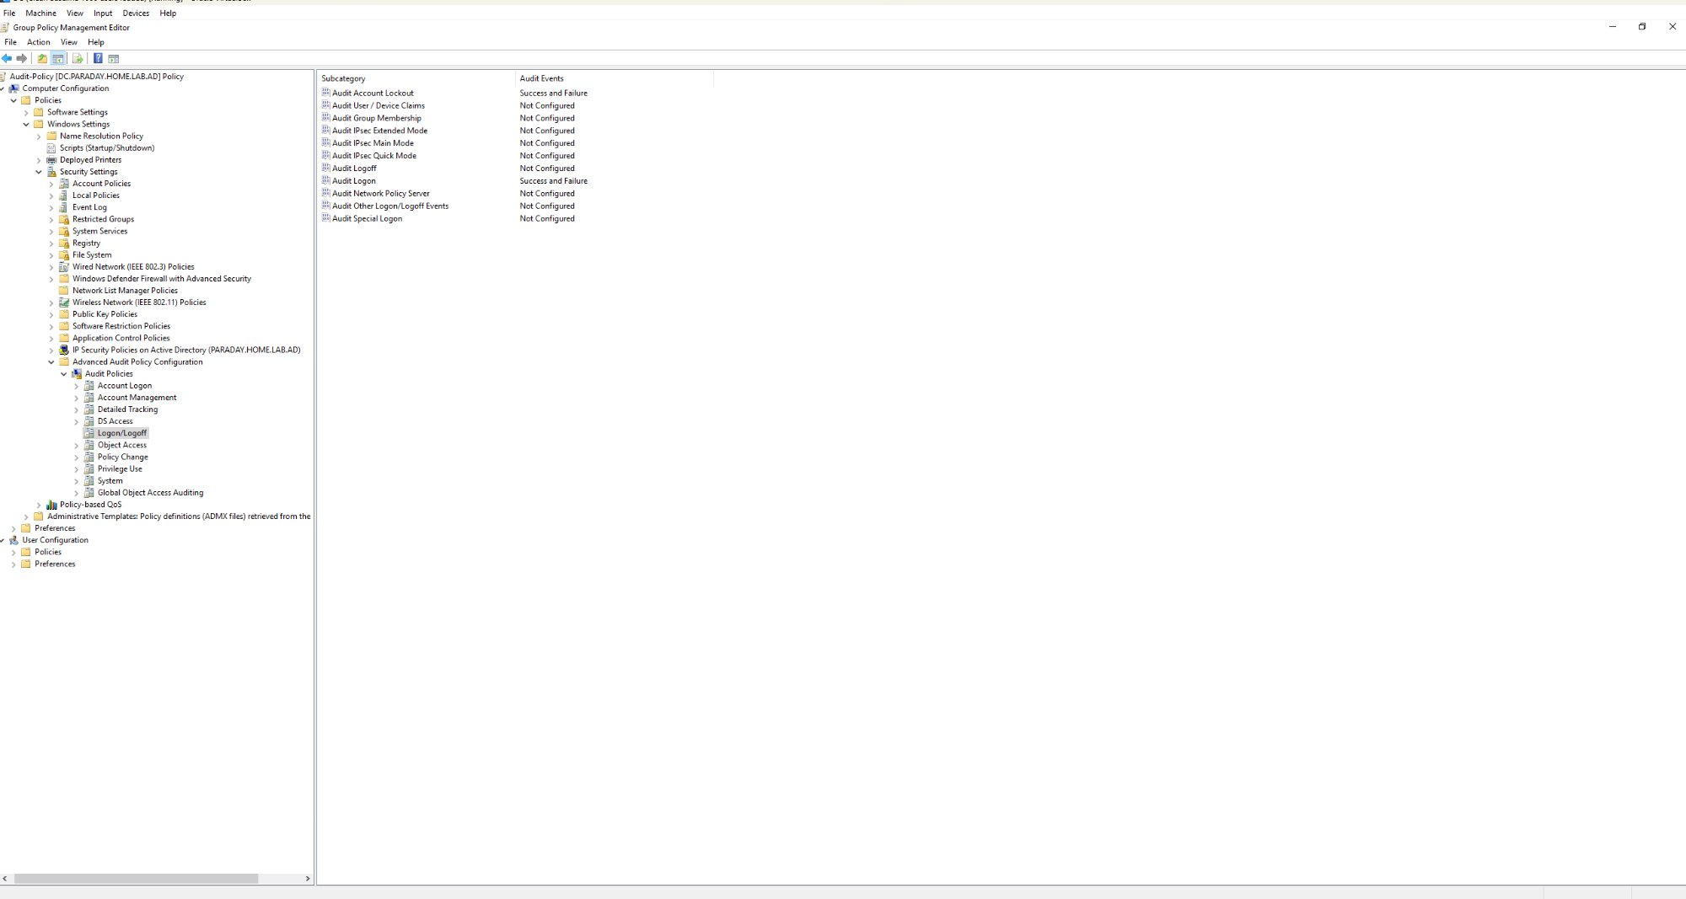
Audit Policy: Logon/Logoff settings showing Account Lockout and Audit Logon set to Success and Failure

Policy Change settings showing Audit Policy Change set to Success and Failure:

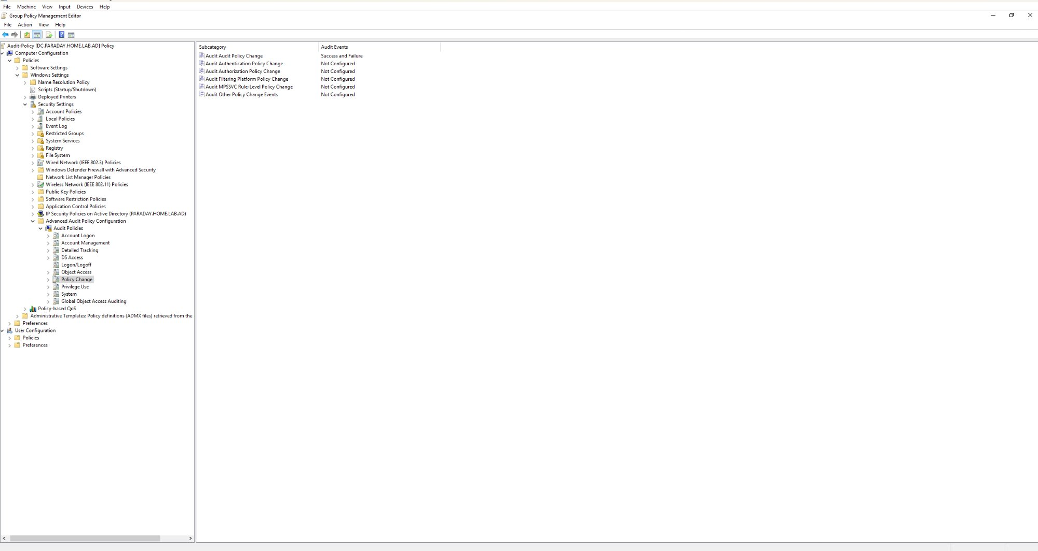
Audit Policy: Policy Change settings showing Audit Audit Policy Change set to Success and Failure

Privilege Use settings showing Sensitive Privilege Use set to Success and Failure:

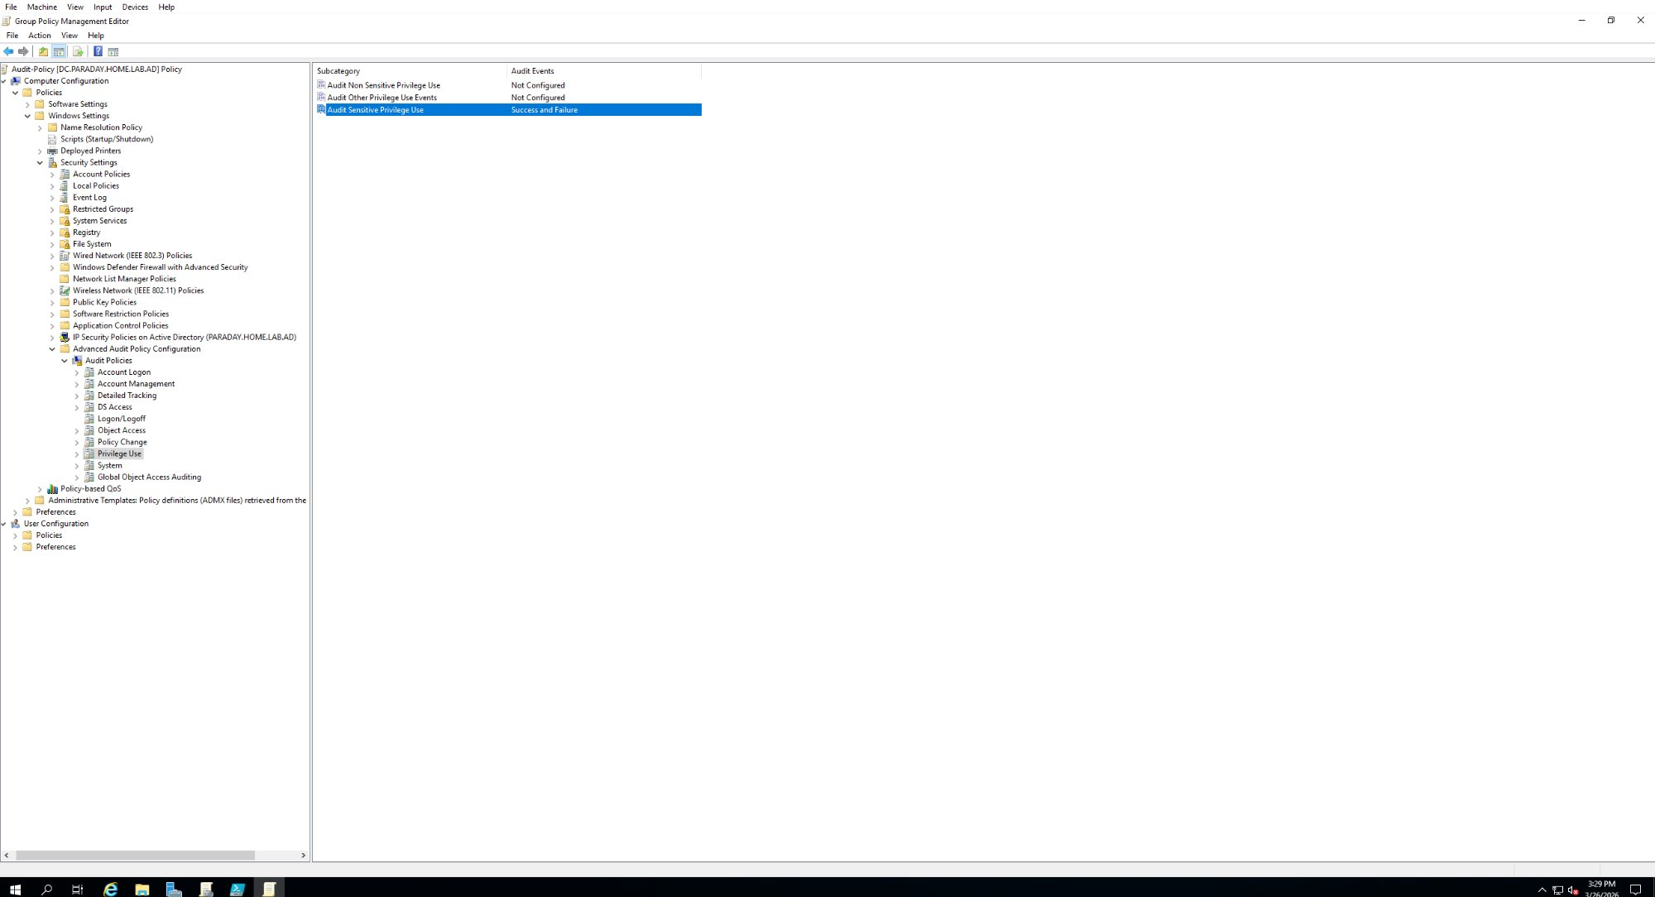
Audit Policy: Privilege Use settings showing Audit Sensitive Privilege Use set to Success and Failure

Forcing GPO updates with gpupdate /force
After configuring each GPO the following command was run on both the server and client VM to immediately push and pull the updated policies without waiting for the automatic refresh cycle:
gpupdate /force

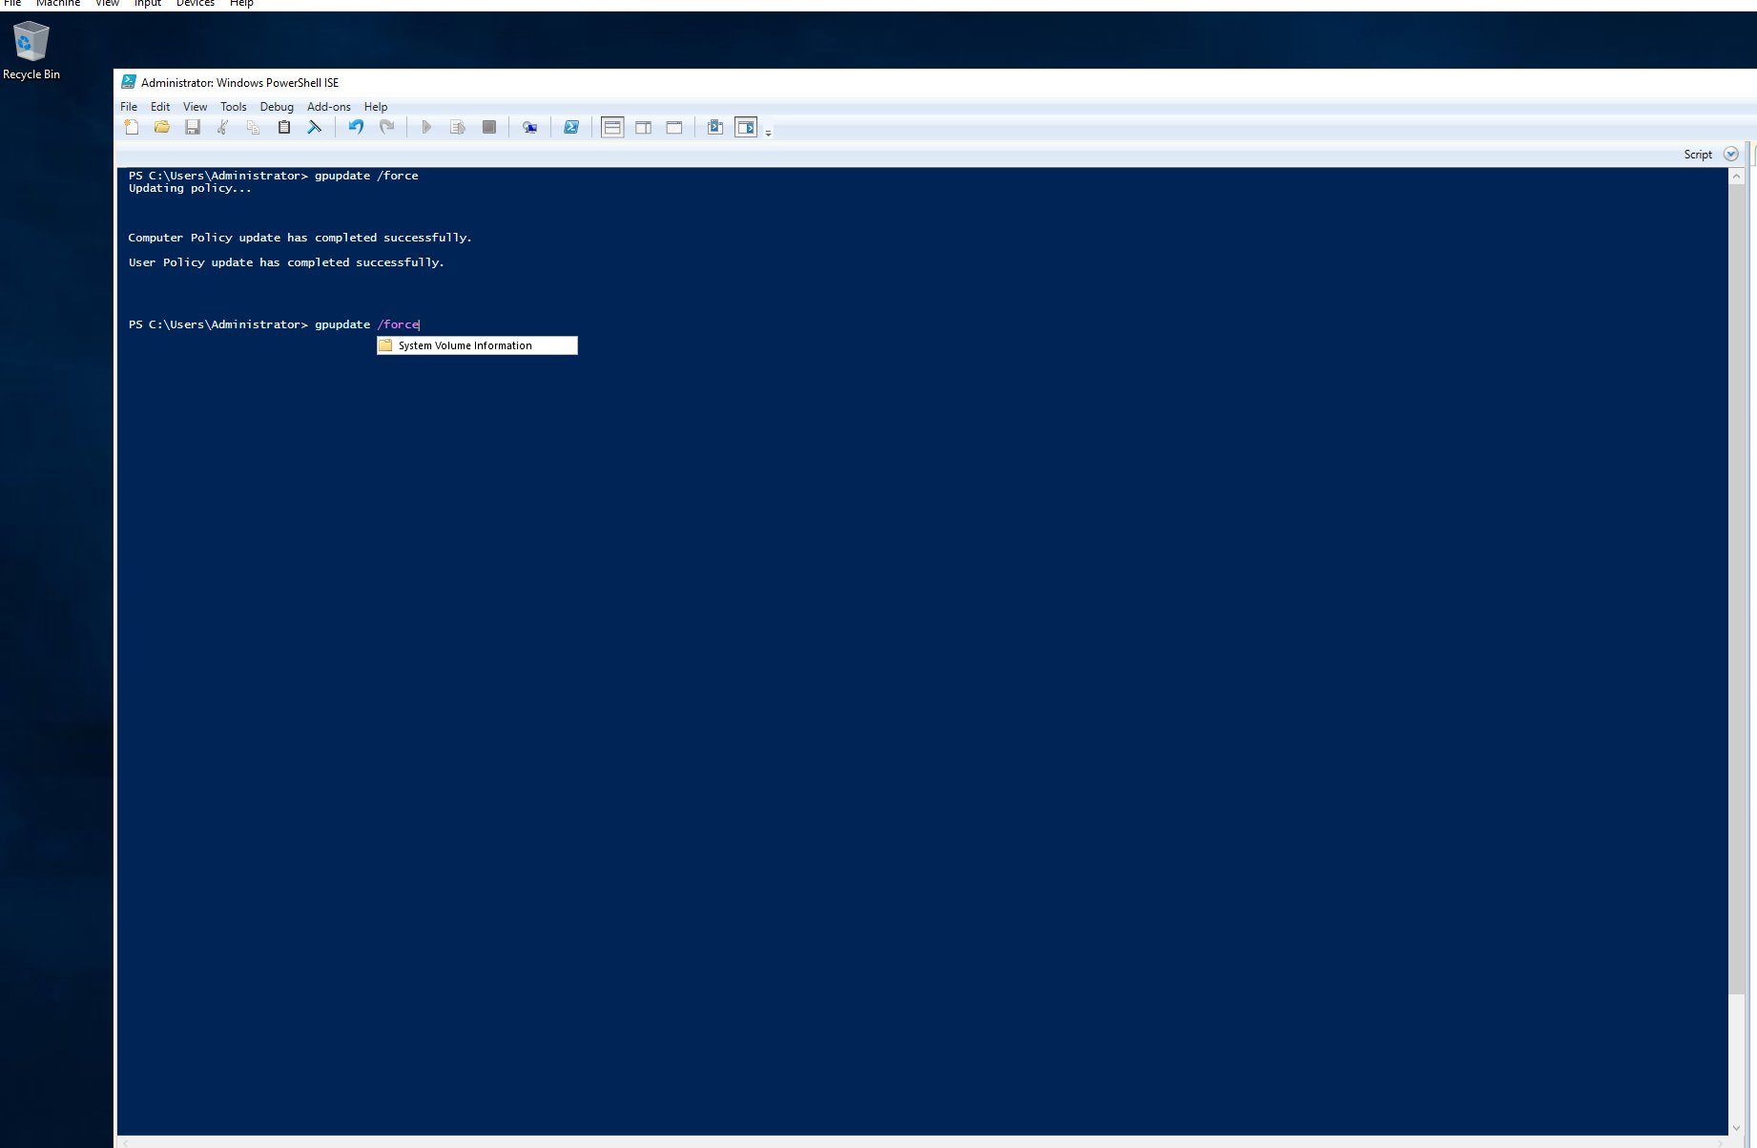
PowerShell showing gpupdate /force completing successfully with Computer Policy and User Policy both updated

9. Event Viewer and Audit Logs

After the Audit Policy was configured and pushed out, the Security log in Event Viewer was used to verify audit events were being recorded correctly. Test events were generated by deliberately attempting failed logins and then logging in successfully to produce real log entries.

Event ID | What It Means | What Was Found
4776 | DC attempted to validate credentials for an account | Confirmed credential validation events from the Administrator account logged on 3/26/2026
4625 | An account failed to log on | Confirmed failed logon attempts recorded with account name, domain PARADAY, and Audit Failure keyword
4624 | An account successfully logged on | Confirmed successful domain user logons being recorded

Event ID 4776 showing the domain controller validating credentials for the Administrator account. This confirms the Audit Credential Validation setting is working:

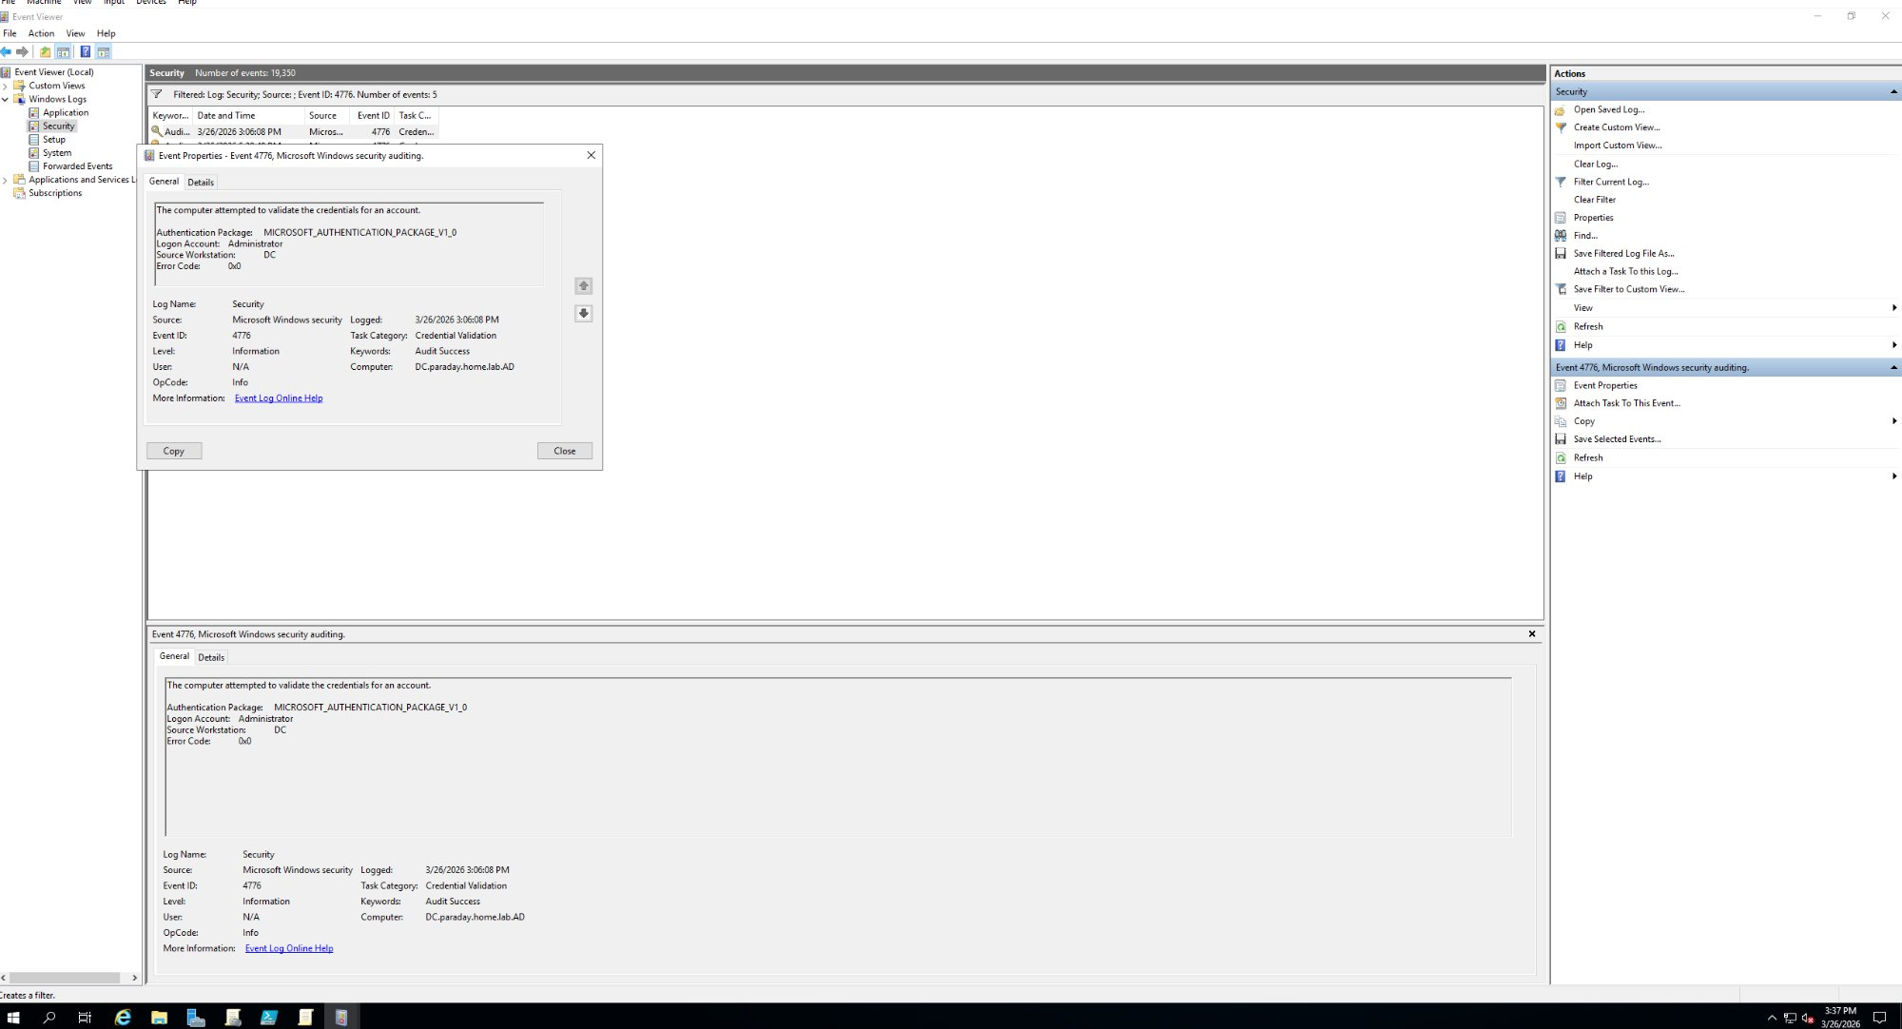
Event Viewer showing Event ID 4776 credential validation attempt on DC.paraday.home.lab.AD on 3/26/2026

Event ID 4625 showing a failed logon attempt. The detail panel confirms the account name, domain PARADAY, and Keywords showing Audit Failure. This is exactly what brute force attempts would look like in logs:

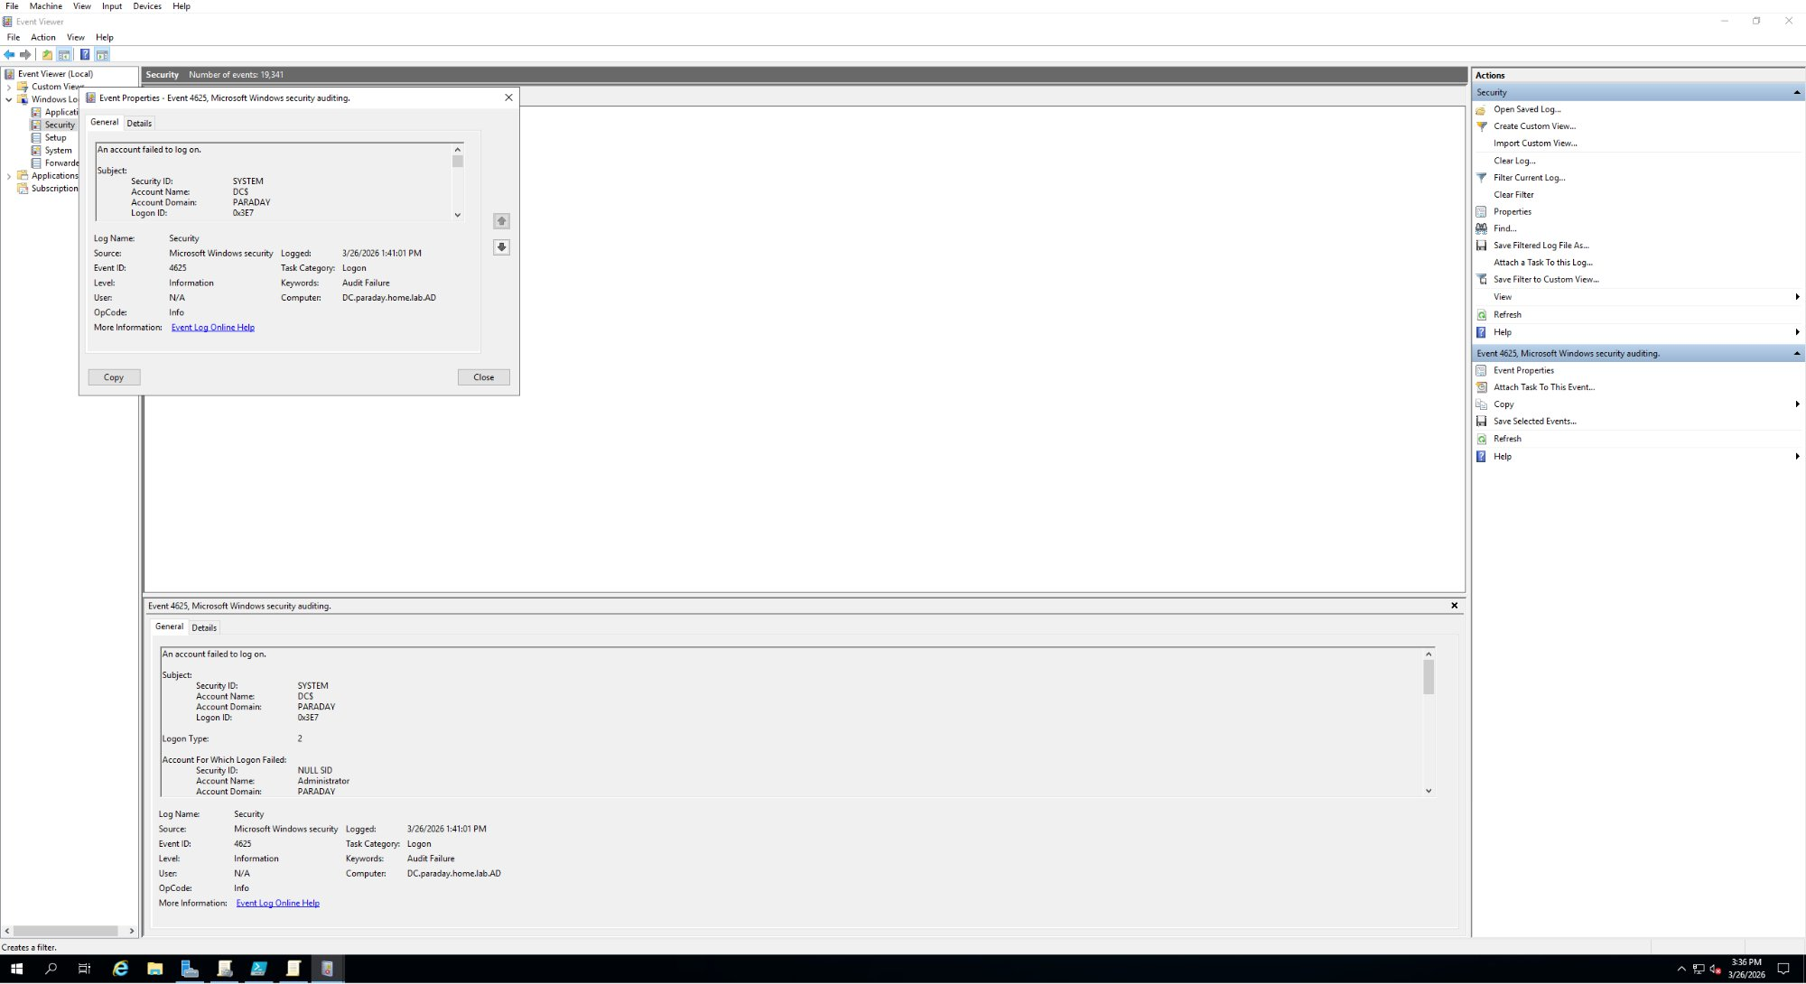
Event Viewer showing Event ID 4625 failed logon attempt with account name Administrator and domain PARADAY logged on 3/26/2026

SCREENSHOT PLACEHOLDER: Event Viewer screenshot showing Event ID 4624 successful logon details

10. PowerShell Scripts

PowerShell is how IAM engineers automate tasks that would take hours to do manually. Every script below was written and run as part of this lab.

Script 1: Find exact OU paths
Run to find the exact distinguished names of all OUs. This was needed because the initial move script kept failing due to incorrect paths.
Get-ADOrganizationalUnit -Filter * | Select-Object Name, DistinguishedName

Script 2: Move all users to department OUs
Took all 1000 users from _USERS and randomly distributed them across the 5 department OUs.
$departments = @('HR', 'IT', 'Finance', 'Sales', 'Marketing')
$users = Get-ADUser -Filter * -SearchBase 'OU=_USERS,OU=_DEPARTMENTS,DC=paraday,DC=home,DC=lab,DC=AD'
foreach ($user in $users) {
$dept = $departments | Get-Random
$targetOU = "OU=$dept,OU=_DEPARTMENTS,DC=paraday,DC=home,DC=lab,DC=AD"
Move-ADObject -Identity $user.DistinguishedName -TargetPath $targetOU
}
Write-Host 'Done! All users moved to departments.'

Script 3: Add all users to ReadOnly security groups
Loops through each department, grabs every user, and adds them to the corresponding ReadOnly group following least privilege principles.
$departments = @('HR', 'IT', 'Finance', 'Sales', 'Marketing')
foreach ($dept in $departments) {
$ouPath = "OU=$dept,OU=_DEPARTMENTS,DC=paraday,DC=home,DC=lab,DC=AD"
$users = Get-ADUser -Filter * -SearchBase $ouPath
foreach ($user in $users) {
Add-ADGroupMember -Identity "$dept-ReadOnly" -Members $user -ErrorAction SilentlyContinue
}
}
Write-Host 'Done! All remaining users added to ReadOnly groups.'

Script 4: Get all members of a group
Get-ADGroupMember -Identity 'IT-Admins' | Select-Object Name, SamAccountName

Script 5: Find all disabled accounts
Search-ADAccount -AccountDisabled | Select-Object Name, DistinguishedName

Script 6: Find accounts inactive for 30 or more days
$cutoff = (Get-Date).AddDays(-30)
Get-ADUser -Filter {LastLogonDate -lt $cutoff -and Enabled -eq $true} -Properties LastLogonDate |
Select-Object Name, LastLogonDate

11. Errors and Troubleshooting

Every error hit during the lab is documented here. Being able to explain how you diagnosed and fixed a problem demonstrates real understanding of the environment and is something interviewers specifically look for.

Error | Cause | Fix
Get-ADUser: Directory object not found | _USERS was nested inside _DEPARTMENTS but the script was only looking at the top level of the domain. | Ran Get-ADOrganizationalUnit to find the exact path. Updated SearchBase to OU=_USERS,OU=_DEPARTMENTS,DC=paraday,DC=home,DC=lab,DC=AD
Move-ADObject: Access is denied | PowerShell ISE was not running as Administrator so it did not have rights to move AD objects. | Closed PowerShell ISE and reopened it by right clicking and selecting Run as Administrator.
Add-ADGroupMember: Insufficient access rights | Same issue as above. PowerShell ISE was not running with admin privileges. | Reopened PowerShell ISE as Administrator and reran the script successfully.
GPO not applying to client VM: Computer Settings | The CLIENT1 computer account was sitting in the default Computers container not inside _DEPARTMENTS. GPOs linked to _DEPARTMENTS only apply to objects inside that OU. | Moved CLIENT1 computer account from default Computers container into _DEPARTMENTS in ADUC. Ran gpupdate /force on client. Verified with gpresult /r.
GPO not applying to client VM: User Settings | Was logged into the client VM with the local user account which is not a domain account. User based GPOs never apply to local accounts. | Logged out of local account. Reset password on a fake domain user in ADUC. Logged into client VM as PARADAY domain user. GPOs applied correctly.
VirtualBox memory error 0x00007ffeb52da0c4 | Hyper-V conflicting with VirtualBox causing memory access errors on VM startup. | Ran bcdedit /set hypervisorlaunchtype off in PowerShell as Administrator and restarted the host machine.
VM settings greyed out in VirtualBox | VM was in an Aborted or Saved state so VirtualBox locks settings to prevent changes while running. | Right clicked VM and selected Discard Saved State. Waited for status to show Powered Off then accessed settings normally.

12. Key Terminology

Term | Definition
Active Directory | Microsoft's directory service that stores and manages identity information for users, computers, and resources.
Forest | The top level container in AD holding one or more domains. Your forest is paraday.home.lab.AD.
Domain | A logical grouping of AD objects sharing the same database. Your domain is paraday.home.lab.ad.
Domain Controller | The server running Active Directory handling all authentication. Your DC has computer name DC.
OU | Organizational Unit. A container inside AD used to organize objects. Always called OUs not folders.
Distinguished Name | The full unique path to any object in AD. Example: CN=jsmith,OU=HR,OU=_DEPARTMENTS,DC=paraday,DC=home,DC=lab,DC=AD.
SamAccountName | The username used to log into the domain.
Security Group | A group used to assign permissions and access. The foundation of RBAC in AD.
RBAC | Role Based Access Control. Assigning permissions based on a users role rather than individually.
Least Privilege | Only giving users the minimum access they need to do their job and nothing more.
GPO | Group Policy Object. A set of rules linked to an OU that enforces settings on all objects inside it.
Identity Lifecycle | The full journey of a user account from creation when they join to deletion when they leave.
Joiner | The process of onboarding a new user including creating their account and assigning the right access.
Mover | The process of updating access when a user changes departments or roles.
Leaver | The process of offboarding a user including disabling their account and removing all access.
Provisioning | Creating a user account and granting appropriate access. Technical term for the joiner process.
Deprovisioning | Removing access and disabling an account. Technical term for the leaver process.
Segregation of Duties | Ensuring no single person has too much control. The approver and implementer should always be different people.
ADUC | Active Directory Users and Computers. The GUI tool for managing users, groups, OUs, and computers.
NetBIOS Name | A short name for the domain used for older compatibility. Your NetBIOS name is PARADAY.
FQDN | Fully Qualified Domain Name. The complete domain name. Your FQDN is paraday.home.lab.ad.
gpupdate /force | Forces a machine to immediately pull all Group Policy updates from the DC without waiting for the automatic refresh cycle.
gpresult /r | Generates a report showing exactly which Group Policies are currently applied to the machine and logged in user.

13. What is Next

Topic | Status | Notes
User and group management in ADUC | Complete | OUs created, groups created, 1000 users distributed and assigned
Group Policy Objects | Complete | Password Policy, Screen Lock, Control Panel Restriction, USB Restriction, and Audit Policy all configured and verified
Fine Grained Password Policies | Not Started | Will apply stricter password rules to IT-Admins group
Identity lifecycle: Joiner, Mover, Leaver | Not Started | Will practice full onboarding and offboarding workflows
PowerShell automation | In Progress | Several scripts written, more to come for lifecycle automation
Active Directory auditing | Complete | Audit Policy configured and Event Viewer logs verified
Delegating permissions in AD | Not Started | Will create helpdesk-admin and delegate password reset rights
DNS and DHCP basics | Not Started | Will explore DNS Manager and DHCP settings on the DC

