RC Light Controller

Instructions for use
for the MK4 TLC5940 LPC812 variant



Introduction
Thanks for using the LANE Boys RC light controller!

The light controller supports the following features:

- 16 LED outputs, constant-current driven. Two light controllers can be cascaded for a total of 32 LED outputs.
- High current switched output of up to 2A to drive a roof light bar
- Parking, Low-beam, High-beam and a roof light bar can be switched on/off manually from the transmitter
- Brake and Reverse lights are automatically controlled by monitoring the throttle channel. The brake lights now automatically turn on for a short, random time when the throttle goes to neutral.
- Combined tail and brake light function in a single LED through controlling the brightness of the LED.
- Separate brake light function for a 3rd brake light
- Indicators only come on when you want to. You have to stay in neutral for one seconds, then hold the steering left/right for one second before they engage. This way normal driving does not trigger the indicators.
- Hazard lights can be switched on/off from the transmitter
- Programmable output designed to drive a steering wheel or a figures head, a gearbox servo or a winch
- Automatic center and end-point adjustment for steering and throttle channel
- Light Programs for custom light animations like police lights, running lights ...
- Simulation of incandescent lights and faulty ground wiring
- Pre-processor for easier wiring
- Up to 3 AUX channels when using the new 5-channel Pre-processor
- All functions can be customized using a web browser-based tool
http://laneboysrc.github.io/rc-light-controller/
- Hardware and software is Open Source
https://github.com/laneboysrc/rc-light-controller/

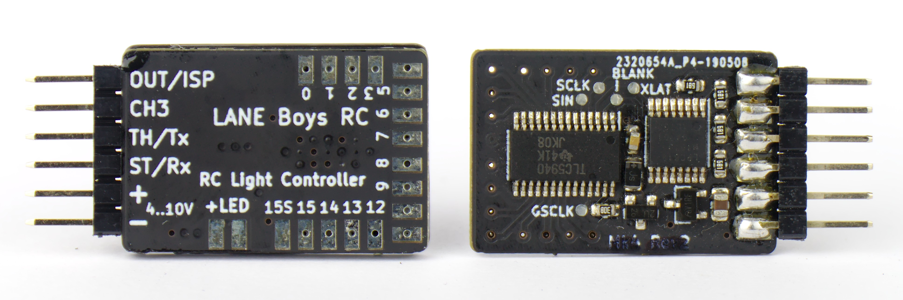
Light controller circuit board, Mk4 revision 2. The revision 2 is identical with the original Mk4 release except that the transistor for the switched light output is in a different location.

Connecting the light controller to your RC car
The light controller is usually powered from the RC receiver. The following sections describe different methods how to route the outputs of the RC receiver to the light controller and the other RC components.

Direct connection to the servo signals
The light controller signals ST/Rx, TH/Tx and CH3 need to connected to the steering, throttle and auxiliary channels of your receiver.

For steering and throttle you will need to utilize a Y-cable as shown on the schematics below:
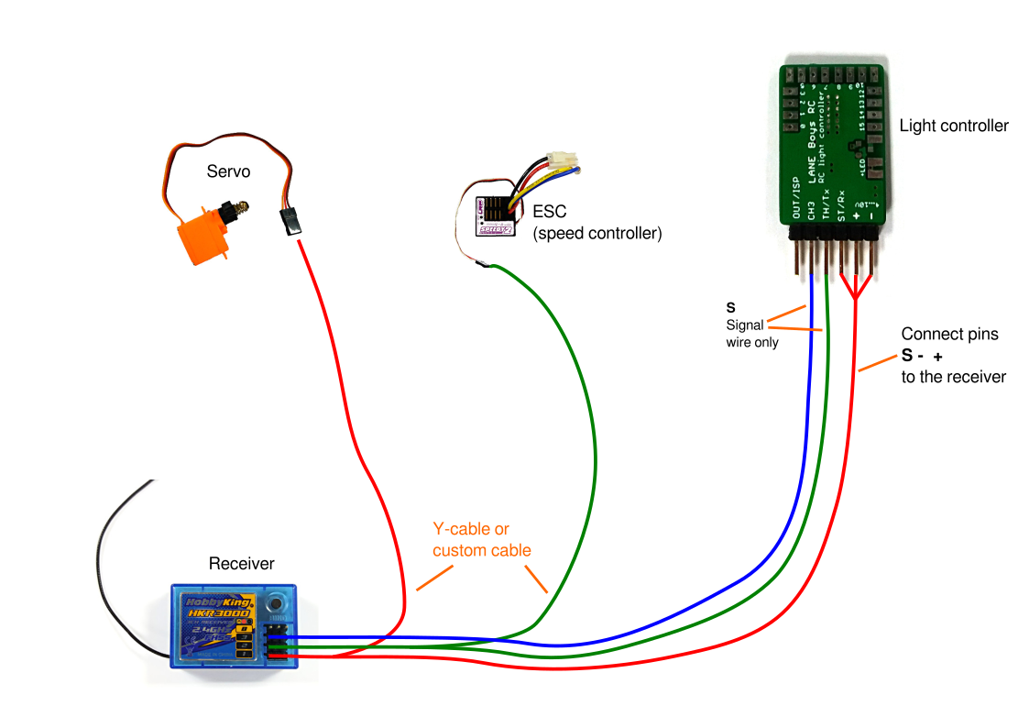

Only one of the channels needs to provide power to the light controller. For the other channels it is sufficient to use just the signal wire (usually orange or white in color). Servo extension leads can be easily reconfigured to achieve this:

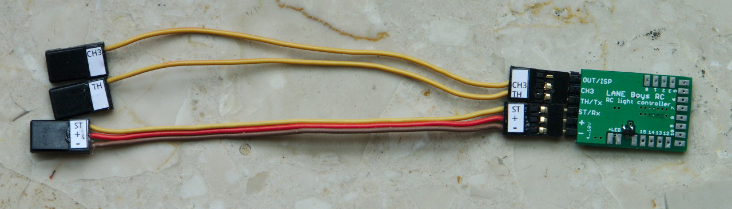

Using a Pre-processor
The Light Controller has a small companion circuit board called Pre-processor.

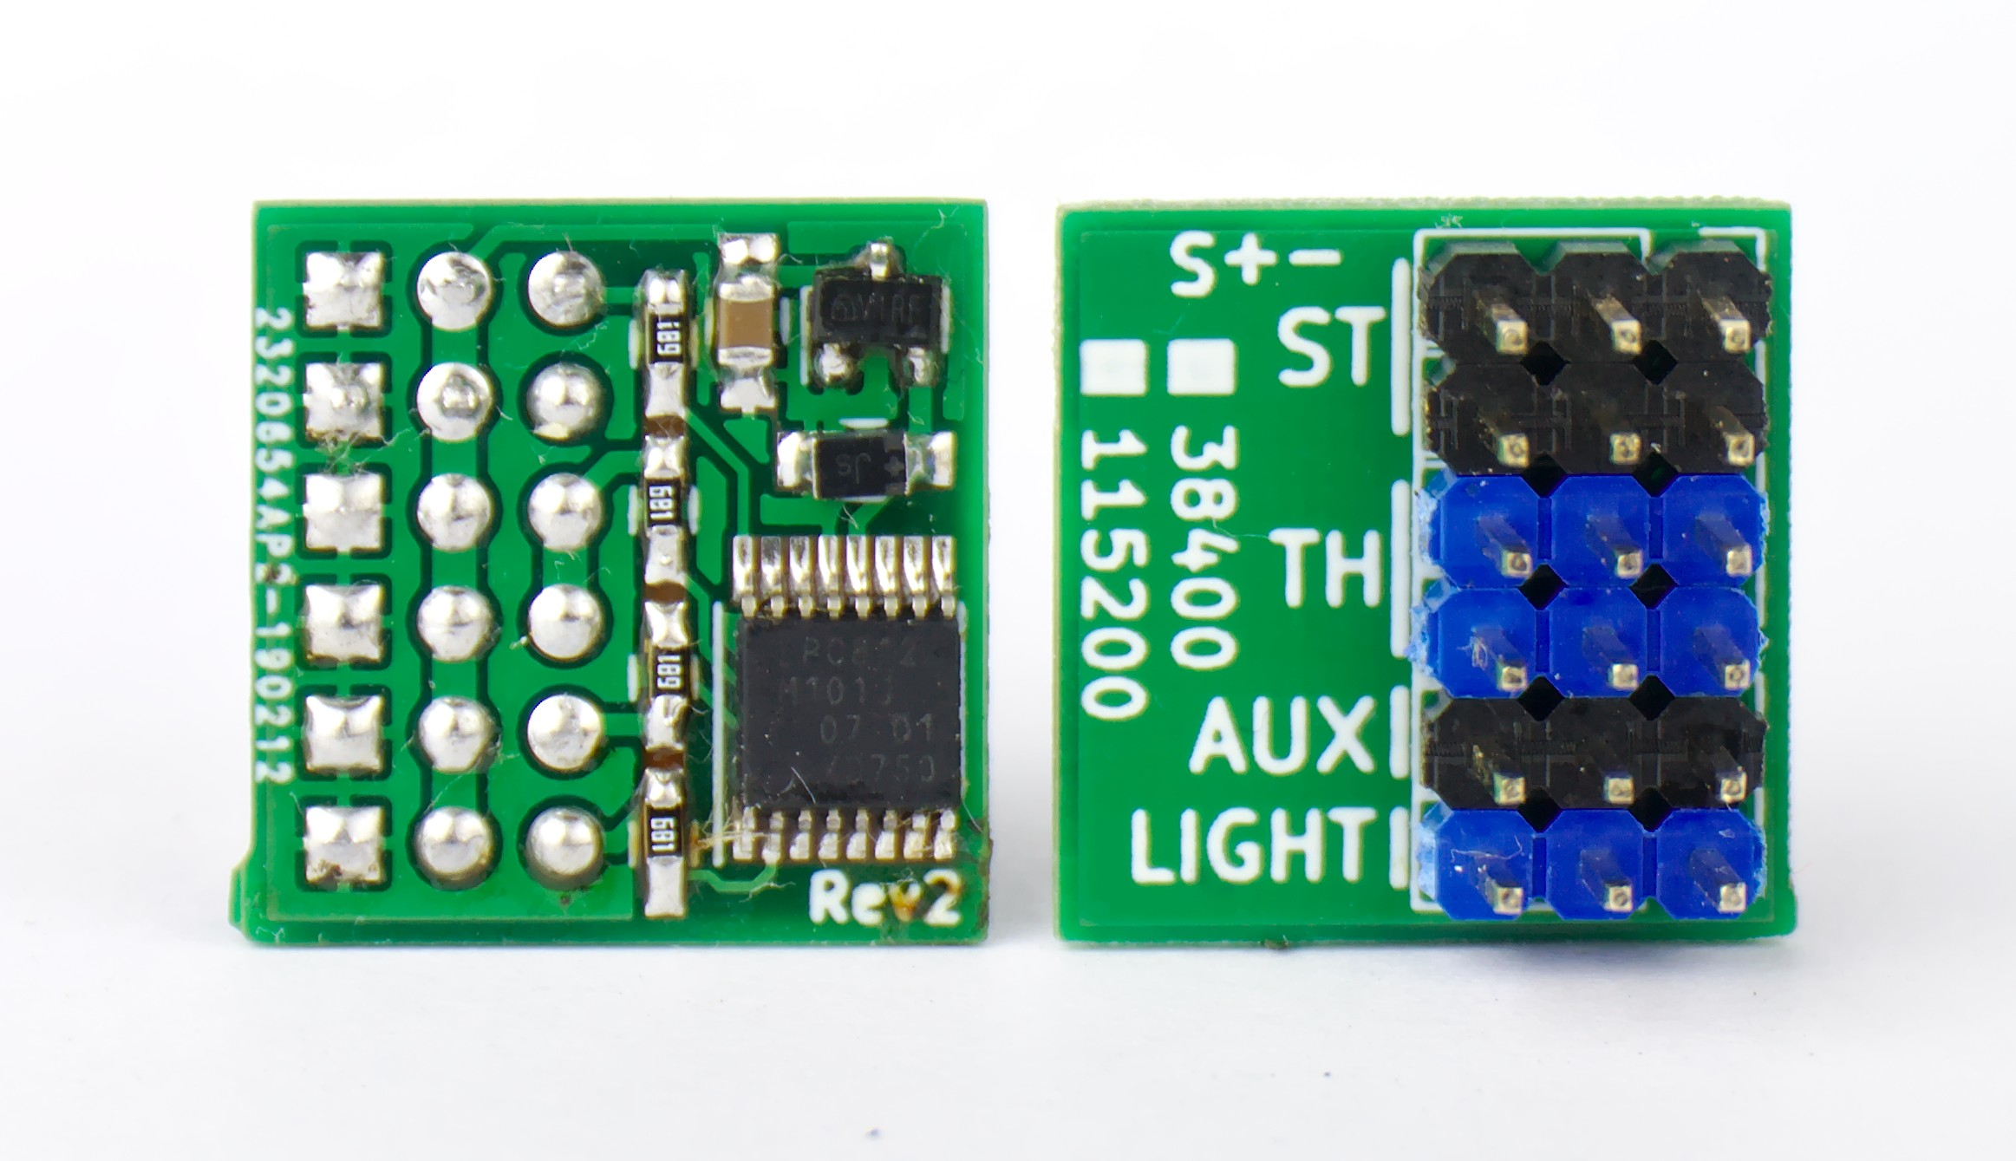3-channel Pre-processor
Instead of connecting the servo signals to the light controller directly, you connect them to the Pre-processor instead. The Pre-processor accumulates all servo signals into a single data line to the light controller. The Pre-processor also has additional connectors for the steering and throttle signal, saving the hassle of Y-cables.
This simplifies wiring drastically: only a 3-pole servo extension cable is needed between the chassis of the car (where receiver, ESC, Servo and Pre-processor reside) and the body shell (where the light controller and the LEDs are).
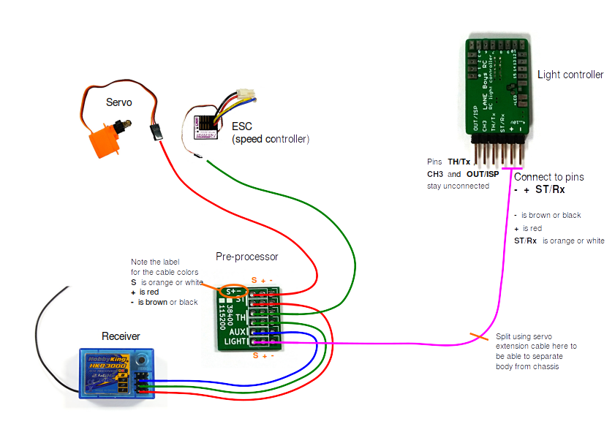
Pre-processor also comes in a 5-channel variant, which is useful if you have a modern RC car radio that supports more than 3 channels. With the 5-channel Pre-processor you can use separate AUX channels for manual indicators, or switching the lights, or turning the hazard lights on an off. The function of each AUX channel can be configured separately.
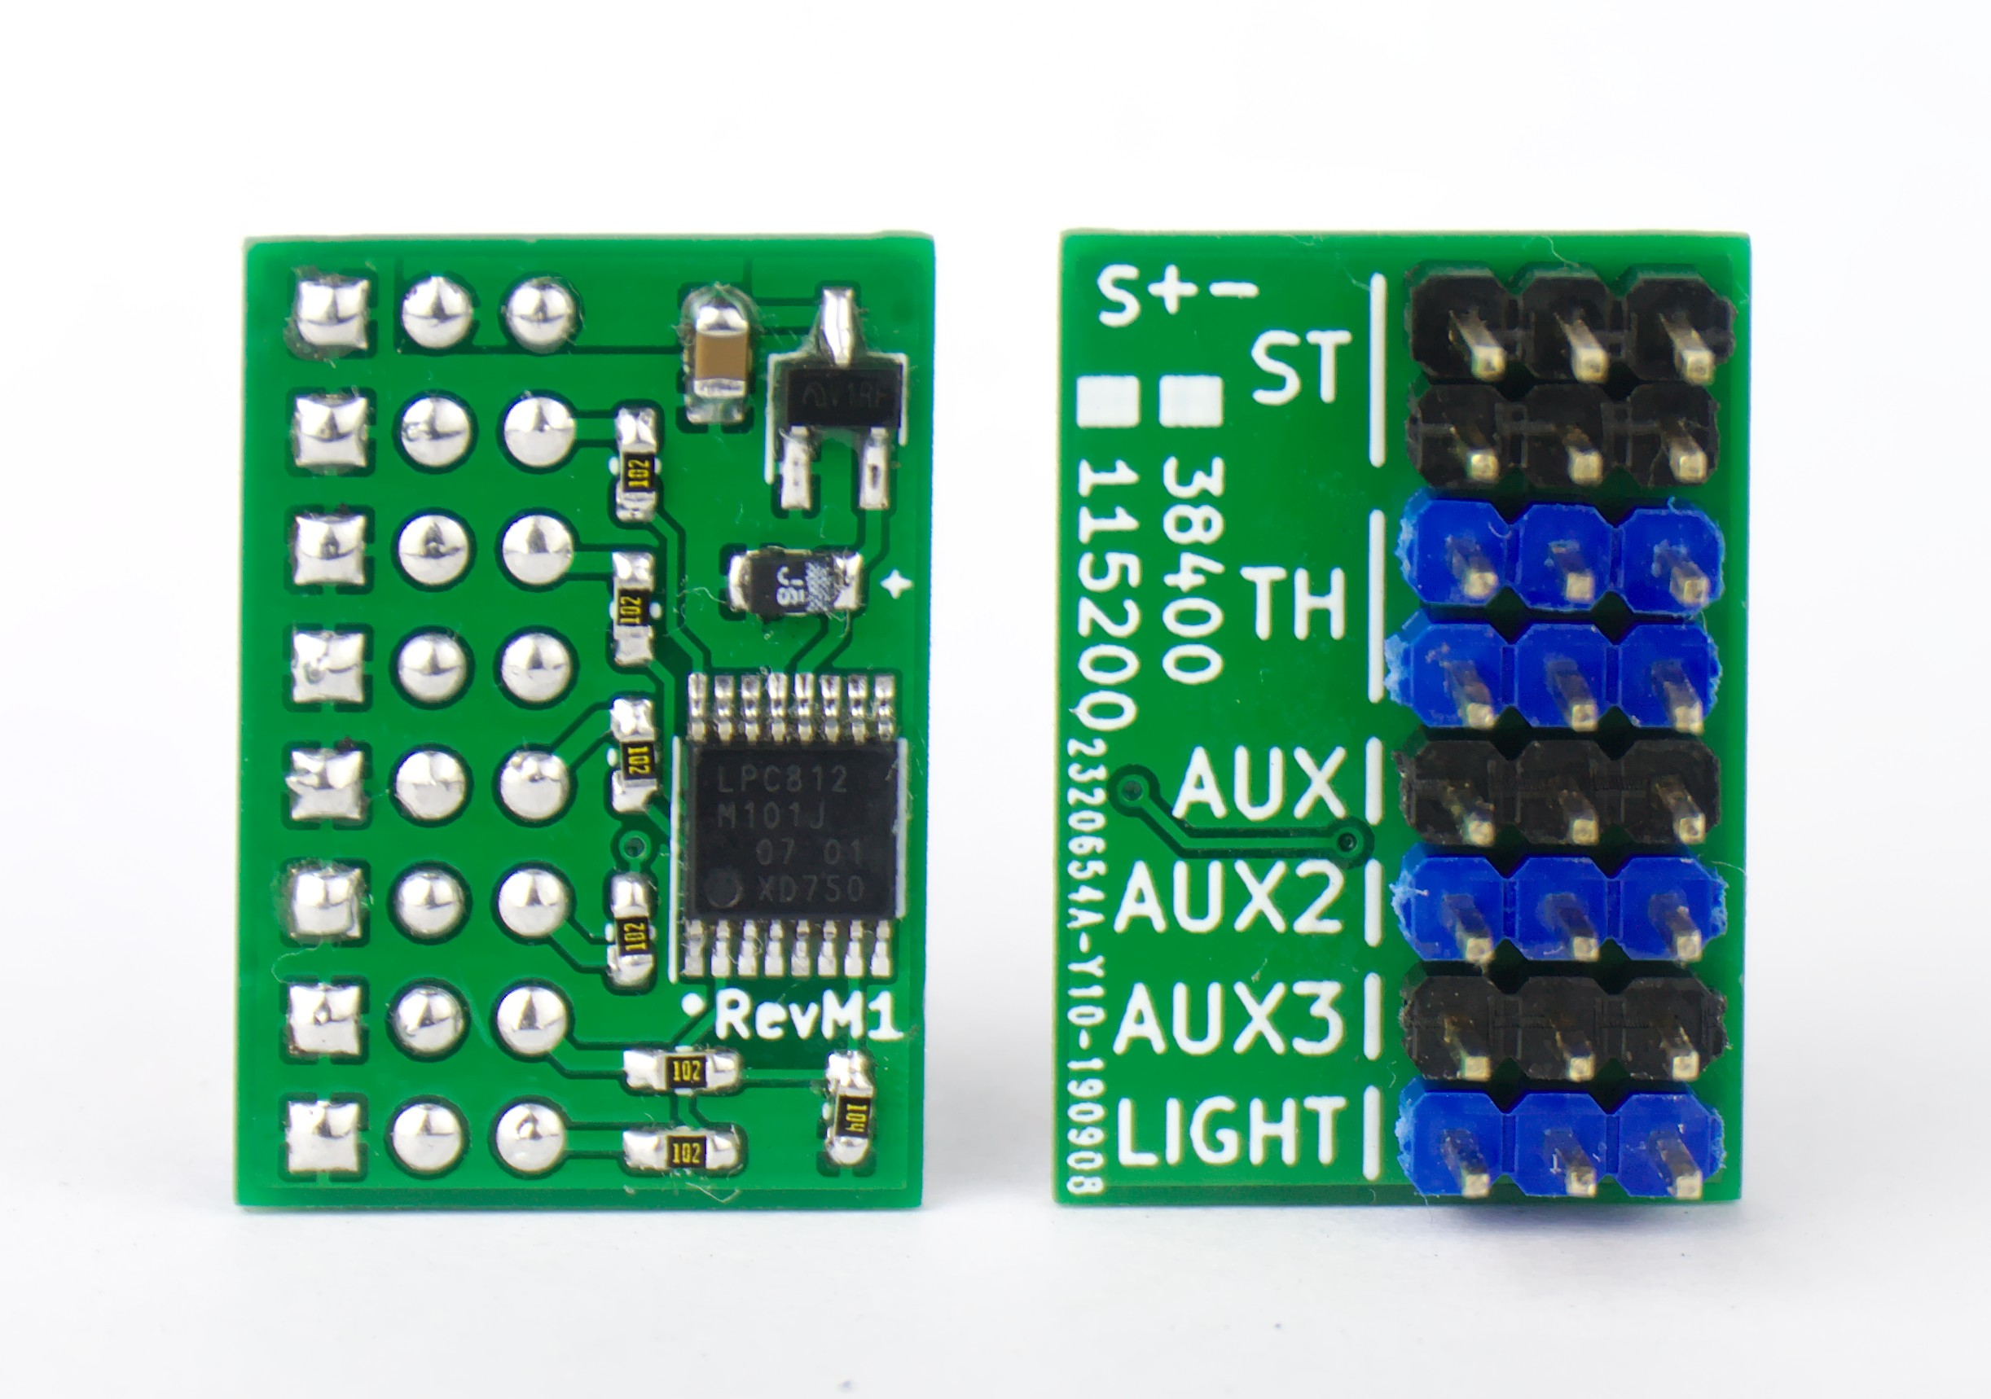5-channel Pre-processor

It is also possible to add a small micro-controller that performs the 3-channel Pre-processor function directly into a receiver:
http://laneboysrc.blogspot.com/2012/12/pre-processor-for-diy-rc-light.html
http://laneboysrc.blogspot.com/2013/01/pre-processor-miniaturization.html
However, this method is only suitable for electronic experts.

Using a push-button installed in the car to switch functions
If you have a two-channel RC transmitter or don’t have a spare channel to control the light functions, then you can alternatively hook up a push-button to the CH3 input directly to the light controller. You can hide the push-button somewhere in the car and access it when needed.
The push-button needs to connect the CH3 input of the light controller to – (Receiver supply minus; GND) when pushed, as shown in the diagram below.
Note that you must enable the Push button on the light controller setting in the Configurator tool described later in this document to enable this function.
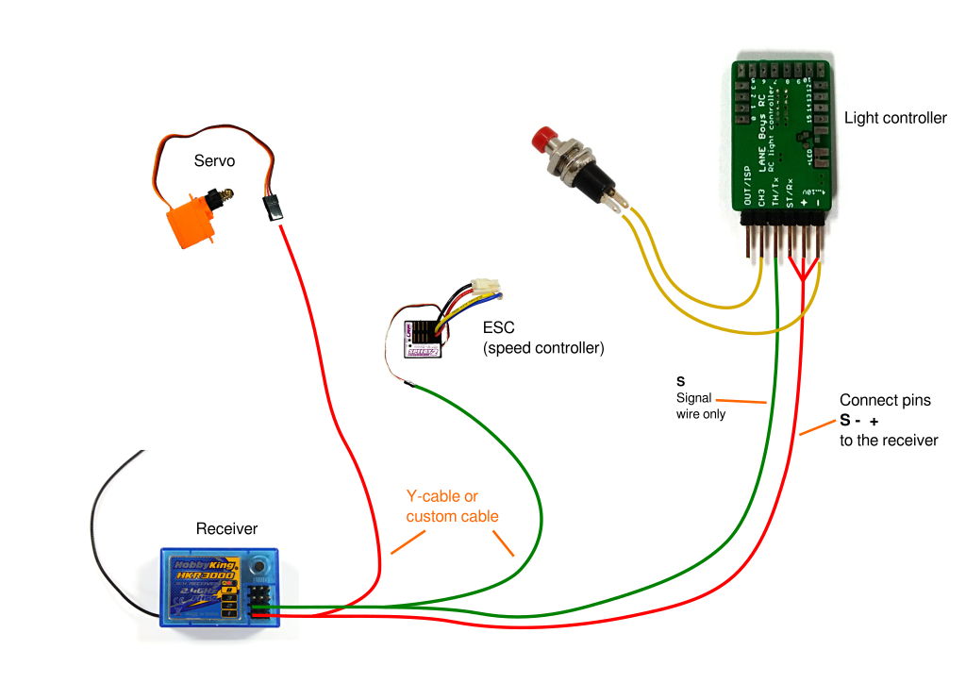

Light Controller outputs
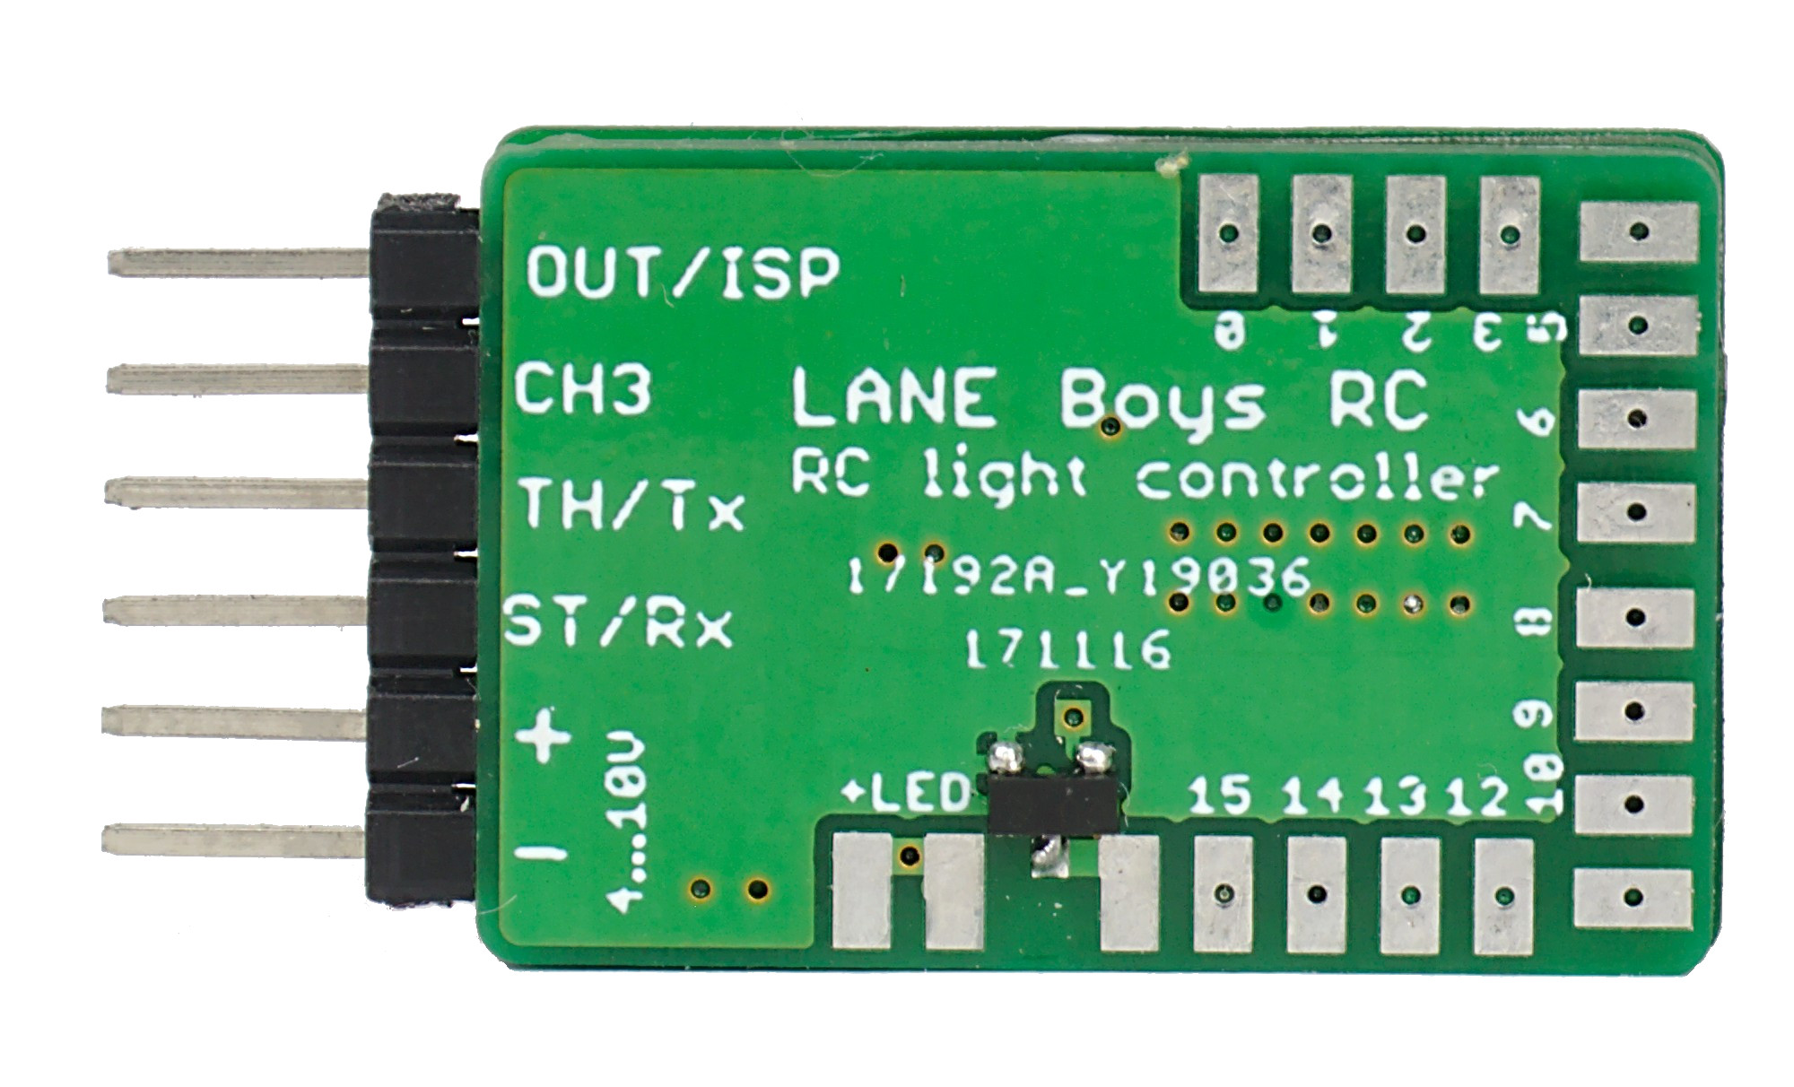

The table below shows how the outputs are configured by default.
Note that all outputs can be fully customized, refer to a later section in this document on how to adapt the light functions to your vehicle.

Name | Function | Description
+ | Positive power supply | +4..10V input voltage, usually taken from the receiver (red wire)
- | Negative power supply (GND) | Supply ground (brown or black wire)
ST/Rx | Steering input | Steering servo signal from the receiver
TH/Tx | Throttle input | Throttle (ESC) signal from the receiver
CH3 | CH3/AUX input | Channel 3 (AUX) signal from the receiver
OUT/ISP | Output | Output to drive a servo or connect a slave controller. The output function can be configured via the configurator.html browser based tool, see below.
+LED | LED supply | Terminal to connect the (+) Anode of the LEDs. Wired internally to the “+” positive power supply connection.
0 | Light output 0 | Parking/Position light front left
1 | … | Parking/Position light front right
2 | … | Main beam front left
3 | … | Main beam front right
4 | … | High beam front left
5 | … | High beam front right
6 | … | Indicator front left
7 | … | Indicator front right
8 | … | Tail/Brake light rear left
9 | … | Tail/Brake light rear right
10 | … | Reversing light rear left
11 | … | Reversing light rear right
12 | … | Indicator rear left
13 | … | Indicator rear right
14 | … | 3rd brake light rear
15 | Light output 15 | Roof light
15S | Switched light output  (left of light output 15) | Carries the same signal as light output 15, but instead of current-controlled it is switched towards Ground (-). Up to 2A of current can be switched....

Connecting LEDs
The (+) Anode (usually the long pin) connections of all LEDs are connected together to the terminals +LED. For soldering convenience there are two terminals that carry +LED.

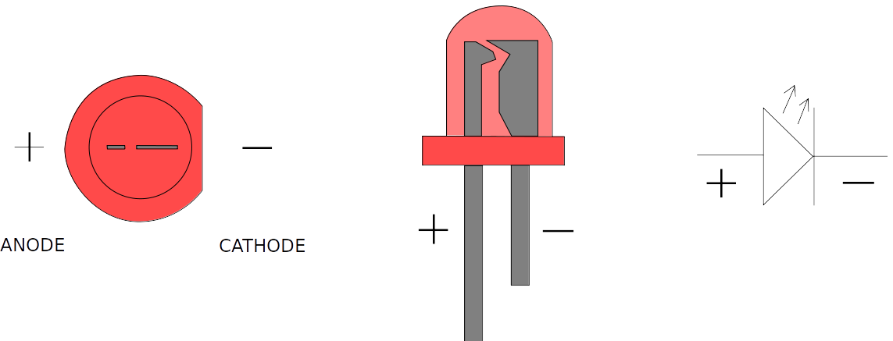
Each light output is designed to drive a single LED. The outputs are driven with a constant current of up to 20mA for optimal LED performance and uniform brightness.

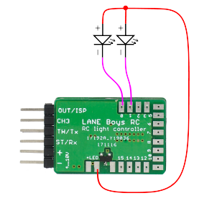

Do not connect a resistor in line with the LED, it is not necessary for this light controller!

Depending on the power supply voltage and the LED's forward voltage, it is possible to drive two LEDs in series on a single light output:

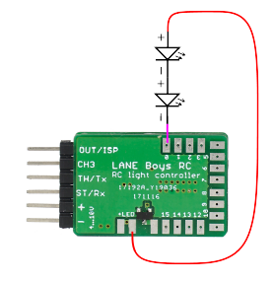
The LED forward voltage depends on the color of the LED. Red and Amber LEDs have a forward voltage of about 1.8V; green LEDs about 2.2V; white LEDs about 3.2V; blue LEDs may require up to 3.6V.
The light controller itself requires at least 0.8 V to be able to control the current.
Usually the light controller is powered from the BEC in the car, which outputs 5V or 6V.

Example: Two red LEDs are wired in series, so the voltage drop across them is 1.8V times 2 = 3.6V. The BEC voltage is 5V. 5V – 3.6V = 1.4V, which is more than the 0.8V that the light controller requires for proper operation, so everything works fine.

Example 2: A white and a blue LED wired in series. The voltage drop across both LEDs is 3.2V + 3.6V = 6.8V. The BEC voltage is 6V, so it is not high enough to drive those LEDs. However, it is possible to power the light controller from the 2S LiPo car battery. A fully charged LiPo is 8.4V. 8.4V – 6.8V = 1.6V, which is more than the 0.8V required by the light controller. As the LiPo discharges and voltage drops below 6.8V + 0.8V = 7.6V, the LEDs will be not driven properly anymore and may become dim.

Note: when powering the light controller directly from a 2S LiPo precautions have to be taken to ensure that the installation is safe against short circuits, as the energy stored in a battery can easily cause fire. Furthermore, the power dissipated in the light controller increases if the input voltage increases. The light controller may become too hot and malfunction.

High current output
Beside the 16 light outputs, there is also a high current capable switched light output. It is designed to drive an off-the-shelf light bar.

The switched light output is located left of the output 15 and turns on in conjunction with output 15. It can sink up to 2 Ampere in current.

Servo output
The light controller also can drive a small servo in synchronization with the steering input. This is designed to turn the steering wheel in the cabin of a truck. The center, endpoints and direction can be fully programmed (see below).

Note: for safety reasons do not connect the steering servo of your vehicle to this output!

The servo output can also be configured for controlling a 2-speed or 3-speed gearbox. Refer to the configuration tool described in later sections of this document for details.

Operation
After turning the power on, the front main beam LEDs will turn on for about two seconds. During this time ensure that steering and throttle controls on the transmitter are kept in neutral position.
If if the front indicators light up instead of the main beam LEDs, this means that neither of the input channels ST, TH and CH3 receive a proper servo signals from the receiver. Turn off the power and check all connections.
After initialization all lights turn off and the system is ready to use.
It is advisable to let the light controller know the endpoints of steering and throttle before driving off. To do this simply move the steering fully left, then fully right. Hold the car in the air safely and pull the throttle full forward, then full backward – ensuring that the drive train does not get damaged.
When driving, the brake and reverse lights will now come on according to the throttle input. The indicators can be engaged by keeping both steering and throttle neutral for one second, then turning the steering into the direction the indicators should show. Once they are engaged you can start driving off with the indicators operating. They will turn off after a short delay when the car goes straight, or immediately when the car turns in the other direction.
Several functions of the light controller are operated manually through the auxiliary channel CH3. Since there are quite a few functions the concept of “clicks” is employed. Similar to the operation of a computer mouse, one can press the CH3 button on the transmitter repeatedly within a short time to invoke different functions.
One click: Turn on more lights at each click: Parking, Main beam, High beam, Roof lights
Two clicks: Turn the lights down; reverse of one click
Three clicks: toggle all lights on and off
Four clicks: toggle hazard lights (all indicators flash) on and off

Here is a video showing the operation:
https://youtu.be/-VyNAVU3-ok

Basic configuration – Channel reversing
The direction of the steering and throttle channels can be programmed to match the car. To do this, perform seven clicks on channel CH3. The front and rear indicators on one side as well as the front main beam lights will turn on. Move the steering wheel on the transmitter into the direction of the indicators that light up (i.e. if the indicators on the left side of the car light up, turn the steering wheel left). When successful the indicators will turn off.
Now engage the throttle forward. When successful the main lights will turn off, programming channel reversing has finished and the light controller will resume normal operation.
The steering and throttle direction are stored persistently so this configuration has to be carried out only once after installing the light controller.

Basic configuration – Steering wheel servo / Gearbox servo
In case a steering wheel servo is utilized, the center point and end points can be configured independently of the car steering.
To set up the steering wheel servo perform eight clicks on channel CH3. The left indicators will light up and the steering wheel servo will follow directly the steering input on the transmitter. Move the steering wheel on the transmitter to the position that shall be used for full left on the steering wheel servo. Note that this may require that you need to turn the steering wheel on the transmitter right, if the servo is reversed. Don't worry, this is correct and lets the light controller know which way to turn the steering wheel servo. Hold the transmitter steering in position while clicking channel CH3 once.
Now both left and right indicators will turn on. Turn the steering wheel on the transmitter to the position that the steering wheel servo is centered and click channel CH3 once. Now the right indicators will turn on. Perform the same procedure as for the left end point and click channel CH3 once.
The center and end points should now be correct, the steering wheel should follow in the same way as the car. The settings are stored persistently and are not affected by steering trims and endpoint adjustments.
Note that after changing endpoints or trim on your RC transmitter you need to restart the light controller so that it learns the new settings.

Configurator: Custom configuration of light functions
The light controller can be configured through a web browser.
To get started, download
https://github.com/laneboysrc/rc-light-controller/blob/master/mk4-tlc5940-lpc812/mk4-download-me.zip?raw=true
This archive contains the configuration tool configurator.html. Open this file in your web browser (tested with Firefox, Chrome and Internet Explorer 10).
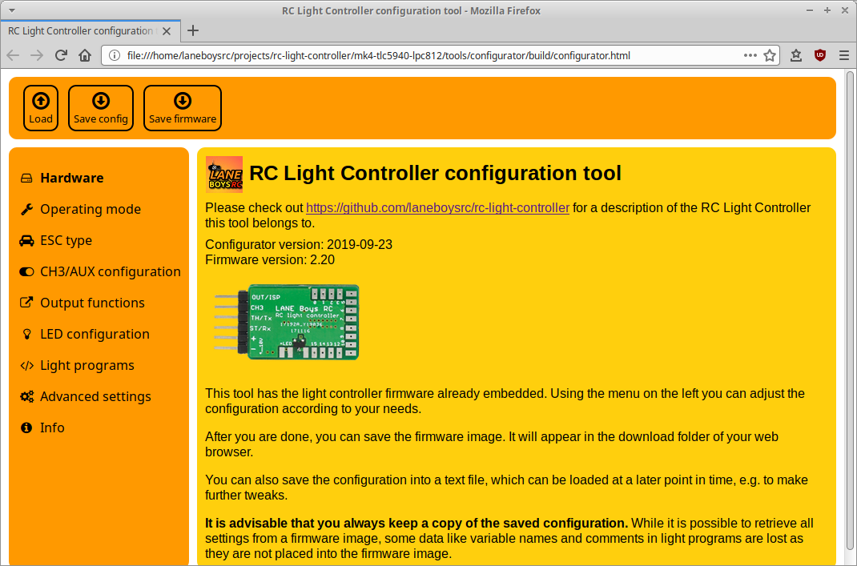
lternatively you can access the latest version of the tool on-line at http://laneboysrc.github.io/rc-light-controller/
configurator.html has the firmware already embedded, just set the options you want and click on the Save firmware image... button. A file named light_controller.hex will be stored in the Download folder of your web browser.
You can now use the LPC81x-ISP tool included in mk4-download-me.zip archive to flash the firmware. You need a USB-to-serial adapter to connect your PC to the light controller.
Wire-up the USB-to-serial adapter as follows:
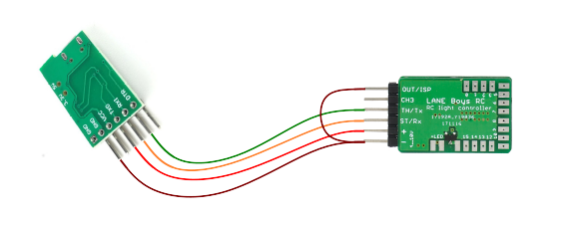
Note: Connect the light controller to the USB-to-serial adapter before plugging the USB-to-serial adapter into the PC. This is necessary as OUT/ISP pin must be connected to (-) GND while power-on to allow the light controller to enter the Flash function.
Start the LPC81x-ISP tool, click on the Select file… button and load the light_controller.hex file that you saved in the download folder earlier.

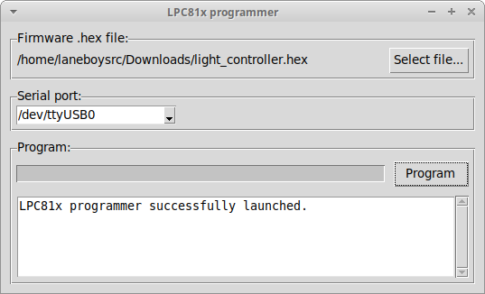
Click the Program button to start the flashing of the new firmware containing your custom configuration.

Technical data
Operating voltage: 4 V .. 10 V (receiver voltage up to 2S LiPo directly)
Constant current outputs: 20 mA per LED output
Dimming: constant current in 63 steps (DC, no PWM)
LED configuration: common Anode (common plus pole, minus pole goes to individual outputs of the light controller)
Dimensions:
Light Controller: 36 x 18 x 3 mm
Pre-processor: 17 x 17 mm
5-channel Pre-processor: 24 x 17 mm

Have fun with RC! Werner

laneboysrc@gmail.com

https://laneboysrc.blogspot.com/
https://www.youtube.com/user/laneboysrc
https://www.flickr.com/photos/78037110@N03/albums/
https://github.com/laneboysrc/rc-light-controller/

