RC Light Controller

Instructions for use
for the MK4 TLC5940 LPC812 variant



Introduction
Thanks for using the LANE Boys RC light controller!

The light controller supports the following features:

- 16 LED outputs, constant-current driven for optimal LED performance. Two light controllers can be cascaded for a total of 32 LED outputs.
- High current switched output of up to 2A to drive a roof light bar
- Parking, Low-beam, High-beam and a roof light bar can be switched on/off manually using CH3/AUX
- Brake and Reverse lights are automatically controlled by monitoring the throttle channel. The brake lights now automatically turn on for a short, random time when the throttle goes to neutral.
- Combined tail and brake light function in a single LED through controlling the brightness of the LED.
- Separate brake light function for a 3rd brake light
- Indicators only come on when you want to. You have to stay in neutral for one seconds, then hold the steering left/right for one second before they engage. This way normal driving does not trigger the indicators.
- Hazard lights can be switched on/off using CH3
- Programmable output designed to drive a steering wheel or a figures head, a gearbox servo or a winch
- Automatic center and end-point adjustment for all channels
- All functions can be customized through a web browser

Connecting the light controller to your RC car
The light controller is powered from the receiver power supply in the car. The input signals of channels ST/Rx, TH/Tx and CH3 need to connected to the steering, throttle and auxiliary channels of your receiver. For steering and throttle you will need to utilize a Y-cable. Only one of the channel cables needs to provide power to the light controller, for the other channels it is sufficient to use the signal cable only (usually orange or white in color).

The following table shows the connections on the light controller:

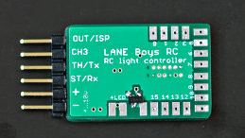

Note: the table shows the default configuration of the firmware. All light outputs are fully customizable, so if your controller has a custom configuration loaded its output configuration may be different.

Name | Function | Description
+ | Positive power supply | +4..10V input voltage, usually taken from the receiver (red wire)
- | Negative power supply (GND) | Supply ground (brown or black wire)
ST/Rx | Steering input | Steering servo signal from the receiver
TH/Tx | Throttle input | Throttle (ESC) signal from the receiver
CH3 | CH3/AUX input | Channel 3 (AUX) signal from the receiver
OUT/ISP | Output | Output to drive a servo or connect a slave controller. The output function can be configured via the configurator.html browser based tool, see below.
+LED | LED supply | Terminal to connect the (+) Anode of the LEDs. Wired internally to the “+” positive power supply connection.
0 | Light output 0 | Parking/Position light front left
1 | … | Parking/Position light front right
2 | … | Main beam front left
3 | … | Main beam front right
4 | … | High beam front left
5 | … | High beam front right
6 | … | Indicator front left
7 | … | Indicator front right
8 | … | Tail/Brake light rear left
9 | … | Tail/Brake light rear right
10 | … | Reversing light rear left
11 | … | Reversing light rear right
12 | … | Indicator rear left
13 | … | Indicator rear right
14 | … | 3rd brake light rear
15 | Light output 15 | Roof light
(left of light output 15) | Switched light output | Carries the same signal as light output 15, but instead of current-controlled it is switched towards Ground (-). Up to 2A of current can be switched....

Connecting LEDs
The (+) Anode (usually the long pin) connections of all LEDs are connected together to the terminals +LED. For soldering convenience there are two terminals that carry +LED.

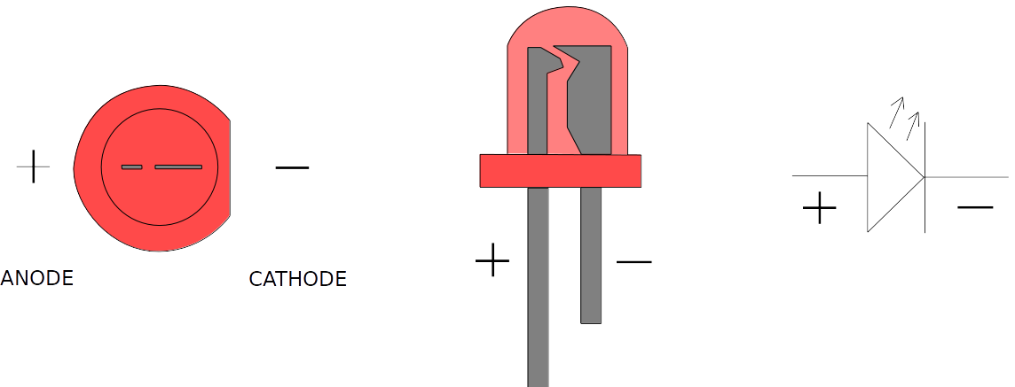

Each light output is designed to drive a single LED. The outputs are driven with a constant current of up to 20mA for optimal LED performance and uniform brightness.

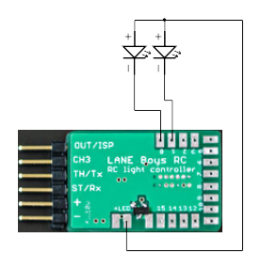

Do not connect a resistor in line with the LEDs, it is not necessary for this light controller!

Depending on the power supply voltage used for the LEDs and the LED's forward voltage, it is possible to drive two LEDs in series on a single light output:

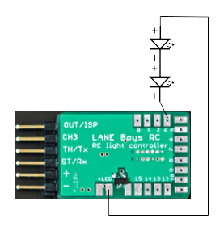
The LED forward voltage depends on the color of the LED. Red and Amber LEDs have a forward voltage of about 1.8V; green LEDs about 2.2V; white LEDs about 3.2V; blue LEDs may require up to 3.6V.
The light controller itself requires at least 0.8 V to be able to control the current.
Usually the light controller is powered from the BEC in the car, which outputs 5V or 6V.

Example: Two red LEDs are wired in series, so the voltage drop across them is 1.8V times 2 = 3.6V. The BEC voltage is 5V. 5V – 3.6V = 1.4V, which is more than the 0.8V that the light controller requires for proper operation, so everything works fine.

Example 2: A white and a blue LED wired in series. The voltage drop across both LEDs is 3.2V + 3.6V = 6.8V. The BEC voltage is 6V, so it is not high enough to drive those LEDs. However, it is possible to power the light controller from the 2S LiPo car battery. A fully charged LiPo is 8.4V. 8.4V – 6.8V = 1.6V, which is more than the 0.8V required by the light controller. As the LiPo discharges and voltage drops below 6.8V + 0.8V = 7.6V, the LEDs will be not driven properly anymore and may become dim.

Note: when powering the light controller directly from a 2S LiPo precautions have to be taken to ensure that the installation is safe against short circuits, as the energy stored in a battery can easily cause fire. Furthermore, the power dissipated in the light controller increases if the input voltage increases. The light controller may become too hot and malfunction.

High current output
Beside the 16 light outputs there is also a high current capable switched light output. It is designed to drive a standard light bar with several LEDs plus respective current limiting resistors connected in parallel. The switched light output is located left of the output 15 and turns on in conjunction with output 15. It can sink up to 2A in current.

Servo output
The light controller also can drive a small servo in synchronization with the steering input. This is designed to turn the steering wheel in the cabin of a truck. The center, endpoints and direction can be fully programmed (see below).

Note: for safety reasons do not connect the steering servo of your vehicle to this output!

The servo output can also be configured for a 2-speed or 3-speed gearbox. Refer to the configuration tool (see below) for details.

Operation
After turning the power on, the front main beam LEDs will turn on for about two seconds. During this time ensure that steering and throttle are kept in neutral position on the transmitter.
If instead of the main beam lights the front indicators light up, this means that neither of the input channels CH1, CH2 and CH3 receives a proper signals from the receiver. Turn the power off and check all connections.
After initializations all lights turn off and the system is ready to use.
It is advisable to let the light controller know the endpoints of steering and throttle before driving off. To do this simply move the steering fully left, then fully right. Hold the car in the air safely and pull the throttle full forward, then full backward – ensuring that the drive train does not get damaged.
When driving, the brake and reverse lights will now come on according to the throttle input. The indicators can be engaged by keeping both steering and throttle neutral for one second, then turning the steering into the direction the indicators should show. Once they are engaged you can start driving off with the indicators operating. They will turn off after a short delay when the car goes straight, or immediately when the car turns in the other direction.
Several functions of the light controller are operated manually through the auxiliary channel CH3. Since there are quite a few functions the concept of “clicks” is employed. Similar to the operation of a computer mouse, one can press the CH3 button on the transmitter repeatedly within a short time to invoke different functions.
One click: Turn on more lights at each click: Parking, Main beam, High beam, Roof lights
Two clicks: Turn the lights down; reverse of one click
Three clicks: toggle all lights on and off
Four clicks: toggle hazard lights (all indicators flash) on and off

Here are two videos showing the operation:
http://youtu.be/ljf41gerEWU
http://www.youtube.com/watch?v=96EBejcPZ_Y

Basic configuration
The direction of the steering and throttle channels can be programmed to match the car. To do this, perform seven clicks on channel CH3. The front and rear indicators on one side as well as the front main beam lights will turn on. Move the steering wheel on the transmitter into the direction of the indicators that light up (i.e. if the indicators on the left side of the car light up, turn the steering wheel left). When successful the indicators will turn off.
Now engage the throttle forward. When successful the main lights will turn off, programming channel reversing has finished and the light controller will resume normal operation.
The steering and throttle direction are stored persistently so this configuration has to be carried out only once after installing the light controller.

In case a steering wheel servo is utilized, the center point and end points can be configured independently of the car steering.
To set up the steering wheel servo perform eight clicks on channel CH3. Both left and right indicators will turn on and the steering wheel servo will follow directly the steering input on the transmitter. Turn the steering wheel on the transmitter to the position that the steering wheel servo is centered and click channel CH3 once. Now the left indicators will light up. Move the steering wheel on the transmitter to the position that shall be used for full left on the steering wheel servo. Note that this may require that you need to turn the steering wheel on the transmitter right, if the servo is reversed. Don't worry, this is correct and lets the light controller know which way to turn the steering wheel servo. Hold the transmitter steering in position while clicking channel CH3 once. Now the right indicators will turn on. Perform the same procedure as for the left end point and click channel CH3 once.
The center and end points should now be correct, the steering wheel should follow in the same way as the car. The settings are stored persistently and are not affected by steering trims and endpoint adjustments. After changing endpoints and trim you need to restart the light controller though so that it learns the new settings.

Custom configuration of light functions
The MK4 TLC5940 LPC812 can be configured through a web browser.

To get started, download
https://github.com/laneboysrc/rc-light-controller/blob/master/mk4-tlc5940-lpc812/mk4-download-me.zip?raw=true
This archive contains the configuration tool configurator.html. Open this file in your web browser (tested with Firefox, Chrome and Internet Explorer 10).
configurator.html has the firmware already embedded, just set the options you want and click on the Save firmware image... button.
The configured firmware image light-controller.hex will be stored in the Download folder of your web browser.

Use the LPC81x-ISP tool included in the downloaded archive to flash the firmware. You need a USB-to-serial adapter to connect your PC to the light controller.
Wire-up the USB-to-serial adapter as follows:
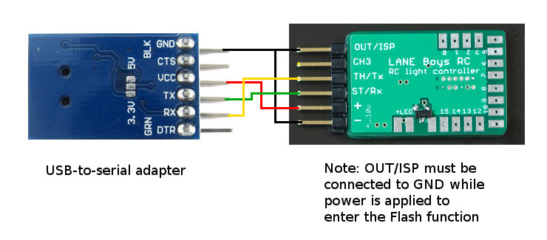

Technical data
Operating voltage: 4V – 10V (receiver voltage up to 2S LiPo directly)
Constant current outputs: 20mA per LED output
Dimming: constant current in 63 steps (i.e. PWM is not utilized)
LED configuration: common Anode (i.e. common plus pole, minus pole goes to individual outputs of the light controller)

Have fun with RC! Werner

laneboysrc@gmail.com

https://laneboysrc.blogspot.com/
https://www.youtube.com/user/laneboysrc
https://www.flickr.com/photos/78037110@N03/albums/
https://github.com/laneboysrc/rc-light-controller/

