The following problem statement is from Kattis and can be found at:
https://open.kattis.com/problems/weakvertices

Weak Vertices
Engineers like to use triangles. It probably has something to do with how a triangle can provide a lot of structural strength. We can describe the physical structure of some designs using an undirected graph. We’ll say vertex I is part of a triangle if i has two different neighbors j and k such that j and k are neighbors of each other. For this problem, find weak vertices in graphs – those vertices that is not part of any triangle.
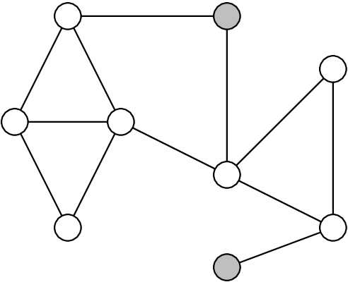
Figure 1: An illustration of the weak vertices (which are shaded) from the sample input graph.

Input
Input consists of up to 100 graphs. Each starts with an integer, 1≤n≤20, giving the number of vertices in the graph. Next come n lines with n integers on each line, which describe an n×n adjacency matrix for the graph. Vertices are numbered from 0 to n−1. If the adjacency matrix contains a one at row r, column c (where 0≤r,c≤n−1), it means that there is an edge from vertex r to vertex c. Since the graph is undirected, the adjacency matrix is symmetric. The end of input is marked by a value of −1 for n.

Output
For each graph, produce a line listing the weak vertices ordered from least to greatest.
Sample Input 1 | Sample Output 1
9  0 1 1 1 0 0 0 0 0  1 0 0 0 0 0 1 0 0  1 0 0 1 0 1 0 0 0  1 0 1 0 0 1 1 0 0  0 0 0 0 0 0 1 1 0  0 0 1 1 0 0 0 0 0  0 1 0 1 1 0 0 1 0  0 0 0 0 1 0 1 0 1  0 0 0 0 0 0 0 1 0  1  0  -1 | 1 8  0

