The following problem statement is from Kattis and can be found at:
https://open.kattis.com/problems/quadrant

Quadrant Selection
A common problem in mathematics is to determine which quadrant a given point lies in. There are four quadrants, numbered from 1 to 4, as shown in the diagram below:
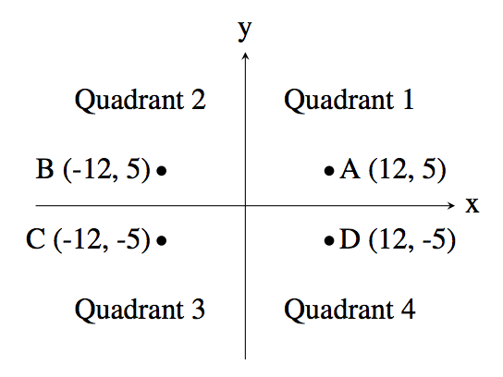
For example, the point A, which is at coordinates (12,5) lies in quadrant 1 since both its x and y values are positive, and point B lies in quadrant 2 since its x value is negative and its y value is positive.
Your job is to take a point and determine the quadrant it is in. You can assume that neither of the two coordinates will be 0.

Input
The first line of input contains the integer x (−1000≤x≤1000;x≠0). The second line of input contains the integer y (−1000≤y≤1000;y≠0).

Output
Output the quadrant number (1, 2, 3 or 4) for the point (x,y).
Sample Input 1 | Sample Output 1
10  6 | 1

Sample Input 2 | Sample Output 2
9  -13 | 4

