Kaden Lizama
Gerald Oden
Module 11 – Milestone #3
CSD 310
To help make the business decisions listed in the Willson Financial case study, we created three key business reports. To display data more concisely on screen, we have also elected to install pandas via pip using the command: pip install pandas
Monthly New Clients: This report will show how many clients have been added for each of the past six months. This helps to understand the growth of the client base over time.
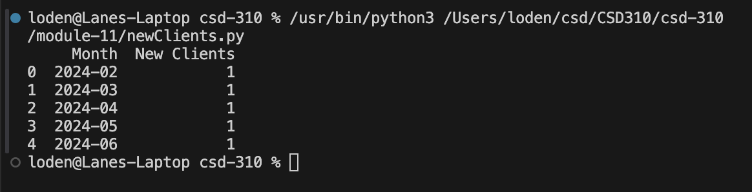
Average Assets Report: This report will provide the average amount of assets for the entire client list. As our business grows, we should expect the average assets to grow with us.
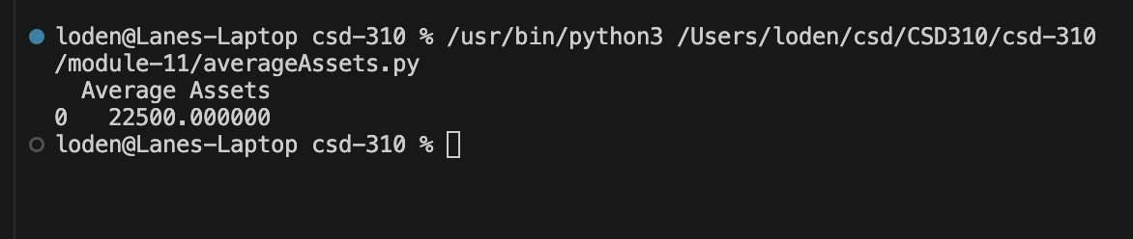
High Transaction Clients Report: Because our most active clients currently only have 3 transactions in a given month, this report will help us identify and understand our clients who have more than 2 transactions in a month. As our business grows, we can extend this to 5, 10, or more transactions to scale the value of the report.
