Gerald Oden
Module 7.2
CSD 310

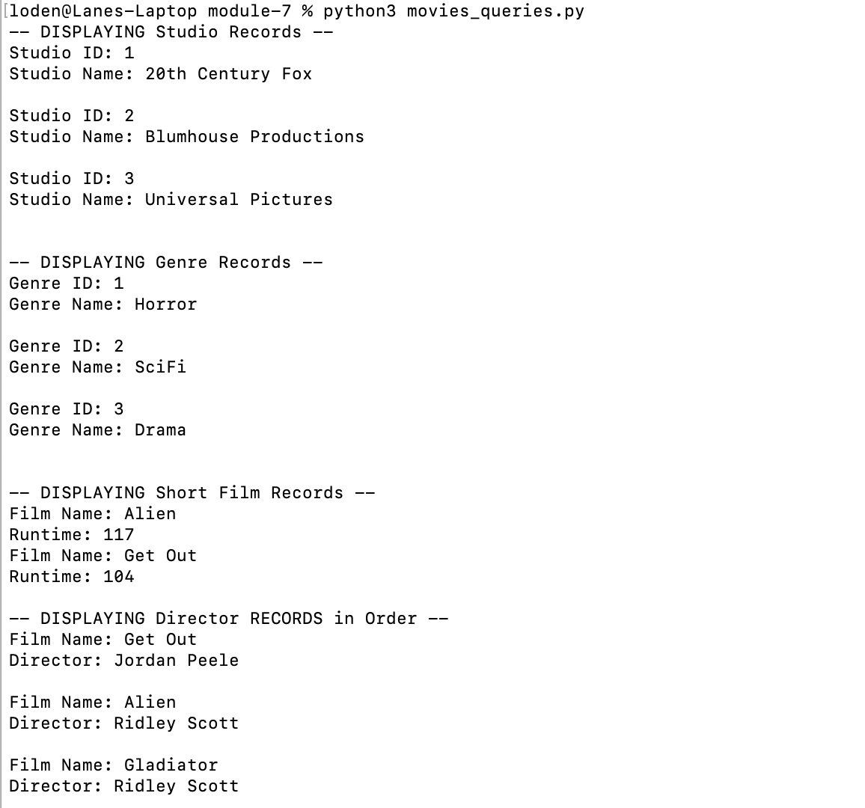
https://github.com/laneoden/csd-310

