Gerald Oden
Module 8.2
CSD310
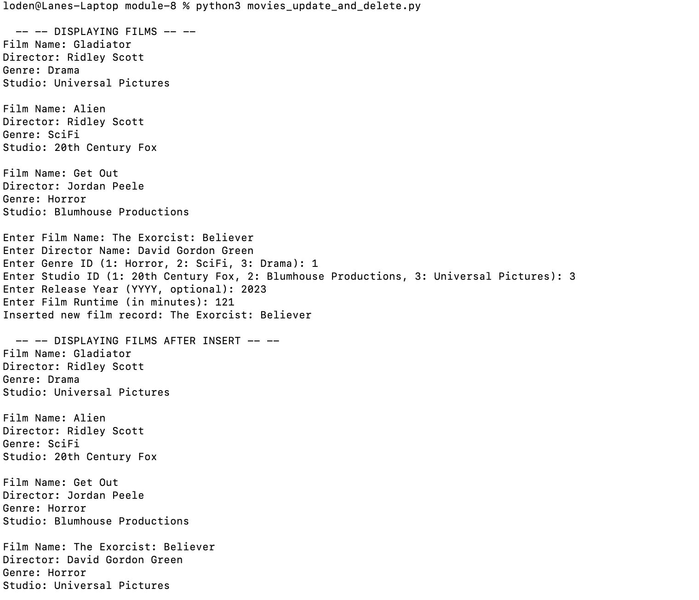
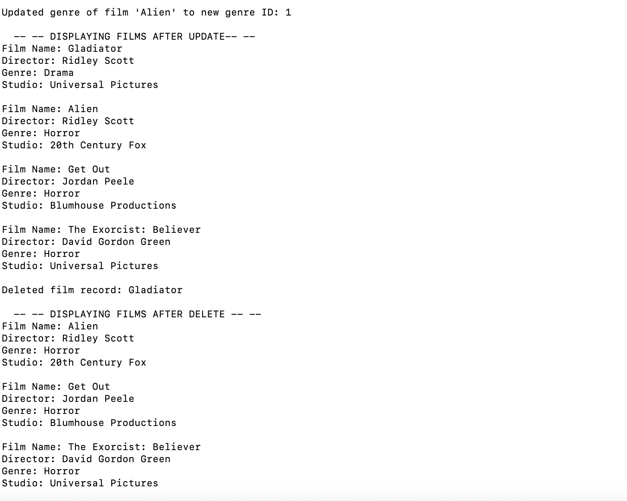
https://github.com/laneoden/csd-310

