Brewster Automated Cocktail Machine

Lane Williams, CE

Madison Schumate, EE

Josh Herndon, EE

Texas Tech University

May 2022

Abstract

This paper provides the technical description of the Brewster automatic cocktail dispenser that uses an intuitive, touch screen interface to allow the user to select which available cocktail will dispense based on the current ingredients. Once a drink is selected by a user, the liquids, controlled via solenoid valves, will be individually gravity fed into a cup to create the perfect cocktail. The hardware and software used is described, along with the data recorded throughout the design and development.

Table of Contents

List of Figures…………………………………………………………………………………..…3

1. Introduction…………………………………………………………………………………..…4

2. Software Design………………………………………………………………………………...5

2.1 User Interface……….……………………………………………………………..…..5

2.2 GPIO Code…………………………………………………………………………….6

2.3 Python Communication……………………………………………………………….7

3. Hardware Components…………………………………………………………………...…..…9

3.1 Raspberry Pi………………………………………………………………………..….9

3.2 Cooling System…………………………………………………………………..……8

3.3 Solenoid Valve……………………………………………………………………….10

3.4 Raspberry Pi Touch Screen…………………………………………………………..10

3.5 Relay Circuit…………………………………………………………………………11

3.6 Housing………………………………………………………………………………12

3.7 Power Supply………………………………………………………………………...13

3.8 Weight Sensor………………………………………………………………………..14

3.9 Air Flow / Filtration………………………………………………………………….16

4. Final Build……………..……………………………………………………………...............16

5. Conclusion………………………………………………………………………….................17

Acknowledgements…………………………………………………………………………...…18

Appendix A - References………………………………..……….…………...……………….19

Appendix B - Safety..…………………….…………………….………………...……………20

Appendix C - Data……………………………………………………………………...……...21

List of Figures

Figure 1: Flowchart.………………………………………………………………………………5

Figure 2: Drink Selection Window…………………………….………………………….…..….6

Figure 3: Liquid Level Window………………………….……………………………………….7

Figure 4: Xojo Drink Code…………………………………………………………………….….8

Figure 5: Raspberry Pi 3b……………..………………………………………..............................9

Figure 6: Solenoid Valves…..…………………………………………………….…………...…10

Figure 7: 7” Touch Screen Display………………………………………………………….…...11

Figure 8: Relay Circuit…………….……………………………….…….……….……..............12

Figure 9: Housing ………...……………………………………..…………………………..…..13

Figure 10: 12 V Power Supply…...…………………………………………..………………….14

Figure 11: Load Cell……………………………………………………………………………..15

Figure 12: Air Flow / Filtration………………………………………………………..………...16

Figure 13: Final Build………………………………………………………………..…………..17

1. Introduction

The purpose of this system is to create the perfect cocktail at the touch of a button. Using the simplest form of liquid dispensation, gravity, solenoid valves controlled by relays will open and close, allowing the exact amount of liquid to be dispensed. The system uses store bought liquor and mixer bottles so users can use their preferred brands and types. A barbed bottle cap connects to each bottle and travels through food grade tubing to a solenoid valve. Once a drink is selected from the application on a Raspberry Pi touch screen, each liquid will sequentially pour in the correct amount. While each liquid is being dispensed, a weight sensor under the cup records changes and updates the level of the liquids on a menu in the application. This allows users to get a heads up when a specific liquid might need replacing. The system is housed in a clear acrylic container that securely holds all of the components while allowing users to view internal workings of the system. This system has the potential to be used anywhere from common households to commercial bars and venues. Future variations could implement the necessary security and dispensing measures to allow use in commercial situations.

2: Software Design

The system is coded using a combination of Xojo and Python. Xojo is a cross-platform IDE that allows intuitive drag and drop placement for the majority of visual components. Xojo also offers support for Raspberry Pi GPIO that is used to communicate with a running python script that detects weight values and controls the solenoid valves. Though Xojo uses a proprietary object-oriented based language, they have a help community. The project flowchart can be seen in Figure 1 below [1].

Figure 1: Flowchart [1]

2.1 User Interface

The user interface is a Xojo application that runs on a Raspberry Pi touch screen. Once the program is initiated, the user will have the option to select a cocktail. Each cocktail listed will have an information icon that, when clicked, displays a detailed description of the drink. Once the user has selected their cocktail of choice, this will send activate a GPIO pin on the Raspberry Pi that is read by the Python script. When the Xojo GPIO pin is detected, the valves sequentially activate Raspberry Pi GPIO ports that will activate different relay switches which control the solenoid valves. While this is taking place, an indeterminate progress bar is displayed on the screen indicating the dispensing progress is taking place. The current main drink selection window is shown in Figured 2 below.

Figure 2: Drink Selection Window

2.2 GPIO Code

The GPIO code allows communication between the Raspberry Pi and the external hardware components. For this system, the main purpose of the GPIO is to activate a series of relays that, once switched, allow the proper voltage to activate the solenoid valves. A clock will control the timing of these intermittent GPIO activations to allow the correct amount of each liquid to dispense sequentially. The second use of GPIO for this system is for the weight sensor. The weight sensor sends data back to the Pi, which the code manipulates into usable weight data. This data is used to determine the liquid levels of each ingredient. When each liquid is done dispensing, a measurement is taken, which deducts the amount of liquid from the overall. The liquid level window can be seen in Figure 3 below.

Figure 3: Liquid Level Window

2.2 Python Communication

A python script that runs in the background houses the code for drink dispensing as well as weight sensing. Whenever a user selects a cocktail, a signal is sent to the Raspberry Pi which is read by the Python script and runs through the code process to activate the solenoids necessary to make the drink. The Python script also reads data from the weight sensor and calculates the empty cups tare value before dispensing. As the drink is being dispensed, the code continuously detects the increasing weight and uses this information to cut off the solenoid valves of each liquid when they have reached their amount. When an entire drink has finished dispensing, the Python script activates a different GPIO pin that is ready by the Xojo application. When this happens, the app shows a new window displaying that the drink has been successfully made. The Xojo code that runs when a drink is selected can be seen in Figure 4 below.

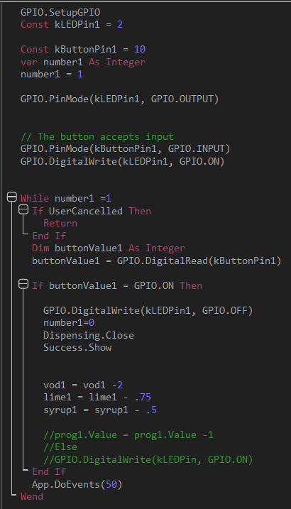

Figure 4: Xojo Drink Code

3 Hardware Components

The system uses nine main pieces of hardware in order to successfully render a functional automatic cocktail dispenser. These pieces of hardware are discussed in detail below.

3.1 Raspberry Pi

The system uses one Raspberry Pi 3b microprocessor. This is used to run the application as well as communicate between the relays and weight sensor. This Pi is connected to a 7 inch touch screen that conveniently shows the application. The Pi resides securely inside the main structure. The Raspberry Pi 4b along with its pin diagram can be seen in Figure 3 below [2].

Figure 5: Raspberry Pi 3b [2]

3.3 Solenoid Valve

The next piece of hardware is a set of six 12 V solenoid valves. These valves are activated by a Raspberry Pi controlled relay circuit that allows for precision liquid dispensation for each ingredient. These solenoid valves are normally closed valves that activate with a 12 V signal. Each solenoid valve is rated for 12 V, 4.8 W, and up to 0.5 MPa. A flyback diode is connected in parallel to eliminate damage from voltage spikes resulting from an inductive load. The solenoid valves can be seen in Figure 6 below [4].

Figure 6: Solenoid Valves [4]

3.4 Raspberry Pi Touch Screen

The next piece of hardware is a 7” touch screen display that is specifically made for Raspberry Pi. The purpose of the display is to allow the user to operate the application and see the displayed updates. The display has a full color display and a resolution of 800 x 480, and only requires two pins connected to the Raspberry Pi to function. The 7” touch screen display can be seen connected to the Raspberry Pi 3b in Figure 17 below [5].

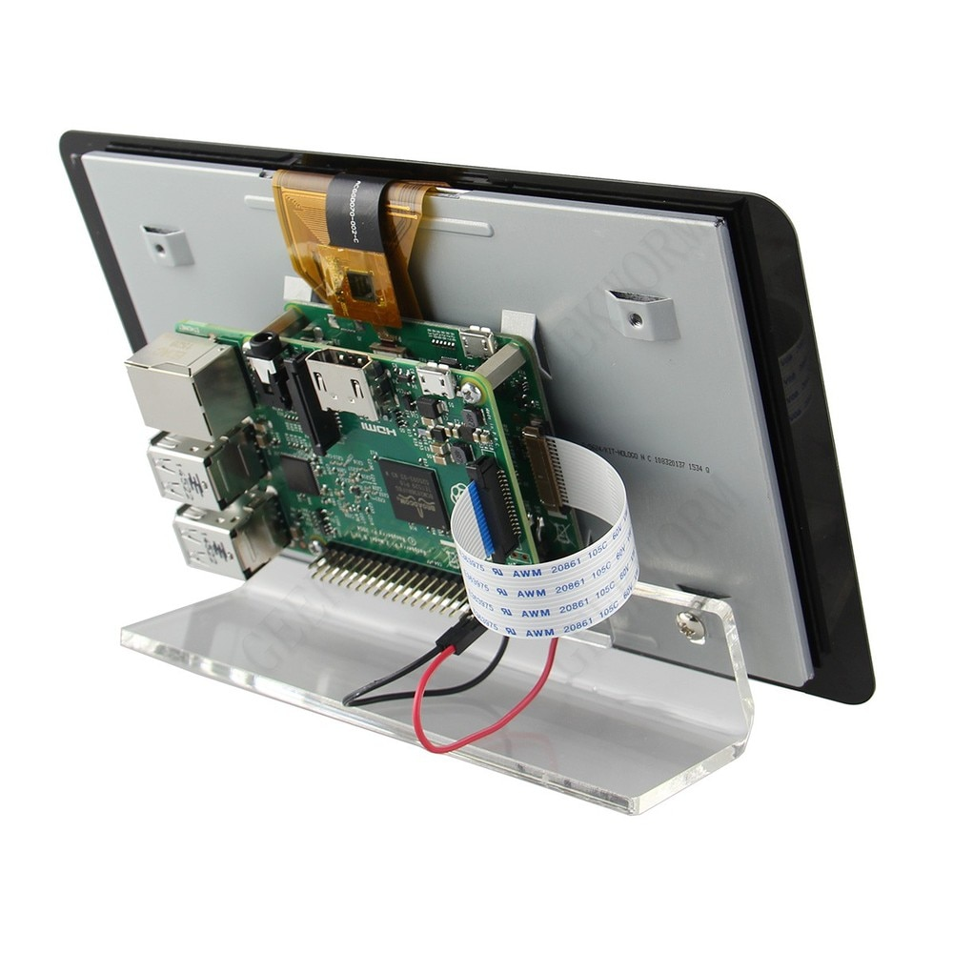

Figure 7: 7” Touch Screen Display [5]

3.5 Relay Circuit

The next piece of hardware is the relay circuit. An AEDIKO 8-channel 5 V relay is used due to smaller form factor and ease of use. The 8-channel relay is tripped using 2.5 V – 5 V and 2 mA to 4 mA. Each channel of the relay circuit is activated via a 3.3 V GPIO port from the Raspberry Pi, which is well within the activation threshold of the relay. Once switched, the relay completes the circuit that supplies 12 V to a solenoid valve. When this happens, liquid begins dispensing. //When specified amount of time has passed for liquid flow, the Raspberry Pi will stop its GPIO signal and the relay circuit will return to an open circuit, effectively stopping the solenoid valve and liquid flow. It will do this operation sequentially until all liquid ingredients have been dispensed into the cup. The overall relay circuit includes a flyback diode to reduce the voltage spike that inevitably occurs when switching with an inductive load. The 8-channel relay and schematic are shown in Figure 8 below [6].

Figure 8: Relay Circuit [6]

3.6 Housing

The next piece of hardware is the housing. The housing is made from clear acrylic sheets. This provides a secure foundation to house all the internal and external components to provide a complete and functional system. The user will have the ability to view internal components and operations. A usable drawer is used to house the bottles in the upper portion. This allows the user to easily slide out the drawer for easy access to the bottles. The acrylic housing, displayed in can be seen in Figure 9 below [7].

Figure 9: Housing [7]

3.7 Power Supply

The next piece of hardware is the power supply. An LLTOP 60 W, 12 V, Waterproof, 5 A power supply is used to provide the necessary 12 V to the solenoid valves and the Peltier plates. The IP67 waterproof design is chosen for safety due to close proximity with various liquids. This small form factor power supply converts 120 V AC from a wall outlet connection to 12 V DC leads on the other. The 60 W rating is plenty to provide power to all solenoid valves and Peltier plates. The 12 V power supply can be seen in Figure 10 below [8].

Figure 10: 12 V Power Supply [8]

3.8 Weight Sensor

The next piece of hardware used is the weight sensor. A 20 kg load cell is used in conjunction with a HX711 load cell amplifier. This sensor incorporates the values of liquid in each full container and, as the weight in the cup increases as the cocktail is being made, it communicates this information with the Pi in order to calculate the amount of liquid used from each ingredient. This is also used to determine how much liquid from each bottle has been used. The load cell is attached between two pieces of acrylic and changes the output voltage based on the amount of weight on the sensor. This data is sent through the HX711 ADC to determine the actual weight. The load cell and its measurement and standard deviation values can be seen in Figure 11 below [9].

Figure 11: Load Cell [9]

3.9 Air Flow / Filtration

In order to allow a consistent flow rate, the gravity fed system must have access to an outside air to relieve the pressure from the closed system, otherwise as liquid is dispensed the pressure decreases, causing the flow rate to decrease over time and be inconsistent with the systems clock. In order to alleviate this issue, all bottles have an air filter attached above. The air filter used can be seen in Figure 12 below.

Figure 12: Air Flow / Filtration

4. Final Build

For the final build, all hardware components are connected and controlled by the Raspberry Pi application. Food grade ¼” tubing as well as ¼” T-connectors are used to allow liquid to flow between components. The 12 V DC power supply provides conditional power when connected to the 5 V relay circuit. The Raspberry Pi and 12 V DC power supply are both powered via 120 V wall outlets. The Pi runs the Xojo app and the Python script. The 7” Raspberry Pi touch screen shows the Xojo application that allows users to select view and select their drink as well as monitor liquid status. In order, the liquid containers on the top are immediately connected to the air flow system. Directly below the bottle the liquids reach the solenoid valve via tubing. Once a particular valve is activated, the liquid is dispensed into the cup. All components and wiring are neatly secured within the acrylic housing. The entire build diagram can be seen in Figure 13 below [10].

Figure 13: Final Build [10]

5. Conclusion

By using all of these components together, the Brewster automated cocktail machine is created with the ability to accurately dispense the precise amount of each liquid ingredient to create cocktails at the touch of a button. The Raspberry Pi, along with the solenoid valves, sensors, and relays that operate in conjunction with the application, provide a unique and user-friendly experience to enjoy cocktails.

Acknowledgements

Project Lab Group:

* Josh Herndon
* Madison Schumate

Funding/Equipment:

* Texas Tech University ECE

Appendix A

References

This appendix includes references for documentation, particularly graphics sourced from teammates and the internet. Almost all in text reference are included in the picture titles above.

1. Flowchart – Madison Schumate
2. *DATASHEET Raspberry Pi 4 Model B*. June 2019, <https://www.raspberrypi.org/documentation/hardware/raspberrypi/bcm2711/rpi_DATA_2711_1p0_preliminary.pdf>.
3. Cooling System – Madison Schumate
4. “Amazon.com: Digiten DC 12V 1/4’ Inlet Feed Water Solenoid ...” *12 V 1/4" Solenoid Valve*, https://www.amazon.com/DIGITEN-Solenoid-Connect-normally-Closed/dp/B016MP1HX0.
5. *Raspberry Pi 7" Touch Screen Display - Amazon.com*. https://www.amazon.com/Raspberry-Pi-7-Touchscreen-Display/dp/B0153R2A9I.
6. Relay Circuit – Josh Herndon
7. Housing Diagram – Madison Schumate
8. *Led Driver 60W Waterproof IP67 Power Supply Transformer ...* https://www.amazon.com/Waterproof-Transformer-Landscape-Lighting-110V-250V/dp/B09P37WQQQ.
9. Load Cell – Madison Schumate

Appendix B

Safety

This appendix discusses the safety protocols used throughout the design and development of the system.

This system requires hands on experiences with various electrical hardware components. While in a lab there are, of course, certain safety protocol that must be followed. In the lab, long pants and closed toe shoes must be worn. Proper care of electrical devices and high voltage equipment must be used, along with all other lab safety protocols. Since liquid is being used in close proximity to electricity, extreme caution must be taken when testing and operating equipment in order to avoid injury as well as hardware damage. This system is intended for the use of alcohol and anyone testing or operating must twenty-one years or older. Drink responsibly.

Appendix C

Data

This appendix includes data such as Gantt chart, budget, mass production estimations, and final code. The Gantt Chart outlines overall design deadlines and performance for each task, and the Budget lists all expenses along with original estimate.

1. Gantt Chart



The Gantt Chart above shows the progress of the project for specific tasks. Overall, successful progress was made.

2. Budget

Labor:

The total amount spent is $27,144.99 which is well below the estimated budget of $34,412.54.

Materials:

The total cost of all components is $$439.68

Prototype vs Mass Production Cost:

The table above shows the cost of prototyping materials vs an estimation of a complete build using pricing based on mass produced materials.

3. Final Code

<https://github.com/lanewill22/Brewster-Automated-Cocktail-Machine>

<https://github.com/madisonshumate/Brewster-Project-Lav-IV>