Hong Kong Metropolitan University

COMP2090SEF
Data Structures, Algorithms And Problem Solving

Course Project Report
Group8 Submission date:
16 April 2026

We declare that:
  - all members of the group have read and checked that all parts of the project (including proposal, code programs, and reports), irrespective of whether they are contributed by individual member or all members as a group, here submitted is original except for source material explicitly acknowledged;
  - the project, in parts or in whole, has not been submitted for more than one purpose without declaration;
  - we are aware of the University's policy and regulations on honesty in academic work and understand the possible consequence when breaching such policy and regulations;
  - we confirm that we have declared in the report about the usage of AI and other generative models, including but not limited to ChatGPT, LLaMA, Gemini, Mistral, and Stable Diffusion, and complied with the instructions provided by HKMU; and
  - we are aware that all members of the group should be held responsible and liable to disciplinary actions, irrespective of whether he/she has signed the declaration and whether he/she has contributed, directly or indirectly, to the problematic contents.
We confirm that we have read through and understood the project requirements. We understand that failure to comply with the project requirements will result in score deduction.

NAME | SID
LANG Jingfei | 13733731
Yang Jinghan | 14181155
Lock Olsson Jeff | 13943248

- The group must acknowledge ALL external resources or code from others referenced. We will only mark the parts that are original, not the parts from others.
- All members are liable to the plagiarism incidence, even if a free-rider.

1. Introduction:
Our team has decided to use the Huffman Tree as our new data structure and Huffman Coding as our new method for this project.
a. Synopsis of the Ideas
Huffman coding is a popular lossless data compression greedy technology. It provides variable-length binary code according to the frequency of characters, instead of fixed-length encoding (such as ordinary 8-bit ASCII). The Huffman tree is a complete binary tree whose characters are stored in leaf nodes, which is the basic data structure that powers the technology. Less common letters are located at the bottom of the tree, while more common characters are located closer to the root, resulting in shorter binary code.
b. Reasons and Useful Applications
The main reason for choosing this topic is to study effective ways to optimize network transmission and storage capacity. When processing text containing a large number of repeated characters, traditional fixed-length encoding will waste a lot of memory. By using the "prefix rule", which indicates that no whole code is a prefix to any other code, the Huffman algorithm cleverly solves this problem and ensures clear decompression. In practice, this method and data structure are the basic framework of contemporary compression technology, including MP3 music coding, JPEG image compression and ZIP file archiving.
2. Data Structure: Huffman Tree
A. Brief Introduction to Huffman Tree Theory
a. Basic definition and operation：Hufman tree is an optimal binary tree. It is constructed through the greedy algorithm:The construction process: each time the two nodes with the smallest weight (frequency) are selected from the node set as the left and right subtrees, and a new node is merged to generate a new node (the weight is the sum of the two), and repeat this process until there is only one tree left.
Coding logic: It is stipulated that the left branch of the path is 0 and the right branch is 1. (Appendix 1, Data Structure Visualization)
b. Core characteristics：Minimum weighted path length (WPL)：Ensure that nodes with large weights are close to the root node and nodes with small weights are far from root nodes, so that the WPL =∑(weight * path_length) of the whole tree reaches the most Small.
Variable length coding: use short code for high-frequency data and long code for low-frequency data to achieve data compression.
c. Complexity analysis：time complexity: O(nlogn), where n is the number of character types, which is mainly consumed in the maintenance of the priority queue). Spatial complexity: O(n), (used to store 2n-1 tree nodes).

B. Code Implementation
a. Node class (Node): We have defined the Node class in the code as the basic unit of the tree: Char: store characters. The leaf node has specific characters (such as 'a'), and the internal node is None. Freq: storage frequency. The leaf node is the number of times characters appear, and the internal node is the sum of the frequency of left and right children. Left, right: point to the left child and the right child respectively
For example: Node ('a', 2) means that the character a appears twice, which is a leaf node.
b. Tree building function (build_huffman_tree): This function is responsible for combining multiple nodes into a tree.
The variables we use: Freq = Counter(text): Count the frequency of characters. For example, enter "abac" to get {'a':2, 'b':1, 'c':1}. Heap = [Node (char, f) for ...]: Convert each character into a node and put it into the list. Heapq.heapify(heap): Convert the list into the smallest heap and sort it from small to large according to freq.
(The core loop code is seen in appendix 1, figure 2)
Give an example (text = "abac"): Initial heap: [b(1), c(1), a(2)] (sorted by frequency). We take out b(1) and c(1), merge them into the internal node n1(None, 2), make n1.left = b, n1.right = c, and then put n1 back to the heap. At this time, the heap becomes: [a(2), n1(2)]. Let's take out a(2) and n1(2) and merge them into root(None, 4), so that root.left = a, root.right = n1. There is only root left in the heap, and the tree building is over. The tree structure is formed.
3. Algorithm: Huffman Coding
A. Algorithmic Mechanism:
The Huffman Coding algorithm follows a "Greedy" strategy to produce the most efficient binary codes. The process involves four major phases as implemented in our source code: Frequency Analysis: The algorithm utilizes the Counter class to determine the frequency of each character in the input text. Min-Heap Initialization: For each unique character, a Node is created and pushed into a priority queue (heapq), which maintains the nodes in ascending order of frequency. Iterative Merging: The algorithm repeatedly pops the two nodes with the lowest frequencies, creates a new parent node with their combined sum, and pushes it back into the heap. This continues until only one root node remains. Recursive Code Generation: The build_codes function traverses the tree from the root, assigning '0' for left branches and '1' for right branches until it reaches a leaf node. (See Table 1 in Appendix 2 for the specific codes generated during our demo run).
B. Time Complexity Analysis: Frequency Counting: O(m), where m is the total number of characters in the input. Building the Initial Heap: O(n), where n is the number of unique characters. Tree Construction: Since there are n-1 merge operations and each heap operation takes O(log n), the total complexity is O(n log n). Encoding/Decoding: O(m), as it requires a linear pass through the text or bitstring.
C. Space Complexity: The space complexity is O(n) to store the tree nodes and the codebook dictionary.
D. Algorithm Demonstration:
In our project, the algorithm processed a sample text to show compression efficiency. By comparing the 8-bit ASCII representation to the Huffman codes, we calculated a specific compression ratio. (Please refer to Appendix 2 in the Appendix for a screenshot of the terminal output, verifying the decompression accuracy and the compression ratio.)
E. Code Implementation：We have implemented the above algorithm in Python. The following is the core code and its explanation, and specific examples and comments are quoted in the code.
Node class Node (lines 5-16 of the code): (Appendix 2，figure 1）Char: store characters (the leaf node has characters, and the internal node is None). Freq: storage frequency. Left, right: left and right child pointers.__lt__: Make the nodes can be compared by frequency for heapq us.
Tree building function build_huffman_tree (code lines 19-42): (Appendix 2, figure 2) Code example: enter text = "abac". Initial heap: [b(1), c(1), a(2)] (sorted by frequency). The first cycle: take out b(1) and c(1), merge them into n1(None, 2), and the heap becomes [a(2), n1(2)]. The second cycle: take out a(2) and n1(2), combine them into root(None, 4), and turn the heap into [root]. End of the loop, return to root.
4.Application examples of Huffman in daily life
A. File Compression (ZIP, RAR) : Frequent characters are assigned short codes, and infrequent ones long codes, thereby reducing file size
B. Barcode / QR Code: Common digit combinations use short bars, while rare ones use long bars, improving scanning efficiency.
5. Project Deliverables
GitHub Repository Link: https://github.com/lang-lab-111/COMP2090_Group_8_Project
(The Python code files, User guide, 5minutes introduction video)
6. Reference
This article does not quote other people's literature. The views of this article are combined with myself and the knowledge I learned on the “python.org” and supplemented by the AI normative structure.

Appendix:
(Appendix 1: Data Structure Visualization)
Figure1
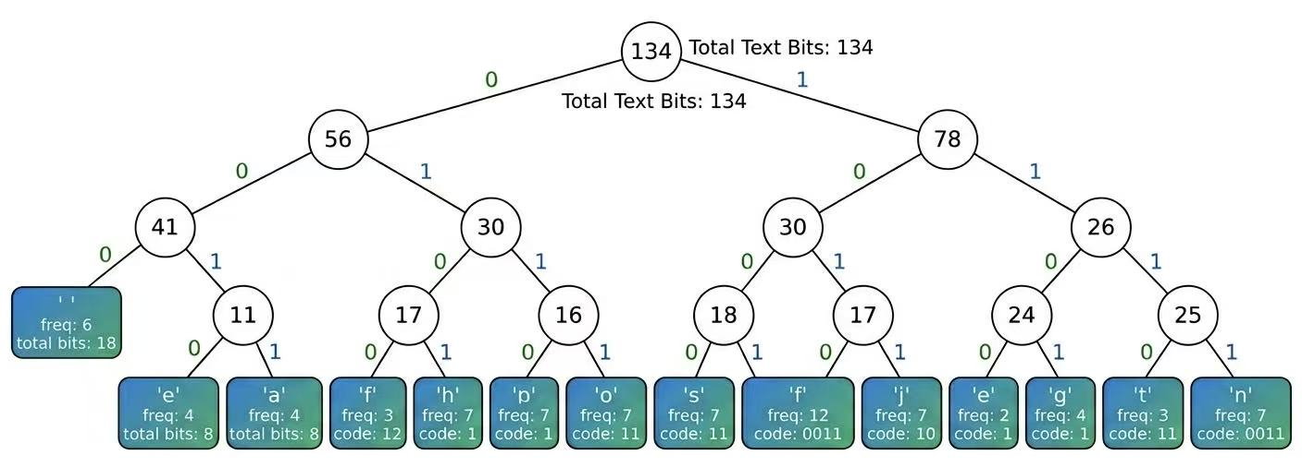
Figure2
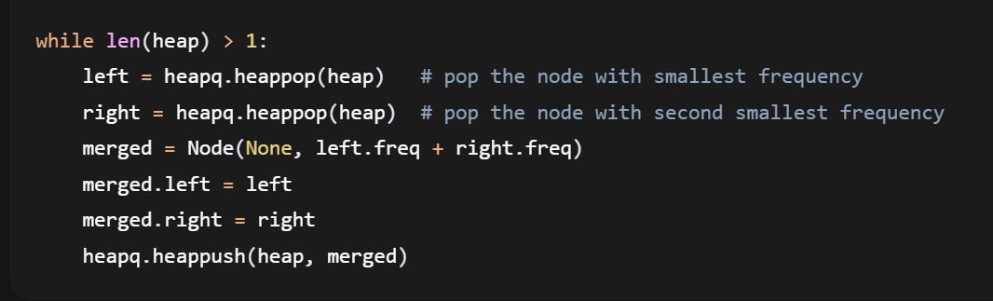

(Appendix 2: Algorithm Execution & Proof)
Figure 1
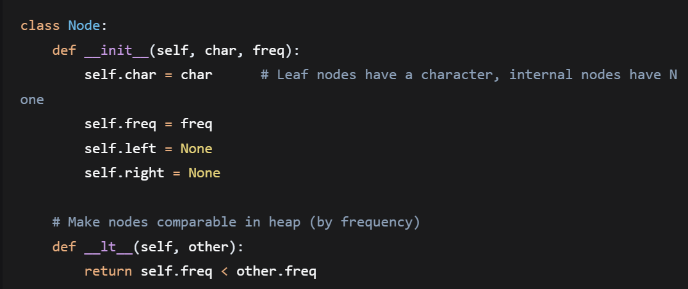
Figure 2
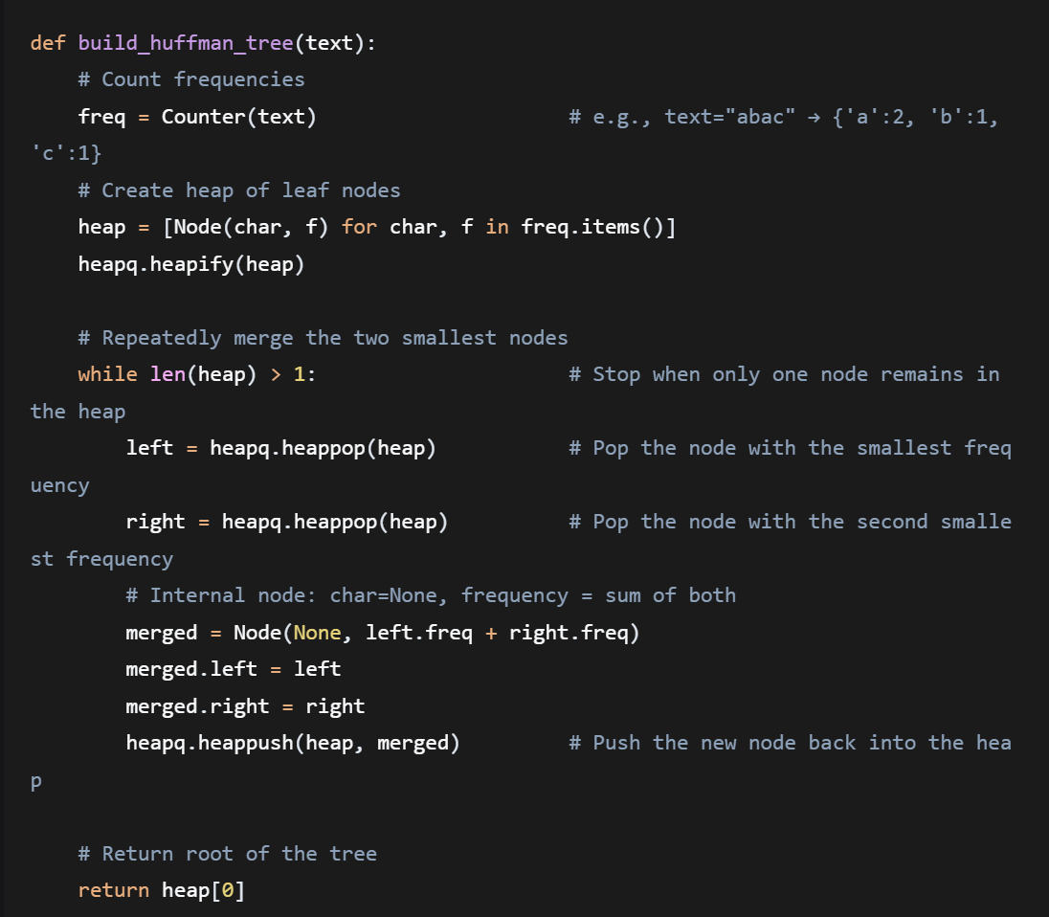
Table1:
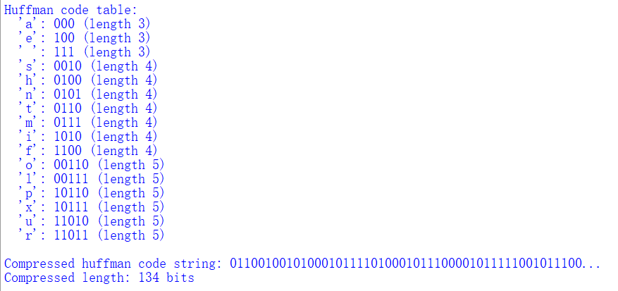

Execution Screenshot:
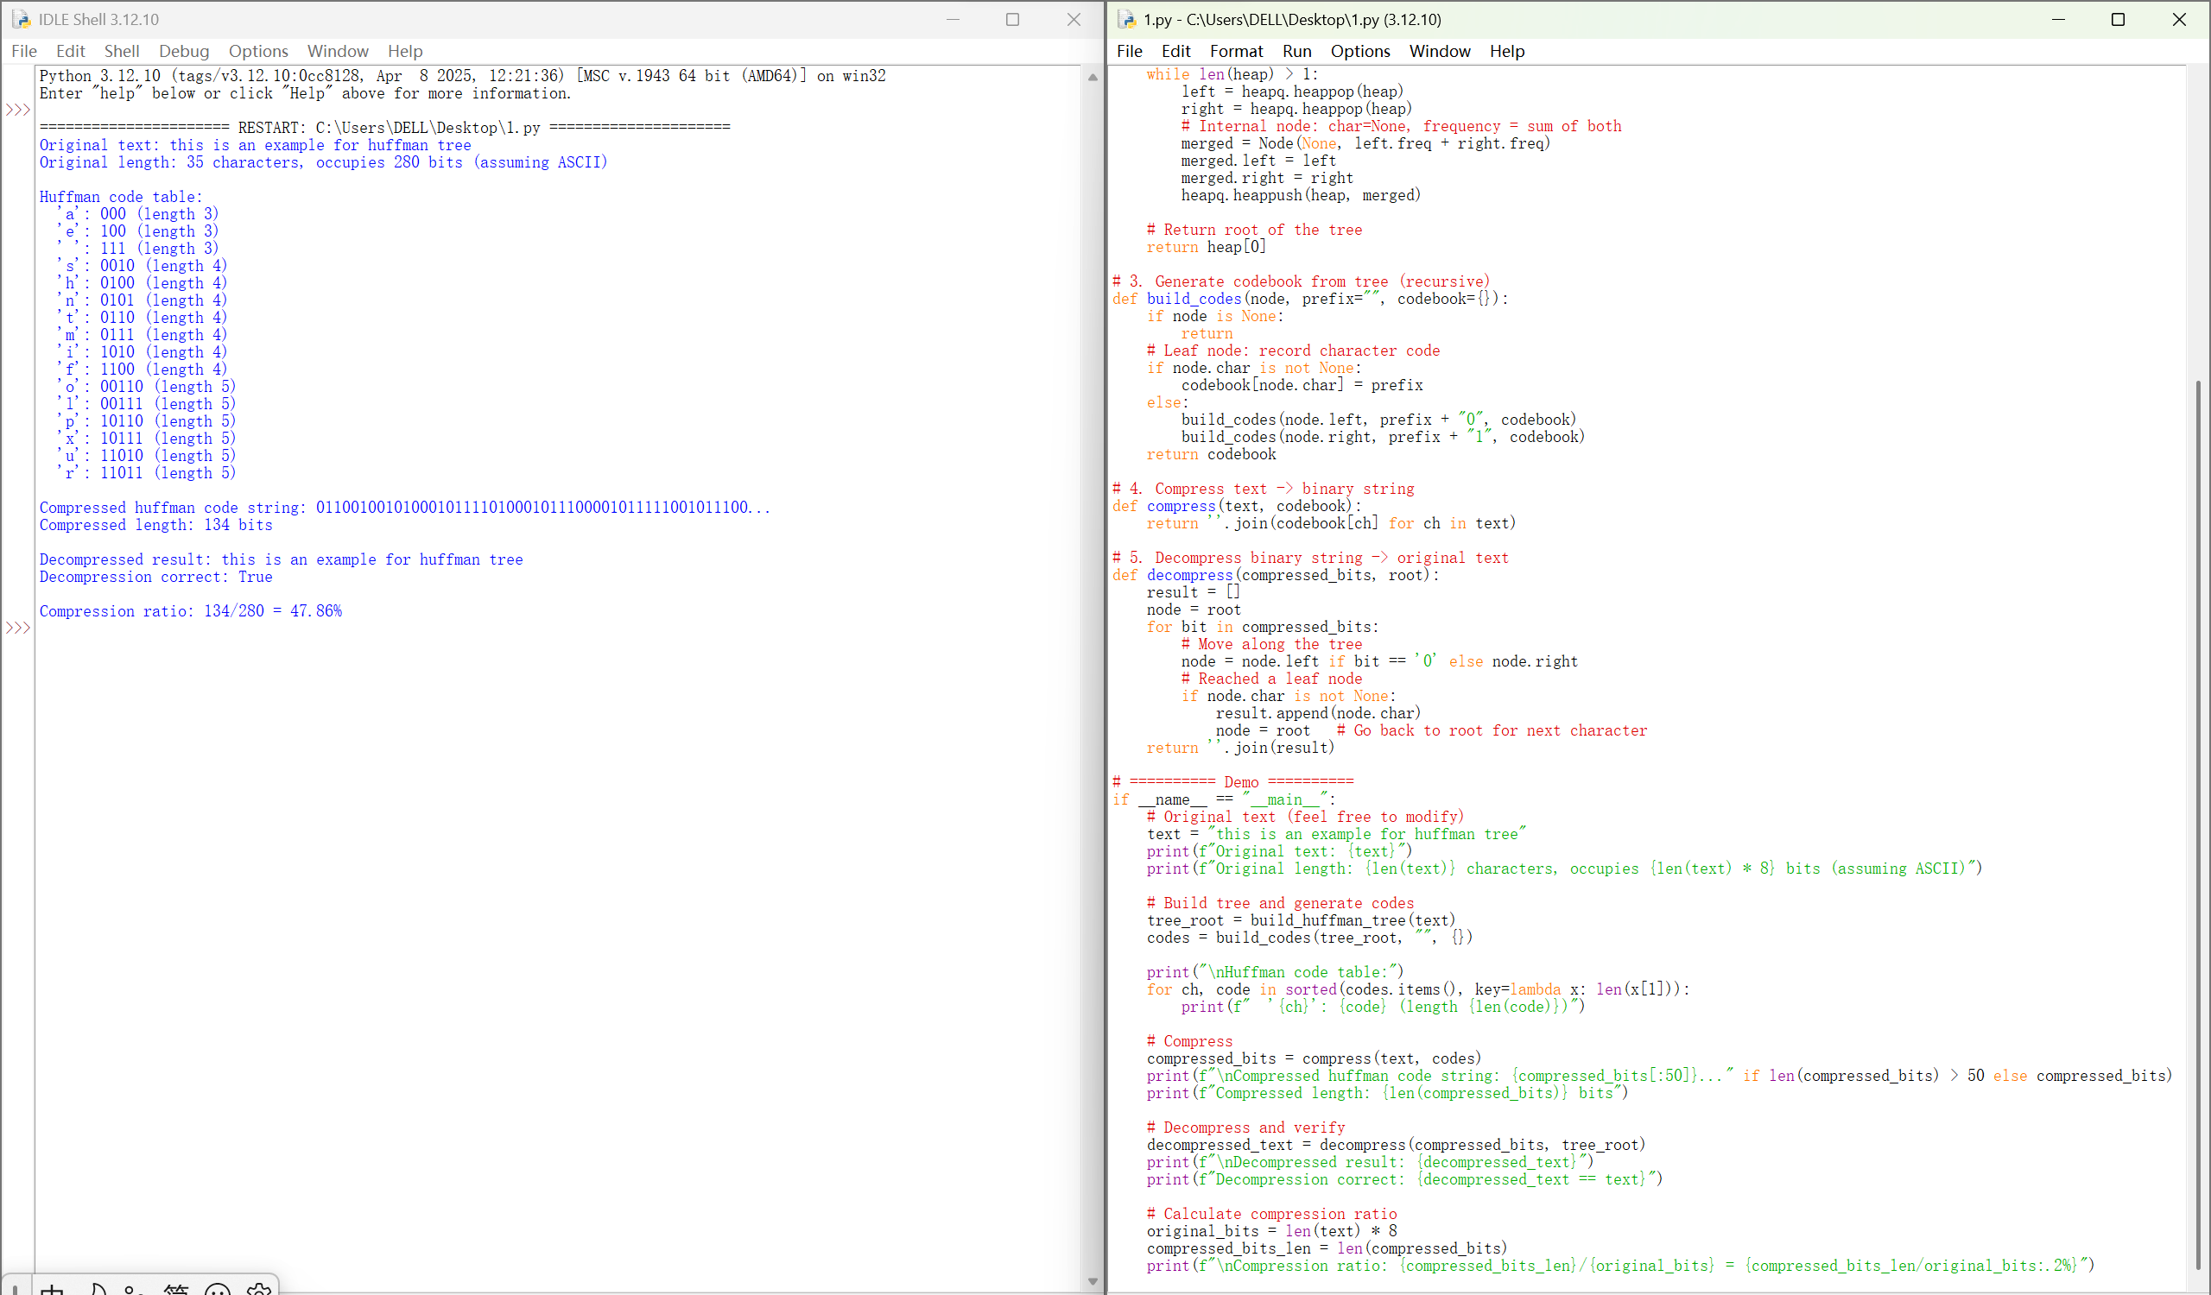

(Appendix 3: Declaration of Contribution)

Member Name | Student ID (SID) | Key Responsibilities & Tasks
LANG Jingfei | [13733731] | Technical Development: Implemented the Node class and Huffman Tree logic in Python; conducted code debugging and performance testing.
YANG Jinghan | [14181155] | Academic Reporting: Authored the main study report, including the ADT definitions, algorithmic mechanism, and time complexity analysis.
Lock Olsson Jeff | [13943248] | Project Coordination & Media: Created the visualization diagrams for the appendix, managed the GitHub repository, and produced the 5-minute introduction video.

Declaration of Generative AI Usage:
We only use AI tools to standardize the structure in self-study task and report, and do not use AI to generate content.

