Picking the “best” noise model after using est_noise
John Langbein
September 1, 2017

The program, est_noise, allows the user a variety of colored noise functions to model the background noise in various time-series. Amongst the noise models and the output of est_noise, it is desired to have a method to quantitively select one noise model over competing noise models. The following describes the results of multiple experiments of simulations of colored noise where the coefficients of different noise models are estimated. With each simulation, there is an associated Max. Likelihood estimate (MLE) (actually, log likelihood). Can the differences in MLE, dMLE, be used to statistically determine whether the simplest noise model, termed the null model, be rejected in favor of the more complex? If so, then what is that threshold and its associated confidence? Does that threshold depend upon the length of the time series and does that threshold depend upon the “strength” of colored noise relative to white noise? In part, this study replicates Figure 4 in Langbein (2004). Noted then, and replicated here is the anomalous behavior of Gauss-Markov noise.
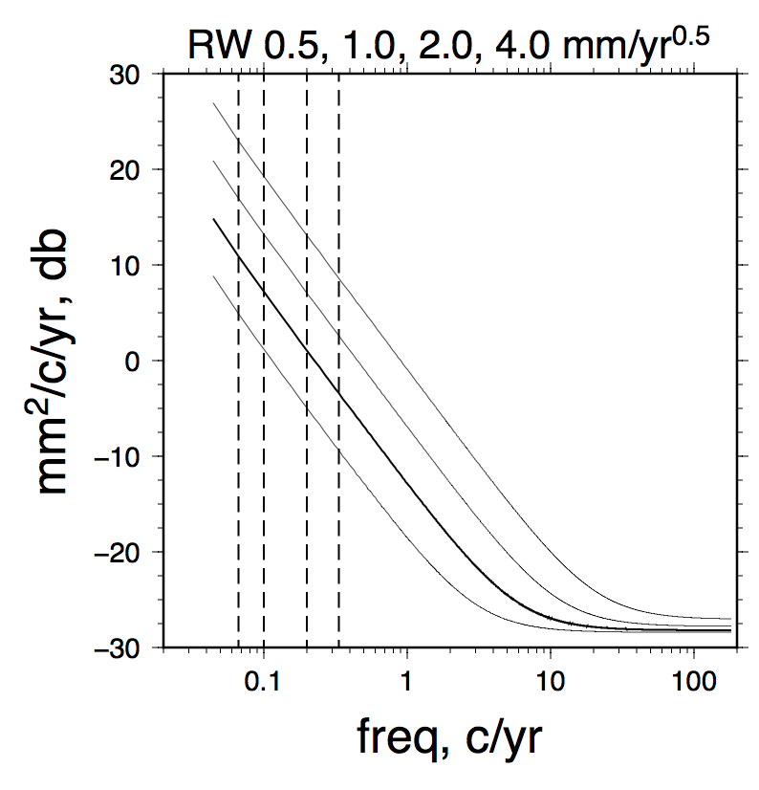Figure 1; Power spectra of the underlying noise for simulated time series. The thicker line is for 1 mm/rt(yr) used in most experiments. The thin, dashed lines represent the 4 lengths, 15 years (1/15 c/yr), 10, 5, and 3 years.

Three tentative conclusions are:
1) Threshold dMLE has a slight dependence upon the length of the time series.
2) Threshold dMLE depends upon both the candidate noise model and the null model
3) Threshold dMLE probably does not depend upon the size of the colored portion of the noise in the time-series.
4) Threshold dMLE for GM and 1st order GM (FOGM) noise is more than twice of any of the other thresholds; Estimating rate and the “flattening” of GM at the lowest frequencies becomes a trade-off and any estimate of the standard error in rate is correlated with the parameters of GM noise such that est_noise under-estimates the true uncertainty in rate.
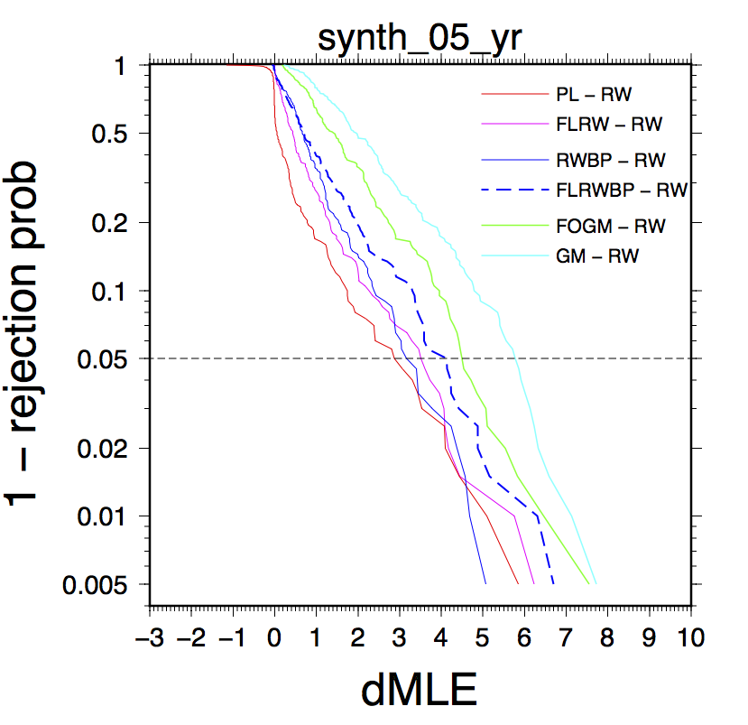Figure 2, Example of a c

The basic test simulates multiple time series that are a combination of white noise plus random walk noise and this is identified the “Null” noise model. For the experiment described here, I've created 200 such time series for each experiment. The underlying model consists of 0.5 mm of white noise and random walk consisting of either 0.5, 1.0, 2.0, or 4.0 mm/rt(yr). Along with estimating the parameters of the noise model(s), est_noise estimate the rate, and the amplitude/phase of 365 and 182 day period sinusoids. Neither the rate nor the sinusoids are prescribed to be present in the simulated time-series. Figure 1 shows the power spectra of these simulated time series. With each simulated time-series, I used est_noise to compute the parameters of various noise models, (all include white noise), random walk (RW), Power Law (PL), Flicker plus Random Walk (FLRW), Band-passed filtered plus RW (RWBP), combination of BP, FL, and RW (FLRWBP), FOGM and GM. For each of these noise models, MLE is saved and compared with the null RW model yielding dMLE for FLRW – RW, PL – RW, and so on.

One set of experiments simulated time series of different lengths, 3, 5, 10, and 15 years. These all used the 1 mm/rt(yr) value of random walk. A second set of experiments uses 5 years of simulated data and varied the size of the simulated random walk. Simulations were done 200 times with the expectation that dMLE can be evaluated as a threshold to reject the null model. A third set of experiment tests the impact of dMLE of estimating rate when the prescribed rate is zero. As such, the dMLE are tabulated and sorted such that probability plots are constructed, Figure 2. For the examples that follow, I've selected two dMLEs, one that corresponds to a 95% confidence in rejecting the null, RW model, and a second threshold corresponding to 75%. (These correspond to either 0.05 or 0.25 levels in the probability plot in Figure 2). For 200 simulations, the threshold with 95% confidence-level in dMLE would have 10 values of dMLE > the threshold; for 75%, then there would be 50 values of dMLE > the threshold value.

dMLE vs Time series length: Figures 3 and 4 show the results of determining the threshold of dMLE for a variety of noise models compared against the null for different lengths of time series, from 3 to 15 years. Each simulated time series has a background rate of zero and 1 mm/rt(yr) of random walk and 0.5 mm of white noise and spans a prescribed amount of time, 3, 5, 10 or 15 years. Then for each simulated time-series, est_noise simultaneously estimates the background rate, the amplitude of two sinusoids (annual and semi-annual periodicity), the white noise and random-walk amplitude (the rate and periodicities are typically estimate for most GPS time-series). It was assumed that the noise model is additive as described by Langbein (2017) such that est_noise runs quickly. (There are no gaps in the simulated time-series). For each simulated time-series, the value of MLE is saved. The first “run” with est_noise assumes the RW model and is identified as the null-model. Then for each time series, more complex noise models are evaluated as they have at least one more free parameter than RW. Those models are PL, FLRW, FOGM, GM, RWBP, and FLRWBP. These calculations were repeated 200 times providing the ability to determine the distribution of dMLE in terms of a probability plot based upon sorting dMLE from the smallest to the largest. Since the underlying model of noise is RW, the change in MLE associated with the more complex model, which includes a RW term, should be 0. In reality, the value of dMLE will be “close to zero” but there will be a few dMLE that exceed 0. With each noise model, the difference in MLE is computed and saved. After a numerical sort of the dMLEs, the 95% and 75% levels of dMLE are identified; that is for 200 simulations, the dMLE for which there are 10 values greater is identified as the 95% level to reject the null hypothesis. The result of these simulations are shown in Figure 3 and 4.
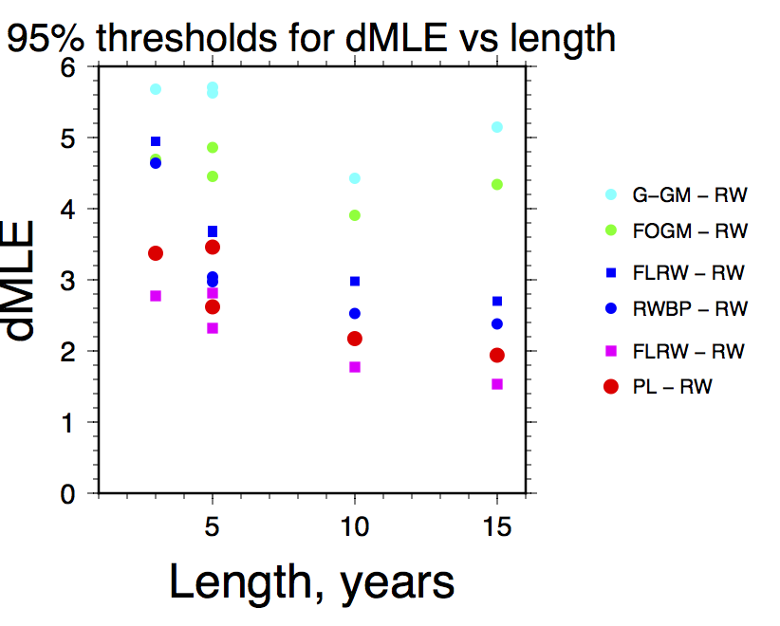Figure 3. Differences in MLE from a variety of noise models relative to the NULL random walk model of noise for a variety of lengths of time series
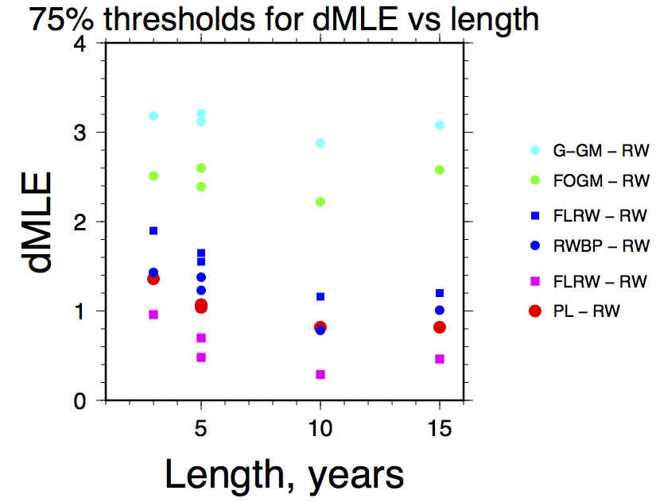Figure 4. Same as Figure 3 but using 75% confidence interval as the rejection criteria

Note, for the 5-year time span, this experiment was run twice to test the ability of determining dMLE with only 200 simulations. Focusing on the 95% levels of dMLE, Figure 3, sseveral features are apparent: 1) dMLE depends upon the pair of models used for comparison. For example, when comparing PL against RW with 15 years of data, any dMLE greater than ~1.9 suggests that the null model can be rejected at the 95% confidence level. On the other hand, dMLE only needs to exceed 1.5 to reject the null RW-model in favor of FLRW model. 2) dMLE has a slight, inverse dependence upon the length of time of the time series. 3) With only 200 simulations, the value of the 95% confidence level is not robust. For 5 years, the 200 simulations were run twice. For one set of simulations, the threshold dMLE at 95% for PL – RW is 2.6, but for the second set, that threshold is 3.5. Consequently, with only 200 simulations, obtaining dMLE threshold for 95% C-I is not robust.

On the other hand, if the C-I is reduced to 75%, then the variability of the threshold dMLE appears to be reduced, too. This is explored in Figure 4 with the 5-year time-span. In comparison with dMLE at 5 years for the 95% C-I in Figure 5, the values of dMLE appear to have less variability for 75% C-I. On the other hand, the observations #1 and #2 noted for the 95% C-I are repeated for the 75% C-I level.

dMLE vs Amplitude of Random Walk noise: Figures 5 and 6 show the results of threshold dMLE for different amplitudes of random-walk noise in simulated time series. For these sets of experiments, simulated noise was created using 0.5, 1.0, 2.0 and 4.0 mm/rt(yr) random walk added to 0.5 mm of white noise. However, the experiments used only 5 years of simulated data.
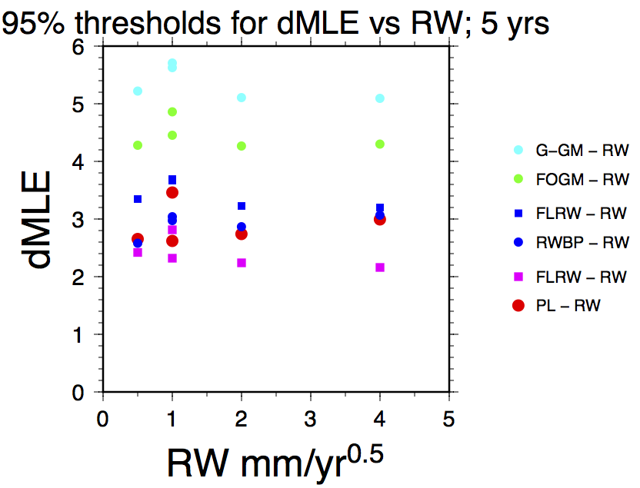Figure 5. Differences in MLE from a variety of noise models relative to the NULL random walk model of noise for a variety of levels of random-walk noise.
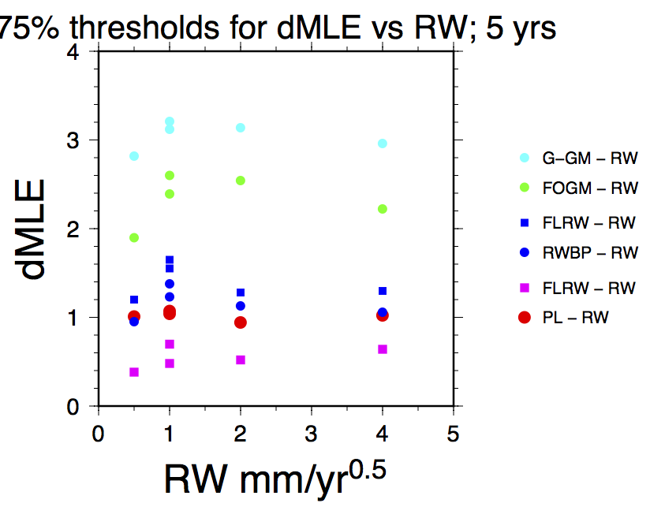Figure 6. Same as Figure 5 but using 75% confidence interval as the rejection criteria

Unlike the slight dependence of dMLE on time series length discussed in the previous section, dMLE does not show any dependence on the amplitude of the underlying noise. For instance, the 95% threshold of dMLE to reject the RW model infavor of FLRW is 2.4 if the underlying RW amplitude is 0.5 mm/rt(yr) and 2.2 if the underlying RW amplitude is 4.0 mm/rt(yr).

Impact of estimating rate in evaluating dMLE; correlation with FOGM/GM noise models. This test consisted of 600 simulations of 5 year long time-series with 1 mm/rt(yr) RW plus 0.5 mm white noise. For each simulated time series, est_noise is run first with estimating the rate plus the parameters of the seven noise models, then a second time where the rate is assumed to be zero. The probability plots for both of these “runs” are shown in Figure 7 and 8.
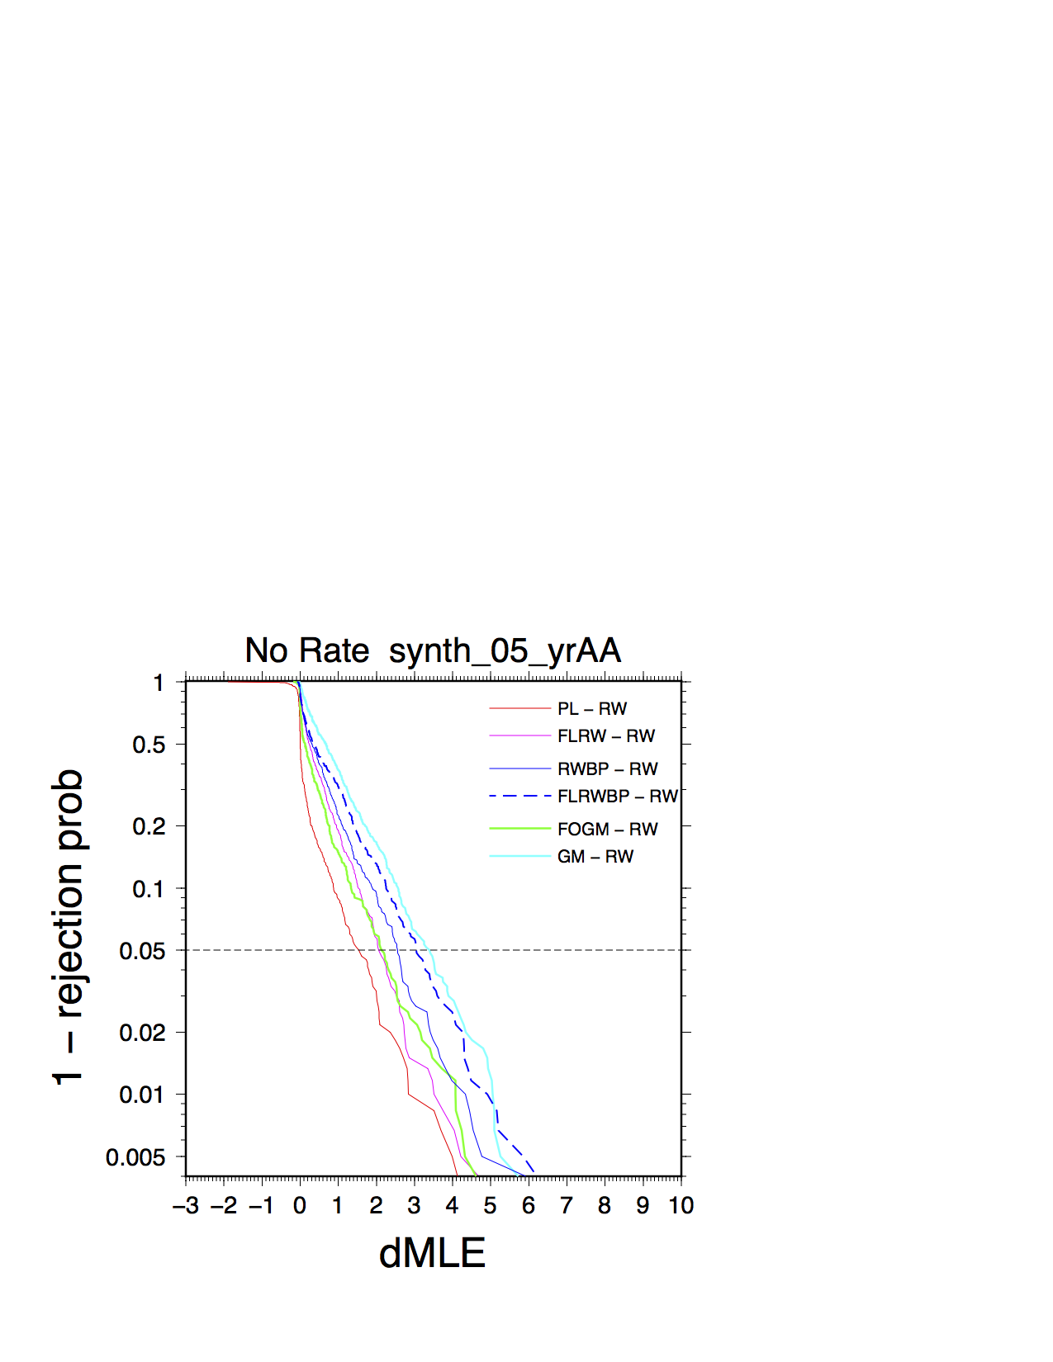Figure 8. Probability plot of dMLE from 600 simulations of 5 years of RW noise when rate is NOT estimated
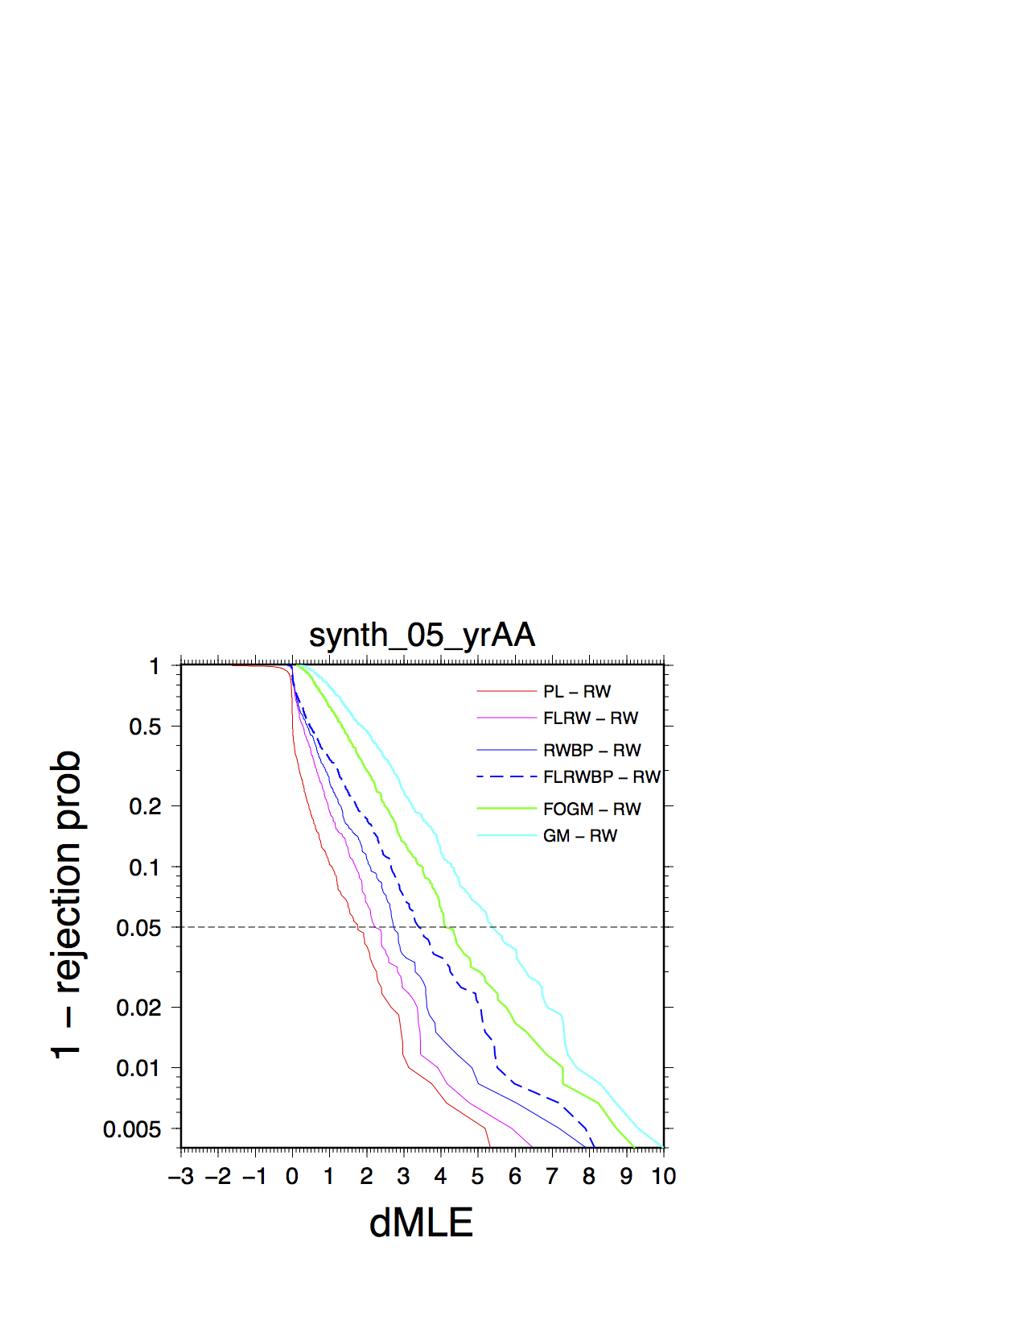Figure 7. Probability plot of dMLE from 600 simulations of 5 years of RW noise when rate is estimated

The key difference between the tow probability plots is the lower dispersion of the rejection criteria of dMLE when rate is not estimated. This is particularity evident with the FOGM and the GM models when compared to the RW model, green and cyan lines, respectively. The differences in the 95% C-I are shown in Table 1 where the FOGM and GM models comparisons are highlighted.
Table 1: dMLE thresholds from 600 simulations testing the impact of estimate rate, 5 year time-series
Model comparison | dMLE, 95% C-I rejection threshold
 | Rate estimated | Rate NOT estimated
PL – RW | 2.19 | 2.04
FLRW - RW | 1.75 | 1.47
FOGM - RW | 4.09 | 2.10
GM - RW | 5.34 | 3.30
BP - RW | 2.71 | 2.54
FLRWBP - RW | 3.35 | 3.04

For the PL, FLRW, and both BP models, the impact estimating rate on dMLE is fairly small, roughly 6 to 20%. On the other hand, the impact of rate-estimation for the GM models is significant, between 60 and 95% contrast.

An alternative view of the impact on rate with the various noise models is plot the histograms of the ratio of estimated rate to the estimated standard-error in rate. The results for all 7 types of noise models are shown in Figure 9. For simulations for which the underlying rate is zero, the histograms of rate should cluster about zero, which does occur for all of the noise models. However, the rate is normalized by its computed standard error; the standard error is derived directly from both the assumed function that represent the background noise and its estimated values. For RW noise, the range in normalized rate is roughly +/- 3, consistent with expectations that 99% of the rate falls within 3-sigma of the “error bar” in rate. Broadly speaking, the +/-3 range for normalized rate is also seen for PL, FLRW, and both BP noise models. On the other hand, visually, all 6 of these histogram slightly exceed the +/-3 range and include a few outliers, too.
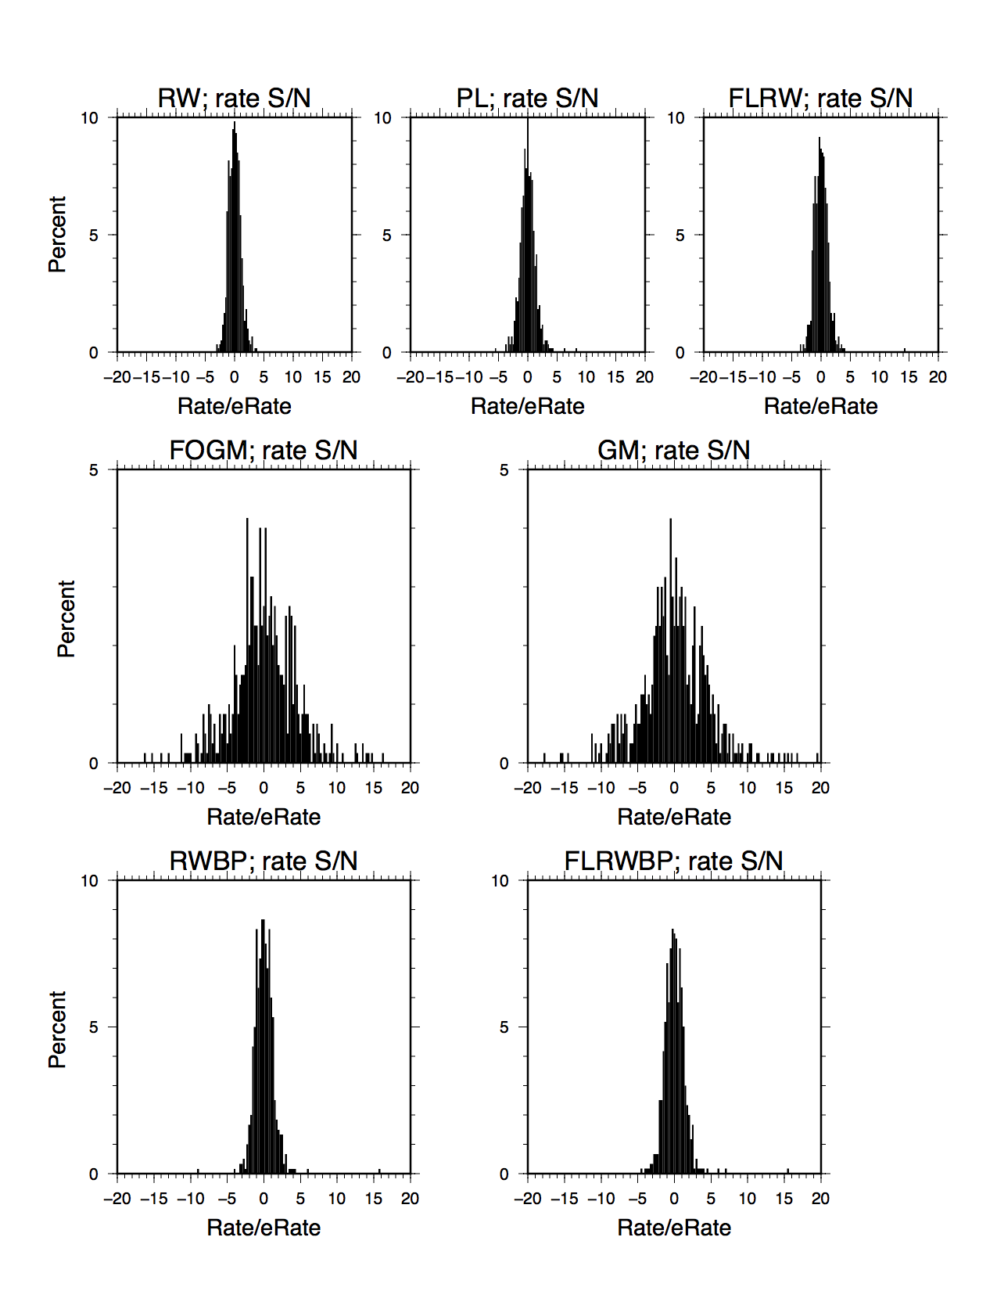 Figure 9. Histograms of estimates of normalized rate (rate divided by the error in rate) using 7 different noise models from 600 simulations of 5 years of data for which underlying rate is zero.
In contrast, the histograms for both GM noise models show that the nominal range for normalized rates vastly exceeds +/-3 and is closer to +/-10, shown in Figure 9. Even though the range in rates estimated using RW or FOGM models are roughly the same, -1.4 to 1.6 units/yr, the largest contrast lies in the denominator, the “error bar”. For the RW noise model, the estimated error in rate ranges from 0.29 to 0.59 units/yr. In contrast, the estimated error in rate ranges from 0.03 to 0.40 units/yr for the FOGM model. Not only do GM type models tend to have smaller estimated “error bars”, in many cases, they are potentially an order of magnitude too low.

The apparent underestimate of the size of the error bar for GM type models can be compared understood from a power spectra of a few functions shown in Figure 10. In this example, the underlying noise model is 1 unit/rt(yr) of RW (plus 0.5 unit of white) shown with a dashed black line. The power spectra for the portion of the spectra is 1/f², where f is frequency. The “average” FOGM noise model obtained from the 600 simulations (rate estimated), is shown with a red line. Note, relative to the RW model, the FOGM power is less at the lowest frequencies. In contrast, the power spectra of rate falls a 1/f⁴, and for a rate of 1 unit/yr, its power at the lowest frequency would “add” to the FOGM spectra – essentially, it compensates (in this example, over compensates) for the attenuated, low frequency portion of FOGM noise such that the sum is closer to the underlying RW model.
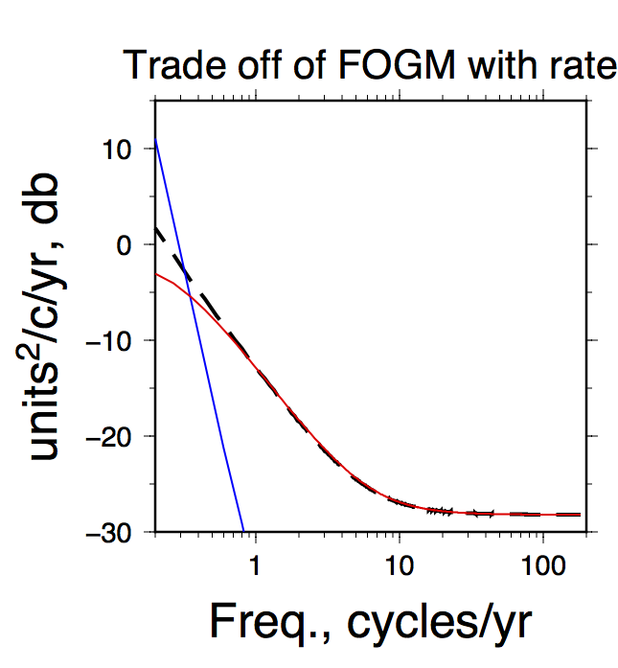Figure 10. Trade-off of power spectra of rate [Blue], 1 unit/yr with FOGM noise (1.6 rad/yr, 0.98 unit/rt(yr)) [Red], with RW noise having 1 unit/rt(yr) [Black}

With the current version of est_noise, although I think it is doable, obtaining accurate measures of the GM parameters is not possible since est_noise assumes that the model estimates of the noise parameters is independent of the time dependent model. That is, for each iteration in est_noise, a noise model is chosen and least squares inversion, using the covariance matrix derived from the noise model, is used to compute the values and their error-bars of the parameters of the time-dependent model. Although est_noise provide cross-correlation values between all of the time-dependent parameters, and in principle, cross-correlations between the parameters of the noise models, these are not mixed; that is, for instance, there is no calculation of the cross correlation (or covariance) between rate and the Gauss-Markov frequency.

Concluding remarks: With only 200 simulations, it is not possible to provide definitive values of threshold values of dMLE, especially at the usual statistical levels of either 95 or 99%. However, even with 200 simulations, the threshold value of dMLE will depend upon the two models being compared. More tentatively, the threshold dMLE shows a slight dependence on the length of the time-series. On the other hand, dMLE seems insensitive to the amount amplitude of noise in the time series.

Like earlier analysis by Langbein (2004), the threshold dMLE for Gauss-Markov noise tend to be much higher, by about 2x, than thresholds for the other noise models including Band-passed filtered. However, that larger threshold can be understood in terms of trade-off between rate and the parameters that describe the GM noise. This trade-off, especially the covariance between rate and the GM frequency, is not handled by the current version of est_noise; consequently, the error-bar in rate obtained from est_noise using a GM model will tend to be too low – I suggest avoid using GM noise models.

The discussion presented here does not evaluate two other metrics, AIC and BIC. Both factor in the change in the number of parameters estimated from the null to the more complex. And BIC does factor in the number of data (or, time-span). At this point however, with the 200 simulations used here, I doubt that these other metrics are any better than dMLE for determining the threshold to reject the null model of noise.

Finally, although dMLE is a valuable metric, I suggest that one needs to examine the plots of “drift” or wander real data in comparison to the drift computed from the estimated noise models.

