# Results

The following analysis consists of two broad components. First, I examine performance on exposure trials in both the *gaze* and *no*-*gaze* conditions to demonstrate the effectiveness of the social cue; that is, to ensure that participants in the *gaze* condition reliably followed the face’s gaze. I then examine performance on test trials to identify any effects of condition. Recall that we hypothesized that participants in the *gaze* condition would look more to the target of the face’s gaze on exposure (“follow gaze”), thus allocating less attention to the non-target object, while participants in the *no-gaze* condition would divide attention more equally between the two objects on exposure and therefore be more likely than *gaze* condition participants to encode multiple potential word-object links. We expected to see evidence of these phenomena in a comparison of participants’ accuracy on test trials across conditions. In particular, we predicted a difference in performance on “Switch” test trials, in which the object the participant looked at less on exposure was the one “kept” on the test trial; we expected participants in the *gaze* condition to perform at chance in this situation, having failed to encode a word-object link for the “kept” object, and participants in the *no-gaze* condition to perform better than participants in the *gaze* condition, having tracked the “kept” object as an alternative referent of the word.

We used mixed-effects regression models to test some of our predictions. Namely, we predicted a quantitative relation between a participant’s amount of looking at the target object during exposure and his or her looking at the target object on the following test trial. We also predicted that condition would have a further effect on test performance; even when two participants looked the same amount at an object during exposure, we expected to see that the participant in the *gaze* condition would perform worse than the participant in the *no-gaze* condition on “Switch” test trials. Code for these models, along with the rest of our analysis code, is located at <https://github.com/langcog/gaze-xsit>.

## Exposure Trials

First, we checked to see whether participants in the *gaze* condition followed the face’s gaze by looking at the object that was the target of gaze. Figure 1 is a histogram showing the percentage of time on each individual exposure trial a participant spent following gaze. The distribution is skewed heavily right, and the mean proportion of gaze following is 77%, suggesting that participants did, for the most part, follow gaze on exposure.

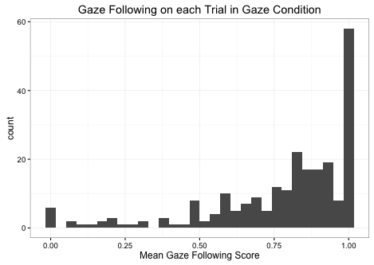

Figure 1. Proportion of time spent looking at the target of gaze on exposure trials.

The side-by-side histograms in Figure 2 display accuracy on each exposure trial. Accuracy is defined as the amount of time spent looking at the object that would subsequently be “kept” in the following test trial. As explained above in the Methods section of this paper, the “kept” object appeared 50% of the time as the leftmost object on exposure trials and 50% of the time as the rightmost object. Furthermore, on the *gaze* condition, the “kept” object was 50% of the time the target of the face’s gaze and 50% of the time the non-target object. The order of trials was randomized for each participant. The *gaze* condition histogram in Figure 2 has a bimodal distribution, which is consistent with predicted gaze-following behavior. The exposure trials in which participants had near 100% accuracy reflect the situation in which participants followed gaze to the “kept” object, allocating almost 100% of their attention to that object. The trials in which participants had near 0% accuracy reflect the situation in which the participants followed gaze to the object that was not “kept”, allocating almost none of their attention to the “kept” object. The *no-gaze* condition histogram acts as a control, displaying a roughly normal distribution, consistent with our prediction that participants in the *no-gaze* condition would distribute their attention roughly equally between the two objects on exposure. While allocating nearly 100% or 0% of one’s attention to the “kept” object is common in the *gaze* condition, it is rare in the *no-gaze* condition; on the other hand, it is common for participants in the *no-gaze* condition to allocate closer to 50% of attention to the “kept” object, and rare for participants in the *gaze* condition to do so.

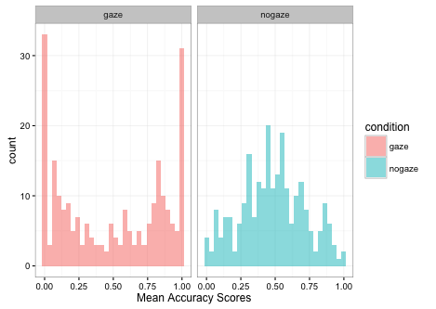

Figure 2. Proportion of time spent looking at the "kept" object on exposure trials in both conditions.

## Test Trials

Accuracy is defined for test trial analysis as the proportion of time spent looking at the “kept” object. Figure 3 shows the mean accuracy in both conditions across all test trials and participants, with the dotted line representing chance performance. The mean accuracy was .689 for the gaze condition and .659 for the no-gaze condition; a t-test revealed no significant difference between the two means (t = 1.168).

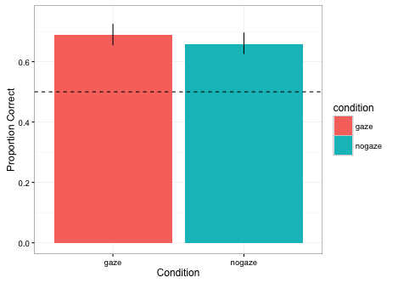

Figure 3. Mean accuracy on test trials in both conditions.

Figures 4 displays accuracy on test trials plotted as a function of accuracy on the corresponding exposure trial. For clarity, a linear regression is fitted to the data and a dotted line representing chance performance is shown. Both conditions show positive slopes overall, indicating a positive correlation between looking time at the “kept” object during exposure and looking time at the “kept” object during testing. Notably, in both conditions, complete failure to look at the “kept” object during exposure results in a mean performance around chance during testing. The distribution of data points differs between conditions. As expected given the bimodal distribution of accuracy during exposure in the *gaze* condition and the roughly normal distribution of accuracy during exposure in the *no-gaze* condition, the data points for the *gaze* condition are concentrated towards the side of the plot, while those for the *no-gaze* condition are concentrated towards the center.

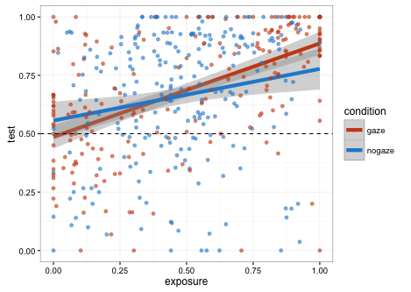

Figure . Performance on test trials as a function of performance on exposure trials, fitted with a linear regression.

Figure 5 displays the same data as does Figure 4, but fitted with a local polynomial regression instead of a linear regression. [explain why this matters]

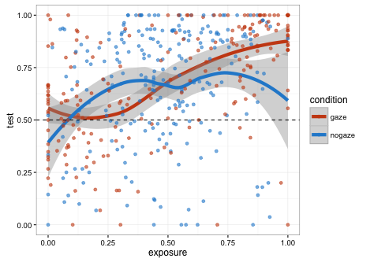

Figure . Performance on test trials as a function of performance on exposure trials, fitted with a local polynomial regression.

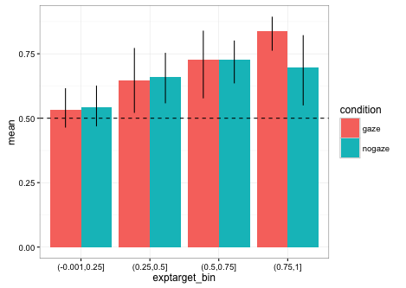

-model 1

-model 2