Quantitative Synthesis of Early Language Acquisition Using Meta-Analysis

Molly Lewis1, Mika Braginsky2, Sho Tsuji, Christina Bergmann3,

Page Piccinini4, Alejandrina Cristia3, Michael C. Frank1

1Department of Psychology, Stanford University

2Department of Brain and Cognitive Sciences, MIT

3Laboratoire de Sciences Cognitives et Psycholinguistique, ENS

4NeuroPsychologie Interventionnelle, ENS

Author note

Correspondence concerning this article should be addressed to Molly Lewis, Psychology

Department, Stanford University. 450 Serra Mall, Stanford, CA 94305. E-mail:

mll@stanford.edu.

Abstract

To acquire a language, children must learn a range of skills, from the sounds of their language to the meanings of words. These skills are typically studied in isolation in separate research programs, but there is a growing body of evidence that these skills may depend on each other in acquisition (e.g., Feldman, Myers, White, Griffiths, & Morgan, 2013; Johnson, Demuth, Jones, & Black, 2010; Shukla, White, & Aslin, 2011). We suggest that the meta-analytic method can support the process of building theories that take a systems-level perspective, as well as provide a tool for detecting bias in a literature. Here we present meta-analyses of 12 phenomena in language acquisition, with over 800 effect sizes. We find that the language acquisition literature overall has a high degree of evidential value. We then present a quantitative synthesis of language acquisition phenomena that suggests interactivity across the system.

*Keywords:* developmental psychology, language acquisition, quantitative theories, meta-analysis

Word count: 4, 603

\body

Children beginning to acquire a language must learn its sounds, its word forms, and their meanings, and a number of other component skills of language understanding and use. A synthetic theory that explains the inputs, mechanisms, and timeline of this process is an aspirational goal for the field of early language learning. One important aspect of such a theory is an account of how the acquisition of individual skills depends on others. For example, to what extent must the sounds of a language be mastered prior to learning word meanings? Although a huge body of research addresses individual aspects of early language learning (see e.g., Kuhl 2004 for review), only a small amount of work addresses the question of relationships between different skills (e.g., Feldman et al. 2013; Johnson et al. 2010; Shukla, White, and Aslin 2011). Yet if such relationships exist, they should play a central role in our theories.

The effort to build synthetic theories is further complicated by the fact that there is often uncertainty about the developmental trajectory of individual skills. Developmental trajectories are typically communicated via verbal (often binary) summaries of a set of variable experimental findings (e.g., "by eight months, infants can segment words from fluent speech"). In the case of contradictory findings then, theorists may be uncertain about which experimental findings can be used to constrain the theory, and often must resort to verbal discounting of one finding or the other based on methodological or theoretical factors. Resolving this issue requires a method for synthesizing findings in a more systematic and principled fashion.

We suggest that a solution to both of these challenges---building integrative whole-system views and evaluating evidential strength in a field of scientific research---is to describe experimental findings in quantitative, rather than qualitative, terms. Quantitative descriptions allow for the use of quantitative methods for aggregating experimental findings in order to evaluate evidential strength. In addition, describing experimental findings as quantitative estimates provides a common language for comparing across phenomena, and a way to make more precise predictions. In this paper, we consider the domain of language acquisition and demonstrate how the quantitative tools of meta-analysis can support theory building in psychological research.

Meta-analysis is a quantitative method for aggregating across experimental findings (Hedges and Olkin 2014; Glass 1976). The fundamental unit of meta-analysis is the *effect size*: a scale-free, quantitative measure of "success" in a phenomenon. Importantly, an effect size provides an estimate of the size of an effect, as well as a measure of uncertainty around this point estimate. With this quantitative measure, we can apply the same reasoning we use to aggregate noisy measurements over participants in a single study: By assuming each study, rather than participant, is sampled from a population, we can appeal to a statistical framework to combine estimates of the effect size for a given phenomenon.

Meta-analytic methods can support theory building in several ways. First, they provide a way to evaluate which effects in a literature are most likely to be observed consistently, and thus should constrain the theory. This issue is particularly important in light of recent evidence that an effect observed in one study may be unlikely to replicate in another (Ebersole et al. 2015; Open Science Collaboration 2012; Open Science Collaboration 2015). Failed replications are difficult to interpret, however, because they may result from a wide variety of causes, including an initial false positive, a subsequent false negative, or differences between initial and replication studies, such that making causal attributions in a situation with two conflicting studies is often difficult (Gilbert et al. 2016; Anderson et al. 2016). By aggregating evidence across studies and assuming that there is some variability in true effect size from study to study, meta-analytic methods can provide a more veridical description of the empirical landscape, which in turn leads to better theory-building.

Second, meta-analysis supports theory building by providing higher fidelity descriptions of phenomena. Given an effect size estimate, meta-analytic methods provide a method for quantifying the amount variability around this point estimate. Furthermore, the quantitative framework allows researchers to measure potential moderators in effect size. This ability is particularly important for developmental phenomena because building a theory requires a precise description of changes in effect size across development. Individual papers typically describe an effect size for 1-2 age groups, but the ultimate goal for the theorist is to detect a moderator---age---in this effect. Given that moderators always require more power to detect (Button et al. 2013), it may be quite difficult to identify size from individual papers. By aggregating across papers using meta-analytic methods, however, we may be better able to detect these changes, leading to more precise description of the empirical phenomena.

Finally, effect size estimates also provide a common language for comparing across phenomena. In the current work, this common language allows us to consider the relationship between different phenomena in the language acquisition domain ("meta-meta-analysis"). Through cross-phenomenon comparisons, we can understand not only the trajectory of a particular phenomenon, such as word learning, but also how the trajectory of each phenomenon might relate to other skills, such as sound learning, gaze following, and many others. This more holistic description of the empirical landscape can inform theories about the extent to which there is interdependence between the acquisition of different linguistic skills.

Meta-analytic methods can be applied to any literature, but we believe that developmental research provides a particularly important case where they can contribute to theory development. One reason is that developmental studies may be uniquely vulnerable to false findings because collecting data from children is expensive, and thus sample sizes are often small and studies are underpowered. In addition, the high cost and practical difficulties associated with collecting large developmental datasets means that replications are relatively rare in the field. Meta-analysis provides a method for addressing these issues by harnessing existing data to estimate effect sizes and developmental trends.

We take as our ultimate goal a broad theory of language acquisition that can explain and predict the range of linguistic skills a child acquires. As a first step toward this end, we collected a dataset of effect sizes in the language acquisition literature across 12 phenomena (Metalab; <http://metalab.stanford.edu>). We use this dataset to demonstrate how meta-analysis supports building this theory in two ways. We first use meta-analytic techniques to evaluate the evidential value of the empirical landscape in language acquisition research. We find broadly that this literature has strong evidential value, and thus that the effects reported in the literature should constrain our theorizing of language acquisition. We then turn toward the task of synthesizing these findings across phenomena and offer a preliminary, quantitative synthesis.

Method

We analyzed 12 different phenomena in language acquisition (Table 1). These phenomena cover development at many different levels of linguistic representation and processing, from the acquisition of prosody and phonemic contrasts, to gaze following in communicative interaction. This wide range of phenomena allowed us to compare the course of development across different domains, as well as to explore questions about the interactive nature of language acquisition. We selected these particular phenomena because of their theoretical importance or because a previously-published meta-analysis already existed.

To obtain estimates of effect size, we either coded or adapted others’ coding of papers reporting experimental data (see SI for details[1]). Within each paper, we calculated a separate effect size estimate for each experiment and age group (we refer to each measurement separated by age as a "condition"). In total, our sample includes estimates from 228 papers, 808 different conditions and 9,799 participants. The process for selecting papers from the literature differed by domain, with some individual meta-analyses using more systematic approaches than others (see SI for specific search strategies). Nevertheless, meta-analytic methods for aggregating even the smallest sample of studies are likely to be less biased than qualitative methods (Valentine, Pigott, and Rothstein, 2010)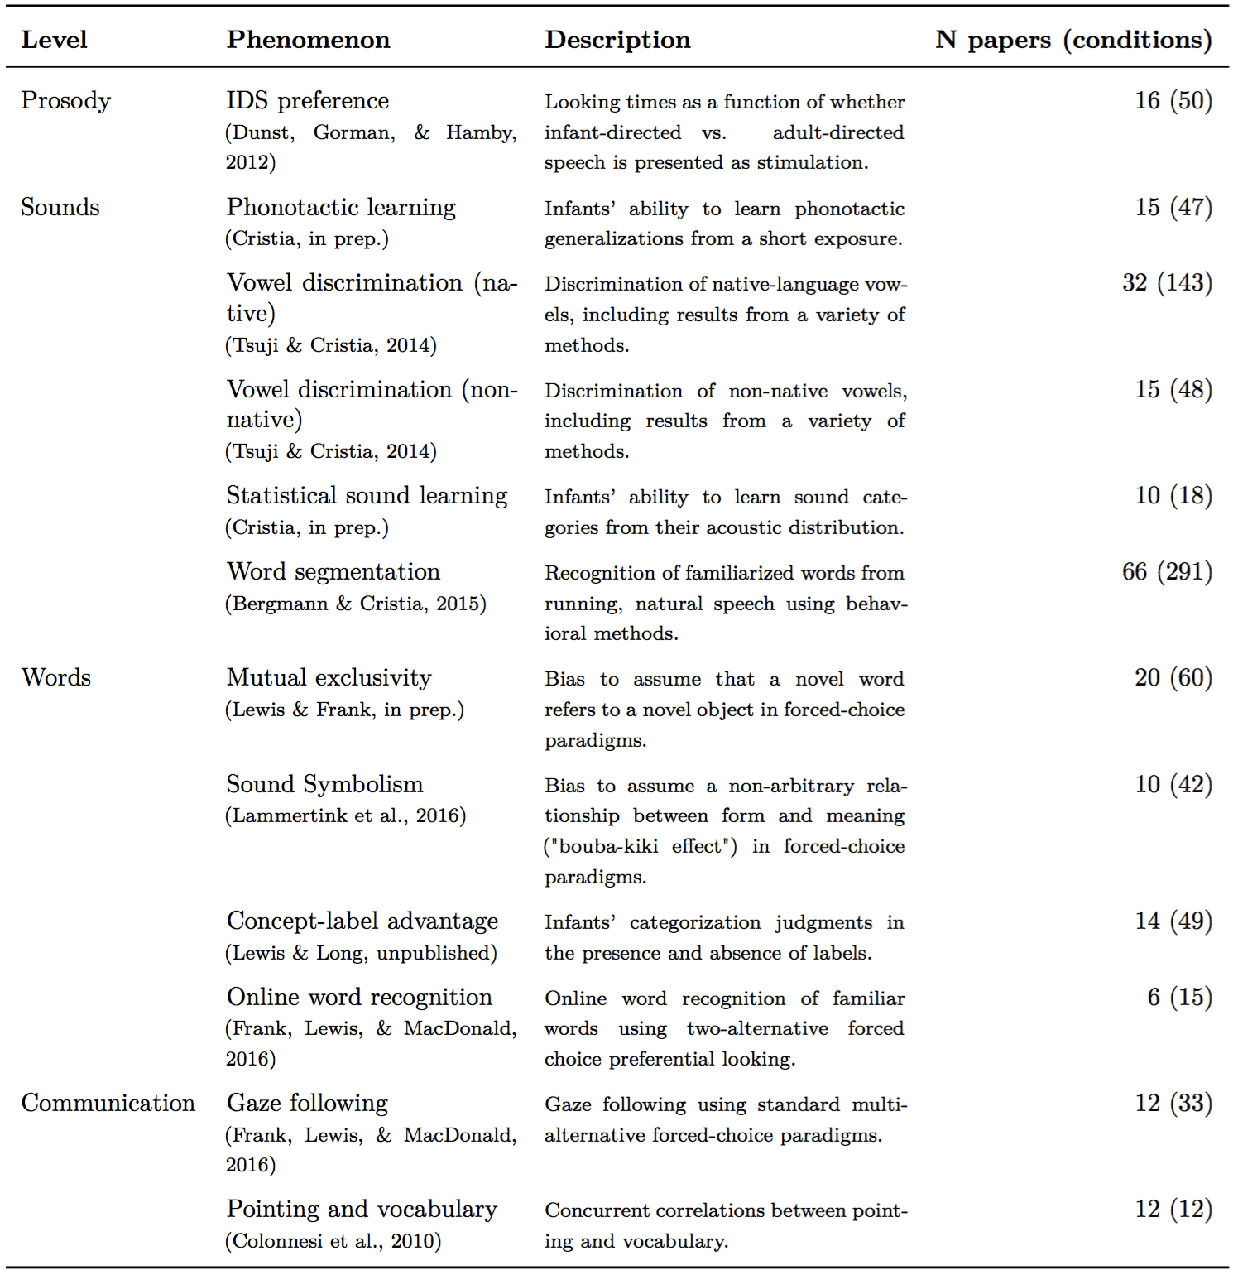*Table 1: Overview of meta-analyses in dataset.*

Replicability of the field

To assess the replicability of language acquisition phenomena, we conducted several diagnostic analyses: Meta-analytic estimates of effect size, fail-safe-N (Orwin 1983), funnel plots, and p-curve (Simonsohn, Nelson, and Simmons 2014b; Simonsohn, Nelson, and Simmons 2014a; Simonsohn, Simmons, and Nelson 2015). These analytical approaches each have limitations, but taken together, they provide converging evidence about whether an effect is likely to exist, and the extent to which publication bias and other questionable research practices are present in the literature. Overall, we find most phenomena in the language acquisition literature have evidential value, and can therefore provide the basis for theoretical development. We also find evidence for some bias, as well as evidence that two phenomena---phonotactic learning and statistical sound learning---likely describe null or near-null effects.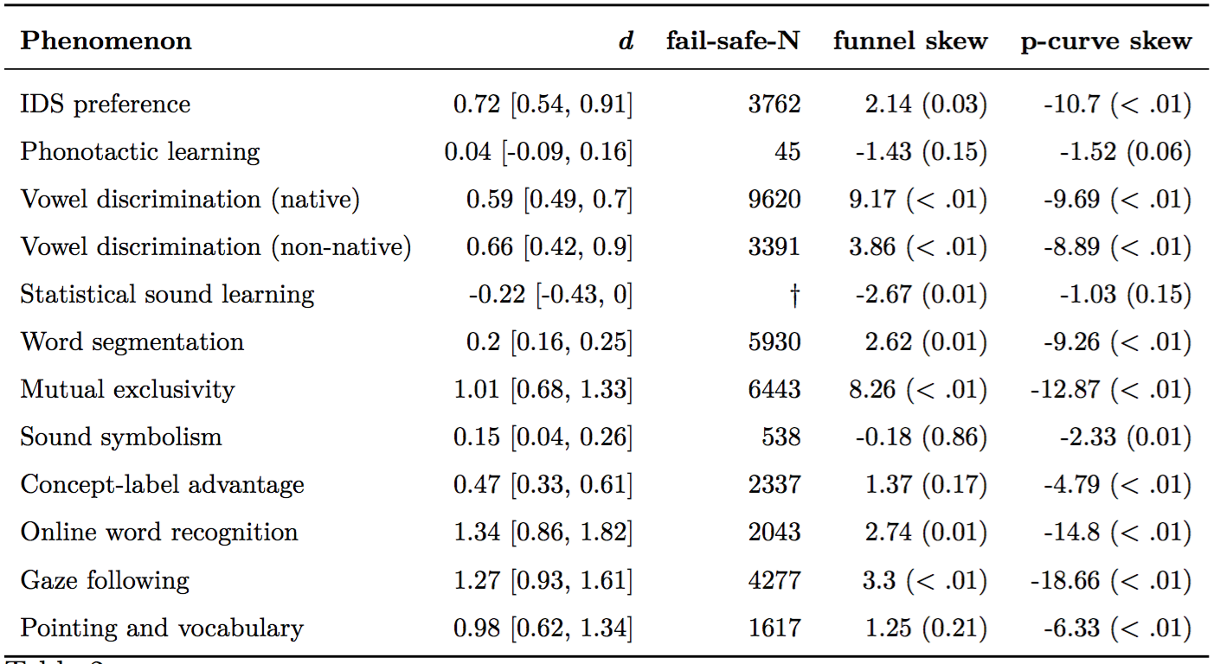

*Table 2: Summary of replicability analyses. d = Effect size (Cohen’s d) estimated random-effect model; fail-safe-N = number of missing studies that would order for the overall effect size to be d = 0; funnel skew = test of asymmetry in funnel plot using the random-effect Egger’s test (Sterne & Egger, 2005); p-curve skew = test of the right skew of the p-curve using the Stouffer method (Simonsohn, Simmons, & Nelson, 2015); Brackets give 95% confidence intervals, and parentheses show p-values.* †*Fail-safe-N is not available here because the meta-analytic effect size estimate is less than 0.*

*Meta-Analytic Effect Size*

To estimate the overall effect size of a literature, effect sizes are pooled across papers to obtain a single meta-analytic estimate. This meta-analytic effect-size can be thought of as the "best estimate" of the effect size for a phenomenon given all the available data in the literature. Table 2, column 2 presents meta-analytic effect size estimates for each of our phenomena. We find evidence for a non-zero effect size in 10 out of 12 of the phenomena in our dataset, suggesting these literatures describe non-zero effects. In the case of phonotactic learning and sound category learning, however, we find that the meta-analytic effect size estimate does not differ from zero, indicating that these literatures do not describe robust effects (as first reported in Cristia, in prep.).

We next turn to methods of assessing evidential value that describe the degree to which a literature has evidential value, and thus the degree to which it should constrain our theory building. In the following three analyses---fail-safe-N, funnel plots, and p-curves---we attempt to quantify the evidential value of these literatures.

*Fail-safe-N*

One approach for quantifying the reliability of a literature is to ask, How many missing studies with null effects would have to exist in the "file drawer" in order for the overall effect size to be zero? This is called the "fail-safe" number of studies (Orwin 1983). This number provides an estimate of the size and variance of an effect using the intuitive unit of number of studies. To calculate this effect, we estimated the overall effect size for each phenomenon (Table 2, column 2), and then used this to estimate the fail-safe-N (Table 2, column 3).

Because of the large number of positive studies in many of the meta-analyses we assessed, this analysis suggests a very large number of studies would have to be "missing" in each literature ( = 3,637) in order for the overall effect sizes to be 0. Thus, while it is possible that some reporting bias is present in the literature, the overall large fail-safe-N suggests that the literature nonetheless likely describes robust effects.

This analysis provides a quantitative estimate of the size of an effect in an intuitive unit, but it does not assess analytical or publication bias (Scargle 2000). Importantly, if experimenters are exercising analytical flexibility through practices like selective reporting of analyses or p-hacking, then the number and magnitude of observed true effects in the literature may be greatly inflated. In the next analysis, we assess the presence of bias through funnel plots.

*Funnel Plots*

Funnel plots provide a visual method for evaluating whether variability in effect sizes is due only to differences in sample size. A funnel plot shows effect sizes versus a metric of sample size, standard error. If there is no bias in a literature, we should expect studies to be randomly sampled around the mean, with more variability for less precise studies.

Figure 1 presents funnel plots for each of our 12 meta-analyses. These plots show evidence of asymmetry (bias) for several of our phenomena (Table 2, column 4). However, an important limitation of this method is that it is difficult to determine the source of this bias. One possibility is that this bias reflects true heterogeneity in phenomena (e.g., different ages).[2] P-curve analyses provide one method for addressing this issue, which we turn to next.

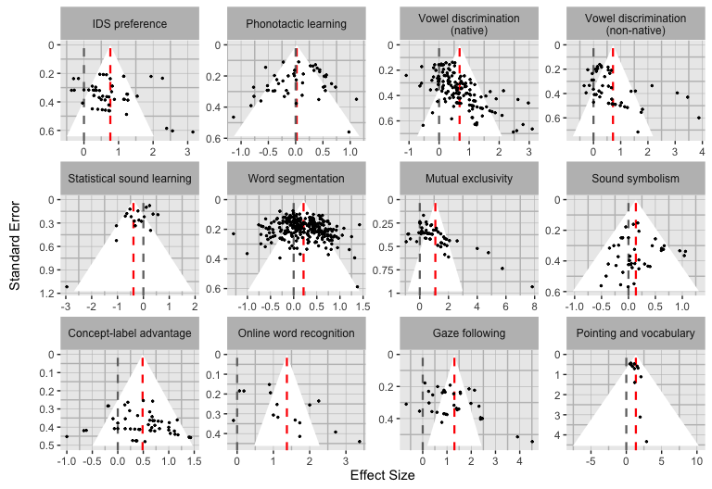

Figure 1: Funnel plots for each meta-analysis. Each effect size estimate is represented by a point, and the mean effect size is shown as a red dashed line. The grey dashed line shows an effect size of zero. The funnel corresponds to a 95% CI around this mean. In the absence of true heterogeneity in effect sizes (no moderators) and bias, we should expect all points to fall inside the funnel.

P-curves

A p-curve is the distribution of p-values for the statistical test of the main hypothesis across a literature (Simonsohn, Nelson, and Simmons 2014b; Simonsohn, Nelson, and Simmons 2014a; Simonsohn, Simmons, and Nelson 2015). Critically, if there is a robust effect in the literature, the shape of the p-curve should reflect this. In particular, we should expect the p-curve to be right-skewed with more small values (e.g., .01) than large values (e.g., .04). An important property of this analysis is that we should expect this skew independent of any true heterogeneity in the data, such as age. Evidence that the curve is in fact right-skewed would suggest that the literature is not biased, and that it provides evidential value for theory building.

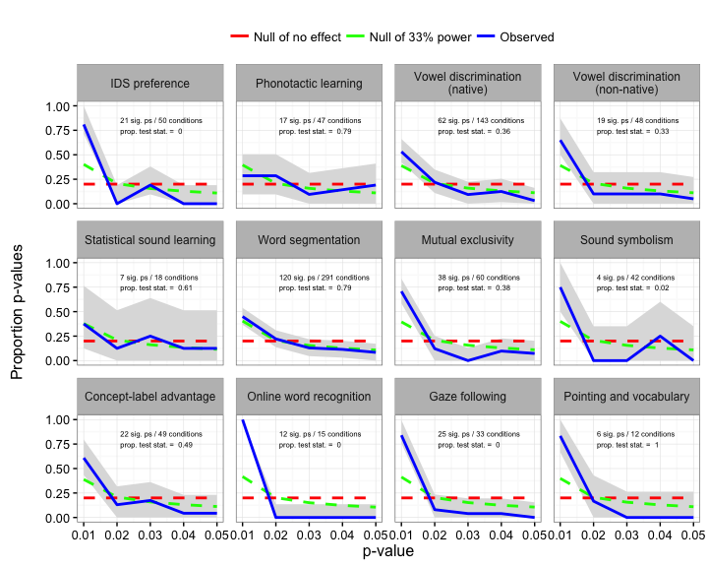

Figure 2: P-curve for each meta-analysis (Simonsohn, Nelson, & Simmons, 2014). In the absence of p-hacking, we should expect the observed p-curve (blue) to be right-skewed (more small values). The red dashed line shows the expected distribution of p-values when the effect is non-existent (the null is true). The green dashed line shows the expected distribution if the effect is real, but studies only have 33% power. Grey ribbons show 95% confidence intervals estimated from a multinomial distribution. Text on each plot shows the number of p-values for each dataset that are less than .05 and thus are represented in each p-curve ("sig. ps"), relative to the total number of conditions for that phenomenon. Each plot also shows the proportion of p-values that were derived from test statistics reported in the paper ("prop. test stat."); all others were derived by conducting analyses on the descriptive statistics or transforming reported effect sizes.

P-values for each condition were calculated based on the reported test statistic. However, test statistics were not available for many conditions, either because they were not reported or because they were not coded. To remedy this, we also calculated p-values indirectly based on descriptive statistics (means and standard deviations; see SI for details).

Figure 2 shows p-curves for each of our 12 meta-analyses. All p-curves show evidence of right skew, with the exception of phonotactic learning and statistical sound learning (Table 2, column 5). This pattern did not differ when only reported test-statistics were used to calculate p-curves (see SI).

In sum, then, meta-analytic methods, along with our dataset of effect sizes, provide an opportunity to assess the replicability of the field of language acquisition. Across a range of analyses, we find that this literature shows some evidence for bias, but overall, it is quite robust.

Quantitative Evaluation of Theories

Next, we turn to how these data can be used to constrain and develop theories of language acquisition.

Meta-analytic methods provide a precise, quantitative description of the developmental trajectory of individual phenomena. Figure 3 presents the developmental trajectories of the phenomena in our dataset at each level in the linguistic hierarchy. By describing how effect sizes change as a function of age, we can begin to understand what factors might moderate that trajectory, such as aspects of a child's experience or maturation. For example, the meta-analysis on mutual exclusivity (the bias for children to select a novel object, given a novel word; Markman and Wachtel 1988) suggests a steep developmental trajectory of this skill. We then can use these data to build quantitative models to understand how aspects of experience (e.g., vocabulary development) or maturational constraints may be related to this trajectory (e.g., Frank, Goodman, and Tenenbaum 2009; McMurray, Horst, and Samuelson 2012).

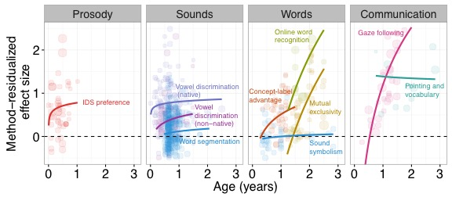

Figure 3: Method-residualized effect size plotted as a function of age across the 10 meta-analyses in our dataset shown to have evidential value (excluding phonotactic learning and sound category learning). Lines show logarithmic model fits. Each point corresponds to a condition, with the size of the point indicating the number of participants.

In addition, meta-analytic methods provide an approach for synthesizing across different linguistic skills via the language of effect sizes. The ultimate goal is to use meta-analytic data to build a single, quantitative model of the language acquisition system, much like those developed for individual language acquisition phenomena, like word learning. Developing a single quantitative model is a lofty goal, however, and will likely require much more precise description of the phenomena than is available in our dataset. Nevertheless, we can use our data to distinguish between broad meta-theories about the interdependency of skills.

We first consider two intuitive theories of task-to-task dependencies that have been articulated in a number of forms. The stage-like theory proposes that linguistic skills are acquired sequentially beginning with skills at the lowest level of the linguistic hierarchy. Under this theory, once a skill is mastered, it can be used to support the acquisition of skills higher in the linguistic hierarchy. In this way, a child sequentially acquires the skills of language, "bootstrapping" from existing knowledge at lower levels to new knowledge at higher levels. There is a wide range of evidence consistent with this view. For example, there is evidence that prosody supports the acquisition of sound categories (e.g., Werker et al. 2007), word boundaries (e.g., Jusczyk, Houston, and Newsome 1999), grammatical categories (e.g., Shi, Werker, and Morgan 1999), and even word learning (e.g., Shukla, White, and Aslin 2011).



Figure 4: The left two panels show the developmental trajectories predicted under different meta-theories of language acquisition. The stage-like theory predicts that a child will not begin learning the next skill in the linguistic hierarchy until the previous skill has been mastered. The interactive theory predicts that multiple skills may be simultaneously acquired. The third panel shows other possible developmental trajectories (decreasing, linear, and non-monotonic). The fourth panel shows the observed meta-analytic data. Effect size is plotted as a function of age from 0-3 years, across 10 different phenomena (excluding phonotactic learning and sound category learning). Model fits are the same as in Figure 3. These developmental curves suggest there is interactivity across language skills, rather than stage-like learning of the linguistic hierarchy.

A second possibility is that there is interactivity in the language system such that multiple skills are learned simultaneously across the system. For example, under this proposal, a child does not wait to begin learning the meanings of words until the sounds of a language are mastered; rather, the child is jointly solving the problem of word learning in concert with other language skills. This possibility is consistent with predictions of a class of hierarchical Bayesian models that suggest that more abstract knowledge may be acquired quickly, before lower-level information, and may in turn support the acquisition of lower information ("blessing of abstraction," Goodman, Ullman, and Tenenbaum 2011). There is evidence for this proposal from work that suggests word learning supports the acquisition of lower-level information like phonemes (Feldman et al. 2013). More broadly, there is evidence that higher-level skills like word learning may be acquired relatively early in development, likely before lower level skills have been mastered (e.g., Bergelson and Swingley 2012; Tincoff and Jusczyk 1999).

These two theories make different predictions about relative trajectories of skills across development. Within the meta-analytic framework, we can represent these different trajectories schematically by plotting the effect sizes for different skills across development. In particular, the bottom-up theory predicts serial acquisition of skills (Figure 4; left) while the interactive theory predicts simultaneous acquisition (left center). We can also specify many other possible trajectories by varying the functional form and parameters of the model. Figure 4 ("Ad hoc"; right center) shows several other possible trajectories. For example, a skill might have a non-monotonic trajectory, increasing with age, and then decreasing. By specifying the shape of these developmental trajectories and the age at which acquisition begins, we can consider many patterns of developmental trajectories, and how these different patterns, in turn, constrain our meta-theories of development.

Our data allow us to begin to differentiate between this space of theories. Figure 4 (right) presents a synthetic representation of the developmental trajectories of the skills in our dataset with literatures shown to have evidential value (all but phonotactic learning and sound category learning). We find strong evidence for the simultaneous acquisition of skills---children begin learning even high-level skills, like the meanings of words, early in development, and even low-level skills like sound categories show a protracted period of development. This pattern is consistent with an interactive theory of language acquisition, and at least prima facie inconsistent with stage-like theories. In future research, we can use this approach to distinguish between a larger space of meta-theories and, ultimately, refine our way towards a single quantitative theory of language acquisition.

Discussion

Building a theory of a complex psychological phenomenon requires making good inductive inferences from the available data. Meta-analysis can support this process by providing a toolkit for quantitative description of individual behaviors and their relationship to important moderators (e.g., age, in our case). Here, we apply the meta-analytic toolkit to the domain of language acquisition---a domain where there are concerns of replicability, and where high-fidelity data are needed for theory building. We find that the existing literature in this domain describes mostly robust phenomena and thus should form the basis of theory development. We then aggregate across phenomena to offer the first quantitative synthesis of the field. We find evidence that linguistic skills are acquired interactively rather than in a stage-like fashion.

In this paper, we focused on theoretical motivations for building meta-analysis, but naturally, there are many other practical reasons for conducting a quantitative synthesis. For example, when planning an experiment, an estimate of the size of an effect on the basis of prior literature can inform the sample size needed to achieve a desired level of power. Meta-analytic estimates of effect sizes can also aid in design choices: If a certain paradigm or measure tends to yield overall larger effect sizes than another, the strategic researcher might select this paradigm in order to maximize the power achieved with a given sample size. These and other advantages, illustrated with the same database used here, are explained in Bergmann et al. (in prep.).

Despite its potential, there are a number of important limitations to the meta-analytic method as tool for theory building in psychological research. One challenging issue is that in many cases method and phenomenon are confounded. This is problematic because a method with less noise than another will produce a bigger effect size for the same phenomenon. As a result, it is difficult to determine the extent to which a difference in effect size between two phenomena is due to an underlying difference in the phenomena, or merely to a difference in they way it was tested. While method may account for some variability in our dataset, we find that method does not have a large impact on effect size for phenomena, relative to other moderators like age (see SI). Nevertheless, the covariance between method and phenomenon in our dataset limits our ability to directly compare effect sizes across phenomena.

Second, meta-analysis, like all analysis methods, requires the researcher to make analytical decisions, and these decisions may be subject to the biases of the researcher. We believe that a virtue of the current approach is that we have applied the same analytical method across all phenomena we examined, thus limiting our “degrees of freedom” in the analysis. However, in some cases this uniform approach to data analysis means that we are unable to take into consideration aspects of a particular phenomenon that might be relevant. For example, in a stand-alone meta-analysis on vowel discrimination, Tsuji and Cristia (2014) elected only to include papers that tested at least two different age groups as a way of focusing on age differences while controlling for other possible differences between experiments. Others however might have reasonably dealt with this issue in another way, by normalizing effect sizes across methods, for example. Notably, this analytical decision has consequences for interpretation: Tsuji and Cristia (2014) found a moderate decrease in effect size with age for non-native vowel discrimination, while the current analysis suggests a moderate increase. We believe that the systematic, uniform analytical approach used here is the most likely to minimize bias by the researcher and reveal robust psychological phenomena. However, there may be cases where this one-size-fits-all approach is inappropriate, particularly in meta-analyses with high heterogeneity.

There are also limits to this method for inferring a meta-theory of language acquisition. Meta-theories of language acquisition suggest a particular causal relationship between different skills and how they change over development. For example, the interactive theory suggests that skills at higher levels support the acquisition at lower levels, even before skills at lower levels are mastered. In the meta-analytic framework, this predicts that there should be simultaneous development of skills across the language hierarchy---as we observe in the current work. Importantly, however, this analysis is inherently correlational, and therefore we cannot directly infer a causal relationship between acquisition at lower levels and acquisition at higher levels. That is, while the observed pattern is consistent with the interactive theory, it is also possible that there is no causal relationship between skills across the language hierarchy, merely parallel trajectories of acquisition. For this reason, experimental work must go hand-in-hand with meta-analysis to address causal questions.

Finally, there are a number of important limitations to the meta-analytic method more broadly. One issue is that the method relies on researchers conducting replications of the same study across a range of ages and, critically, reporting these data so that they can be used in meta-analyses. To the extent that researchers do not conduct these studies, or report the necessary statistics in their write-ups (e.g., means and standard deviations), the meta-analytic method cannot be applied. In addition, the meta-analytic method, as in the case of qualitative forms of synthesis (e.g., literature review), is limited by the potential presence of bias, which can come from a range of sources including non-representative participant populations, failure to publish null findings, and analytical degrees-of-freedom. To the extent these biases are present in the literature, methods of synthesizing these findings will also be biased.

In sum, understanding the psychological mechanisms underlying complex phenomena is a difficult inferential task: The researcher must develop a predictive and explanatory theory on the basis of limited and noisy experimental data. Here we have focused on language acquisition as a case study of how meta-analytic methods can be productively leveraged as a tool for theory building. Meta-analytic methods allow the researcher to determine whether phenomena are robust, synthesize across contradictory findings, and ultimately, build an integrative theory across phenomena. Moving forward, we see meta-analysis as a powerful tool in the researcher’s toolkit for developing quantitative theories to account for complex psychological phenomena.

\body

Author Contributions

ML, ST, CB, PP, AC, and MF wrote the paper. ML, ST, CB, AC, and MF coded papers for the meta-analytic dataset. All authors contributed to data analysis. MB, MF, and ML developed the Metalab website infrastructure.

References

Anderson, Christopher J, Štěpán Bahník, Michael Barnett-Cowan, Frank A Bosco, Jesse Chandler, Christopher R Chartier, Felix Cheung, et al. 2016. “Response to Comment on ‘Estimating the Reproducibility of Psychological Science’.” *Science* 351 (6277). American Association for the Advancement of Science: 1037–7.

Bergelson, Elika, and Daniel Swingley. 2012. “At 6–9 Months, Human Infants Know the Meanings of Many Common Nouns.” *Proceedings of the National Academy of Sciences* 109 (9). National Acad Sciences: 3253–8.

Bergmann, Christina, and Alejandrina Cristia. 2015. “Development of Infants’ Segmentation of Words from Native Speech: A Meta-Analytic Approach.” *Developmental Science*. Wiley Online Library.

Bergmann, Christina, Sho Tsuji, Page Piccinini, Molly Lewis, Mika Braginsky, Michael Frank, and Alejandrina Cristia. in prep. “Building Broad-Shouldered Giants: Synthesizing Studies to Plan for Reproducible Research.”

Button, Katherine S, John PA Ioannidis, Claire Mokrysz, Brian A Nosek, Jonathan Flint, Emma SJ Robinson, and Marcus R Munafò. 2013. “Power Failure: Why Small Sample Size Undermines the Reliability of Neuroscience.” *Nature Reviews Neuroscience* 14 (5). Nature Publishing Group: 365–76.

Colonnesi, Cristina, Geert Jan JM Stams, Irene Koster, and Marc J Noom. 2010. “The Relation Between Pointing and Language Development: A Meta-Analysis.” *Developmental Review* 30 (4). Elsevier: 352–66.

Cristia, Alejandrina. in prep. “Infants’ Phonology Learning in the Lab.”

Dunst, Carl, Ellen Gorman, and Deborah Hamby. 2012. “Preference for Infant-Directed Speech in Preverbal Young Children.” *Center for Early Literacy Learning* 5 (1).

Ebersole, CR, OE Atherton, AL Belanger, HM Skulborstad, RB Adams, J Allen, and BA Nosek. 2015. “Many Labs 3: Evaluating Participant Pool Quality Across the Academic Semester via Replication.” *Journal of Experimental Social Psychology*.

Feldman, Naomi H, Emily B Myers, Katherine S White, Thomas L Griffiths, and James L Morgan. 2013. “Word-Level Information Influences Phonetic Learning in Adults and Infants.” *Cognition* 127 (3). Elsevier: 427–38.

Frank, Michael C, Noah D Goodman, and Joshua B Tenenbaum. 2009. “Using Speakers’ Referential Intentions to Model Early Cross-Situational Word Learning.” *Psychological Science* 20 (5). SAGE Publications: 578–85.

Frank, Michael C, Molly Lewis, and Kyle MacDonald. 2016. “A Performance Model for Early Word Learning.” In *Proceedings of the 38th Annual Conference of the Cognitive Science Society*.

Gilbert, Daniel T., Gary King, Stephen Pettigrew, and Timothy D. Wilson. 2016. “Comment on Estimating the Reproducibility of Psychological Science.” *Science* 351 (6277). American Association for the Advancement of Science: 1037–7. doi:[10.1126/science.aad7243](https://doi.org/10.1126/science.aad7243).

Glass, Gene V. 1976. “Primary, Secondary, and Meta-Analysis of Research.” *Educational Researcher* 5 (10). JSTOR: 3–8.

Goodman, Noah D, Tomer D Ullman, and Joshua B Tenenbaum. 2011. “Learning a Theory of Causality.” *Psychological Review* 118 (1). American Psychological Association: 110.

Hedges, Larry V, and Ingram Olkin. 2014. *Statistical Methods for Meta-Analysis*. Academic press.

Johnson, Mark, Katherine Demuth, Bevan Jones, and Michael J Black. 2010. “Synergies in Learning Words and Their Referents.” In *Advances in Neural Information Processing Systems*, 1018–26.

Jusczyk, Peter W, Derek M Houston, and Mary Newsome. 1999. “The Beginnings of Word Segmentation in English-Learning Infants.” *Cognitive Psychology* 39 (3). Elsevier: 159–207.

Kuhl, Patricia K. 2004. “Early Language Acquisition: Cracking the Speech Code.” *Nature Reviews Neuroscience* 5 (11). Nature Publishing Group: 831–43.

Lammertink, I., M. Fort, S. Peperkamp, P. Fikkert, A. Guevara-Rukoz, and S. Tsuji. 2016. “SymBuki: A meta-analysis on the sound-symbolic bouba-kiki effect in infants and toddlers. Poster presented at the XXI Biennial International Congress of Infant Studies, New Orleans, USA.”

Lewis, Molly L, and Michael C Frank. in prep. “Mutual Exclusivity: A Meta-Analysis.”

Lewis, Molly, and Bria Long. unpublished. “Meta-Analysis of the Concept-Label Advantage.”

Markman, E.M., and G.F. Wachtel. 1988. “Children’s Use of Mutual Exclusivity to Constrain the Meanings of Words.” *Cognitive Psychology* 20 (2). Elsevier: 121–57.

McMurray, Bob, Jessica S Horst, and Larissa K Samuelson. 2012. “Word Learning Emerges from the Interaction of Online Referent Selection and Slow Associative Learning.” *Psychological Review* 119 (4). American Psychological Association: 831.

Open Science Collaboration. 2012. “An Open, Large-Scale, Collaborative Effort to Estimate the Reproducibility of Psychological Science.” *Perspectives on Psychological Science* 7 (6). Sage Publications: 657–60.

———. 2015. “Estimating the Reproducibility of Psychological Science.” *Science* 349 (6251). American Association for the Advancement of Science: aac4716.

Orwin, Robert G. 1983. “A Fail-Safe N for Effect Size in Meta-Analysis.” *Journal of Educational Statistics*. JSTOR, 157–59.

Scargle, Jeffrey D. 2000. “Publication Bias: The ‘File-Drawer Problem’ in Scientific Inference.” *Journal of Scientific Exploration* 14 (1): 91–106.

Shi, Rushen, Janet F Werker, and James L Morgan. 1999. “Newborn Infants’ Sensitivity to Perceptual Cues to Lexical and Grammatical Words.” *Cognition* 72 (2). Elsevier: B11–B21.

Shukla, Mohinish, Katherine S White, and Richard N Aslin. 2011. “Prosody Guides the Rapid Mapping of Auditory Word Forms onto Visual Objects in 6-Mo-Old Infants.” *Proceedings of the National Academy of Sciences* 108 (15). National Acad Sciences: 6038–43.

Simonsohn, Leif D Nelson, and Joseph P Simmons. 2014a. “P-Curve and Effect Size Correcting for Publication Bias Using Only Significant Results.” *Perspectives on Psychological Science* 9 (6). SAGE Publications: 666–81.

———. 2014b. “P-Curve: A Key to the File-Drawer.” *Journal of Experimental Psychology: General* 143 (2). American Psychological Association: 534.

Simonsohn, Joseph P Simmons, and Leif D Nelson. 2015. “Better P-Curves.” *Journal of Experimental Psychology: General*.

Sterne, Jonathan AC, and Matthias Egger. 2005. “Regression Methods to Detect Publication and Other Bias in Meta-Analysis.” *Publication Bias in Meta-Analysis: Prevention, Assessment, and Adjustments*, 99–110.

Tincoff, Ruth, and Peter W Jusczyk. 1999. “Some Beginnings of Word Comprehension in 6-Month-Olds.” *Psychological Science* 10 (2). SAGE Publications: 172–75.

Tsuji, Sho, and Alejandrina Cristia. 2014. “Perceptual Attunement in Vowels: A Meta-Analysis.” *Developmental Psychobiology* 56 (2). Wiley Online Library: 179–91.

Valentine, Jeffrey C, Therese D Pigott, and Hannah R Rothstein. 2010. “How Many Studies Do You Need? A Primer on Statistical Power for Meta-Analysis.” *Journal of Educational and Behavioral Statistics* 35 (2). Sage Publications: 215–47.

Werker, Janet F, Ferran Pons, Christiane Dietrich, Sachiyo Kajikawa, Laurel Fais, and Shigeaki Amano. 2007. “Infant-Directed Speech Supports Phonetic Category Learning in English and Japanese.” *Cognition* 103 (1). Elsevier: 147–62.

1. Supplemental Information available at: http://rpubs.com/mll/synthesis
2. The role of moderators such as age can be interactively explored on the Metalab website (http://metalab.stanford.edu).