**Advanced Modeling of Groundwater Flow (GW3099)**

**Lincoln, Nebraska**

**October 22 - 26, 2018**

Course Instructors:

Mike Fienen, Joe Hughes, Chris Langevin, Eric Morway, Rich Niswonger

# Laptop Requirement

Each course participant is expected to **arrive with a laptop computer that has the required software installed and tested** according to the instructions presented here. Laptop computers should be running the Windows operating system if possible. It is important that you **try this installation as soon as possible** so that there is time to fix any installation problems that occur.

Please contact Chris Langevin ([langevin@usgs.gov](mailto:langevin@usgs.gov)) if your laptop is running a 32-bit version of the Windows operating system or the Mac or Linux operating systems.

If possible, users should have administrator privileges on the laptop in the event that additional software installation is required.

# Software Requirements

We ask that you download the following file, and follow the instructions provided here.

<ftp://ftpext.usgs.gov/pub/er/va/reston/gw3099/gw3099.zip>

Please use the provided installers so that everyone is using the same version.

# Big Picture

We have designed the course files to be structured in the following manner. It’s important that folders are named according to the list below. Unfortunately, these files are very large, in excess of several Gigabytes.

* gw3099 (main directory)
  + installation (Scripts for installing the software. Provided in the zip file.)
  + software (Software and/or installers. Windows versions are provided in the zip file.)
  + Miniconda3 (Python distribution we will use for this class. This folder will be created when you install Miniconda.)
  + gw3099_classrepo.git (course repository mirroring https://github.com/langevin-usgs/gw3099_classrepo. We will use git to download the repository on the first day of class.)
  + working (a working folder)

# Software Installation on Windows

Note: if at any time, you get the following Windows Defender message, press “more info.”

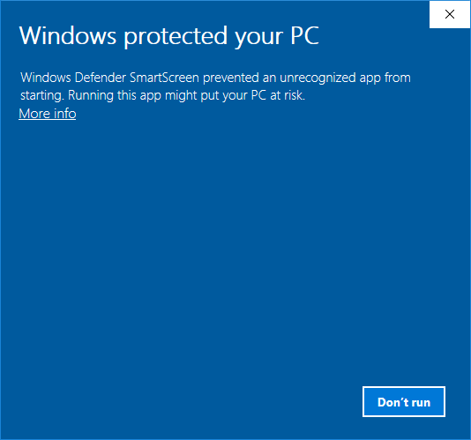

Then you should see the following message. Here you should click the “run anyway” button.

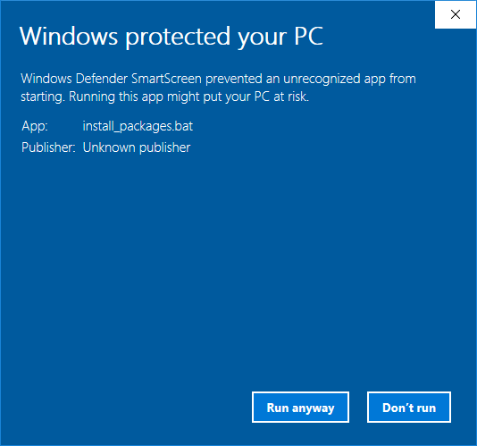

**Step 1:**

Download and unzip the gw3099.zip file available at:

<ftp://ftpext.usgs.gov/pub/er/va/reston/gw3099/gw3099.zip>

**Step 2:**

Navigate to the gw3099\installation folder and double-click on the install_Miniconda.bat batch file. This will install the Miniconda Python distribution into a folder called gw3099\Miniconda3. This may take several minutes, so please wait until the installation is complete. There will be a message saying “hit key to continue” when the Miniconda installation is complete.

**Step 3:**

Navigate to the gw3099\installation folder and double-click on the install_packages.bat batch file. This will install specific python packages that we will be using for the class. This step can take a while (> 15 min) depending on your internet connection, so you may need some patience here. There will be a message saying “hit key to continue” when the package installation is complete.

**Step 4:**

If git is not installed on your laptop, navigate to the gw3099\software folder install git (Git-2.19.0-64-bit.exe). This software will be used to pull class materials from a git repository set up for the class.

# Windows Software Testing

After installing the software, navigate to gw3099\installation and double click on test_install.bat. Alternatively, open a command line in gw3099\installation and run the test_install.bat batch file. The batch file must be run with the user login that you will be using during the class.

The test_install.bat batch file will test that Python and the Python packages that will be used in the class have been correctly installed. Output from the test_install.bat batch file should look like the following:

------------------------------------------------------------------------

GW3099: Advanced Modeling of Groundwater Flow

Checking your python distribution and installed modules.

Evaluating system information

Your python version: 3.6.5 | packaged by conda-forge | (default, Apr 6 2018, 16:13:55) [MSC v.1900 64 bit (AMD64)]

Your platform is: win32

Module available for use: numpy

Module available for use: matplotlib

Module available for use: shutil

Module available for use: subprocess

Module available for use: pandas

Module available for use: platform

Module available for use: shapefile

Module available for use: flopy

Testing matplotlib installation

Done checking...

------------------------------------------------------------------------

Press any key to continue . . .

As a final test, navigate to the gw3099\working folder, and double-click on start_notebook.bat. This should open a terminal window that looks something like the following:

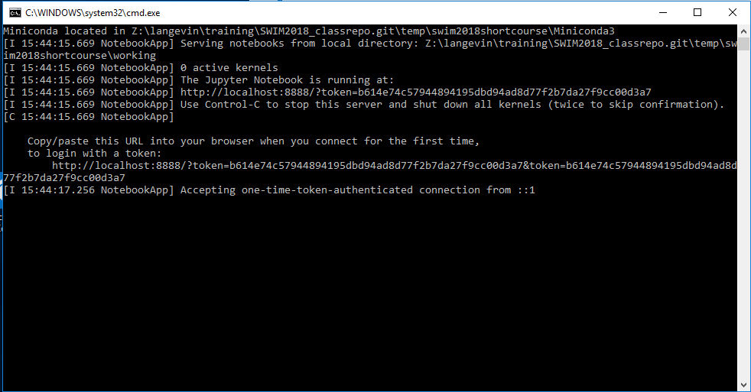

Your default web browser should also open and you should see something like the following:

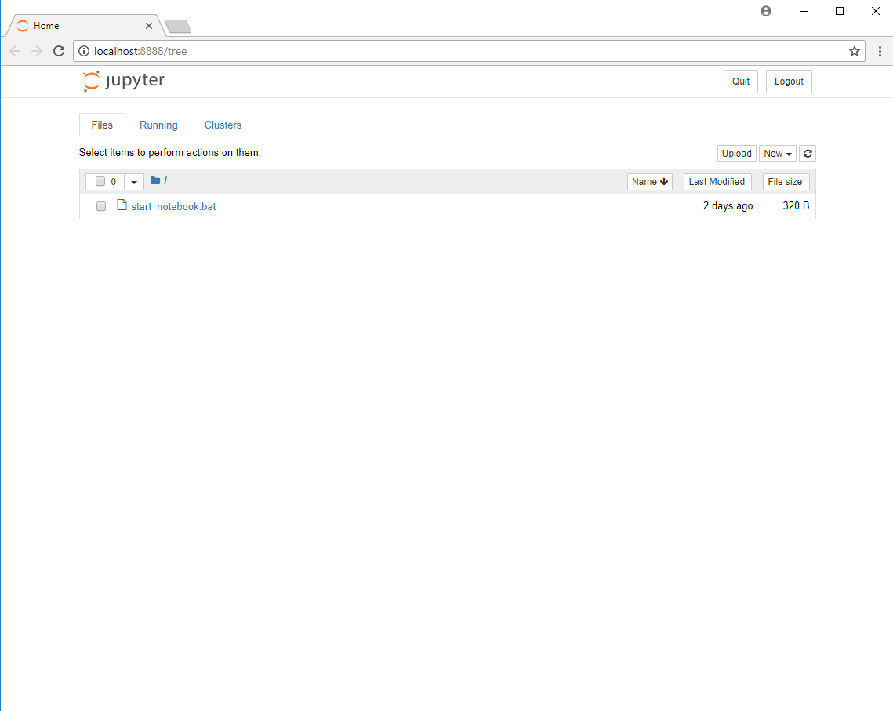

You can simply close these windows when you’re done. Please let Chris Langevin (langevin@usgs.gov) know if you encounter any warnings or errors.

# Mac/Linux Software Installation

For you Mac and Linux people, we’re going to assume that you can install software. It is important that you end up with the folder structure

**Step 1:**

Download and unzip the gw3099.zip file available at:

<ftp://ftpext.usgs.gov/pub/er/va/reston/gw3099/gw3099.zip>

**Step 2:**

Install Miniconda. Installers are available at: <https://conda.io/miniconda.html>. You should install Miniconda to a Miniconda3 folder directly under the gw3099 folder.

**Step 3:**

Use the Miniconda3 version of python to run the install packages python script. This script is located at: gw3099\installation\install_packages.py.

**Step 4:**

You will not be able to install Model Viewer on Mac or Linux. Sorry.

**Step 5:**

You need git. You may have it installed already. If not, you can download it from: <https://git-scm.com/download>.

# Mac/Linux Software Testing

Use the Miniconda3 version of python to run the install packages python script. This script is located at: gw3099\installation\ test_root_install.py.

The test_root_install.py script will test that Python and the Python packages that will be used in the class have been correctly installed. Output will look like the following:

------------------------------------------------------------------------

GW3099: Advanced Modeling of Groundwater Flow

Checking your python distribution and installed modules.

Evaluating system information

Your python version: 3.6.5 | packaged by conda-forge | (default, Apr 6 2018, 16:13:55) [MSC v.1900 64 bit (AMD64)]

Your platform is: win32

Module available for use: numpy

Module available for use: matplotlib

Module available for use: shutil

Module available for use: subprocess

Module available for use: pandas

Module available for use: platform

Module available for use: shapefile

Module available for use: flopy

Testing matplotlib installation

Done checking...

------------------------------------------------------------------------

Press any key to continue . . .

Please let Chris Langevin (langevin@usgs.gov) know if you encounter any warnings or errors.