Learning to predict output error on individual problems based on problem structure
Bill Langford - Nov 24, 2021
Given huge variation in problem difficulty and input uncertainty, knowing the average output error across all problems has little utility for a single, specific conservation decision. Consequently, the paper briefly summarized here looks at whether it’s possible to predict how much error a given reserve selector is likely to have on the user’s own problem.
In real problems, we can’t know things like the true amount of input error or the correct solution, so we need performance predictors that can be measured on the problem as given to us with all its erroneous inputs. Problem size is one family of knowable predictor, but Figure 4 shows that it’s a poor predictor.
Another lens is to look at measures of problem complexity, so I converted each problem from a list of species and planning units into a bipartite graph and measured various attributes of that graph to use as predictors. I then fit models to predict what the total output error would be on a given problem using different kinds of knowable predictors (Figure 5). The bipartite measures did surprisingly well and much better than any of the other input variables.
General notes about the plots
- Red dots are problems where the added uncertainty was dominated by False Positives (i.e., input data declared a species to be on a Planning Unit where it actually does not occur) and blue dots are dominated by False Negative errors (species that actually occur on a Planning Unit are not reported there). Behavior is very different for FP and FN dominated problems.
- In what follows, “cost error” does not refer to errors in the input Planning Unit costs. It refers to errors in the reserve selector’s estimate of the optimal total solution cost, i.e., the total number of planning units required to meet all species targets.
- Results here are from 4 reserve selectors: Gurobi (mixed integer programming), Marxan (Simulated Annealing), Marxan’s Summed Solution (voting), and UR_Forward (a simple greedy “unprotected richness” heuristic). Only the voting method Marxan_SA_SS differs much from the others.
Figures 4 and 5 compare results of predicting individual problem output error using problem size vs. bipartite graph measures. The main messages are that problem size is a poor predictor but it’s possible to get a surprisingly reasonable predictor from the graph measures even without any knowledge of input error.
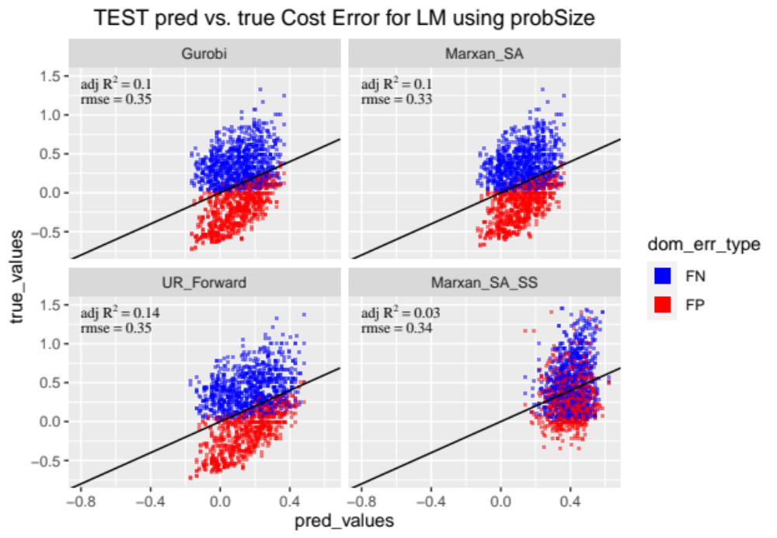
Figure 4: Results of fitting solution cost error using just PROBLEM SIZE variables.

Figure 4 shows results of learning a model to predict total output error for a given reserve selector and problem based on size of the problem (number of species, etc).
- The x-axis is the total output error value predicted for a given problem by the learned model.
- The y-axis is the true amount of total output error for the given reserve selector on the given problem.
- The diagonal line shows the desired outcome of predicted = true.
- I think that many people’s intuition is that as the problem gets bigger, it gets harder. However, as you can see in Figure 4, size matters some, but not much.

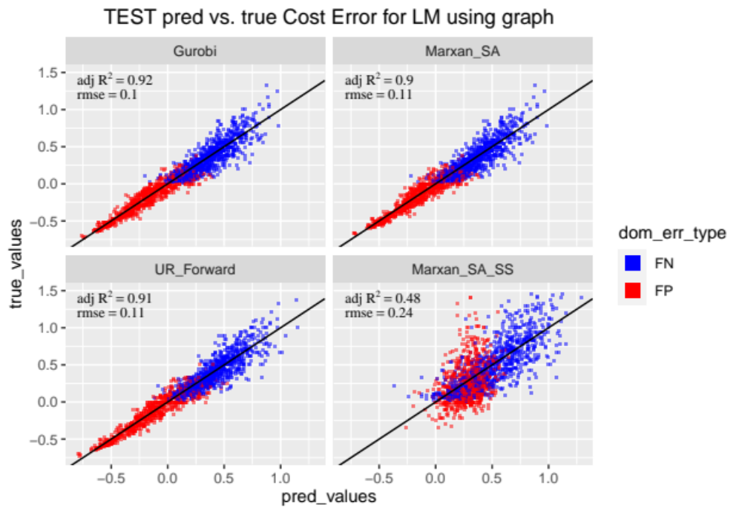
Figure 5: Results of fitting solution cost error using just BIPARTITE GRAPH measures.
Figure 5 shows an alternative, where I mapped each problem as a bipartite graph with planning units as one type of node and species as the other type and then ran a bunch of bipartite graph measures over that graph. I then learned a model using some of those measures as the independent variables.
- This model reduced the rmse by 2/3 for the 3 more exact reserve selectors compared to the values when using problem size.
  - Interestingly, Marxan’s summed solution behavior is much less predictable with either set of input variables.
- I’ve also fit a bunch of other models using combinations of problem size and bipartite measures, as well as things that you can’t actually know, such as the amount of input error.
  - Nothing helps more than a hundredth or two in the rmse or the adjusted $R^{2}$. The bipartite measures capture almost all of the predictive power.
  - Also note that the rmse and adjusted $R^{2}$ values are computed on a separate 2,000 problem test set, not the 2,000 problem training set (where the scores were higher). I still have another 8,000 problems set aside to use in the final paper that I haven’t looked at other than the summary statistics and plotting shown in the paper submitted to Methods in Ecology & Evolution (MEE). I haven’t used them at all for training or testing or feature selection for any predictive models.
- While even the bipartite model is far from perfect, it does show that there are different, structural ways of looking at characteristics of problems that help you predict how much you should trust a given reserve selector’s solution. This is something that I think managers would benefit from knowing and researchers are not addressing. Problem difficulty doesn’t seem to be on anyone’s radar at all and the comparisons in the paper submitted to MEE show that it may be quite important.

