Species spatial characteristics as drivers in conservation prioritization

Gordon, Kujala, xxx

Potential Journals

*Methods in Ecology and Evolution*

Key words:

INTRO

* Aim of systematic conservation planning is to preserve all biodiversity. However, in real life conservation problems species are rarely thought be equally important. Typical approach in conservation prioritization analyses is to weight species according to characteristics that are meaningful, such as threat category or endemism.
* Weighting approaches can be fairly complex and non-transparent and often the trade-offs of using weighting schemes are not properly quantified. Our approach allows a way to measure the direct influence of a species in a given prioritization and could be used as a guide to set weights in spatial prioritizations.
* Often neglected fact is that many spatial prioritization algorithms have in-built mechanisms in the way they treat trade-offs between species and that these mechanisms may interact or outplay used weighting schemes, leading to unintentional inefficiencies in resource use.
* We provide a simple step-by-step instructions on how to think about and set weights for species

MATERIAL AND METHODS

* running Zonation with set of species, dropping off one species in each prioritization, and comparing the resulting prioritizations (species included vs. not included) in terms of:
  + absolute difference of ranks between solutions – overlapping the two solutions and taking the absolute difference and summing it up across all grid cells
  + sum of AUCs of remaining species (species curves)
    - or change in AUC for remaining species
    - or change in the average AUC in comparison to the average of remaining sp in the full model
  + spatial distance of equally ranked grid cells (sum of distances, or a dissimilarity measure)
  + overlap and spatial distance of top ranks, cutting the top ranks at increasing percentage
  + spatial dissimilarity between the solution and the distribution of the dropped sp
* these metrics can then be modelled using species characteristics
  + impact of including spj ~ spj characteristics
  + rarity/distribution size
  + species richness within distribution –average/sum species richness in each cell within distribution of sp *j*
    - Instead of thresholding distributions, use the probabilities (or presences) of the dropped sp as weight, calculate richness of all other sp in each pixel (summing the values) and take a weighted mean.
  + ‘isolation’/co-occurrence (dissimilarity)
  + Spatial similarity of full prioritization and dropped sp distribution
  + other?

*Test data (Hunter Valley)*

The SDMs represent seven charismatic species that occur in the Lower Hunter region of New South Wales, Australia: koala (*Phascolarctos cinereus*), yellow bellied glider (*Petaurus australis*), squirrel glider (*Petaurus norfolcensis*), tiger quoll (*Dasyurus maculatus*), powerful owl (*Ninox strenua*), sooty owl (*Tyto tenbricosa*) and the masked owl (*Tyto novaehollandiae*). The SDMs were produced using GAMs or GLMs and PA data, as described in Wintle *et al.* (2005).

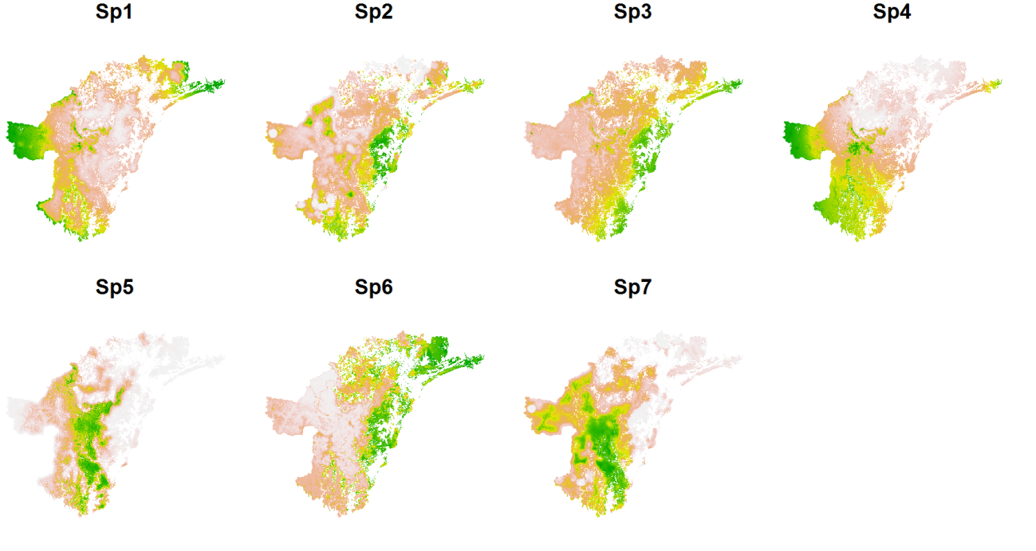

Figure xxx. Species distributions in the Hunter Valley test data.

For each species we estimated their distribution size (sum of probabilities), and, after thesholding the original distribution maps (assuming p>0.5 as presence), calculated the average species richness within their distribution and the mean Jaccard similarity (using package ‘Picante’ in R). The Jaccard similarity index is calculated for each species pair using information on their distribution and co-occurrence. It varies between 0 and 1, values of zero indicating a complete absence of [spatial] relationship.

RESULTS

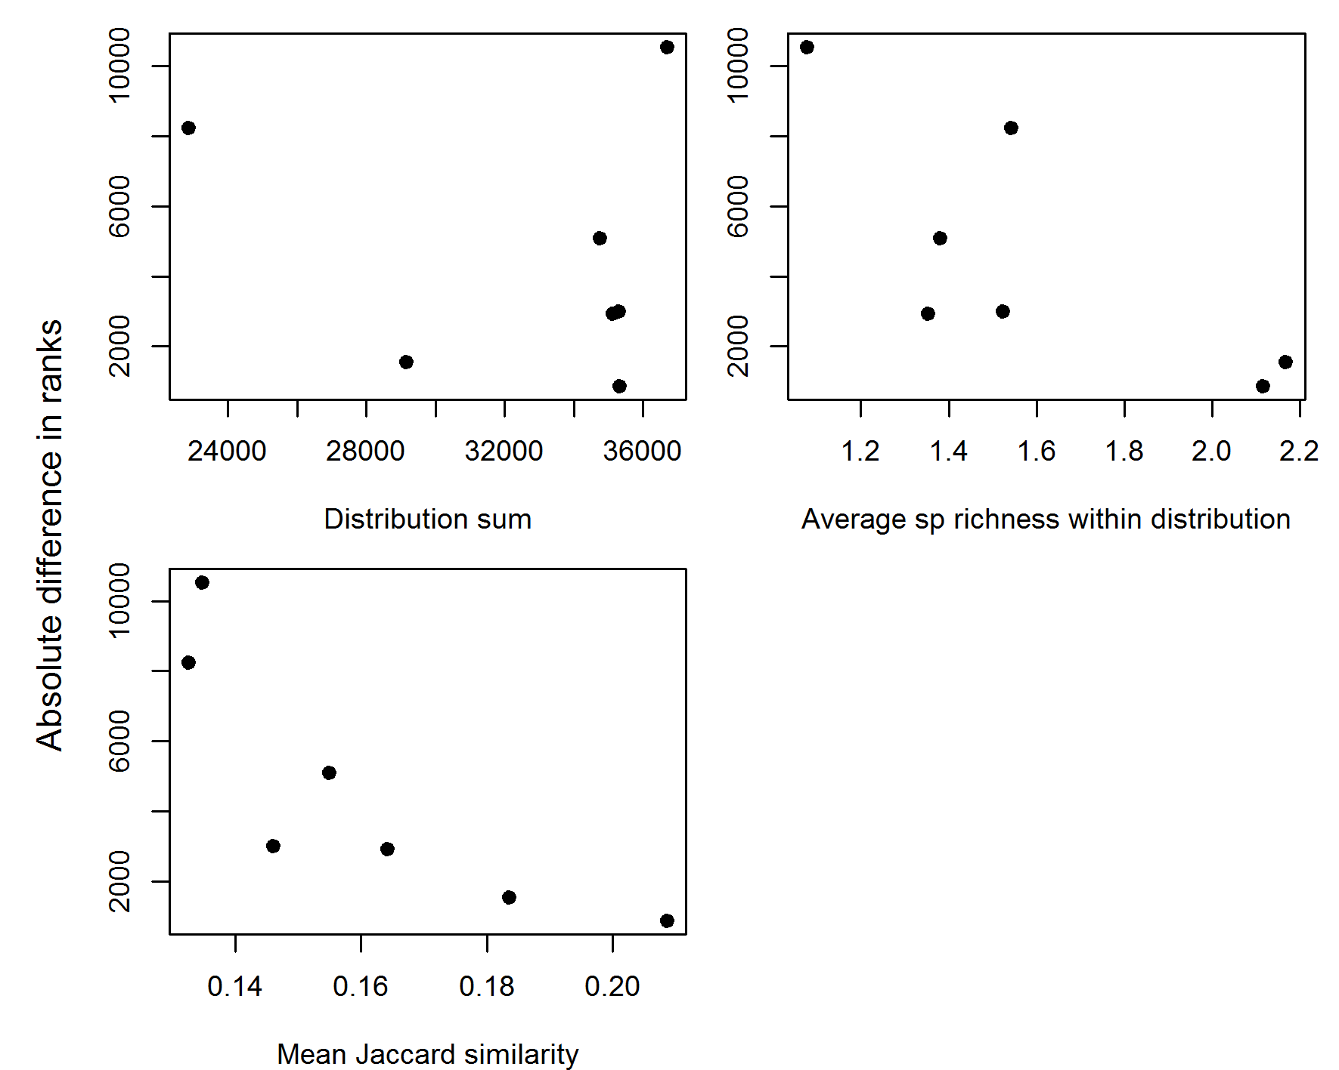

Fig xxx. Changes in priority rank values in comparison to species characteristics. The Y-axis gives the summed absolute difference in spatial priority ranks across all grid cells, when species are iteratively dropped out and the landscape is re-prioritized. The measured difference in ranks is then plotted against the ecological characteristics of the excluded species.

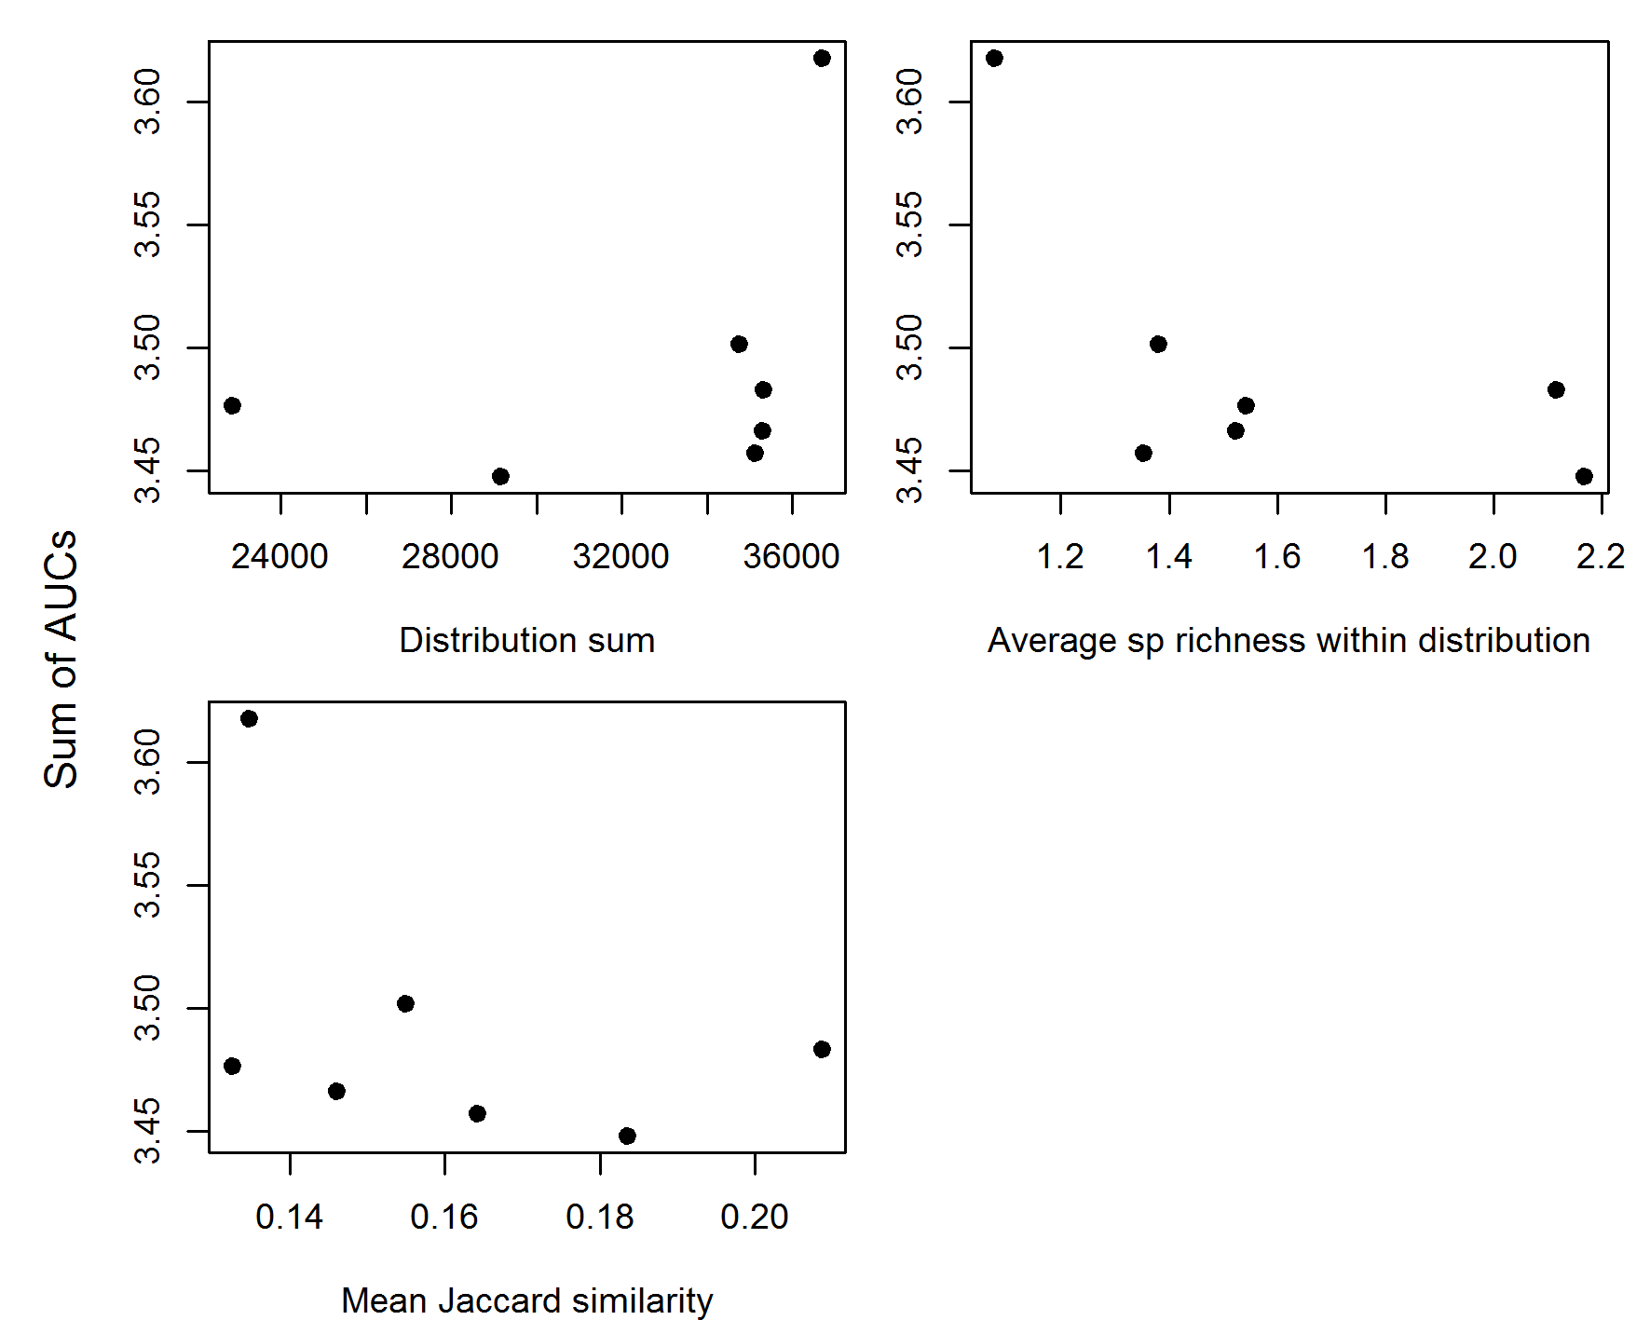

Fig xxx. Changes in the cumulative covered distribution size of all species and across all budgets in comparison to species characteristics. The Y-axis gives the summed area under the curve (AUC), when species are iteratively dropped out and the landscape is re-prioritized, plotted against the ecological characteristics of the excluded species.

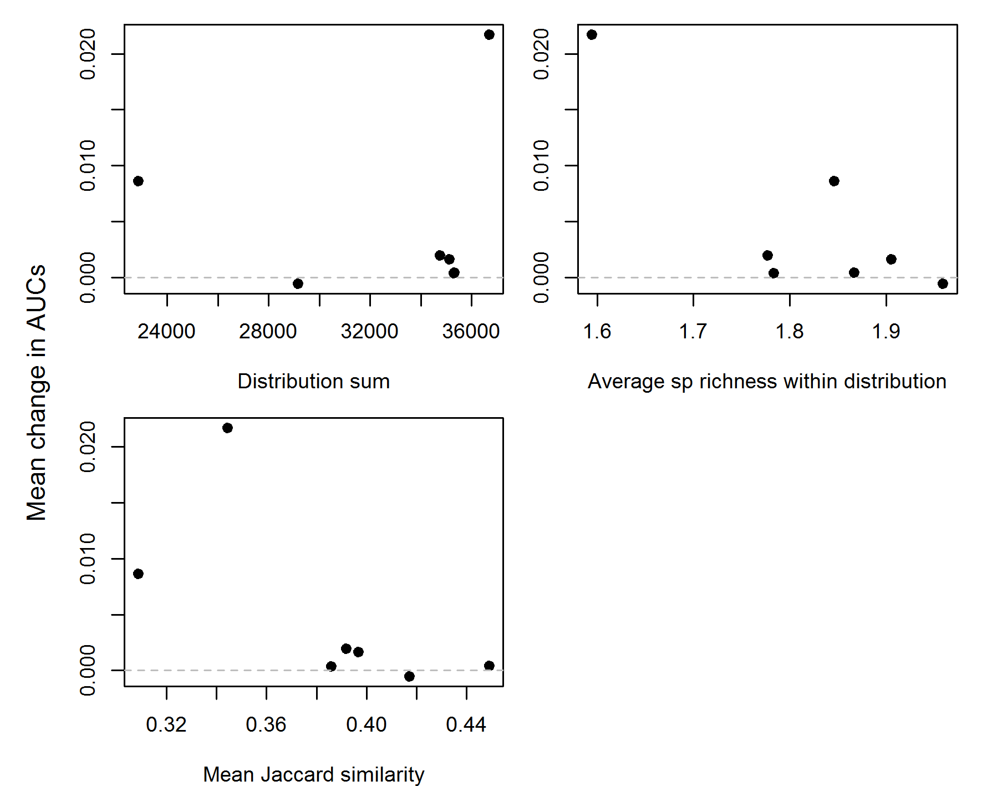

Fig xxx. Mean change in the cumulative covered distribution size of all species and across all budgets in comparison to species characteristics. The Y-axis gives the average change in the area under the curve (AUC), when species are iteratively dropped out and the landscape is re-prioritized, against the ecological characteristics of the excluded species. Point below the horizontal dashed line indicate that, on average, lower proportions of species distributions are retained within the top priorities than what would be by the full model that includes all species.

Next steps

* HEINI: redo the basic analyses with larger data sets (Hunter and FIN birds)
  + prepare Zonation input files
  + runs + data analysis
* ASCELIN: prioritize by adding species in the (descending or ascending) order of their characteristics – e.g. start by prioritizing the two sp with lowest Jaccard distance, add the next sp and re-prioritize and compare the spatial difference of top ranks etc.

CONCLUSIONS

REFERENCES

Wintle, B.A., J. Elith and J.M. Potts. 2005. Fauna habitat modelling and mapping: a review and case study in the Lower Hunter Central Coast region of NSW. Austral Ecology **30**:719–738.