Grazioso Salvare Dashboard
Enhanced Project Documentation

Michael Langille
Southern New Hampshire University
CS 499 Computer Science Capstone
Enhanced from CS 340 Client/Server Development
August 2026
Artifact files
AnimalShelter_enhanced.py
ProjectTwoDashboard_enhanced.ipynb
Project_Two_Grazioso_Salvare_README_Enhanced.docx

1. Project Overview
The Grazioso Salvare dashboard is an interactive client/server application that analyzes Austin Animal Center adoption records and helps identify dogs suitable for specialized rescue training. The original CS 340 artifact provided a MongoDB-backed Dash interface with an interactive data table, rescue-category filters, a Leaflet location map, and a Plotly breed chart. This enhanced CS 499 version preserves those core capabilities while improving security, maintainability, scalability, validation, error handling, and analytical processing.

Purpose of the Enhancement
The enhancement transforms a functional academic dashboard into a more production-oriented portfolio artifact. The revised design separates configuration from source code, verifies database connectivity, limits large result sets, retrieves selected fields, converts query results directly to Pandas DataFrames, provides structured operation results, and improves the dashboard’s responsiveness and user feedback.

Required Functionality
- View animal shelter records in a searchable, sortable, and paginated Dash DataTable.
- Filter animals into Water Rescue, Mountain/Wilderness Rescue, and Disaster/Individual Tracking categories.
- Display the selected animal’s location on a responsive Leaflet map.
- Display a dynamic bar chart of the top breeds in the current selection.
- Communicate with MongoDB through a reusable Python data-access class.
- Show database connection status and clear messages when no records are found.
- Support secure local configuration without hard-coded credentials.

2. Original and Enhanced Artifact Comparison
Area | Original CS 340 Artifact | Enhanced CS 499 Artifact
Credentials | Username and password entered in source/notebook cells. | Environment-based configuration through AnimalShelter.from_env(); supports an external MongoDB URI and avoids exposing credentials.
Connection | MongoClient created without an explicit health check. | Immediate MongoDB ping, configurable timeouts, health_check(), and connection lifecycle management.
Error handling | CRUD methods printed errors and returned False, zero, or an empty list. | Custom exceptions, structured logging, detailed operation results, and callback-level user feedback.
Read processing | MongoDB cursor converted to a Python list, then manually converted to a DataFrame. | read_dataframe() performs controlled retrieval and produces a DataFrame directly for vectorized analysis.
Scalability | Unrestricted read({}) could load the entire collection. | Projection, sorting, limits, pagination, streaming, and a dashboard record cap.
Data integrity | Basic nonempty-dictionary checks. | Required-field validation, prohibited-operator checks, duplicate-key handling, optional indexes, and audit fields.
Deletion | Permanent delete operation only. | Permanent deletion remains available, with safer soft_delete() and restore() methods.
Dashboard code | Repeated imports, duplicate app initialization, fixed-width map, and long conditional filter chain. | Single Dash initialization, reusable query dictionary, responsive layout, stable columns, coordinate validation, and status messages.

3. Architecture and Design

Model
MongoDB remains the data model. Animal records are stored as BSON documents in the aac database and animals collection. The enhanced AnimalShelter class is the data-access layer. It owns connection creation, validation, query execution, operation metadata, DataFrame conversion, audit support, and index management.

Controller
Dash callbacks act as the controller. They translate radio-button selections and table-row selections into database queries, table records, map locations, chart data, and user-facing status messages.

View
The Dash layout is the view. It presents the Grazioso Salvare logo, database status, rescue filters, DataTable, Leaflet map, Plotly bar chart, and selection messages in a responsive browser interface.

4. Enhanced AnimalShelter Data-Access Layer

Secure Configuration
The enhanced class can load connection settings from environment variables. This allows the source code and notebook to be published without including a database password.
shelter = AnimalShelter.from_env(
verify_connection=True,
audit_fields=True,
)

Connection Verification and Cleanup
- MongoDB is pinged during initialization when verify_connection=True.
- Server-selection and connection timeouts prevent the application from waiting indefinitely.
- health_check() reports whether the server is responding.
- close(), __enter__(), and __exit__() support controlled cleanup.

Validation and Defensive Programming
- Configuration values, query mappings, sort directions, page numbers, page sizes, and limits are validated.
- Empty update and delete queries remain blocked.
- Dangerous server-side JavaScript operators are rejected from external query input.
- Optional required fields can be enforced when new animal records are created.
- Duplicate-key errors are reported as validation failures rather than generic database failures.

Structured Results and Logging
Detailed create, update, and delete methods return an OperationResult that separates success, inserted ID, matched count, modified count, deleted count, and explanatory text. The original Boolean and integer methods remain available for compatibility. Python logging replaces print-based database error reporting.

DataFrame and Large-Result Support
The read_dataframe() method converts selected MongoDB results directly into a Pandas DataFrame. This supports vectorized filtering, aggregation, transformation, charting, and other in-memory analysis. Pagination, result limits, field projection, and stream() reduce the risk of loading an unrestricted collection into memory.
df = shelter.read_dataframe(
query={"animal_type": "Dog"},
projection={"_id": 0, "name": 1, "breed": 1},
limit=500,
sort=[("breed", 1)],
)

Audit and Retention Features
- created_at and updated_at timestamps can be maintained automatically.
- soft_delete() preserves a record while marking it unavailable to normal reads.
- restore() reactivates a soft-deleted record.
- ensure_indexes() can create common query indexes and an optional unique animal_id index after duplicate checking.

5. Enhanced Dashboard

Database-Side Filtering
The rescue categories are stored in a RESCUE_QUERIES dictionary instead of a long if/elif chain. Each selection is sent to MongoDB, where filtering occurs before the results are transferred to the dashboard. A projection requests only the fields needed by the table, map, and chart.

DataFrame-Based Analytics
The dashboard calls read_dataframe() directly. The returned DataFrame is used by the Dash DataTable and Plotly chart. Breed counts are produced with Pandas value_counts(), allowing rapid vectorized aggregation without row-by-row Python loops.

User Feedback and Reliability
- Database connection status and active-record count are displayed near the dashboard header.
- The table callback reports the selected rescue category and number of displayed records.
- Empty results produce a clear message rather than an unexplained blank dashboard.
- Database exceptions are logged and handled without exposing credentials.
- Table columns remain stable even when no records are returned.

Responsive Visualization
- The map uses 100 percent of its container width instead of a fixed 1,000-pixel width.
- Latitude and longitude are validated by field name rather than fragile column-position indexes.
- The map safely defaults to the Austin area when coordinates are absent or invalid.
- The bar chart title describes the current selection and handles missing breed data.
- The table, map, and chart use a responsive grid suitable for different screen sizes.

6. Tools and Rationale
Tool | Purpose | Rationale
Python 3 | Core language | Supports object-oriented design, data processing, testing, Dash, Pandas, and PyMongo.
MongoDB | Document database | Stores AAC records as flexible BSON documents and supports database-side filtering and indexes.
PyMongo | MongoDB driver | Provides authenticated CRUD operations, projections, sorting, pagination, and error types.
Pandas | Analytical data structure | Provides vectorized DataFrame operations for tables, filtering, aggregation, and visualization.
Dash | Web application framework | Combines a Python server, interactive callbacks, and browser-based components.
Dash Leaflet | Geolocation view | Displays the selected animal on an interactive map.
Plotly Express | Charting library | Builds interactive breed-frequency charts from DataFrames.
JupyterLab | Development environment | Supports iterative execution, documentation, testing, and demonstration of the dashboard.
python-dotenv | Optional local configuration | Loads a local .env file without placing credentials in notebook cells.

7. Local Installation and Configuration

Recommended Folder Structure
Grazioso-Salvare-Enhanced/
├── AnimalShelter_enhanced.py
├── ProjectTwoDashboard_enhanced.ipynb
├── requirements.txt
├── .env.example
├── .gitignore
└── assets/
└── GraziosoSalvareLogo.png

Install Dependencies
python -m pip install --upgrade pip
pip install dash dash-leaflet plotly pandas pymongo jupyterlab python-dotenv

Create the Environment File
Create a local file named .env. Do not commit the real .env file to GitHub.
MONGO_USERNAME=aacuser
MONGO_PASSWORD=your_local_password
MONGO_HOST=localhost
MONGO_PORT=27017
MONGO_AUTH_SOURCE=admin
MONGO_DB_NAME=aac
MONGO_COLLECTION_NAME=animals
MONGO_TLS=false
MONGO_USE_SRV=false
MONGO_TIMEOUT_MS=5000

Recommended .gitignore
.env
.venv/
__pycache__/
.ipynb_checkpoints/
*.pyc

Run the Dashboard
- Start the local MongoDB service or verify access to the configured MongoDB deployment.
- Confirm that the aac database and animals collection contain the AAC dataset.
- Open ProjectTwoDashboard_enhanced.ipynb in JupyterLab.
- Run the notebook cells from top to bottom.
- Confirm that the dashboard reports Database connected.
- Test Reset and each rescue category.
- Select different table rows and confirm that the map marker changes.
- Confirm that the breed chart changes when the table is filtered.
- Run the cleanup cell when finished.

8. Testing and Validation Plan
Test | Expected Result | Evidence to Capture
Valid connection | Dashboard reports connected status and an active-record count. | Header/status screenshot and health_check() result.
Invalid credentials | Initialization raises a clear connection error without displaying the password. | Log excerpt or controlled error screenshot.
Reset filter | A limited set of active records appears with table, map, and chart. | Full enhanced-dashboard screenshot.
Water rescue | Only matching breeds, intact sex values, and age criteria are returned. | Filter screenshot and sample rows.
Mountain rescue | Matching mountain/wilderness candidates are displayed. | Filter screenshot and chart.
Disaster tracking | Matching disaster/tracking candidates are displayed. | Filter screenshot and chart.
Empty result | Table stays stable and status reports no matching animals. | Status-message screenshot.
Row selection | Map marker and popup update to the selected row. | Map screenshot.
DataFrame output | read_dataframe() returns expected columns and row count. | Notebook output.
Large result control | Dashboard returns no more than DASHBOARD_LIMIT records. | Status message showing the limit.
Soft delete/restore | Record is hidden from normal reads and later restored. | Test output from a test collection.
Index creation | Expected index names are returned and visible in MongoDB. | MongoDB index listing.

9. CS 499 Category Alignment

Software Engineering and Design
- Refactored responsibilities and reusable configuration methods.
- Custom exceptions, structured logging, and clearer error states.
- Context-manager connection cleanup and maintainable helper functions.
- Responsive Dash layout and reusable query definitions.
- Backward-compatible CRUD methods plus richer detailed methods.

Algorithms and Data Structures
- Dictionaries provide direct rescue-query lookup and structured MongoDB filters.
- DataFrames enable vectorized aggregation and transformation.
- Pagination, sorting, projection, limits, and streaming improve memory and query efficiency.
- Boundary validation protects page, limit, sort, and coordinate operations.
- Structured operation results preserve more information than a single Boolean or integer.

Databases
- Authenticated MongoDB access with secure external configuration.
- Connection verification and controlled failure handling.
- Schema-oriented validation and duplicate-key handling.
- Index creation for frequently queried fields.
- Audit timestamps, soft deletion, restoration, and least-destructive data management.

10. Challenges and Resolutions
Challenge | Resolution
Hard-coded credentials made the artifact unsafe for a public repository. | Moved connection settings to environment variables and documented .env/.gitignore usage.
A read with an empty query could load the entire collection. | Added projections, sorting, limits, pagination, streaming, and a dashboard record cap.
An empty result and a database failure could look identical. | Added custom exceptions, detailed operation results, logging, and dashboard status messages.
The dashboard manually converted lists to DataFrames. | Added read_dataframe() and used it directly in the enhanced notebook.
Fixed-width visualization could overflow smaller screens. | Implemented responsive map and chart containers.
Map logic depended on numeric column positions. | Used named latitude and longitude fields with safe conversion and fallback coordinates.
Permanent deletion did not preserve history. | Added soft deletion and restoration while retaining explicit permanent deletion.
The original bar-chart DataFrame could contain ambiguous column names. | Used value_counts().rename_axis().reset_index(name="count") for stable chart columns.

11. Original Artifact Evidence
The following images document the functional CS 340 baseline. They should be retained as before-enhancement evidence. After the enhanced notebook is run locally, capture new screenshots showing the connection-status message, revised title, responsive layout, and result-count messages, then place them in the CS 499 portfolio beside these baseline images.
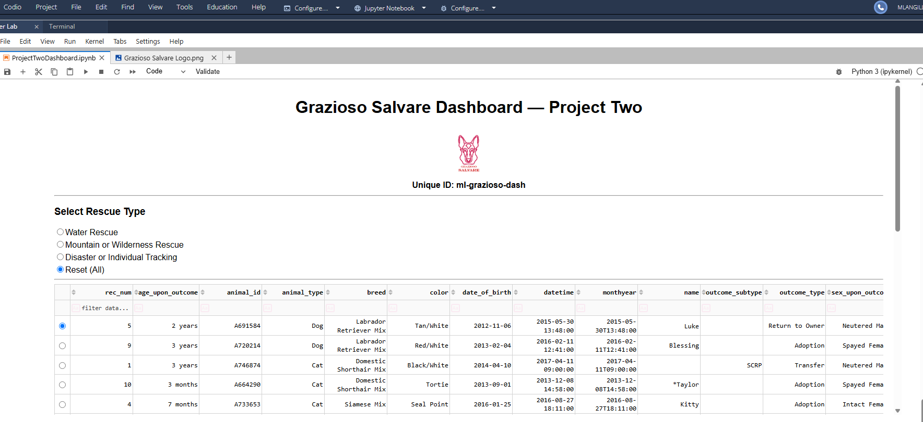
Figure 1. Original dashboard default view.
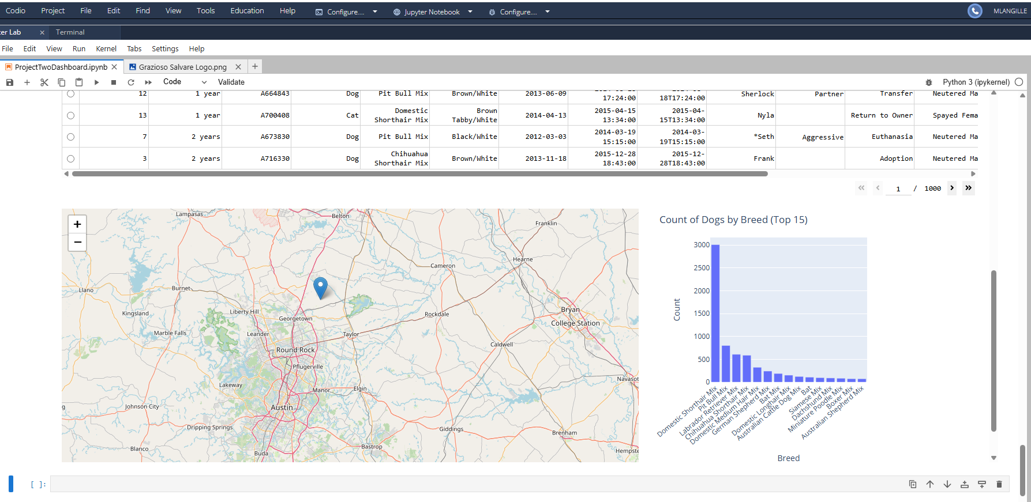
Figure 2. Original default view with map and breed chart.
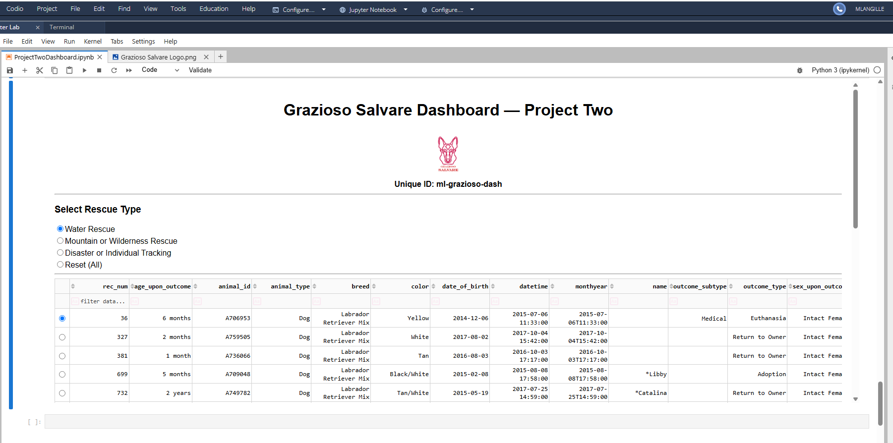
Figure 3. Original Water Rescue filter table.
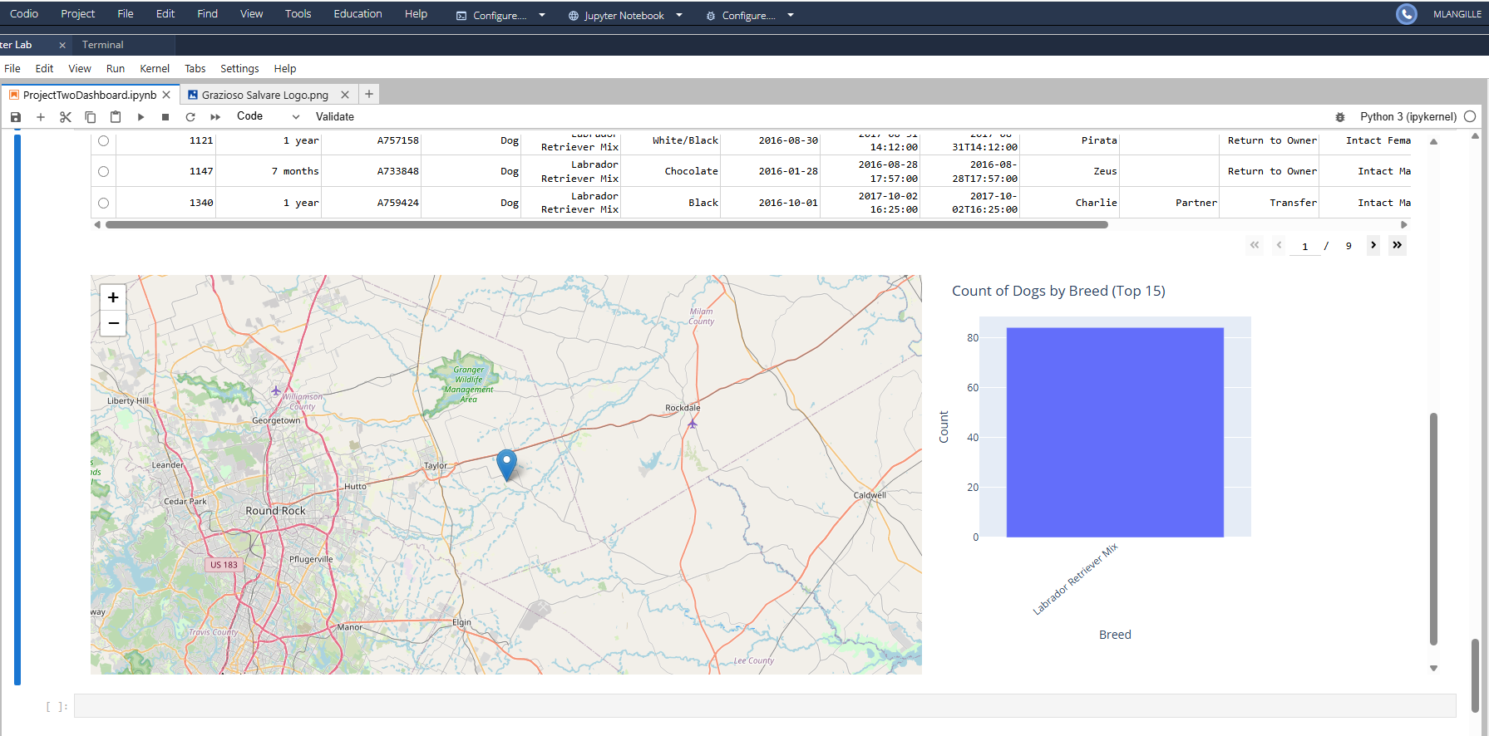
Figure 4. Original Water Rescue map and chart.
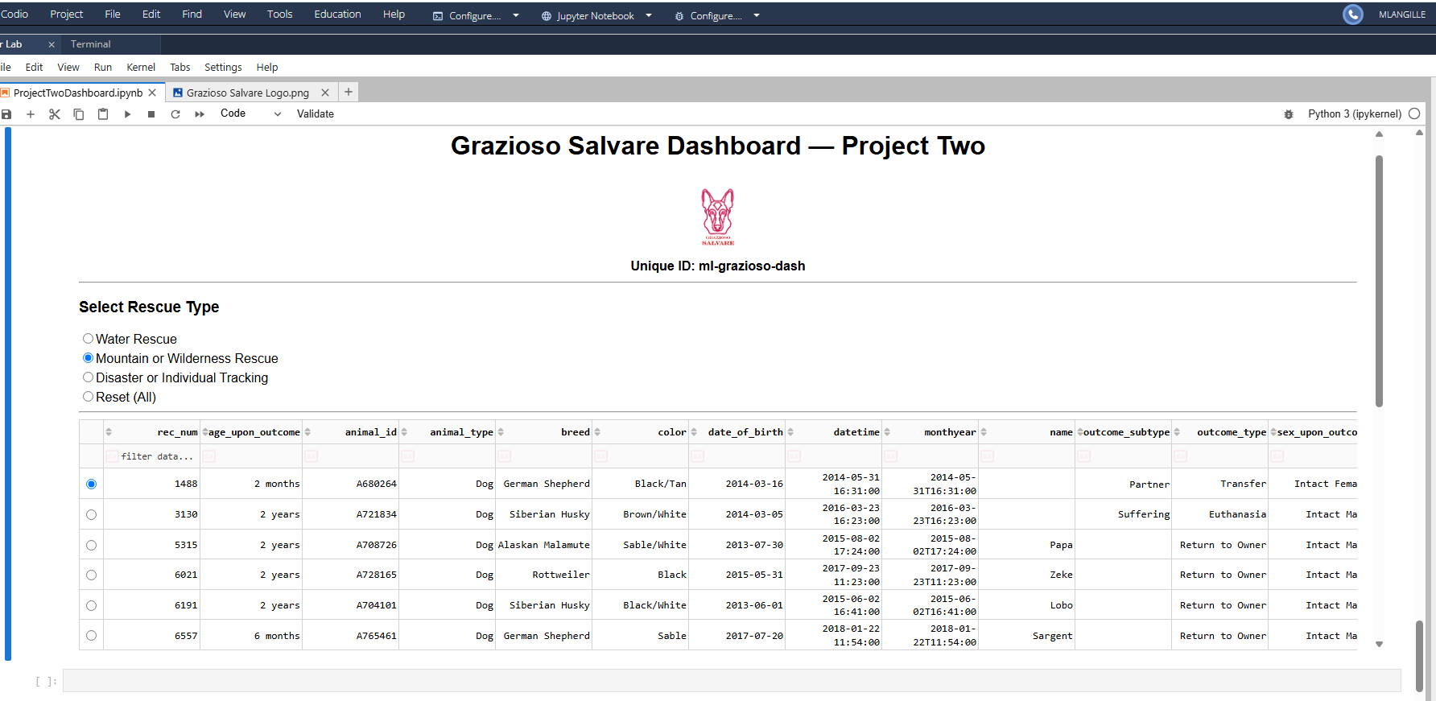
Figure 5. Original Mountain/Wilderness filter table.
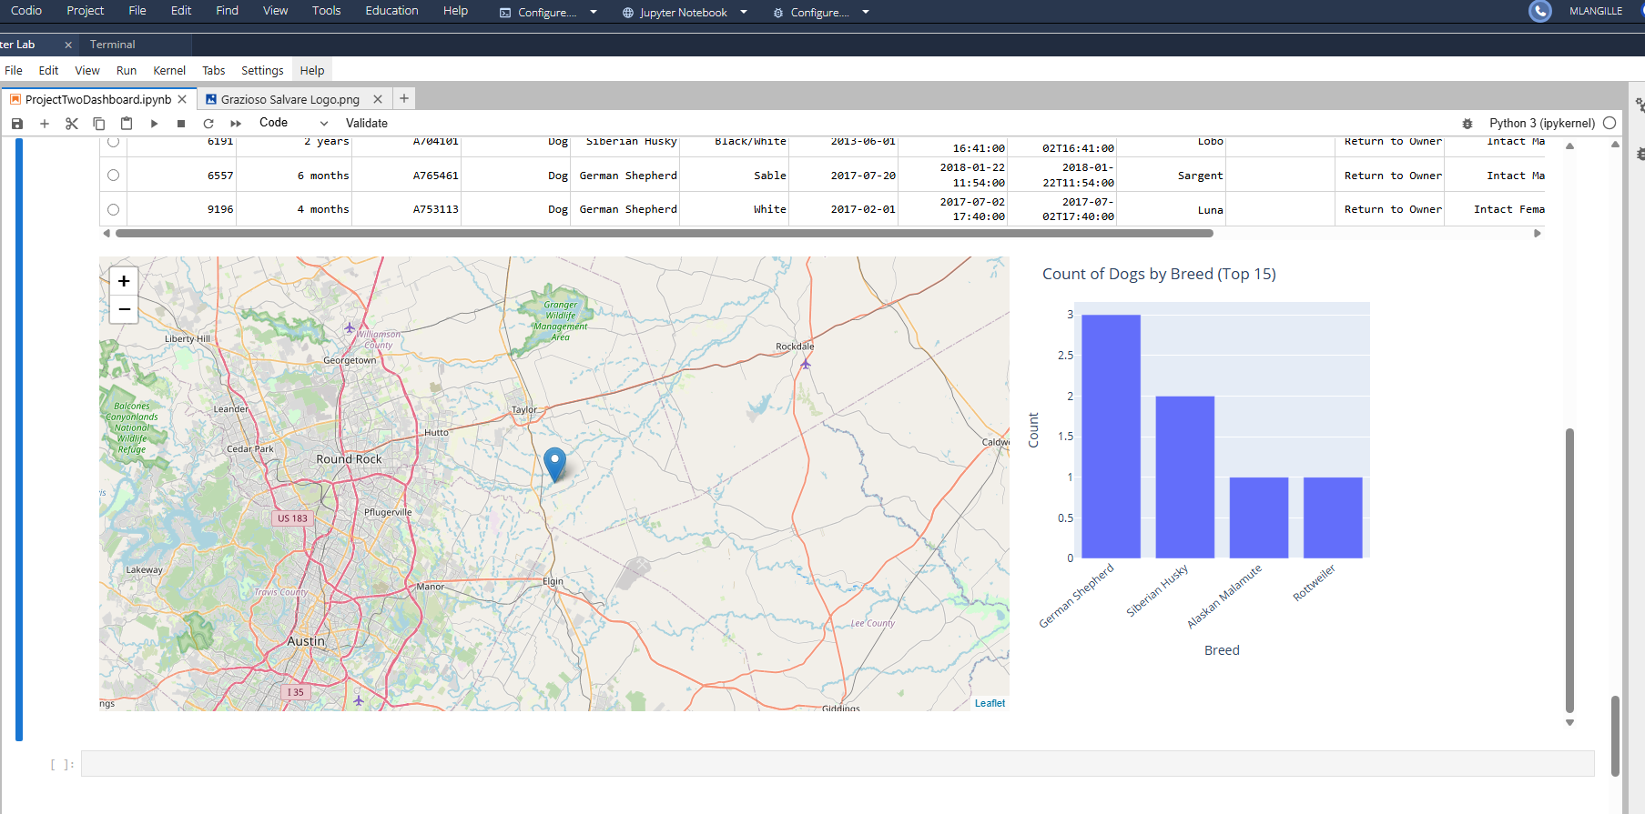
Figure 6. Original Mountain/Wilderness map and chart.
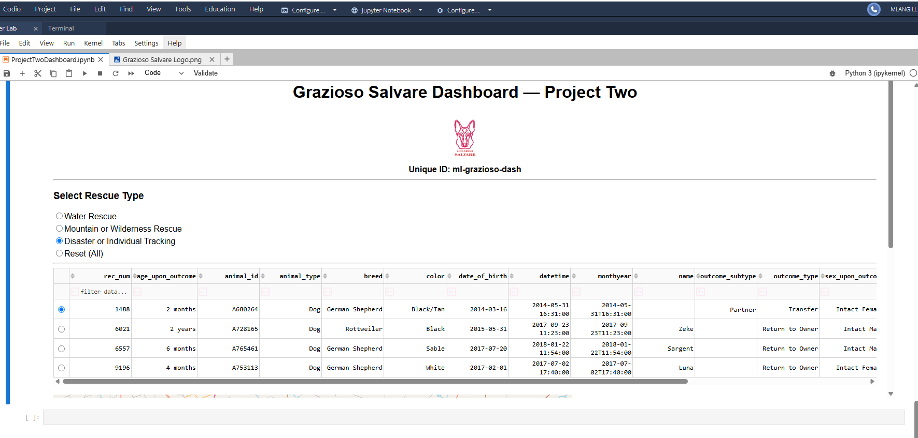
Figure 7. Original Disaster/Tracking filter table.
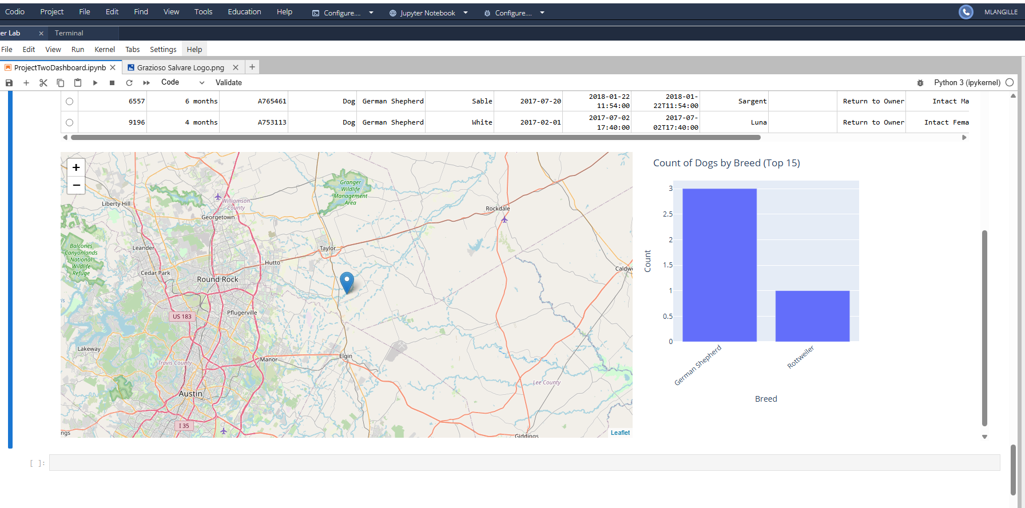
Figure 8. Original Disaster/Tracking map and chart.

12. Enhanced Evidence Checklist
- Enhanced default view showing the revised title, logo, unique ID, database status, and active-record count.
- Enhanced Water Rescue view showing result count, table, map, and chart.
- Enhanced Mountain/Wilderness view showing result count, table, map, and chart.
- Enhanced Disaster/Tracking view showing result count, table, map, and chart.
- No-result status message produced by a controlled test query.
- Notebook output showing read_dataframe() columns and row count.
- Connection-failure test showing a safe error without credentials.
- Optional MongoDB index listing and soft-delete/restore test output.

13. Conclusion
The enhanced Grazioso Salvare project retains the original dashboard’s purpose while demonstrating measurable growth in software engineering, algorithms and data structures, and database development. The revised AnimalShelter class improves configuration security, validation, connection management, query control, analytical output, auditing, and error reporting. The revised dashboard applies those capabilities through database-side filtering, direct DataFrame retrieval, clearer callback design, responsive visualization, and visible status information. Together, the artifacts present a stronger, more maintainable, and more professional ePortfolio example than the original classroom implementation.

Appendix A. Files to Publish
- Original artifact: AnimalShelter.py
- Original artifact: ProjectTwoDashboard.ipynb
- Original documentation: Project_Two_Grazioso_Salvare_README.docx
- Enhanced artifact: AnimalShelter_enhanced.py
- Enhanced artifact: ProjectTwoDashboard_enhanced.ipynb
- Enhanced documentation: Project_Two_Grazioso_Salvare_README_Enhanced.docx
- Public configuration template: .env.example
- Dependency list: requirements.txt
- Logo file in the assets directory
- New enhanced-dashboard screenshots after local validation

