CS-340-Module Seven Project Two README

Michael Langille
Southern New Hampshire University
CS-340-10397-M01 Client/Server Development
Robert Kayl
October 19, 2025

Grazioso Salvare Dashboard, Project Documentation

Project Overview and Required Functionality
The purpose of this project was to develop an interactive data dashboard for Grazioso Salvare to analyze and visualize adoption data from the Austin Animal Center (AAC). The completed dashboard allows the organization to:
- View the entire AAC dataset in an interactive DataTable.
- Filter dogs by rescue training categories (Water Rescue, Mountain/Wilderness Rescue, Disaster or Tracking).
- Visualize adoption locations on a Leaflet geolocation map.
- View a dynamic bar chart displaying the most common dog breeds in each filter selection
- Identify dogs suitable for specialized rescue training
All components communicate with a MongoDB database through a custom CRUD (Python) module, adhering to the Model-View-Controller (MVC) design pattern.

Proof of Functionality
Below are the screenshots taken while testing and deploying the dashboard. Each screenshot demonstrates successful functionality for a key dashboard feature.
- Figure 1. Dashboard Default View (Reset)
Dashboard default view (Reset) displays all Austin Animal Center outcome records. The Leaflet map centers on Austin, TX, and the bar chart shows the top 15 dog breeds by count.
. 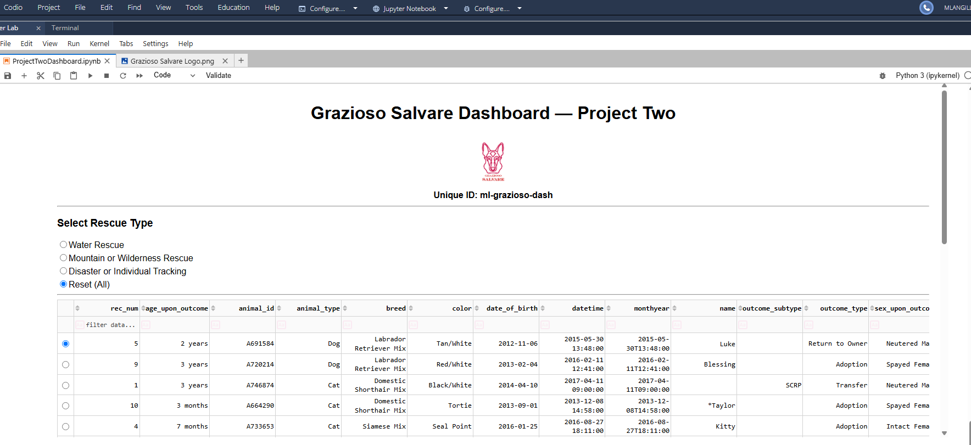
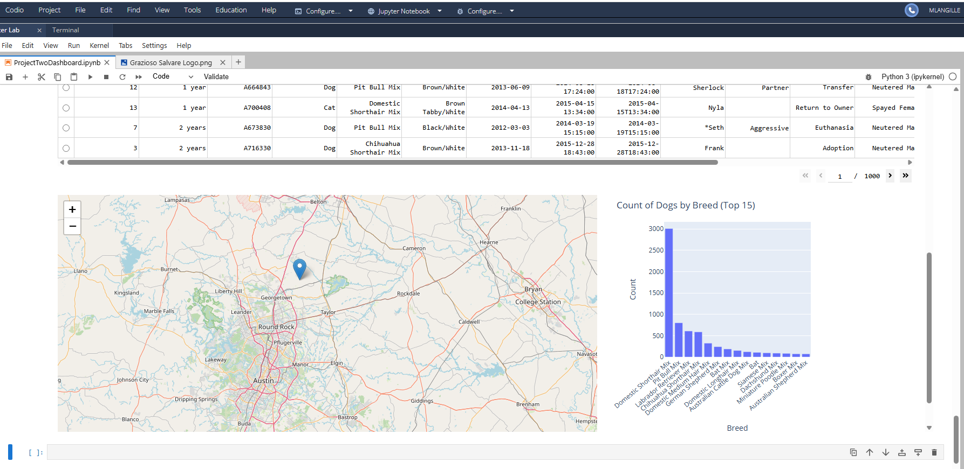
Figure 2. Water Rescue Filter Applied
Water Rescue Filter Applied displays Labrador Retriever, Chesapeake Bay Retriever, and Newfoundland breeds suitable for water rescue.
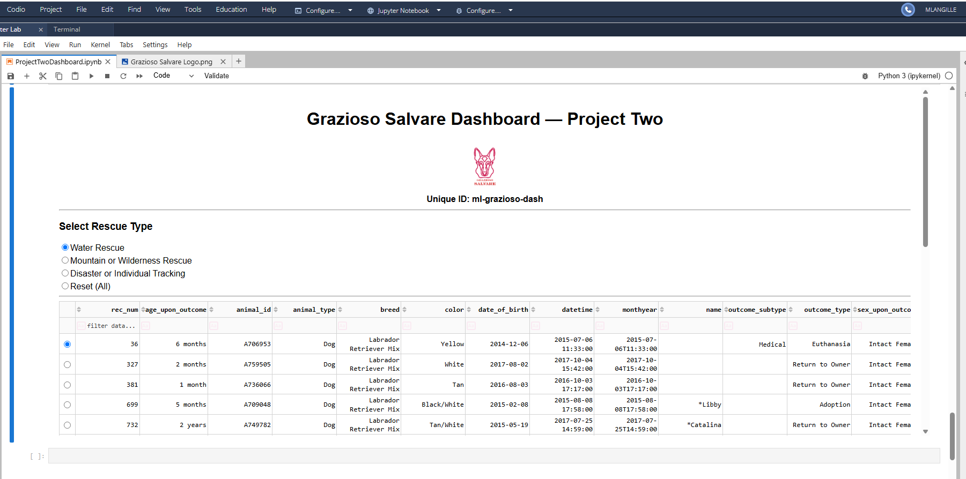
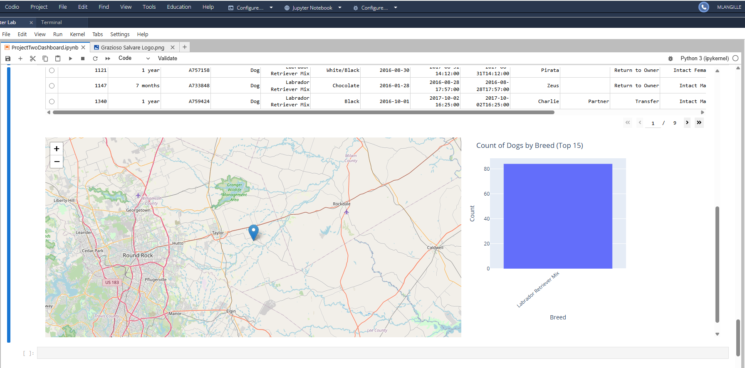
- Figure 3. Mountain / Wilderness Rescue Filter Applied
Mountain/Wilderness Rescue Filter Applied shows breeds such as German Shepherds and Siberian Huskies often used in search and rescue missions.

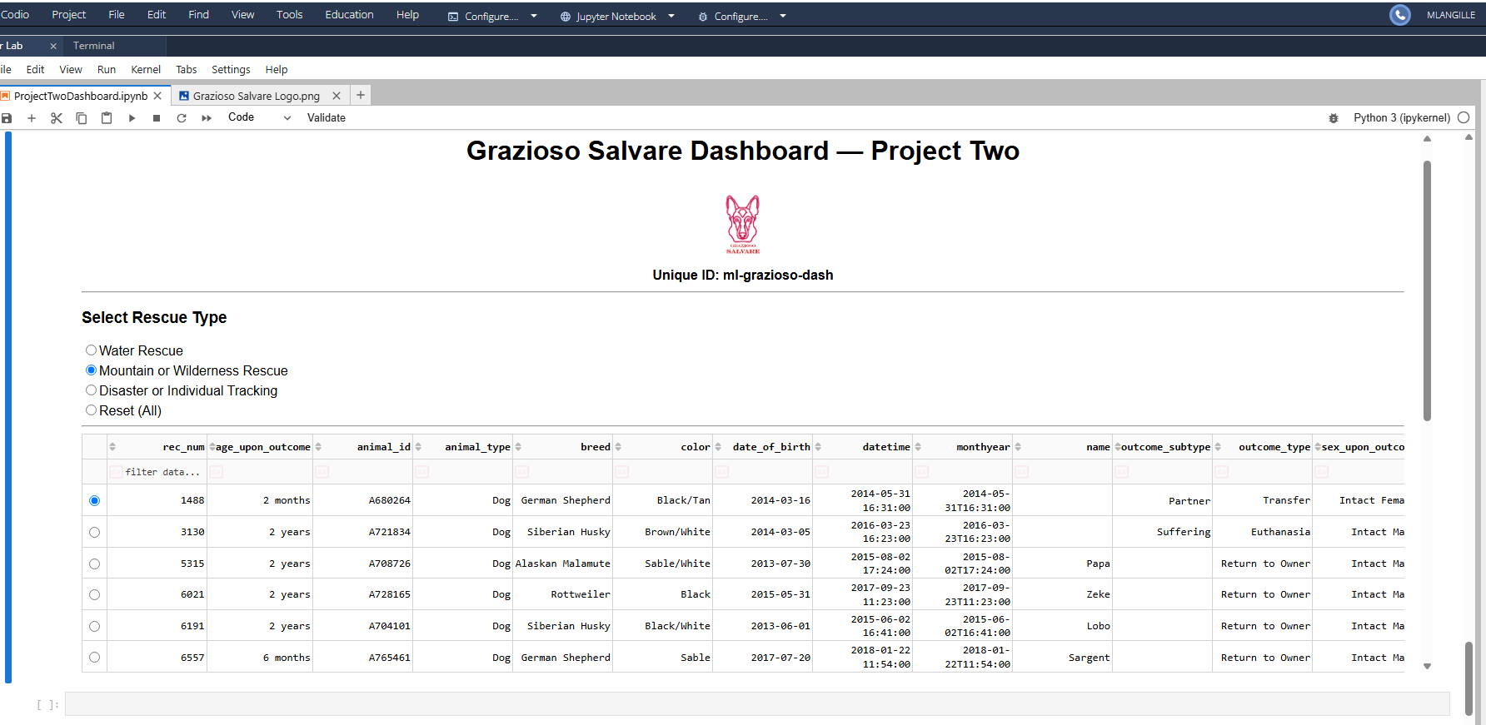
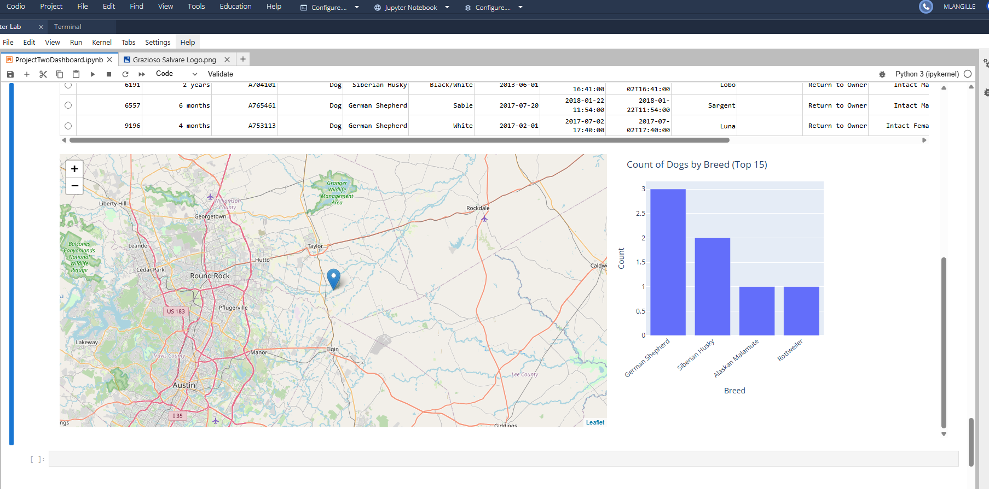
Figure 4. Disaster / Individual Tracking Filter Applied
Disaster/Tracking Filter Applied highlights strong, trainable breeds such as Doberman Pinschers, Golden Retrievers, and Rottweilers.
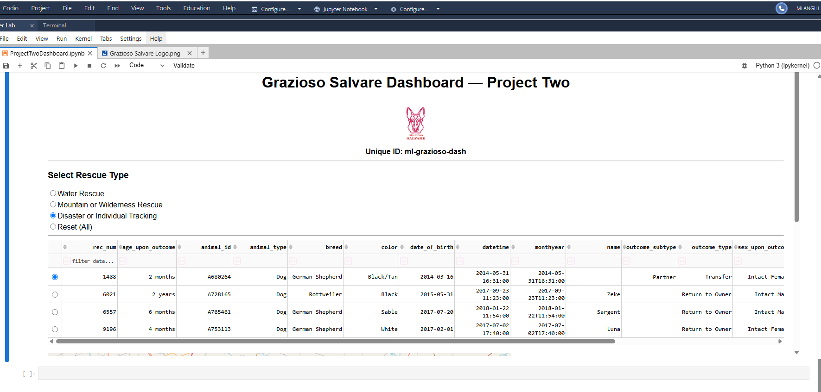
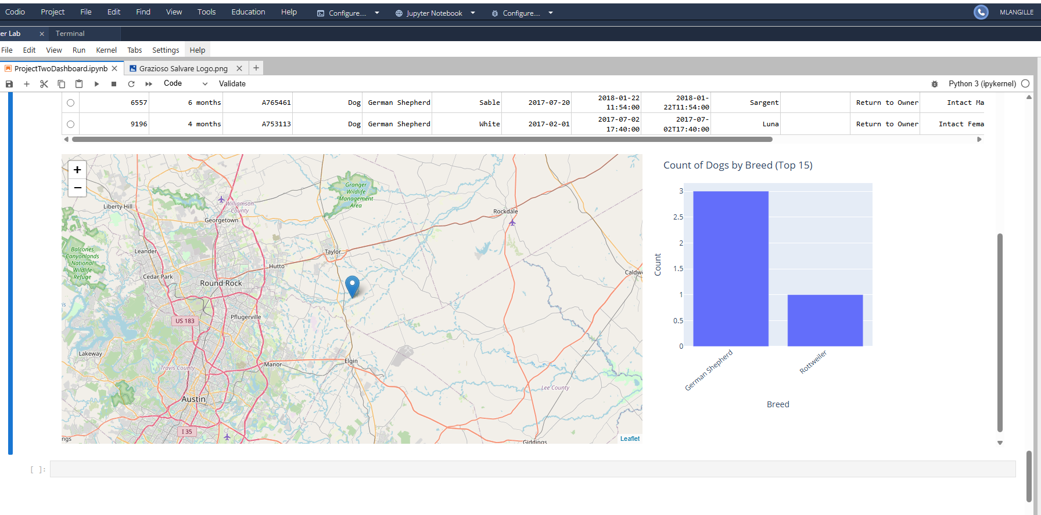
Each screenshot also shows:
- The Grazioso Salvare logo from the assets/ folder
- The unique student ID displayed for verification
- The Leaflet map marker updating dynamically with table row selection
Tools Used and Rationale
Tool | Purpose | Rationale
Python 3.11 | Core development language | Provides flexible data-processing, integration with Dash, and MongoDB support
Dash by Plotly | Framework for building interactive web apps in Python | Combines Flask (server), Plotly (graphing), and React.js (front-end) into a single MVC framework
Dash Leaflet | Map component used for geolocation visualization | Enables live map rendering and dynamic marker updates
Plotly Express | Data visualization library | Generates interactive bar charts directly from Pandas DataFrames
MongoDB | Document-based database (Model) | Flexible schema, stores complex records as JSON-like documents, and seamlessly interfaces with Python via PyMongo
PyMongo | MongoDB driver for Python | Provides direct CRUD operations (Create, Read, Update, Delete)
Pandas | Data analysis library | Converts MongoDB records to DataFrames for chart and table display
JupyterLab / JupyterDash | Interactive environment for Dash apps | Allows development and testing within an IPYNB notebook

Why MongoDB Was Chosen as the Model
MongoDB was selected for its schema-flexible design and native support for JSON-style documents that mirror Python dictionaries. This eliminates the need for complex table joins and simplifies data retrieval with the PyMongo API. MongoDB’s key advantages for this project include:
- Document Storage Model: Stores each record as a BSON document for fast serialization into Python objects.

- Query Flexibility: Supports powerful filter and aggregation operations used in the rescue type filters.

- Integration with Python: Through the PyMongo driver, data can be retrieved and converted directly into a Pandas DataFrame for Dash.

- Scalability: Easily accommodates growing datasets without schema migration issues.

Dash Framework (Controller and View)
Dash serves as both the View and Controller in this MVC application.
- View: Defines the layout and components (DataTable, Maps, Charts, Logos). All elements are rendered as HTML via Dash components.

- Controller: Implements callback functions to link user interactions (e.g., filter selections, row clicks) to visual updates in real time.

- Integration: Dash combines Flask (server framework), Plotly (graphics engine), and React.js (front-end) to create responsive web applications entirely in Python.
This combination simplified development by eliminating the need for separate front-end and back-end codebases, allowing the project to remain fully Python-based.

Steps to Reproduce the Project
- Install Dependencies

pip install dash dash-leaflet jupyter-dash plotly pandas pymongo

- Start MongoDB (local service or Atlas cluster).
- Open ProjectTwoDashboard.ipynb in JupyterLab.
- Update Credentials in Cell 1 (aacuser username and password).
- Ensure Folder Structure:
ProjectTwoDashboard.ipynb
AnimalShelter.py
assets/
GraziosoSalvareLogo.png
- Run All Cells in order (top to bottom).
- Test Filter Buttons and Map Interactions to verify live updates.
- Capture Screenshots of each view (Figures 1-4).

Resources and References
- Dash Documentation
- MongoDB Documentation
- PyMongo API Docs
- Plotly Express Guide
- JupyterDash GitHub Repository

Challenges and Solutions
Challenge | Resolution
Duplicate column names in bar chart caused a Plotly error (ValueError: 'x' is not the name of a column). | Rebuild the DataFrame using reset_index(name='count') to explicitly define column names.
Logo not displayed in the dashboard. | Created an assets/ folder and used app.get_asset_url('GraziosoSalvareLogo.png') to load the image correctly.
Map not updating when no row was selected. | Added a default selection (selected_rows=[0]) to ensure the map always loads a marker.
Authentication error connecting to MongoDB. | Verified database credentials and authSource='admin' in the AnimalShelter class.

Conclusion
The Grazioso Salvare dashboard is a fully functional, data-driven application that bridges MongoDB data storage with an interactive Python front end. By leveraging Dash for visualization and MongoDB for flexible data access, the project achieves both technical performance and maintainability. This documentation ensures that future developers and Grazioso Salvare team members can reproduce and extend the system with confidence.

