WEEK 5 INDIVIDUAL STATEMENT

INTRODUCTION

The purpose of this document is to detail the changes being made to the “about us” web page of our group project and my contributions to the group project as a whole.

MY CONTRIBUTIONS TO THIS WEEK’S PROJECT

* Replied to Jeremy Davis’s post requesting for help on why his JavaScript file menuValidation.js was not running.
  + I downloaded it and upon viewing, I discovered that it consisted of all code on one line. I responded to his post that this might be the cause.
  + I decided to take it upon myself to insert carriage returns (by pressing the enter key while in the Vi editor) into the menuValidation.js JavaScript file. I uploaded the file to the server, and it executed. I posted once again to the forum of the results to confirm my suspicions.
* Created JavaScript file contactValidation.js for the purpose of validating user input from the Contact section of the About Us web page.

HTML DOCUMENT (version 0.3)

* Filename: aboutus.html
* URL: <http://laureatestudentserver.com/IN61/aboutus.html>
* Revisions:
  + Adrian Thompson
    - Footer added by Adrian Thompson to make it more consistent with other web pages.
  + Emanuel Langit
    - Id attributes added to input tags to allow changing border colors using the getElementById function within the JavaScript validation program.
    - Added JavaScript file specification in head tag.
    - validateForm() function called to validate the user input.

JAVASCRIPT PROGRAM (version 0.1)

* Filename: contactValidation.js
* Author: Emanuel Langit
* Purpose: Used to validate the user input received through the about us web page.
* Precondition(s):
  + The validateForm() function is called in the HTML document.
* Postcondition(s):
  + The name, email address, and message given by the user through the web page are validated.
  + Error messages are displayed using the alert function to inform the user of any invalid input.
  + The border color of the text boxes used for input are changed to red if they contain invalid input.
* Function(s)
  + validateForm()
    - variables:
      * errorFree: Initially set to true. If any errors encountered with the user’s input, it is set to false.
      * errorMessageArray[]: Error messages are pushed into this array.
      * errorMessage: The contents of every element of the errorMessageArray are concatenated into a string stored by this variable.
      * emailAddress: Stores the email address provided by the user. Validation was modeled after example given by W3Schools (W3Schools, n.d.).
      * atPosition: Stores the position number of the “@” character within the email address (Zero based) using the indexOf function.
      * dotPosition: Stores the position number of the last “.” Character within the email address (Zero based) using the lastIndexOf function.

TOOLS USED BY ME

* Editors: Vi, Eclipse
* Operating systems used: Mac OSX while at home, and Windows 7 while at my office of employment.
* Filezilla to transfer files between the server and my local computer.
* GitHub for version control and syncing files between my two laptop computers.

SCREENSHOTS

No errors:

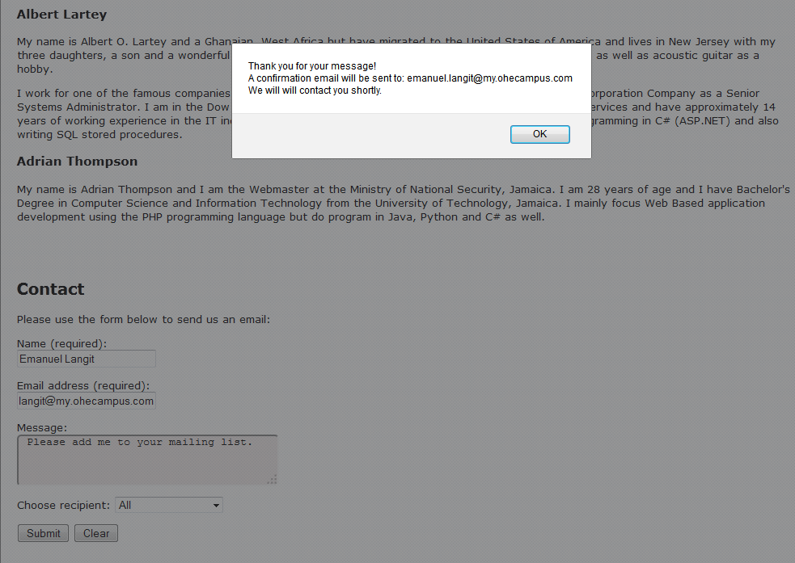

No fields filled:

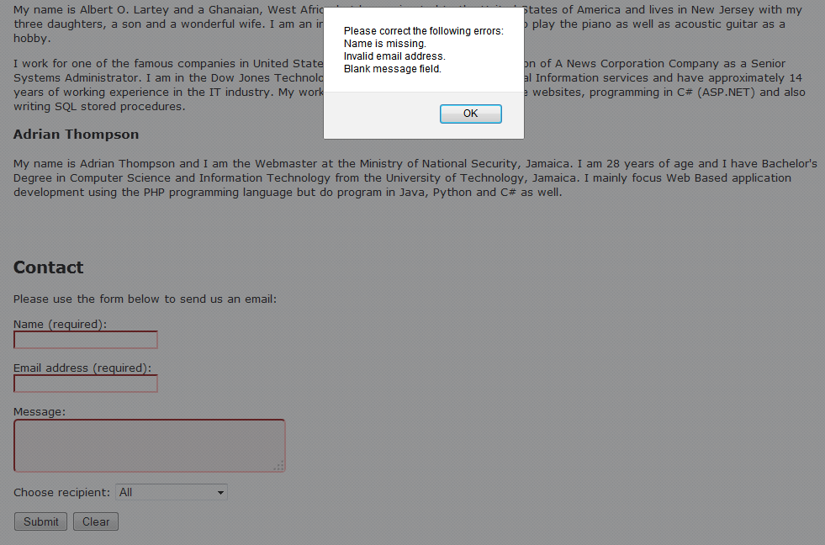

Invalid email address:

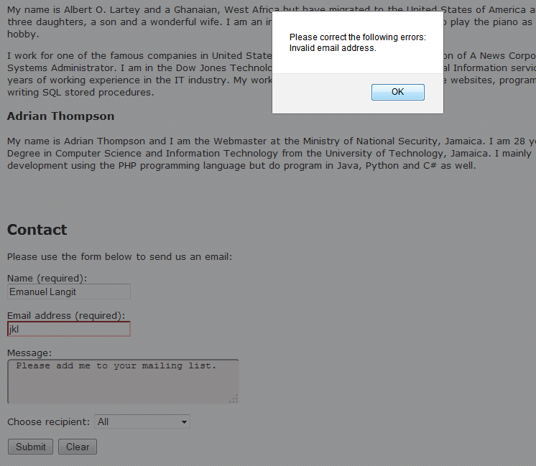

No name provided:

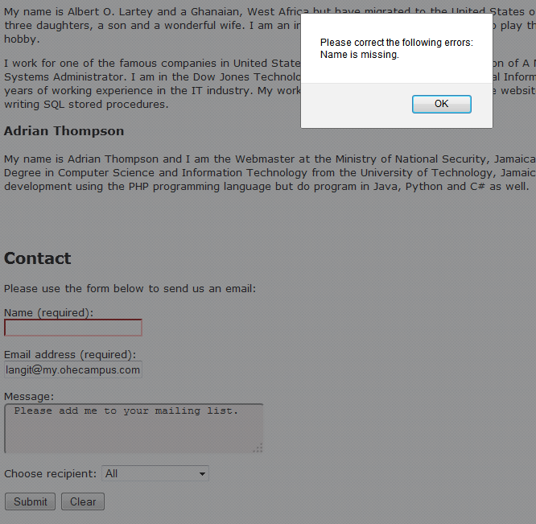

No message provided:

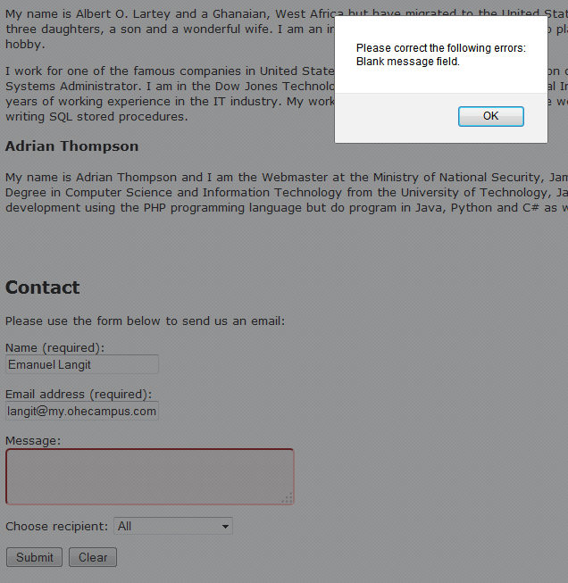

REFERENCES

W3Schools (n.d.) JavaScript Form Validation [Online]. Available from: <http://www.w3schools.com/js/js_form_validation.asp> (Accessed: 18 June 2014)