1. URL from where to run assignment 6: <http://laureatestudentserver.com/IN61/Emanuel/main-inc.html>
2. The following files were modified:
   1. Adding **include("../../../connection.php");** and commenting out existing declarations of variables involved in database connectivity.
      1. **allDevices.php**
      2. **singleDevice.php**
      3. **updateDevice1.php**
      4. **updateDevice2.php**
   2. **main-inc.html**
      1. URLs were added for user to add and delete a new device.
3. Files that were added:
   1. **addNewDevice.html**
      1. This file was based on the **updateDevice.html** file given in the code examples.
         1. Changes:
            1. Asks user for a “new” reference number.
            2. Action was changed to the new php file.
   2. **addNewDevice1.php**
      1. This file was mostly based on the **updateDevice1.php** file given in the code examples.
         1. Major changes:
            1. If the reference number given exists, then a table is displayed of the record. This code for this table was based on a section of code from the **singleDevice.php** file.
   3. **addNewDevice2.php**
      1. This file was based on the **updateDevice2.php** file given in the code examples.
         1. Major changes:
            1. The SQL query inserts a new record into the database, instead of update.
   4. **deleteDevice.html**
      1. This file was based on the **updateDevice.html** file given in the code examples.
         1. Changes:
            1. Is specific in asking the user for an “existing reference number”.
            2. The button was changed to “device reference number”.
   5. **deleteDevice1.php**
      1. This file was mostly based on the **updateDevice1.php** file.
         1. Major changes:
            1. A table is displayed of the record corresponding to the reference number the user provided. The code for this table was based on code taken from the **singleDevice.php** file.
            2. If the record exists, the user is prompted with a button confirming if they want to delete the record
   6. **deleteDevice2.php**
      1. This file was based on the **updateDevice2.php** file.
         1. Major changes:
            1. The SQL query deletes the row with the corresponding reference number provided by the user.
4. Screenshots
   1. Main page:

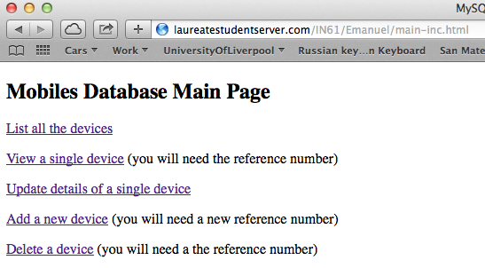

* 1. Adding new device:

First adding record

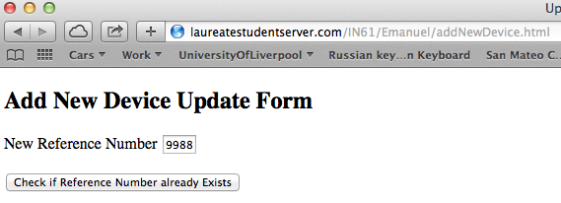

Entering fields for new device:

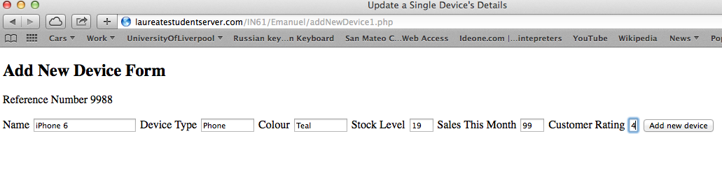

Confirmation:

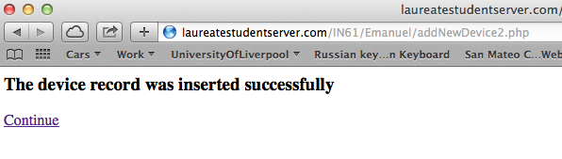

Proof that it was added:

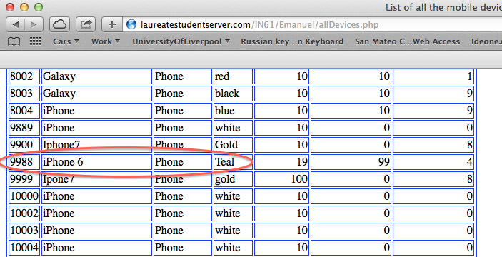

* 1. Deleting the device:

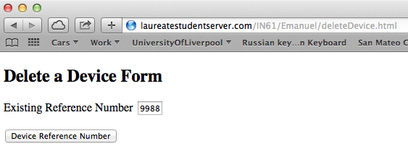

Prompt the user to confirm delete:

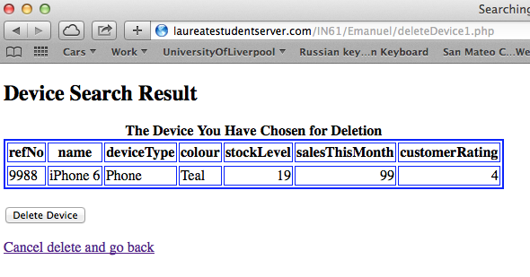

Confirmation of delete successful:

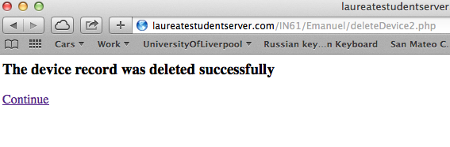

Proof it was deleted:

