1. URL from where to run assignment 6: <http://laureatestudentserver.com/IN61/Emanuel/main-inc.html>
2. The following files were modified:
   1. Adding **include("../../../connection.php");** and commenting out existing declarations of variables involved in database connectivity.
      1. **allDevices.php**
      2. **singleDevice.php**
      3. **updateDevice1.php**
      4. **updateDevice2.php**
   2. main-inc.html
      1. URLs were added for user to add and delete a new device.
3. Files that were added:
   1. **addNewDevice.html**
      1. This file was based on the **updateDevice.html** file given in the code examples.
         1. Changes:
            1. Asks user for a “new” reference number.
            2. Action was changed to the new php file.
   2. **addNewDevice1.php**
      1. This file was mostly based on the **updateDevice1.php** file given in the code examples.
         1. Major changes:
            1. If the reference number given exists, then a table is displayed of the record. This code for this table was based on a section of code from the **singleDevice.php** file.
   3. **addNewDevice2.php**
      1. This file was based on the **updateDevice2.php** file given in the code examples.
         1. Major changes:
            1. The SQL query inserts a new record into the database, instead of update.
   4. **deleteDevice.html**
      1. This file was based on the **updateDevice.html** file given in the code examples.
         1. Changes:
            1. Is specific in asking the user for an “existing reference number”.
            2. The button was changed to “device reference number”.
   5. **deleteDevice1.php**
      1. This file was mostly based on the **updateDevice1.php** file.
         1. Major changes:
            1. A table is displayed of the record corresponding to the reference number the user provided. The code for this table was based on code taken from the **singleDevice.php** file.
            2. If the record exists, the user is prompted with a button confirming if they want to delete the record
   6. **deleteDevice2.php**
      1. This file was based on the **updateDevice2.php** file.
         1. Major changes:
            1. The SQL query deletes the row with the corresponding reference number provided by the user.
   7. assignment6.js
      1. In the spirit of doing extra work, this was created with the intention of validating user input. I ran out of time, and was not able to implement it.
4. Screenshots
   1. Main page:

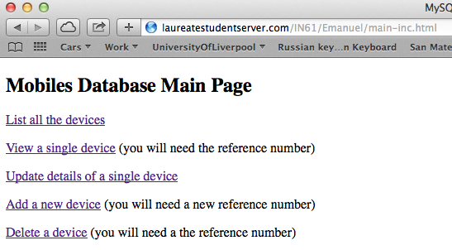

* 1. Adding new device:

First adding record

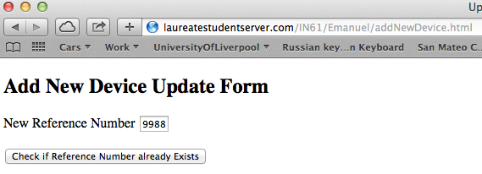

Entering fields for new device:

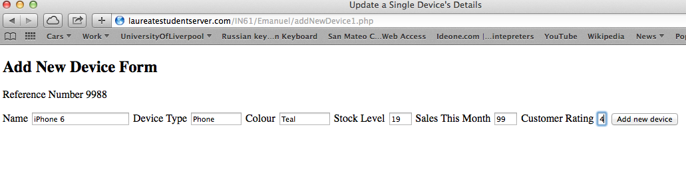

Confirmation:

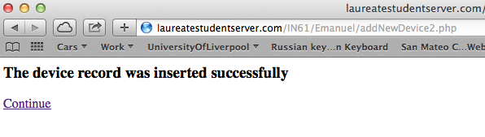

Proof that it was added:

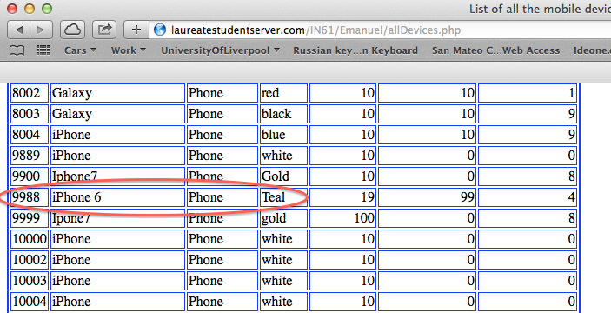

* 1. Deleting the device:

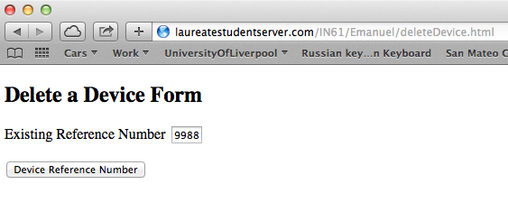

Prompt the user to confirm delete:

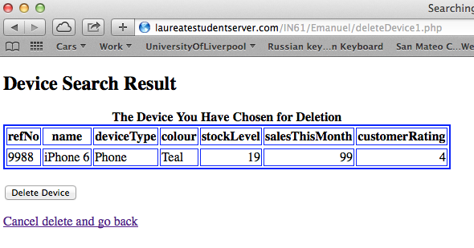

Confirmation of delete successful:

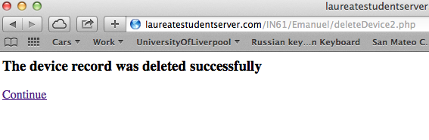

Proof it was deleted:

