WEEK 7 STATEMENT

INTRODUCTION

I have continued to take responsibility for the “About Us” webpage of our group’s website, as I did in week’s 3 and 5. The purpose of this document is to give a description on the changes made to this web page since the week 5 version. Screenshots are attached at the end of this document.

MY CONTRIBUTIONS TO THIS WEEK’S PROJECT

* Created the week 7 thread in our group’s discussion forum. Started it by explaining all functionalities that must be implemented by the group. I stated which features I planned to implement into the “About Us” webpage.
* Created a PHP script for the purpose of validating the user input from the contact section of the About Us web page, inserting it into a specified table in our group’s database. The PHP script also sends an email to the user confirming that their message was received.
* Created the **Messages_from_aboutUs** table in the **laureate_IN61** database.
  + This was created using MySQLWorkBench.
  + Columns:
    - messageID (Primary key, auto increments)
    - EmailAddress
    - Name
    - Message
    - Recipient

HTML DOCUMENT (version 0.4)

* Filename: **aboutus.html**
* URL: <http://laureatestudentserver.com/IN61/aboutus.html>
* Revisions:
  + The PHP script was specified in the form tag:

<form name="contactForm" method="post" action="Scripts/ about_us_contact_form_validation.php">

PHP SCRIPT (version 0.1)

* Filename: about_us_contact_form_validation.php
* Location: /Scripts/ about_us_contact_form_validation.php
* Author: Emanuel Langit
* Purpose:
  + Validate user input received through the “Contact” form in the About Us webpage.
  + Insert the input received from the Contact form into the **Messages_from_aboutUs** table.
  + Send an email confirmation to the user.

RESULTS

* Invalid input:
  + No row was inserted into the table. Validated by querying the database table.
* Valid input resulted:
  + New row was inserted into the table. Validated by querying the database table
  + Email confirmation was successfully sent. Validated by checking email inbox.

TOOLS USED BY ME

* Editors: Vi, TextWrangler, Notepad++
* Operating systems used: Mac OSX while at home, and Windows 7 while at my office of employment.
* Filezilla to transfer files between the server and my local computer.
* MySQLWorkBench used to create the table in the database.
* GitHub for version control and syncing files between my two laptop computers.

SCREENSHOTS

Filling out form:

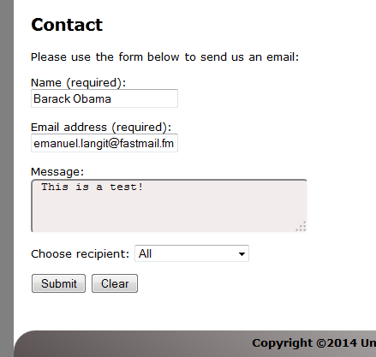

Acknowledgement from JavaScript:

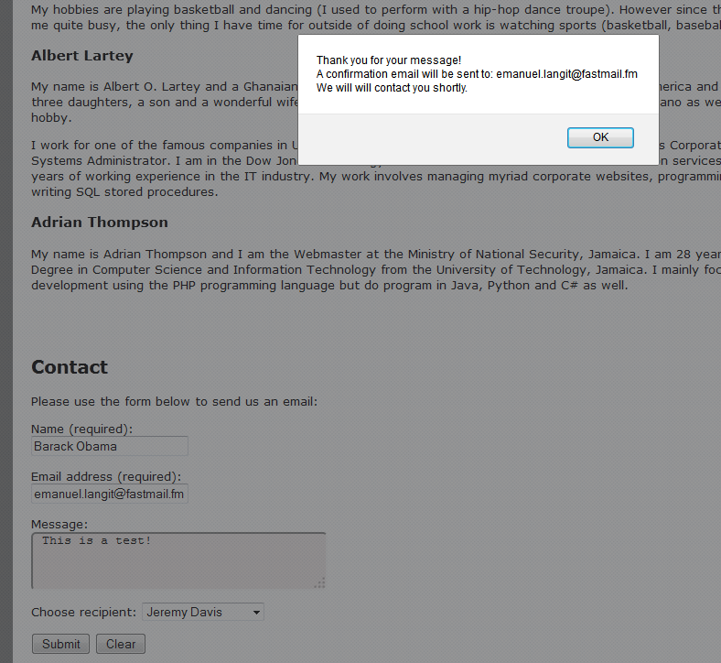

Confirmed that it was inserted into the table through MySQL Workbench:

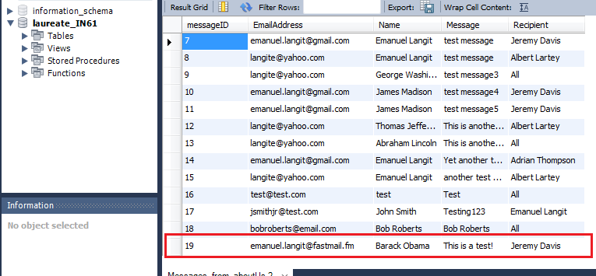

Checked my email:

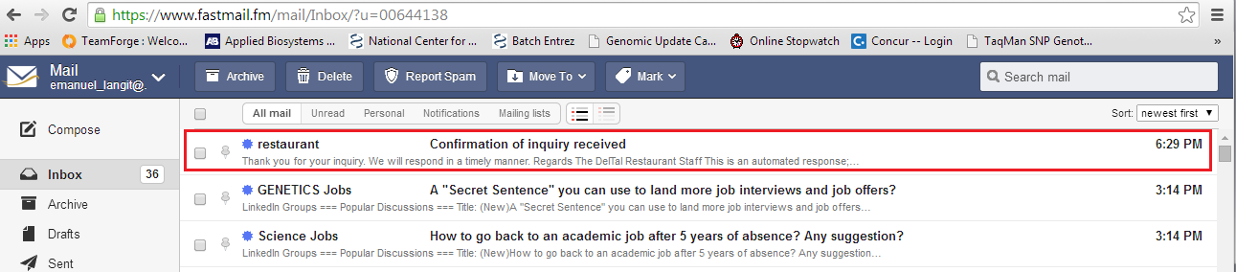

Opened email:

