Hi Olatunde,

Thank you for your comments. From your remarks, it appears that digital divide is much more pronounced in developing countries. I briefly skimmed your reference and it looks like both Intel and Microsoft have committed to seeing Nigeria bridge the digital divide. However, I hope that Nigeria, and other developing countries do not fall into the same trap that we have in the United States. It seems like many parents are just happy seeing their children preoccupied with gadgets, and believe that substitute for actual “parenting” time.

This unproductive use of the Internet, and of computing resources in general is not limited to children. “Cyberloafing” which is described as “voluntary acts of employees using their companies’ Internet access for nonwork-related purposes during working hours” has been a cause for concern for many companies (Vitak, Crouse, and LaRose, 2011). Since we are all students here, I think that this could also be applied to school, not just at the office. Some employers block the access of email, social media, and entertainment websites. Perhaps parents could do something similar on their children’s devices.

Regards,

Emanuel

Reference:

Vitak, J., Crouse, J., & LaRose, R. (2011) 'Personal Internet use at work: Understanding cyberslacking', *Computers In Human Behavior*, 27, 5, pp. 1751-1759, Social Sciences Citation Index, EBSCOhost, (Accessed: 30 June 2014)

“As mentioned above, we conduct penetration testing for new Web applications or any major changes to existing ones as part of central bank mandate and other mandates like PCI-DSS (Payment Card Industry Data Security Standard).”

Hi Ala,

Great post. I am largely ignorant of penetration testing, so I decided to briefly research it myself. From my readings, it can simply be defined as conducting attacks on a computer system (with permission of course). I still have a few questions though. How does one train in penetration testing? Is it taught in courses? I would think that one could build their own system at home, and practice attacking it. However, I can see how “real” penetration testing should be done by an independent party to be really effective. A good analogy to this would be that I was taught in a previous module that software quality assurance should not be performed by the developer of the software. Maybe penetration testing should be contracted out to a completely different company?

Regards,

Emanuel

Hi Frank and Olatunde,

At home, I think that keeping the computer in a common area (e.g., living room) could solve the problem of both children and adults using the Internet for unproductive uses. Both children and adults when then have added eyes making sure that they are not viewing pornography. Parents could also see if their children were mainly using the Internet for entertainment and social media (e.g., YouTube, Facebook, Twitter, Instagram). Parents would then be pressured to be a good example by also limiting their use of the Internet for entertainment purposes.

For mobile devices, I saw a few packages online, but this one from a company named Mobicip looked good:

<http://www.mobicip.com/>

It works on iOS, Android, and Windows devices. It has custom filtering, and alert features. The parent could then be notified if even an attempt was made to access a restricted site on a device. I especially like that it gives a browsing history report:

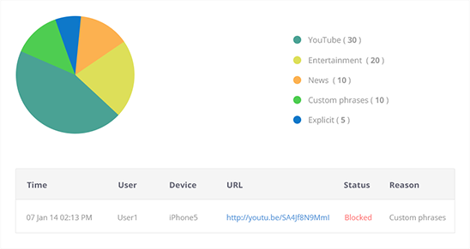

(Mobicip, 2014)

The price looks reasonable: $39.99 a year for 5 devices. I say this though as someone that lives in the United States. I do not know if this price is reasonable for the average person living in a developing country.

Regards,

Emanuel

Reference:

Mobicip (2014) *Browsing History Reports* [Online]. Available from: <http://www.mobicip.com/features#browsing_history_reports_logo> (Accessed: 1 July 2014)