“According to Laureate Online Education (2013) the negative impact of having these user disgruntled and unhappy that they can’t access your website application can cause damages in more than one way to your business or organization.”

Hi Adrian,

Thank you for bringing this topic up. I briefly skimmed the lecture notes, and did not pay enough attention to this. Being a staunch free-market capitalist, I usually do not agree with most laws that dictate how private businesses should be run. However, organizations that do make sure that their websites are accessible to the disabled can help themselves in regards to their public relations with the community. Such improvements in an organization’s perceived image can help many organizations, thereby actually improving their bottom line in the long run. For example, Google has stated on their website that it is their “mission to make the world’s information universally accessible and useful, we’re committed to making accessibility a reality for all of our users, including those with disabilities.” (Google, n.d.a.), and they actually serve on committees that promote web standards (Google, n.d.b.). I have no doubt that such activity on their part is really nothing more than self-promotion, though I am pleased with the outcome because those with disabilities are gaining access to information due to these efforts. The skeptic in me though is slightly suspicious of this all; I do wonder if large organizations such as Google being part of standards committees can actually stifle better standards coming from competitors.

Regards,

Emanuel

References:

Google (n.d.a.) *Making Google Accessible* [Online]. Available from: <https://www.google.com/accessibility/> (Accessed: 7 July 2014)

Google (n.d.b.) *Accessible Web Initiatives* [Online]. Available from: <https://www.google.com/accessibility/policy/> (Accessed: 7 July 2014)

Hi Annibal,

Thank you for your response. I never knew that about the “Lorem Ipsum”. I’ve seen it before, but always just assumed that it was only in Microsoft Products. After reading more about it, it looks like the reason for its use is that “meaningful content” can potentially be distracting, therefore nonsensical content would be more useful so that one could concentrate on the overall appearance of the letters (Lipsum, 2014). I also like how the website you cited has versions for other languages that use different alphabets (E.g., Russian, Chinese, Vietnamese, Arabic, etc.). Since one of this week’s topics is accessibility, I thought it might be a good idea to mention.

Regards,

Emanuel

References:

Lipsum (n.d.) *Lorem Ipsum* [Online]. Available from: <http://www.lipsum.com> (Accessed: 7 July 2014)

“The second system I looked at was The DelTal sub shop, In terms of the usability of the site in totality I feel that they have done a good job in establishing a clean design and look and the navigation through the site is fairly simple and uncomplicated, I do however feel there is an issue with the images used on a number of the tabs I have experienced loading issues while navigating through some of the pages. In terms of functionality I feel the systems functionality works really well for the requirements of a system used to order products online example one can order meals online, this is the extent of the functionality but I feel it works well, I feel that they have done a good job in terms of database functionality and tying all aspects of the sites together to present a cohesive solution as a group project.

In conclusion I feel that DelTal app might benefit from implementing more functionality into the application ass it feels a bit like a catalogue rather than an online restaurant, usability can also be improved by improving how the images are processed on the site, I also feel that the site must have at least a sample pic of what each meal looks like in the order menu, this will speak volumes to the usability and user-friendliness of the system.”

Hi Zubair,

Thank you for your compliments and critique of my group’s website. I remember that during our group’s first teleconference, I brought up the idea of incorporating a real time order tracker, to show the customer the status of their order, similar to what this website has:

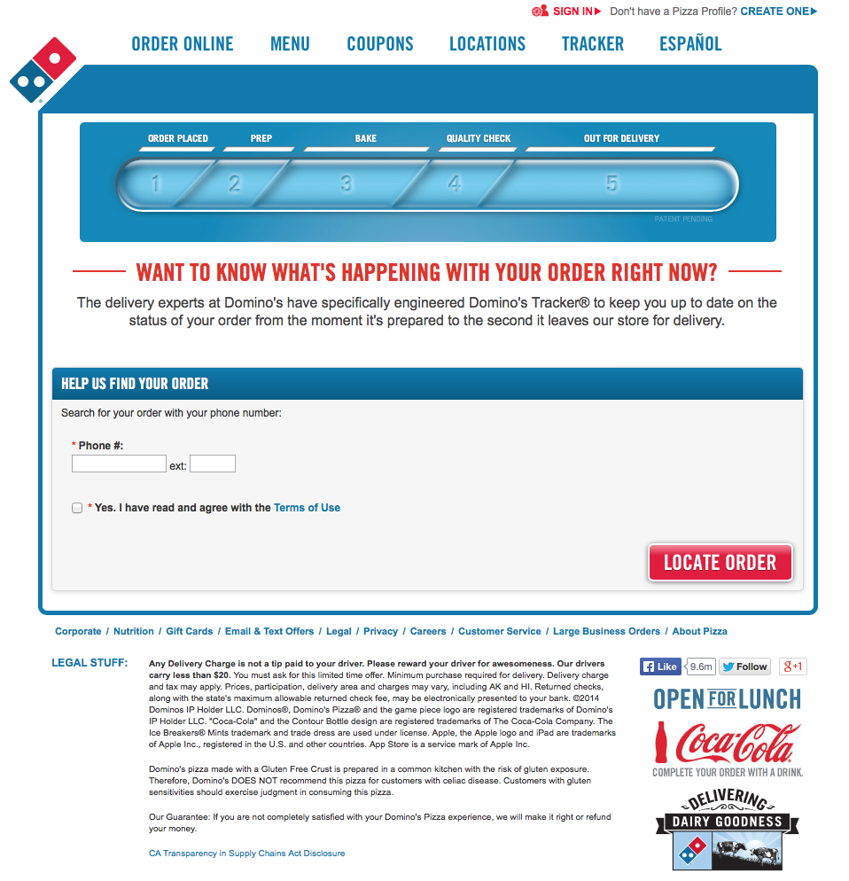

(Domino’s Pizza, 2014)

Of course, this idea was immediately shot down, and I’m glad it was; integrating such a feature would have probably been extremely difficult.

In regards to your comment “feel that the site must have at least a sample pic of what each meal looks like in the order menu”, there are 3 drawings in the menu page. The first picture is of a sandwich, which is ambiguous enough to be any of the sandwiches offered in the menu. I think that a picture of chips would probably not be necessary. Maybe we could have had pictures of the different types of salads. However, I do understand that these are things a real business should pay more attention to.

Regards,

Emanuel

Reference:

Domino’s Pizza (2014) *Tracker Search for Order – Track Your Domino’s Order* [Online]. Available from: <https://order.dominos.com/en/pages/tracker/#/track/order/> (Accessed: 7 July 2014)

“The aboutus.html doesn’t validate at all it just recommend using client and server-side validation.”

Hi Anibal,

Could you clarify further on this? I was responsible for this page, and it uses both client and server-side validation. I’ve tested on Chrome and Firefox, and giving incorrect inputs into the form at the bottom of the page results in the JavaScript alert function telling the user of the error(s):

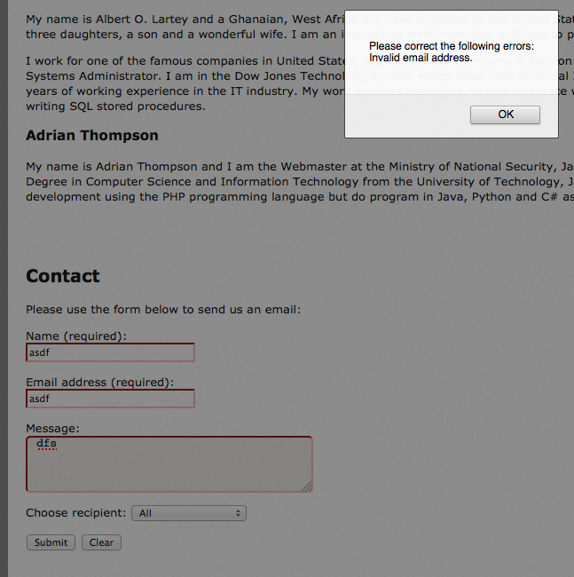

Validation is also done on the server-side using a PHP script in case incorrect input has bypassed the client-side validation. What exactly happened when you tried it?

Regards,

Emanuel