**Week 2 Hand-in Assignment**

**You should use** the text, discussion (things you and your peers have said or uncovered that help you solve the problems) and/or other resources to formulate your answers - just remember not to directly discuss these questions until after I have posted the answers next week.

I would prefer it if you attach the .java file and all the associated files to your submission message together with some appropriate introduction and discussion of your answers.

**Problem**

By day 7 of this week, post your solution to the following problem in the assignments folder. Post whatever you have completed, even if it is not working.

Using JOptionPanes to handle your input and output, develop a Java program which, given the width, length and depth (in metres), of a swimming pool, determines and outputs: (a) the volume in litres, and (b) the time in hours to fill the swimming pool. Assume the rate of flow into the pool is 2.5 litres per second. Note: 1 litre = 1000 cubic centimetres, therefore 10 litres = 0.01 cubic metre, hence 1 cubic metre = 1000 litres (see figure below).

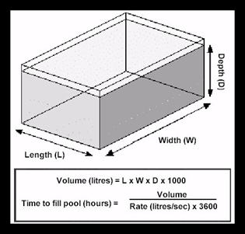

Remember to write the source code for each class in a separate file which must have the same name as the class name together with the extension **.java**. Remember also that by convention, class names commence with a capital letter.

As with all programs you write, you should provide a well-structured solution that is easy to read. You should use meaningful identifier names and should provide useful comments. A large proportion of the marks for this assignment will be based on the structure of your classes, not whether they do or don't work correctly.

**The focus of the assignment is for you to familiarise yourself with the Java concepts introduced in this seminar (data, data types, type conversions, etc).** If you have difficulty with the assignment, you may discuss these problems in the discussion folder as long as you do not directly discuss the assignment problems.

**In the event of compilation problems (i.e. your program will not compile), do not post entire classes and ask what is wrong with them.** This would violate the above stricture of not discussing the assignment problems in the main folder. Instead, try and identify the source of the problem through a process of elimination (by commenting out chunks of the code). You may discuss error messages you may receive, and you may discuss compilation problems with the Hello World2! and integer input applications, and perhaps these discussions will help you to figure out where your errors lie. In addition, you may always contact me via private e-mail if you are having a specific problem and none of the above solutions seem to work for you. Please use this option as a last resort, however!

It is a good idea to work in a step-by-step *top-down* manner. For example, first define the general structure of a class with empty methods and compile the file. Once it compiles successfully, then start adding further detail, recompiling after every few lines. This way, the risk of getting a screen full of error messages is reduced, and you can be assured of handing in something that works by the end of the week.