**Week 3 Hand-in Assignment**

Answer the following questions by the end of the cycle Wednesday night and place the response in the assignment folder.  **You should use** the text, discussion (things you and your peers have said or uncovered that help you solve the problems) and/or other resources to formulate your answers - just remember not to directly discuss these questions until after I have posted the answers next week.  At that time, in the main folder for seminar 3, you may ask any lingering questions about the assignment for this week that you would like.

I would prefer it if you attach a Word or .java file with your coding answer to your assignment post rather than embedding the code in the message - attaching the Word or .java files make it much easier for me to check your code for any problems you may have encountered.

**Problem**

Using JOptionPanes to handle your input and output, produce a Java program which, given three sides of a triangle, determines whether the triangle is:

1.  Equilateral - all sides the same length,

2.  Isosceles - two sides the same length or

3.  Scalene - no sides the same length

(see **Figure 1**).  Assume that any individual side must be a positive number not greater than 100.0.

Also use an appropriate loop to allow the user to repeat the above actions until they choose to exit the program.

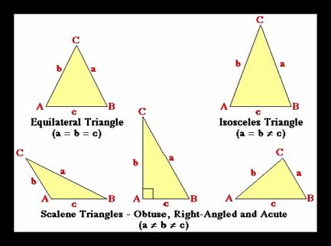

**Figure 1**:  *Triangle Types*

Remember to write the source code for each class in a separate file which must have the same name as the class name together with the extension **.java**.  Remember also that by convention, class names commence with a capital letter.

As with all programs you write, you should provide a well-structured solution that is easy to read.  You should use meaningful identifier names and should provide useful comments.  A large proportion of the marks for this assignment will be based on the structure of your classes, not whether they do or don't work correctly.

**The focus of the assignment is for you to familiarise yourself with the Java concepts introduced in this seminar (loops, decision structures, etc.).** If you have difficulty with the assignment, you may discuss these problems in the discussion folder as long as you do not directly discuss the assignment problems.

**In the event of compilation problems (i.e. your program will not compile), do not post entire classes and ask what is wrong with them.**  This would violate the above stricture of not discussing the assignment problems in the main folder.  Instead, try and identify the source of the problem through a process of elimination (by commenting out chunks of the code).  You may discuss error messages you may receive, and you may discuss compilation problems with the lecture applications, and perhaps these discussions will help you to figure out where your errors lie.  In addition, you may always contact me via private e-mail if you are having a specific problem and none of the above solutions seem to work for you.  Please use this option as a last resort, however!

It is a good idea to work in a step-by-step *top-down* manner.  For example, first define the general structure of a class with empty methods and compile the file.  Once it compiles successfully, then start adding further detail, recompiling after every few lines.  This way, the risk of getting a screen full of error messages is reduced, and you can be assured of handing in something that works by the end of the week.

Use the Safe Assign link below to submit your assignment.