Introduction Document for Week6 Hand-in Assignment

This project contains 3 public classes:

1. SetOfIntegers class:
   1. This class serves as the blueprint for the SetOfIntegers objects.
   2. Contains the following instance variables:
      1. intArray, which is an array that holds values of type int. The size of the array is set by the constant ARRAY_LENGTH = 10.
         1. The elements of the array are initialized by instantiating a SetOfIntegers object:
            1. No arguments: all are set to zero.
            2. Supplying 10 integer arguments.
   3. Contains the public method bubbleSortArray() that:
      1. Sorts in ascending order the contents of the inArray instance variable using the bubble sort algorithm (Martin, 2007).
      2. Returns the sorted array.
2. Assignment6App
   1. This class is the application class for this project, and is used to create an instance of the SetOfIntegers class.
   2. Extends the JFrame class, so it inherits all of its instance variables and methods.
   3. Contains instance variables:
      1. JLabels, JPanels, and JTextFields for:
         1. All 10 integers entered by the user.
         2. Displaying the unsorted and sorted values entered by the user.
      2. JButtons for entering the integers or exiting the program.
   4. Contains the private class ButtonHandler, which implements the ActionListener interface.
      1. This private class is used for event handling (what to do when buttons are pressed).
   5. Contains the private methods:
      1. receiveInputFromUserSuccessful()
         1. Executes if the sort button is pressed.
         2. Checks that values entered by the user are integers.
         3. If it returns true, then:
            1. Values entered by the user into the 10 text fields are assigned to the 10 integer instance variables.
            2. The integers are displayed in the unsorted and sorted JTextFields in the window.
      2. displayArray(int[] arrayToBeDisplayed, JTextField textField)
         1. Displays the contents of arrayToBeDisplayed, which is passed in as an argument. It is displayed as one line: {n1, n2, n3, …} in the JTextField that is passed in.
3. Assignment6Driver
   1. This class is used to create an instance of the Assignment6App class.
   2. The size of the JFrame created is specified.
   3. When the JFrame is closed, the program exits.

Screenshots:

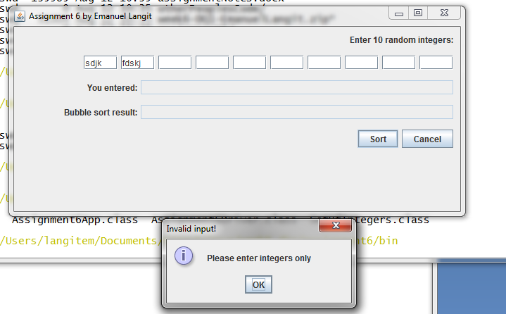

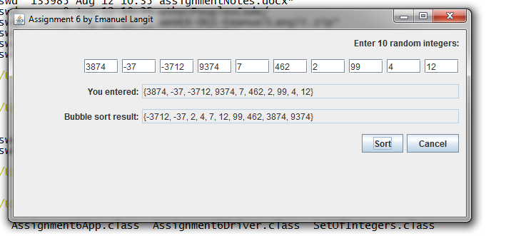

Reference:

Martin, D. (2007) *Bubble Sort* [Online]. Available from: <http://www.sorting-algorithms.com/bubble-sort> (Accessed: 14 August 2013)