PWGSC WPSS Validation Tool

User Guide

Version 2.5.0
EDRM # 1067511
May 17, 2011

1 Introduction 3
1.1 Tool Limitations 3
1.2 Tool Risks 3
2 Installation 4
2.1 Remove Existing PL File Associations 4
2.2 Install ActivePerl 4
2.3 Install WPSS Tool files 4
3 Uninstall 5
3.1 Uninstalling Perl 5
4 How To Use 6
4.1 Site Details 6
4.1.1 Entry URLs 6
4.2 Login/Logout Pages 8
4.2.1 Login/Logout URLs 9
4.3 Saving Site Details 10
4.3.1 Loading Site Details 10
4.4 Perform Site Crawl and Analyse Documents 10
4.5 Direct HTML Analyses 10
4.6 List of URLs 11
4.7 Tool Analysis Configuration 12
4.8 Results Window 13
4.8.1 Saving Analysis Results 15
4.8.2 Stopping Crawler and Analysis 15
4.9 Application Login 15
4.10 Web Server Protected Sites 16
4.11 Reporting Passes and Fails 16
4.12 Capture HTML Content on Errors 16
5 Configuration Files 18
5.1 Domain Network Scope 18
5.2 Domain Alias Map 18
6 Trouble Shooting 19
6.1 Entry Page Rewritten 19
6.2 Forbidden by robots.txt 19
6.3 User Agent String 19
6.4 Perl Command Line Interpreter Error 19

Introduction

The PWGSC WPSS Validation Tool provides web developers and quality assurance testers the ability to perform a number of web site and web page validation tasks at one time. The tool crawls a site to find all of the documents then analyses each document with a number of validation tools. The analysis includes

- HTML Validation
- CSS Validation
- Robots.txt Validation
- Link Violation Checking
- Metadata Checking
- Technical Quality Assurance (TQA) Checking
- HTML Document feature reporting (e.g. forms)

Details of these analysis tools can be found in document “Web-WPSS Tool”.

Tool Limitations
There are limitations within the tool that may affect the validation results, these limitations are:

- The tools do not support JavaScript, sites that rely on JavaScript may not be crawled or analysed accurately.
- The tools do not use a standard Web browser User Agent name, sites that rely on the User Agent name may not be crawled or analysed accurately.
- The tools default behaviour is to respect robots directives, if a site has a robots.txt that prohibits crawlers, then no validation of the site’s documents would be performed. The tool can be configured to ignore robots.txt directives, see section “Tool Analysis Configuration” below.
- The output some of the individual validation tools is in English only. Users should be aware that this tool is using 3rd-party software components. The source of these components is available only in the language in which it was authored.

Tool Risks
This validation tool includes a crawler that will follow links and retrieve web documents from sites. Care should be taken with this tool to
- Ensure entry page URLs for the sites are accurate so the crawler does not go beyond the site being analysed.
- Ensure that document retrieval from the site being analysed, and any links to other sites, do not impose excessive loads on web servers and the network.

Installation

The PWGSC WPSS Validation Tool requires that a Perl distribution be installed on the workstation and that .pl files be associated with the Perl interpreter. This tool has been tested with ActivePerl version 5.10. Other versions of ActivePerl and other Perl installations may not work as expected or may be missing required modules.

Remove Existing PL File Associations
Remove any existing .pl file type associations. The installation of ActivePerl will create a new association to ensure the proper execution of Perl programs.
- Open the Control Panel,
- Open the Folder Options tool
- Select the “File Types” tab
- Scan the file extensions list, select the .pl entry and click delete the association.

Install ActivePerl
- Run the ActivePerl-5.10.0.1003-MSWin32-x86-285500.msi installer to extract and install the Perl package.
- Select all the default options in the installation wizard.

Install WPSS Tool files
- Unzip the WPSS_Tool.zip file, the files will extract into a folder called WPSS_Tool.
- Run the install.pl installation script.

Uninstall
The PWGSC WPSS Validation tool can be removed from a workstation by running its uninstall script.

- Using Windows Explorer navigate to the WPSS_Tool folder.
- Run the uninstall.pl script.

Uninstalling Perl
The Perl installation can be removed by using the “Control Panel”, “Add or Remove Programs” utility.

How To Use

Start the PWGSC WPSS Validation Tool, by using Windows Explorer to navigate to the WPSS_Tool folder. Double click on the wpss_tool.pl file to launch the tool.

The main window consists of 5 tabs. The first tab allows the user to enter details for crawling a site, the second for entering login/logout information, the third allows for pasting in HTML code, the fourth for entering a list of URLs, and the fifth allows the user to select tool configuration options.

Site Details
In order to crawl and analyse the documents in a site, the URLs for the site and entry page addresses must be entered into the tool. The “Site Details” tab is used to enter these details. The following details must be entered in order to properly define a site for crawling.

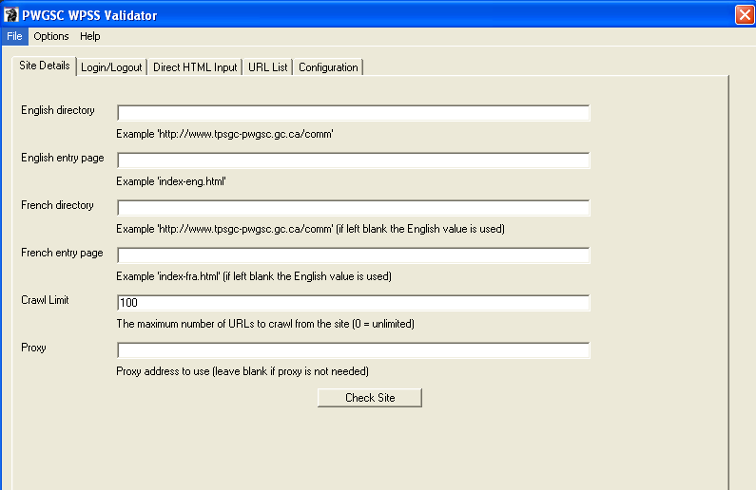

Entry URLs
The English and French URLs for the site along with the entry page names must be entered into the top page of the “Site Details” tab

English Directory – This is the English URL to the directory containing all of the site’s documents (HTML documents, image files, css files, etc.). Examples,
- http://www.tpsgc-pwgsc.gc.ca/comm/index-eng.html the English Directory is http://www.tpsgc-pwgsc.gc.ca/comm/

- http://source.tpsgc-pwgsc.gc.ca/policy/text/index-e.html the English Directory is http://source.tpsgc-pwgsc.gc.ca/policy/

- http://id-reo.tpsgc-pwgsc.gc.ca/public/ffchrdspl.do?page=acclhm&lang=en the English Directory is http://id-reo.tpsgc-pwgsc.gc.ca/public/

- http://crownassets.pwgsc.gc.ca/mn-eng.cfm?snc=hm the English Directory is http://crownassets.pwgsc.gc.ca/

English Entry Page – The directory and file name of the English entry page. This is not the full URL, just the directory, file name and arguments portion. The entry page name can be found by viewing the site’s splash page to get the URL referenced by the English language button. For example
- http://www.tpsgc-pwgsc.gc.ca/comm/index-eng.html the English Entry Page is index-eng.html.

- http://source.tpsgc-pwgsc.gc.ca/policy/text/index-e.html the English Entry Page is text/index-e.html

- http://id-reo.tpsgc-pwgsc.gc.ca/public/ffchrdspl.do?page=acclhm&lang=en the English Entry Page is ffchrdspl.do?page=acclhm&lang=en.

- http://crownassets.pwgsc.gc.ca/mn-eng.cfm?snc=hm the English Entry Page is mn-eng.cfm?snc=hm.

French Directory – This is the French URL to the directory containing all of the site’s documents (HTML documents, image files, css files, etc.). If the French Directory is the same as the English Directory, it can be left blank. Examples,
- http://www.tpsgc-pwgsc.gc.ca/comm/index-eng.html the French Directory can be left blank, as it is the same as the English directory.

- http://source.tpsgc-pwgsc.gc.ca/politique/text/index-f.html the French Directory is http://source.tpsgc-pwgsc.gc.ca/politique. Since the directory name politique differs from the English name, policy, the French directory must be specified.

- http://id-reo.tpsgc-pwgsc.gc.ca/public/ffchrdspl.do?page=acclhm&lang=fr the French Directory can be left blank as it is the same as the English directory.

- http://biensdelacouronne.tpsgc.gc.ca/mn-fra.cfm?snc=hm the French Directory is http://biensdelacouronne.tpsgc.gc.ca. The site has separate English and French domain names.

French Entry Page – The directory and file name of the French entry page. This is not the full URL, just the directory, file name and arguments portion. The entry page name can be found by viewing the site’s splash page to get the URL referenced by the French language button. For example
- http://www.tpsgc-pwgsc.gc.ca/comm/index-fra.html the French Entry Page is index-fra.html.

- http://source.tpsgc-pwgsc.gc.ca/politique/text/index-f.html the French Entry Page is text/index-f.html

- http://id-reo.tpsgc-pwgsc.gc.ca/public/ffchrdspl.do?page=acclhm&lang=fr the French Entry Page is ffchrdspl.do?page=acclhm&lang=fr.

- http://biensdelacouronne.tpsgc.gc.ca/mn-fracfm?snc=hm the French Entry Page is mn-fra.cfm?snc=hm.

Crawl Limit – The maximum number of URLs the tool will retrieve and analyse from the site. The URLs include all file types, HTML, PDF, images, CSS files, etc. If the value 0 is specified then the entire site will be crawled.

Login/Logout Pages
The WPSS Tool can crawl application sites that have a simple login page consisting of a single form for login credentials. If the site to crawl does have a login, then the following additional data items must be entered. If the site does not have a login, these fields should remain blank.

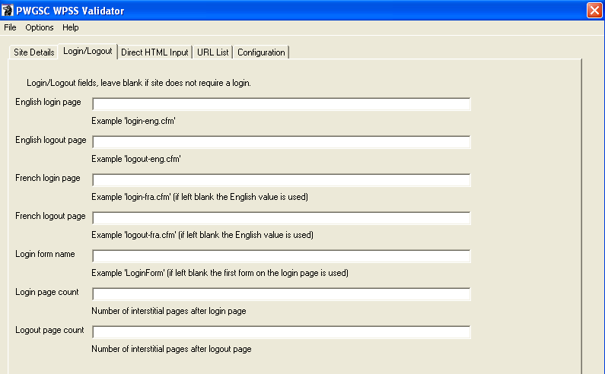

Login/Logout URLs

English Login Page – The directory and file name of the English login page. This is not the full URL, just the directory, file name and arguments portion. For example
- http://crownassets.pwgsc.gc.ca/mn-eng.cfm?snc=hm the English Login Page is mn-eng.cfm?snc=ouv-log&ouvlog=1&vndsld=0.

English Logout Page – The directory and file name of the English logout page. This is not the full URL, just the directory, file name and arguments portion. For example
- http://crownassets.pwgsc.gc.ca/mn-eng.cfm?snc=hm the English Logout Page is mn-eng.cfm?snc=ouv-log&ouvlog=1&vndsld=0.

French Login Page – The directory and file name of the French login page. This is not the full URL, just the directory, file name and arguments portion. For example
- http://biensdelacouronne.tpsgc.gc.ca/mn-eng.cfm?snc=hm the French Login Page is mn-fra.cfm?snc=ouv-log&ouvlog=1&vndsld=0.

French Logout Page – The directory and file name of the French logout page. This is not the full URL, just the directory, file name and arguments portion. For example
- http://biensdelacouronne.tpsgc.gc.ca/mn-eng.cfm?snc=hm the French Logout Page is mn-fra.cfm?snc=ouv-log&ouvlog=1&vndsld=0.

Login Form Name – If the login page contains more than 1 form (e.g. a search form along with the login form), then the name of the form must be specified. The name is the value of the name or id attribute of the form. If there is only 1 form on the login page, this field can be left blank.

Saving Site Details
The above site details can be saved in a configuration file for sharing or easy access for subsequent runs of the tool. This is accomplished by selecting the “Save Site Config” item from the “File” menu. The folder and file name can be specified file chooser dialog. In order to manage site configuration files it is suggested that the configuration files be saved in the profiles folder within the WPSS_Tool folder.

Loading Site Details
A previously saved site configuration can be easily loaded into the “Site Details” fields by selecting the “Load Site Config” item from the “File” menu. Select the file in the file chooser dialog. Once the site details are loaded, they can be used as is, or modified if need be.

Perform Site Crawl and Analyse Documents
Once the site details have been entered and the analysis configuration items have been selected, a crawl of the site can be initiated. By selecting the “Check Site” button on the “Site Details” tab the WPSS Tool begins to crawl the site and analyses each of its documents. The results are provided in the results window.

Direct HTML Analyses
To analyse a single page, the HTML mark up of that page can be entered into the “Direct HTML Input” tab. Once the text has been pasted into the text area, the “Check” button can be used to analyse the HTML content. The analysis configuration options from the “Configuration” tab are used to control the tool and the results appear in the results window.

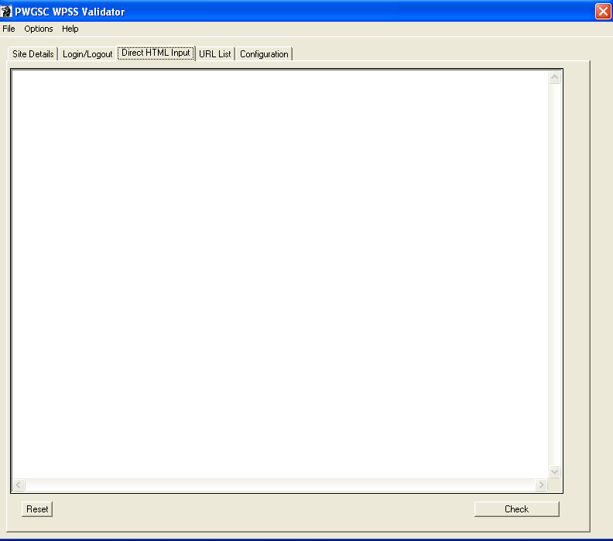

List of URLs
The “URL List” tab allows the user to enter a list of URLs to be analysed. The list of URLs can be types directly into the text area or loaded from a file. The “Check URL List” button begins the analysis each of documents. The results are provided in the results window.
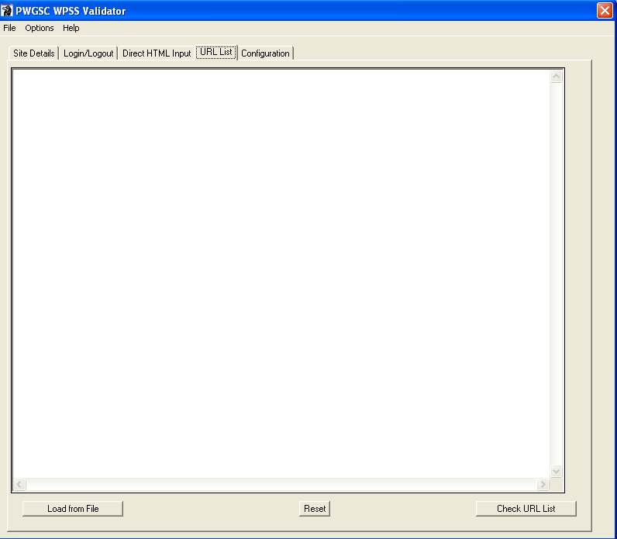

Tool Analysis Configuration
The “Configuration” tab allows the user to select options for the analysis tools. The options include

- 401 status handling – Controls the behaviour of the tool if it encounters a 401 – Not Authorized code.
The selections include
  - Prompt for credentials
  - Ignore

- Content Check Testcase Profile – Select the appropriate Content Check testcase to validate with. The selections include
  - All – All content check testcases

- HTML Feature Profile – Select the appropriate HTML feature profile to report on. The selections include
  - All – Report all HTML features

- Metadata Profile – Select the appropriate Metadata profile to validate with. The selections include
  - PWGSC – The PWGSC CLF 2.0 Metadata profile.
  - None – No Metadata required.
  - TBS CLF 2.0 – The TBS CLF 2.0 profile.

- PDF Property Profile – Select the appropriate PDF Property profile to validate with. The selections include
  - PWGSC – The PWGSC profile.
  - None – No properties required.

- TQA Testcase Profile – Select the desired Technical Quality Assurance test case profile. The selections include
  - Alt Text Plus 2.0 – CLF, PWGSC and WCAG 2.0 testcases
  - Alt Text Plus 1.0 – CLF, PWGSC and WCAG 1.0 testcases

- Robots.txt handling – Controls the behaviour of the tool if it encounters a 403 – Forbidden by robots code.
The selections include
  - Respect robots.txt
  - Ignore robots.txt

These configuration options are not saved with the site information, they must be set before starting the analysis.

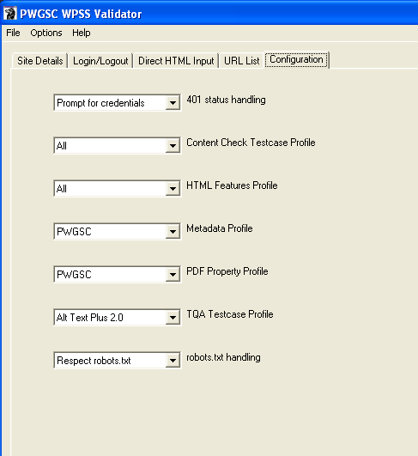

Results Window
The “Results Window” contains a number of tabs, each containing the output of an individual analysis tool. The output in each tab includes a header that lists the English and French site directory URLs along with the time and date when the analysis started.

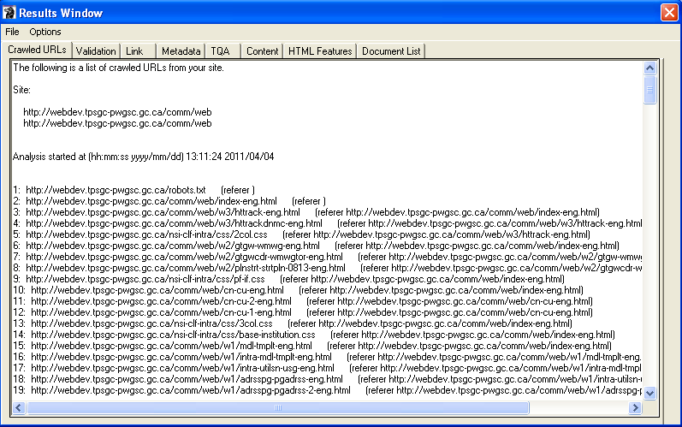

The list of output tabs is:

Crawled URLs – This provides the list of URLs that are analysed by the tool. It lists the referrer page to indicate how the crawler reached a particular page. This tab can be used to monitor the WPSS tool to ensure it is actively crawling and analysing a site’s pages.

Validation – This tab contains the output of the HTML/XHTML, CSS and Robots.txt validation tools.

Link – This tab contains the output of the Link Check tool.

Metadata – This tab contains the output of the Metadata Check tool.

TQA – This tab contains the output of the TQA Check tool.

Content – This tab contains the output of the Content Check tool.

HTML Features – This tab contains a list of documents that have HTML features like forms, tables, etc.

Document List – This tab is written after the site analysis is complete. It contains the sorted list of documents found in the site. It includes all documents, HTML/XHTML, PDF, images, CSS, etc.

Once the analysis is complete, the time & date is included at the end of the report in each tab.

Saving Analysis Results
To save the analysis results, select the “Save As” item from the “File” menu in the Results window. Select the file name and folder path in the file chooser dialog. The results are stored in a number of files, one for each result tab. Each file name will contain a suffix identifying the report type. For example, if the results are to be saved in the file www_corp.txt, the actual results files will be

- www_corp_crawl.txt
- www_corp_val.txt
- www_corp_link.text
- www_corp_meta.txt
- www_corp_tqa.txt
- www_corp_feat.txt
- www_corp_urls.txt

In addition to the above results, some HTML reports are also generated and saved with the result files.

- www_corp_img.html – Image Details report
- www_corp_h.html – Headings Outline report

It is suggested that the base name of the results be the same as the site profile name and that the results are stored in the results folder in the WPSS_Tool folder.

Stopping Crawler and Analysis
To stop the crawler and analysis tools while they are running, select the “Stop Crawl” item in the “Options” menu in the results menu. This will stop the tool after the current document is processed and add a note to the bottom of each output tab indicating that analysis was aborted.

Application Login
If the site being analysed is an application with a login page (specified in the Site Details tab of the main window) the tools must be able login to the application in order to view pages behind the login. When the English login page is reached, the user is presented with a Login window in order to provide application credentials. All of the input fields listed in the login form are presented to the user in a login window. The order of the fields may be different than what appears on the web page.

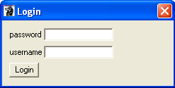

Once the credentials are provided and the “Login” button is selected, the WPSS tool attempts to login to the application site. The user is not prompted for login credentials for the French login page rather the English credentials are reused.

Web Server Protected Sites
If the site being analysed contains directories that are password protected by the web server using Basic Authentication, the tool must be able to provide the credentials in order to view the documents. When a document is reached that requires authentication, the user is presented with a Login window in order to provide the credentials.

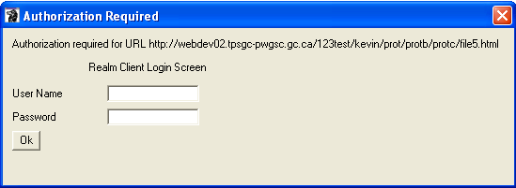

Once the credentials are provided and the “Login” button is selected, the WPSS tool attempts to get the document.

Reporting Passes and Fails
The default behaviour of the analysis tools is to report only on URLs that fail checks. If you wish to see an entry in the results for both passes and fails, the “Report Fails and Passes” item in the “Options” menu of the main window should be selected. The URL for documents that pass checks are then recorded in the results output.

Selecting the “Report Fails Only” item from the “Options” menu of the main window will turn off this feature.

Capture HTML Content on Errors
Sometimes having the URL of a document with errors is not sufficient, especially if the content is generated by an application on the fly. In order to capture the HTML content of a document with errors it is necessary to stop the analysis process when the error occurs. By selecting the “Stop on Error” item in the “Options” menu of the main window, the crawler and analysis tools will stop when an error is detected. Once stopped, the user is presented with an option to save the HTML content or to continue on with the next document. The saved content includes HTML comments at the top of the file providing the full URL of the document along with the tool error message.

Selecting the “Continue on Error” item from the “Options” menu of the main window will turn off this feature.

Configuration Files
There are a number configuration files that modify the behaviour of the tool. Most of these files should remain untouched with the exception of the wpss_tool.config file. This file contains the network scope designation for domains as well as the domain and domain alias mapping. The file is a plain text file with simple name value pairs for configuration parameters.

Domain Network Scope
This defines the network scope of a specific domain. The network scope is one of
- Internet
- GC Intranet
- PWGSC Intranet
- Internet development
- GC Intranet development
- PWGSC Intranet development

Domain Alias Map
This provides a mapping of domain names and their aliases.

Trouble Shooting

Entry Page Rewritten
Message | Entry page http://webdev02.pwgsc.gc.ca/comm/index-eng.html rewritten to http://webdev02.tpsgc-pwgsc.gc.ca/comm/index-eng.html
Cause | The entry page provided in the site configuration is redirected by the web server.
Correction | Provide the rewritten entry page URL in the site configuration.

Forbidden by robots.txt
Message | Failed to get url http://ssi-iss.tpsgc-pwgsc.gc.ca/index-eng.html,error is 403 Forbidden by robots.txt
Cause | The site has a robots.txt file that prohibits crawlers from accessing the site. The WPSS Tool honours robots, so is unable to crawl and analyse the site.
Correction | Select the “Ignore robots.txt” value for the “robots.txt handling” item in the Configuration tab.

User Agent String
The validation tools have their own User Agent string that is different from a user’s browser. Some sites look at the User Agent string and present different output depending upon its value (e.g. check for a minimum browser version).

Message | Varies
Cause | The validation tools User Agent string not recognized by the site being analysed.
Correction | Change site to not depend on a specific User Agent string and/or browser.

Perl Command Line Interpreter Error
The WPSS Tool uses a number of Perl modules. These modules may have errors that cause the program to fail. The following dialog may be encountered

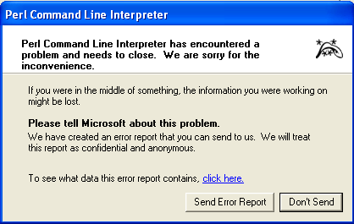

Message | Perl Command Line Interpreter has encountered a problem
Cause | An error in the supporting Perl modules..
Correction | Restart the WPSS Tool, if the problem persists contact PlanificationWeb-WebPlanning@tpsgc-pwgsc.gc.ca

