Make sure you have installed the WPSS
Open the “WPSS_Tool” from Start > Programs > WPSS_Tool > WPSS_Tool
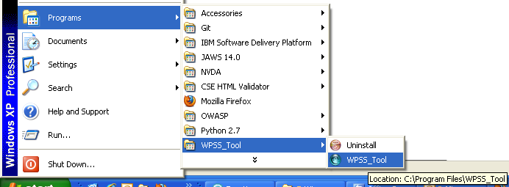

The easiest way to find all Broken Links is the Select the URL List Tab
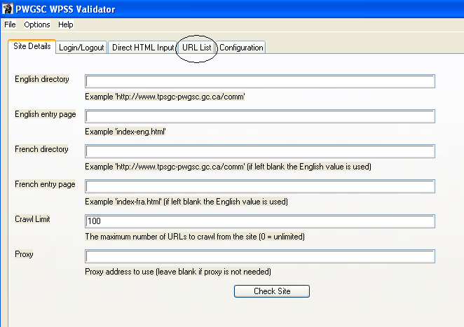

From the URL List tab, enter the URL a List of URL then click on the “Check URL List” button
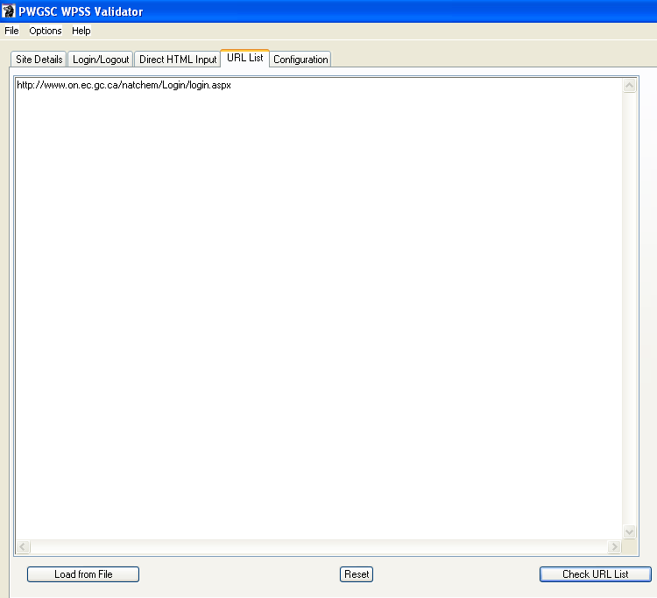

The Results Window will appear then wait a few second until the Analysis is completed
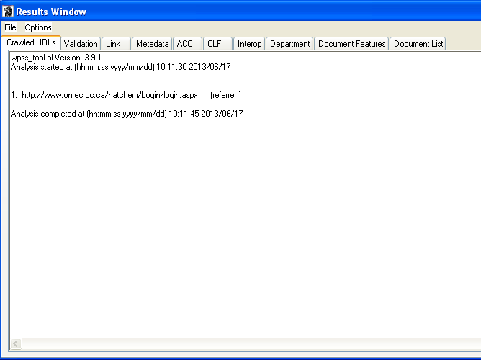
From the Results Window, Select the Link tab to display all Broken Link on error
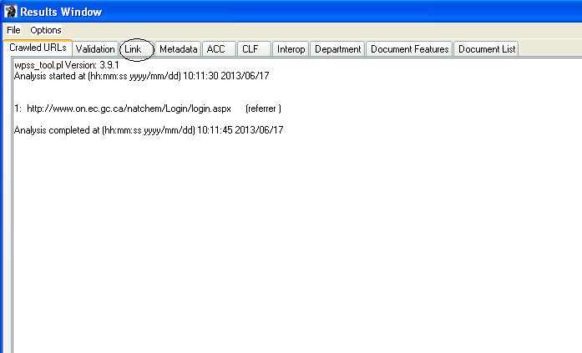

If there is any broken link problem, it will appear as the following example:
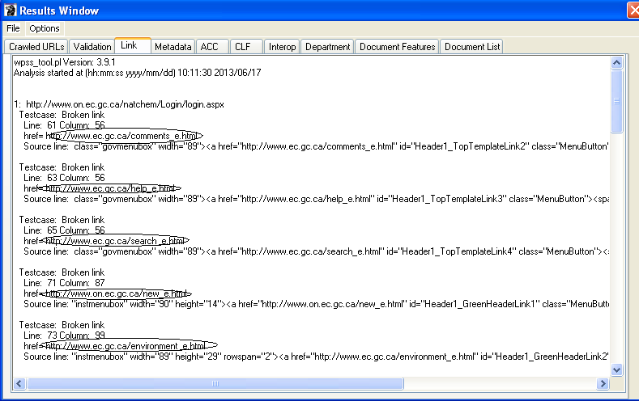

You can also find Broken Links by crawling the entire Web Application is you wish.
P.S. Make sure to Reset before a new search and Select the “Site Details” tab
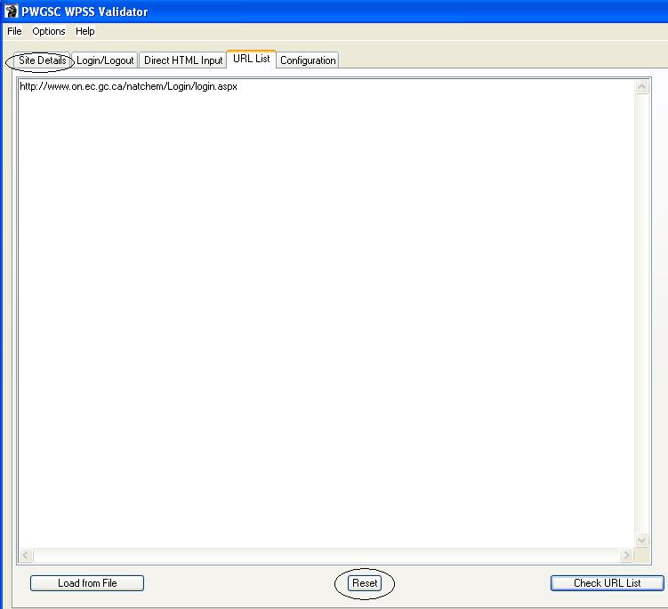

For example, enter the first part of the URL in English directory and the second part in the English entry page
The Crawl Limit is 100, In this case, we are testing only the login page then click on the “Check Site” button
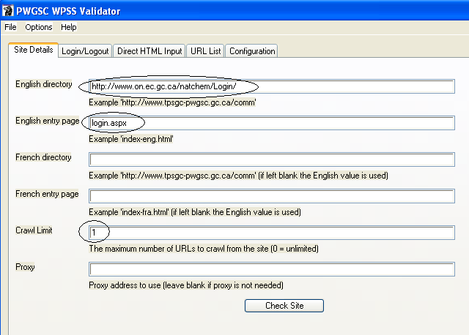
The Results Window will appear then wait a few second until the Analysis is completed

From the Results Window, Select the Link tab to display all Broken Link on error

If there is any broken link problem, it will appear as the following example:

