**Orientalism and Portrayal of ‘The Other’ In Western Comic Art**

The idea of ‘The Other’ is one that has existed ever since humans learned to notice differences between themselves and other members of their own species. As human culture has developed we have found new and increasingly complex ways of illustrating contrast between ourselves and people of different colours, ethnicities, religions, genders and sexualities. However, out of all the various art forms that we have developed over the centuries, bande dessiné (or comics), is arguably the best medium for illustrating and understanding the cultural perceptions of a particular period. Of course, as with any art form, the people that write and illustrate bandes dessinées do not live in a cave, they live within a society that inevitably impacts and can be seen in their work. While this may also be true of other, more contemporary art forms, one feature of bande dessinée distinguishes it from all the rest. Bande dessinée artists do not draw intricate masterpieces with as much detail as a renaissance painting. Instead they use more of an artistic short-hand. This often results in depictions of certain subjects being rather simplified, stereotypical, and even vastly generalised. This provides a glimpse of the views and cultural zeitgeists of the time when the bande was first drawn (Stromberg, 2003).

This essay will first discuss some of the key principles of Orientalism, which does have some overlap with the concept of the Other, as described by Edward Said and Homi K. Bhabha respectively. Then, we will look at some examples of Orientalism and the Other being used in bande dessiné, from both American and Franco-Belgian publishers. Fredrik Stromberg’s books, *Black Images* *in the Comics* and *Comic Art Propaganda* are incredibly useful and extensive collections of western and eastern comic art, where one can find numerous examples of Orientalism and the Other being depicted in comic images throughout history. Although the term Orientalism encompasses Asian, African and Middle Eastern countries, the images discussed in this essay will be depictions of Asian (specifically Chinese stereotypes). The depiction of other cultural stereotypes in bande dessiné must absolutely be studied, however this is essay is too short to provide in depth analysis of stereotyping for all three categories. Since Stromberg’s work effectively deals with the African and Middle Eastern contingents, this essay will focus on Asians.

Edward Said’s book, *Orientalism* (1978), details the West’s (Europe and America) relationship with Africa and the Middle and Far East, (the other in this context being the East). In it, he argues that western societies have, over several centuries, constructed an idea of the East (or the Orient) that is distinctly contrasted with westerners’ image of themselves. This perceived contrast provides the basis for innumerable theories, attitudes and preconceptions of the Orient. The recurring theme however, throughout the vast majority of oriental discourse, is a token superiority of the West over the East. A large part of Western cultural identity stems from contrasting oneself against various Eastern stereotypes, based on the accumulated knowledge of centuries of oriental discourse. This knowledge however, is incomplete and biased at best, and is largely based on Western projections and ideas of what the East *should* be. Nonetheless, the West needs something to justify its own superior self-image, something to prop itself up against. The classic juxtaposition of ‘us and them’ is just another incarnation of ‘the other’, and this is exactly what fuels western cultural identity. Said argues that in renaissance times, the contrast was civilised westerners versus impoverished eastern peasants. Nowadays it could be argued that there is no shortage of middle eastern stereotypes for westerners to position themselves against.

The concept of the Other is a hefty one – the term itself is quite vague and encompasses various smaller schools of thought, one of them being Orientalism. To understand the concept, it is necessary to discuss the work of Homi Bhabha. Bhabha deals more directly with the idea of the Other than Said does. A key component of Bhabha’s work is the idea of the stereotype, which helps to narrow down the idea of the Other. Bhabha, for the most part, agrees with Said on the issue of oriental discourse, as he incorporates it into his more general argument of colonial discourse. Though this is an even denser and more general topic than Orientalism, stereotyping and the Other feature more prominently on the surface of Bhabha’s arguments than they do in Said’s. In *The Location of Culture* (1994) Bhabha argues that the West’s colonizing and domination of the East is (falsely) justified by the ‘othering’ of the colonized people, and by stereotyping them as inferior and needing governed. However, racial stereotyping or ‘othering’, and therefore colonial power and discourse, are dependent on the stability and regularity of constructed stereotypes. Stereotypes depend on validation of projections and confirmation and repetition of previously acquired knowledge. However, as stated before with Orientalism, this kind of knowledge is never stable, and is based on projections by the colonizers onto the colonized. Knowledge, or rather the lack thereof, is the source of stereotyping and ‘othering’. As always humans fear that which they lack knowledge of, and so we develop oriental or colonial discourse, as a means of understanding, controlling or ruling over something which we do not actually truly understand.

This brings us back to Stromberg. His books consist of collections of images from various bandes dessinées that portray people of various races in a crude and offensive manner. In *Black Images in the Comics* (2003), Stromberg prefixes these images with a brief explanation of what he believes to be the cause of racial stereotyping in Western comic art. He, like Bhabha, argues that lack of knowledge may be what results in simplified, stereotypical depictions of ‘others’ in comics. He states that it is more difficult to accurately depict people of colours and ethnicities different from one’s own. If this is true, and racism is not a factor, then it merely becomes even more imperative to study these images, as they illustrate the image that people had of ‘others’ at a particular time. However, Charles Johnson, who writes the prologue for Stromberg’s book, disagrees. He argues that the whole point of comic art, and art in general, is to be able to take a look from behind the eyes of others. Furthermore, he accuses those who simplify and stereotype their illustrations of other races of ignorance, and intellectual and creative laziness. He rejects the idea that artists were products of their time, and that they should not be content to work with pre-fabricated knowledge and projections that contribute to such stereotyping (Johnson, 2003)

One artist who dramatically reinvented his work, going from offensively stereotypical to incredibly accurate, was none other than the legendary Hergé. The Belgian artist’s first four Tintin adventures were awash with the sort of lazy stereotypes that Charles Johnson accused twentieth century writers of. Despite being bande dessinée royalty, *Tintin au pays des Soviets, Tintin au Congo, Tintin en Amerique,* and *Les Cigares de Pharoan*, were heavily based on stereotypes that readers had of these countries at that time. However, everything changed when Hergé met Chinese art student, Zhang Chongren. Just prior to the creation of the fifth Tintin adventure, Chongren was a source of inspiration for Hergé that revolutionised both the technical and political aspects of his work, and by extension the work of countless bande dessinée artists that would follow Hergé’s example. Hergé’s newfound interest in Chinese calligraphy would help develop his *Ligne Claire* style of writing, which would allow for more accurate depiction of people and environments. Furthermore, Hergé’s friendship with Chongren would allow him to do what Charles Johnson envisioned an artist should do – put oneself behind the eyes of another. Entitled *Le Lotus Bleu*, the fifth album turned out to be the most accurate representation of far eastern culture at the time. Hergé tacitly handled the tense political climate between China and Japan during the build up to the second world war. The album was so well done in fact, that Hergé was invited to China by the Great Leader – Chiang Kai-shek. One could argue then, that *Le Lotus Bleu* is a rare example of accurate Oriental discourse, produced by a westerner, but accepted by the East. This example seems to vindicate Johnson’s argument that artists should try harder to produce accurate and informed depictions of others in bandes dessinées. Hergé’s development of *Ligne Claire* refutes Stromberg’s defence of illustrators that use artistic short-hand to portray others in their art, and is complicit in Johnson’s condemnation of these artists as creatively and intellectually lazy.

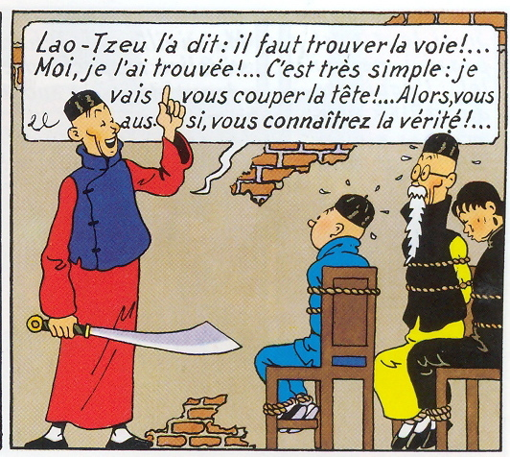

*Hergé, (1936) *Le Lotus Bleu*

Hergé’s tactful representation of the Chinese is a rare exception however, and is a stark contrast to images of Asians in certain weekly The Wasp was a satirical magazine based in San Francisco, and was notorious for its use of stereotypical caricatures of Chinese-Americans. The two images below were published in 1877 and 1881 respectively, around the time that anti-Asian sentiments were running high in the U.S. This was due to a large intake of Chinese immigrants in the previous few decades, following a trade agreement with China. Coincidentally, the states were in the midst of an economic downturn at the time. Chinese immigrants, despite their relatively low numbers compared to the American populace, were an easy target for scapegoating, and accused of stealing American jobs. This trend of blaming the Chinese for the economic decline was known as ‘The Yellow Peril’, which became the tagline for numerous racist caricatures.

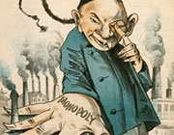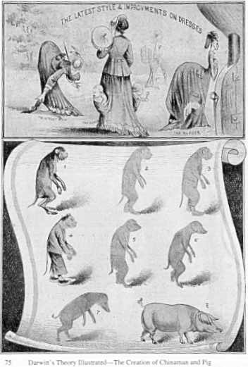

*Unknown artist (1887) Unknown Title *Keller (1881) *The Coming Man*

The first image is a play on the theory of evolution, suggesting that Asians are subhuman and more related to pigs, monkeys, dogs and rats. Published a century before Art Spiegelman’s *Maus*, this image acts as a precursor to the depiction of people as animals in comics. It is crude and dehumanizing, and the polar opposite of Spiegelman’s work, which despite using animals, made the characters somehow more human. The second image is interesting, as it employs a level of detail uncharacteristic of stereotypical depictions of Asians and others in general. One can only assume that the artist went to great lengths to emphasise the stereotypical physical features of Chinese men in order to demonize them and instil fear in viewers. The description in the article reads “The unsophisticated Mongol, imitating, ape-like, his fellows of this country, attains a monopoly of the cigar and laundry business, and smiles a cunning smile of triumph at his discomforted rivals” (Stromberg, 2003:16)

In conclusion then, we can see from these images that Orientalism and Othering are ever-present influences in western comic art. Throughout the 19th and 20th centuries, band dessiné illustrators have often used artistic short-hand to depict races other than their own, resulting in simplified and stereotypical caricatures. Highly stylized and informed artists, such as Hergé during the Blue Lotus period, can produce works that accurately and tactfully depict their subjects, but such precision and devotion is uncommon. As in Oriental and Colonial discourse, most portrayals of others in bande dessiné rely on scarce, questionable information that results in inaccurate and often racist content. However, no matter what the quality or accuracy, bande dessiné helps us understand how Orientalism and the Other influenced western and eastern society in the 19th and 20th centuries, as every drawn line provides an idea of the thinking behind it.

**References:**

* Bhabha, H.K. (1994) *The Location of Culture*, Routledge, London
* Hergé (1936) *Le Lotus Bleu*, Casterman, Tournai
* Johnson, C. (2003) in Strömberg, F. (2003) *Black images in the Comics: A Visual History*, Fantagraphics Books, Seattle, Wash
* Keller, G.F. (1881) *The Coming Man*, The Wasp, San Francisco,
* Said, E.W. (1978) *Orientalism*, Routledge and Kegan Paul, London
* Strömberg, F. (2003) *Black images in the Comics: A Visual History*, Fantagraphics Books, Seattle, Wash
* Strömberg, F. (2010) *Comic Art Propaganda: A Graphic History*, IIex, Lewes, pp. 16-19
* Unknown (1877) Unknown, The Wasp, San Francisco