Community Profile- Maryhill

Maryhill is located in the council region of Glasgow North. Spread over the 7 miles along Maryhill Road, including areas such as Gairbraid, Maryhill Park, North Kelvinside and several more. There is a total population of 13,074 in the Maryhill Road corridor and 11,735 in North Maryhill and Summerston (Shipton & Whyte , 2011). In the late 1700s and early 1800s the canal was built in Maryhill, this included several dry docks and other waterways. This enabled an increase in employment in the area in the shipbuilding industry and so increasing in the local population. This lead to Maryhill to become a Police Burgh in 1856. Following the building of the railway there was the introduction of brewing, glass, timber and rubber manufacture With the increase in prosperity in the area more leisure time activities were introduced and hence the introduction of a football team (Black, Second CIty of the Empire, 2004). In the 21st century employment has changed and moved away from industrial and manufacturing jobs to the service industry. As of April 2012, 7.5% of working age people in Maryhill were claiming Job Seekers Allowance and National Insurance Credits. This was the highest rate in Scotland (Liddell, 2012). This statistic may not reflect the level of unemployment in Maryhill during that period as it had only taken into account the level of people on JSA and NIC, not how many people were receiving Disability Living Allowance (now known as Personal Independence Payments) and other benefits which would mean they were not in employment.

The Scottish Index of Multiple Deprivation shows Maryhill to be in the 1st decile of deprivation overall (see appendix 1-3). There are 3-5 areas on the map that can be considered to be in the Maryhill area. There are separate areas of deprivation considered in the overall calculation and individually these include: income, employment, health, educations/skills, housing, geographic access and crime. For all except the geographical area Maryhill is in the first decile, including housing (Crown, 2012). The housing domain is described as “person in households which are over-crowded” and “persons in households without central heating” (National Statistics, 2012). Housing is considered to be on the third level of the Dahlgren and Whitehead model in the structural factors section (Whitehead, Dahlgren, & Gilson, 2001). Housing as a factor can have a profound impact on an individual’s quality of life, from the area that they live in, to the type of housing they are living in.

Housing is especially important to older adults, specifically those who are aged 65 and over. This age group make up 11.5% of the population of Maryhill Rd Corridor and 7.1% of the North Maryhill and Summerston area (Glasgow Centre for Population Health , 2016). Within these areas, a large proportion of the accommodations available are not suitable for people who have limited mobility. The properties are predominantly flats and many of which do not have lifts, and cannot accommodate chairs lifts. This can mean that many older people find it very challenging to leave their flats or may be unable to leave at all. For those completely unable to leave their flats it can lead to isolation and often depression, this will increase the pressure on District Nurses and local health care practices. It will often mean that if family cannot assist in the care of the older person then carers will have to be brought in to assist with shopping and other activities of daily living. Living circumstances and poverty are one of the five factors said to affect a person’s mental health, the others are: discrimination, relationships, physical health and participation in meaningful activities (Mental Health Foundation, 2016). Living in a flat with limited access to the outside world could be considered in several of these factors, the main one being poverty. If the person did not live in poverty, then there would be a greater opportunity to change their living circumstances. When it is also considered that they are unable to leave their flat then they would be unable to participate in “meaningful life activities”. Factoring in all of these parts it was not surprising that the level of mental health illness is as high as it is in the older adult, 22% of men and 28% of women aged 65 and over have depression (Mental Health Foundation, 2016).

In Maryhill, the availability of affordable and healthy food can also be limited in some areas. There is a large supermarket on Maryhill Rd with good access by local buses but this is not accessible to people who cannot travel there. That leaves people having to shop at whatever is local to where they live and those shops are often more expensive and do not stock fresh fruit and vegetables. This can mean that people become malnourished very easily. This is especially important in the older adult as they are more prone to self-neglect.

The Council has put several projects in place in order to help combat the type of housing available in Maryhill. The project was started in 2010 and is ongoing. The redevelopment includes two phases of development, the first stage has been completed and there are 35 new homes, with the second phase still being completed with over 100 new homes being developed (Glasgow City Council, 2016). The new accommodation will hopefully tackle some of the issues with the current housing such as the lack of disabled access. New building regulations will mean that the doorways in the houses will have to be a minimum width which allows the accommodation of wheelchairs (HM Government, 2015). Although the type of housing will be improved there are no plans to change the local shops, which will mean that although there is some improvement in living conditions older people with limited mobility will still be unable to access fresh fruit and vegetables without outside help from family or carers.

For people, able to get out of their house but unable to walk to bus stops or drive themselves they are able to access the local dial-a-bus service, run by Strathclyde Passenger Transport (SPT). This bus was charged at the same rate as the local bus service but will pick people up from their house and drop them off as close to their desired destination as possible. In the same way that public buses are free for people with a Scottish Citizen’s National Entitlement Card so was the dial-a-bus (Transport, 2016). The service provides a great help to older adults who were previously unable to get out in the community before this service. Although the service does help to get people to doctors’ appointments and to the shops out with their local area it does not help people who are unable to climb the stairs to get out of their own flats.

The role of the nurse with the older adult has a very broad application, and is no longer just concerned with the physical ailments of their patients, although this is still a large part of the role. In the situation of people being unable to climb the stairs up and down to their flat then the nurse would have to judge whether it is appropriate to refer the patient to Occupational Therapy and if that is not the case ensuring that social work is involved to make sure that the patients get the care package appropriate for their specific needs. Healthy eating promotion is also part of a nurses’ role and where appropriate the nurse can advise on the best things for the older person to be eating and should be actively encouraging the older person to eat. Older people have been shown to have reduced appetite which means that it is very important for a nurse to promote eating to the older patients, nutrition is a key element in the overall health of a person (Crawley & Hocking, 2011).

From the experience, I have had in Maryhill and the literature I have read the current provision of services is not meeting the needs of the older people within the Maryhill Community. There are people who are unable to leave their own homes due to the structure of the building they live in and there is currently no provision of housing for them to transfer to somewhere more suitable. Adding to this they are unable to get out to see people or to access local leisure groups or elderly services within the community. With regards to the nutrition of the older adult the local shops are lacking and carers coming in to cook food often are not providing healthy nutritious meals, they are often microwave or ready meals which do not contain fresh fruit and vegetables. There is room for improvement in Maryhill but without the relevant funding and time this will not be able to be tackled. District nurses do a very good job with the time and funds they have available but without help from the government then progress will not be made.

Appendix

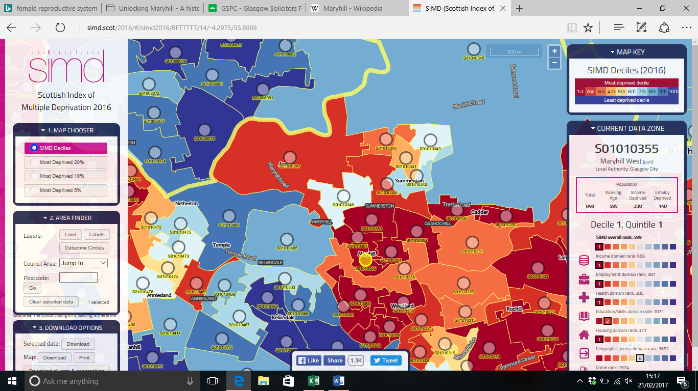Appendix 1.0-

Appendix 2.0-

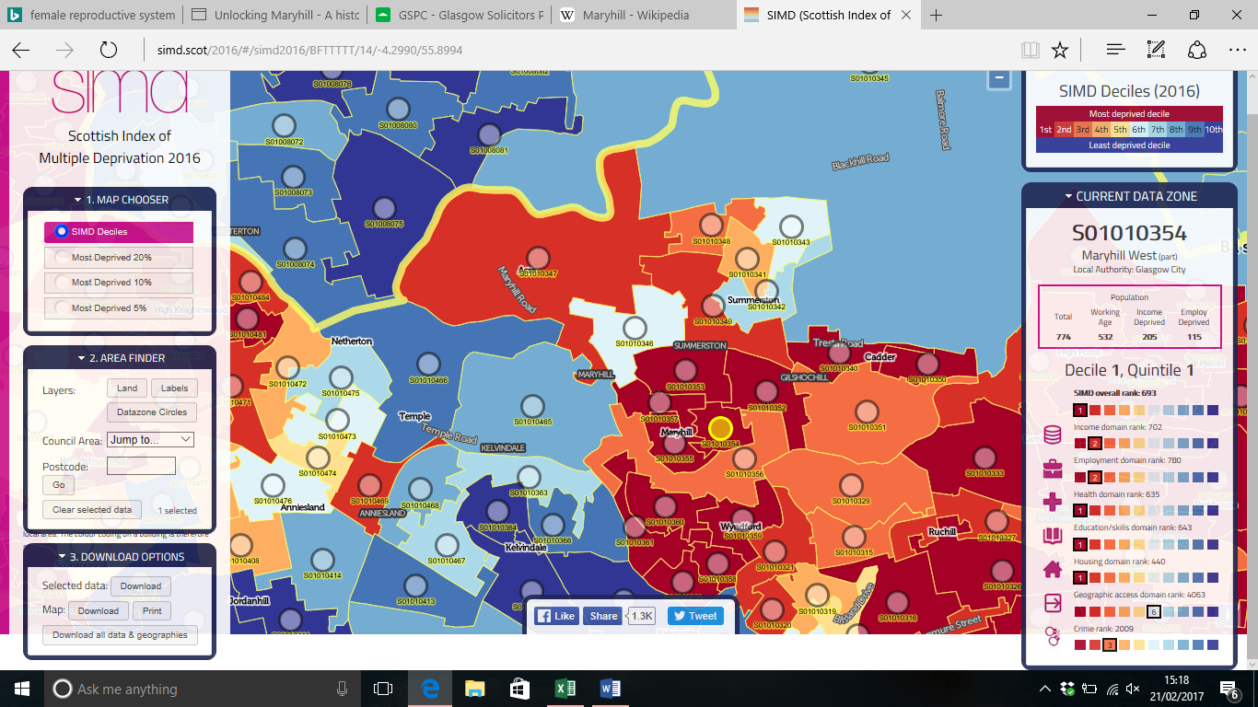Appendix 3.0-

# References

Black, W. B. (2004). *Second CIty of the Empire*. Retrieved from The Glasgow Story: http://www.theglasgowstory.com/story/?id=TGSDG05

Crawley, H., & Hocking, E. (2011). *Eating well: supporting older peoople and older people with dementia .* Herts: The Caroline Walker Trust .

Crown. (2012). *Scottish Index for Multiple Deprivation* . Retrieved from SIMD: http://simd.scot/2016/#/simd2016/BFTTTTT/14/-4.2847/55.8921/

Glasgow Centre for Population Health . (2016). *The Glasgow Indicators Project*. Retrieved from Understanding Glasgow : http://www.understandingglasgow.com/profiles/neighbourhood_profiles/3_nw_sector/3_north_maryhill_and_summerston

Glasgow City Council. (2016). *Maryhill TRA*. Retrieved from Glasgow City Council: https://www.glasgow.gov.uk/index.aspx?articleid=18392

HM Government. (2015). *The Building Regualtions 2010.* HM Government .

Liddell, G. (2012). *Financial Scrutiny Unit Briefing- April 2012 .* Edinburgh : The Scottish Parliament.

Mental Health Foundation. (2016). *Mental Health*. Retrieved from Mental Health: https://www.mentalhealth.org.uk/statistics/mental-health-statistics-older-people

National Statistics. (2012). *SIMD16 Technical Notes.* Glasgow: National Statistics.

Shipton, D., & Whyte , B. (2011). *Mental Health in Focus: a rpofile of mental health and wellbeing in Greater Glasgow and Clyde.* Glasgow: Glasgow Centre for Population Health.

Transport, S. P. (2016). *Enable Scotland.* Retrieved from Enable Scotland: http://www.enable.org.uk/families/Getting%20around/Pages/Dial-a-bus.aspx

Whitehead, M., Dahlgren, G., & Gilson, L. (2001). Developing the policy response to inequalities in Health: a globalperspective. *Oxford University Press*, 309-322.