

**Introduction to Software Engineering**

BY

ABDULROMAN MOHAMADSALEH

611431024

HasanBinhajimasman

62431028

FOR

[Mr. Kholed Langsari](http://reg.ftu.ac.th/registrar/evaluate_form.asp?avs417786948=22&cl=58921&of=424)

A PROJECT REPORT SUBMITTED IN PARTIAL FULFILMENT OF THE

REQUIREMENT FOR THE DEGREE OF BACHELOR OF INFORMATION

TECHNOLOGY

1/10/2021

Contents

**1.1OVERVIEW** 4

**1.2 PROBLEM STATEMENT :What is the propose? Why u do it?** 5

**1.3 SCOPE Who is your target?** 5

**1.4 SOFTWARE AND HARDWARE REQUIREMENTS** 6

1.4.1Software Requirement 6

1.4.2.Hardware Requirement 6

**2.1 MEANING THE QURAN AND MATERIALS** 7

**2.2 RELATED WORK** 7

2.2.1 Quran.com https://quran.com/ 7

**2.3 Compare feature web Quran in Thai language** 11

**3.1 Agile** 13

3.1.1 Phases of Agile Model: 13

**3.2 LIST OF REQUIREMENTS** 14

**3.3 USE CASE DIAGRAM** 16

**3.4 USE CASE SPECIFICATION (Description)** 18

3.4.1 USE CASE :Registration (REQ_11) 18

3.4.2USE CASE :Login 19

3.3.3USE CASE : Manage Users 20

**3.4 ACTIVITY DIAGRAM** 21

**3.5 SEQUENCE DIAGRAM** 29

34

35

36

**3.6 CLASS DIAGRAM** 37

3.6.1 USER INTERFACE 38

**3.7 ARCITICTURE** 41

**CHAPTER I**

**INTRODUCTION**

# **1.1 OVERVIEW**

The Holy Quran is the Holy Book or the Scripture of the Muslims. It lays down for them the law and commandments, codes for their social and moral behaviour, and contains a comprehensive religious philosophy. The language of the Quran is Arabic. It is a compilation of the verbal revelations given to the Holy Prophet Muhammad(Peace be upon him) over a period of twenty three years.

The Holy Quran is divided into 114 Chapters and each Chapter consists of individual verses. The Chapters (called Surah in Arabic) are of varying lengths, some consisting of a few lines while others run for many pages. The text of the Holy Quran has remained unchanged over the past 1500 years. The millions of copies of the Quran circulating in the world today are all identical down to a single letter. And this is not strange since God says in the Holy Quran that He Himself will guard this book:

اِنَّا نَحۡنُ نَزَّلۡنَا الذِّكۡرَ وَاِنَّا لَهٗ لَحٰـفِظُوۡنَ‏ ﴿15:9﴾

“Surely it is We Who have revealed the Exposition, and surely it is We Who are its guardians” (15:9)

That’s lead me to do this project “Quran Web Application For Thai Language” .Quran in web application so all people can access it any time this project include the basic necessary feature for user such as Quran Text, Quran translation (thai-eng) , audio , Quran Search , Video , Tafseer and short note, bookmark.

# **1.2 PROBLEM STATEMENT :What is the propose? Why u do it?**

according to my research , There are not many website for Thai language there is few like [www.quran-for-all.com](http://www.quran-for-all.com) and [www.daasee.com](http://www.daasee.com) but not completely consist of basic feature compare with website quran.com .in this project it will be fully function like Quran Text, Quran translation (thai) , audio , Quran Search , Video , Tafseer and short note, bookmark.

This project will help a lot of Thai speaker who cant find Quran web application in that language or struggle to find online resources to learn al-Quran onlline.

**OBJECTIVE**

1.To design and develop Quran Web Application in Thai language.

2.To make convenience for user in learning The Quran.

# **1.3 SCOPE Who is your target?**

1. The target is for Thai speaker in all ages.

2.it also for all people globally because it will support English language.

3.There are four users include admin, member, visitor and staff. They are standing in

different roles of using.

4.The Web application is available for visitor to learn The Quran by read Quran and Quran transla-

tion , listen audio , select verses or chapter , using quran search ,learn Tafseer and create short note

# **1.4 SOFTWARE AND HARDWARE REQUIREMENTS**

## 1.4.1Software Requirement

|  |  |
| --- | --- |
| **Software** | **Version** |
| PHP | 7.2.5 | 8.0 |
| Laravel | 6.20 |
| MySQL | 10.1.37 |
| Bootstrap | 4.6.0 |
| Git | 2.32.0 |
| VS code | 1.60.2 |

*Table 1.1 Software Requirement*

## 1.4.2.Hardware Requirement

|  |  |
| --- | --- |
| **Specifications** | MacBook Pro (13-inch,2018) |
| **OS** | Windows 7,10 |
| **CPU** | Core i5 and up |
| **Display** | 13.3-inch, and up |
| **Memory** | 4 GB 8 GB and up |
| **Storage** | 251 GB Storage and up |

*Table 1.2 Hardware Requirement*

**CHAPTER II**

LITERATURE REVIEW

# **2.1 MEANING THE QURAN AND MATERIALS**

The Quran (/kʊˈrɑːn/, kor-AHN;Arabic: الــــقرآن ,romanized: al-Qurʼān, lit. 'the recitation', Ara-

bic pronunciation: [alqurˈʔaːn]), also romanized Qur'an or Koran, is the central religious text of Is-

lam, believed by Muslims to be a revelation from God (Allah).It is widely regarded as the finest

# **2.2 RELATED WORK**

## 2.2.1 Quran.com <https://quran.com/>

The Noble Quran is the central religious text of Islam. Muslims believe the Qur’an is the book of

Divine guidance and direction for mankind, and consider the original Arabic text the final revelation

of Allah (God). All translations of the original Arabic text are thus interpretations of the original

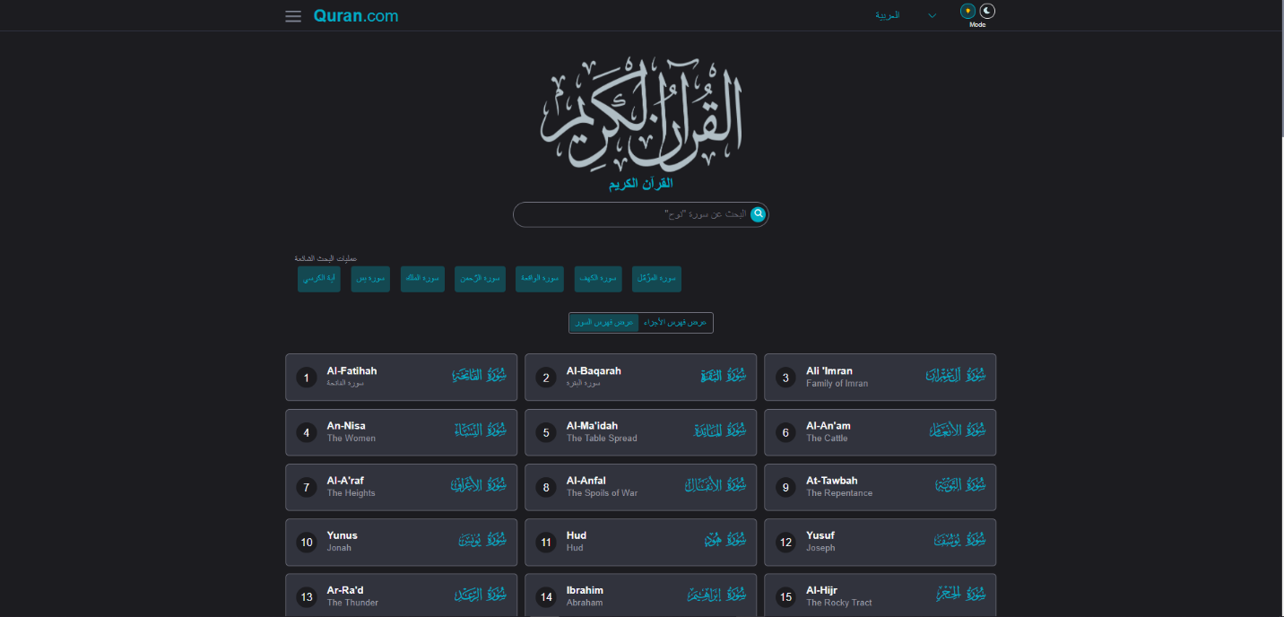meanings and should be embraced as such.

*Figure 2.2: user interface of Surah page* [*https://quran.com/1*](https://quran.com/1)

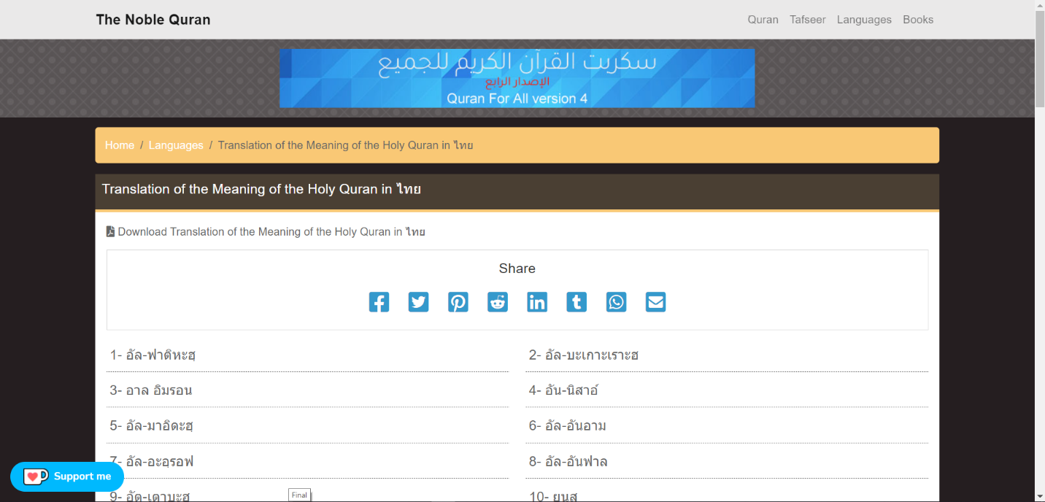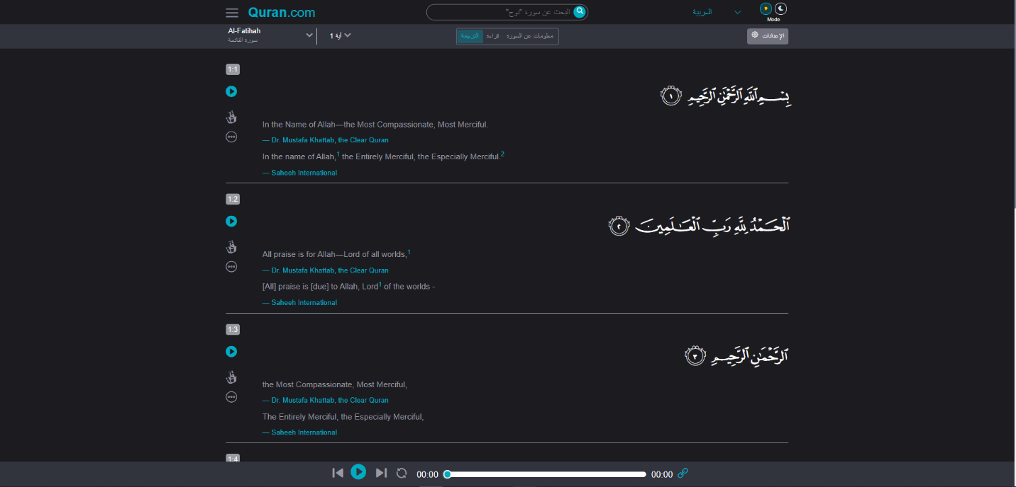Figure 2.2 : interface of main page [*https://www.quran-for-all.com/language-th.html*](https://www.quran-for-all.com/language-th.html)

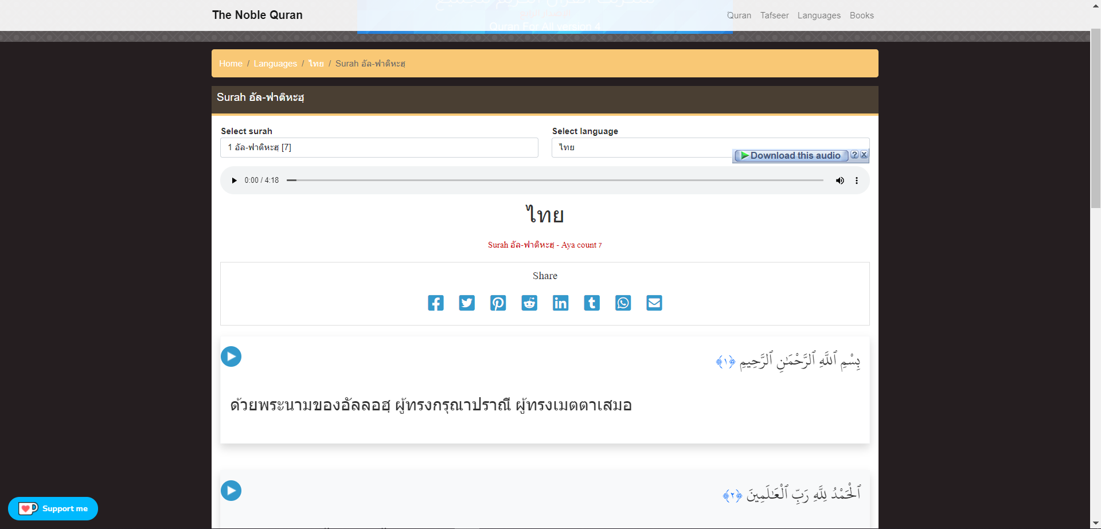

Figure 2.2: user interface of Surah page [*https://www.quran-for-all.com/translate-th-1.html*](https://www.quran-for-all.com/translate-th-1.html)

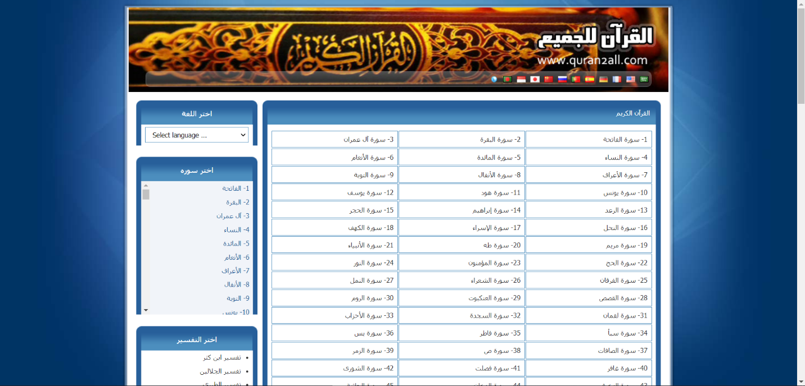

**2.2.** *interface of home page* [القران للجميع http://aiadk.com/](القران%20للجميع%20%20%20http://aiadk.com/)

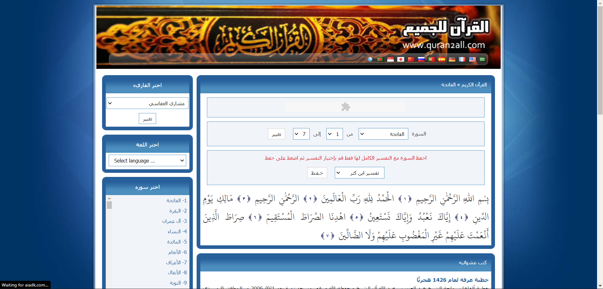

interface of main page [*http://aiadk.com/sora-1.html*](http://aiadk.com/sora-1.html)

# **2.3 Compare feature web Quran in Thai language**

Due to my research, we can compare feature The Quran website using Thai language following :

|  |  |  |  |  |
| --- | --- | --- | --- | --- |
|  | Website Name | | |  |
| Name of feather | [Quran.com](https://quran.com/)  <https://quran.com/> | The Noble Quran  <https://www.quran-for-all.com/language-th.html> | [القران للجميع](http://aiadk.com/)  <http://aiadk.com/> | My Site |
| Home Page |  |  |  |  |
| Display all surahs name | **O** | **O** | **O** | **O** |
| Search By surah name | **O** | **O** | **O** | **O** |
| Filter by juz | **O** | **X** | **X** | **X** |
| Show book marked | **O** | **X** | **X** | **O** |
| Show must search surah | **O** | **X** | **X** | **X** |
| Multi lang | **O** | **O** | **O** | **O** |
| Thai lang | **X** | **O** | **X** | **O** |
| Dark mode | **O** | **X** | **X** | **O** |
| Pray time | **O** | **X** | **X** | **O** |
| Hadith | **O** | **X** | **X** | **O** |
| Book | **X** | **O** | **O** | **-** |
| Surah page |  |  |  |  |
| Show Verse Text, | **O** | **O** | **O** | **O** |
| Audio each Verse | **O** | **O** | **O** | **O** |
| Audio hole surah | **O** | **O** | **O** | **O** |
| Video | **X** | **X** | **X** | **O** |
| Translation | **O** | **O** | **O** | **O** |
| Tafseer | **O** | **X** | **O** | **O** |
| Short-Note | **O** | **X** | **X** | **O** |
| Transliteration | **X** | **O** | **X** | **O** |
| Bookmark | **O** | **X** | **X** | **O** |
| Move to specific Verse | **O** | **X** | **O** | **O** |
| Display infatuation about surah (number :Ayahs- Pages, Revelation Place , Name) | **O** | **X** | **O** | **O** |
| Read surah mode | **O** | **X** | **O** | **O** |
| Read (Spell) word by click it | **O** | **X** | **X** | **X** |
| Navigation next or previous (Surah) | **O** | **O** | **X** | **O** |
| Listen to this verse in a loop | **X** | **X** | **X** | **X** |
| Audio speed | **X** | **X** | **X** | **X** |
| Choose the reciter | **X** | **X** | **O** | **X** |
| Extra Feature |  |  |  |  |
| Download Audio & Quran | **X** | **O** | **O** | **X** |
| Resize Text size | **O** | **X** | **X** | **X** |
| Responsive Web | **O** | **O** | **X** | **O** |
| User And Admin |  |  |  |  |
| Register | **X** | **X** | **X** | **O** |
| User Can login | **X** | **X** | **X** | **O** |
| User can upload Book Or video Or nasiha | **x** | **x** | **x** | **O** |

*Table 2.3 : Compare Feature The Al-Quran website using Thai language*

**CHAPTER III:**

**METHODOLOGY**

# **3.1 Agile**

The meaning of Agile is swift or versatile."Agile process model" refers to a software development approach based on iterative development. Agile methods break tasks into smaller iterations, or parts do not directly involve long term planning. The project scope and requirements are laid down at the beginning of the development process. Plans regarding the number of iterations, the duration and the scope of each iteration are clearly defined in advance.

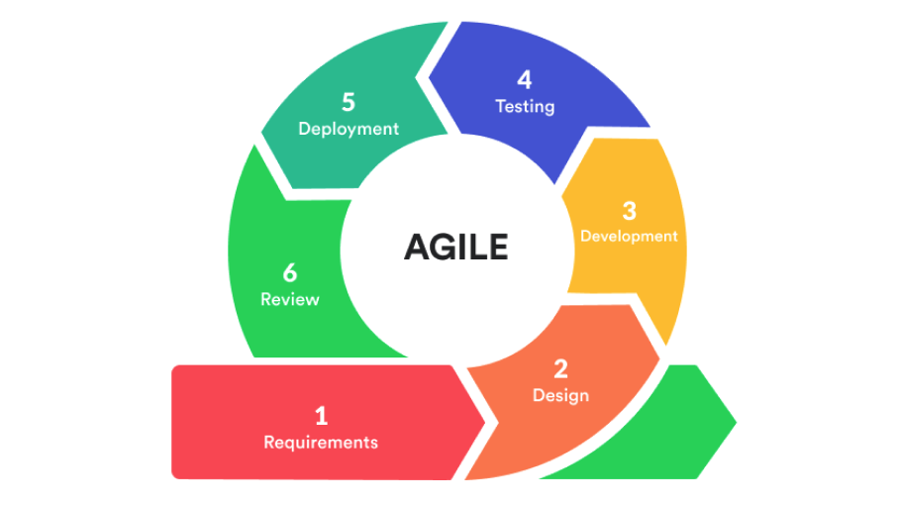

## 3.1.1 Phases of Agile Model:

Following are the phases in the Agile model are as follows:

1. Requirements gathering
2. Design the requirements
3. Construction/ iteration
4. Testing/ Quality assurance
5. Deployment
6. Feedback

# **3.2 LIST OF REQUIREMENTS**

M - Mandatory requirement (what the system must do)

D – Desirable requirement (what the system preferably should do)

O– Optional requirement (what the system may do)

|  |  |  |  |
| --- | --- | --- | --- |
|  |  |  |  |
| ID | **Requirements ID** | **Requirement Description** | **Priority** |
|  | **REQ_01** | **Surah Info** |  |
| 1 | REQ_01.01 | Admin and Stuff CRUD Surah info (name, Revelation Place) | **M** |
| 2 | REQ_01.02 | Display Surah Info to end user | **M** |
|  | **REQ_02** | **Verses** |  |
| 3 | REQ_02.01 | Admin and Stuff CRUD Verses | **M** |
| 4 | REQ_02.02 | Display Verses -Text to end user | **M** |
|  | **REQ_03** | **Translation (**Verses) |  |
| 5 | REQ_03.02 | Admin and Stuff can CRUD translation for Verses | **M** |
| 6 | REQ_03.04 | Display translation Verses to end user | **M** |
|  | **REQ_04** | **Transliteration (**Verses) |  |
| 7 | REQ_04.01 | Admin and Stuff can CRUD transliteration for Verses | **M** |
| 8 | REQ_04.02 | Display transliteration Verses to end user | **M** |
|  | **REQ_05** | **Audio**(Verses) |  |
| 9 | REQ_05.01 | Admin and Stuff can CRUD Audio | **M** |
| 10 | REQ_05.02 | End user can Listen to Audio | **M** |
|  | **REQ_05** | **Video** (Surah) |  |
| 11 | REQ_05.01 | Admin and Stuff can CRUD Video | **M** |
| 12 | REQ_05.02 | End user can Watch Video | **M** |
|  | **REQ_06** | **Tafseer** (Verses) |  |
| 13 | REQ_06.01 | Admin and Stuff CRUD can Tafseer | **M** |
| 14 | REQ_06.02 | Display Tafseer to end user | **M** |
|  | **REQ_07** | **Bookmark** |  |
| 15 | REQ_07.01 | End user can make Bookmark | **M** |
|  | **REQ_08** | **Short Note** |  |
| 16 | REQ_08.01 | End user can CRUD Short note | **M** |
|  | **REQ_09** | **Select Display Mode** |  |
| 17 | REQ_09.01 | End user can choose read only | **D** |
| 18 | REQ_09.02 | End user can choose read with translation | **D** |
| 19 | REQ_09.03 | End user can choose Dark mode and light mode | **D** |
|  | **REQ_10** | **Search** (Surah) |  |
| 20 | REQ_10.01 | End user can surah by its name | **M** |
| 21 | REQ_10.02 | End user can surah by its number | **D** |
|  | **REQ_11** | **Register** |  |
| 22 | REQ_11.01 | End user can register by (Name, Email, Password, Confirm Password) | **D** |
|  | **REQ_12** | **Log In** |  |
| 23 | REQ_12.01 | Admin can log in | **M** |
| 24 | REQ_12.02 | Staff can log in | **M** |
| 25 | REQ_12.03 | Member can log in | **D** |
|  | **REQ_13** | **Manage Users** |  |
| 26 | REQ_13.01 | Admin can CRUD staff and Members | **M** |
| 27 | REQ_13.02 | staff can CRUD only Members | **D** |
|  | **REQ_14** | **Upload Post (Nasiha)** |  |
| 28 | REQ_14.01 | Member can CRUD nasiha | **D** |
| 29 | REQ_14.02 | Staff approve and validate nasiha that Members upload | **D** |
| 30 | REQ_14.03 | Staff can CRUD nasiha that Members upload | **D** |
|  | **REQ_15** | **Pray time** |  |
| 31 | REQ_15.01 | Display Pray time to end user | **D** |
|  | **REQ_16** | **Hadith** |  |
| 32 | REQ_16.01 | Display Hadith to end user | **D** |
|  | **REQ_17** | **Navigation** |  |
| 33 | REQ_17.01 | End user can Navigate to next or previous (Surah) | **D** |
| 34 | REQ_17.02 | End user can Navigate to next or previous (Verse) | **D** |
| 35 | REQ_17.03 | End user can Move to specific Verse by its number | **D** |
|  | **REQ_18** | **Addition** |  |
| 36 | REQ_18.01 | Download Audio & Quran | **D** |
| 37 | REQ_18.02 | Resize Text size | **D** |
| 38 | REQ_18.03 | Responsive Web | **M** |

# **3.3 USE CASE DIAGRAM**

Use cases are a technique for capturing the functional requirements of a system. Use

cases work by describing the typical interactions between the users of a system and

the system itself, providing a narrative of how a system is used.

According to figure 3.2describes about use case of users who relate with this

system and capable manage The Quran web application. Truly there are four actors

including Admin, Staff, End Users and Visitor.

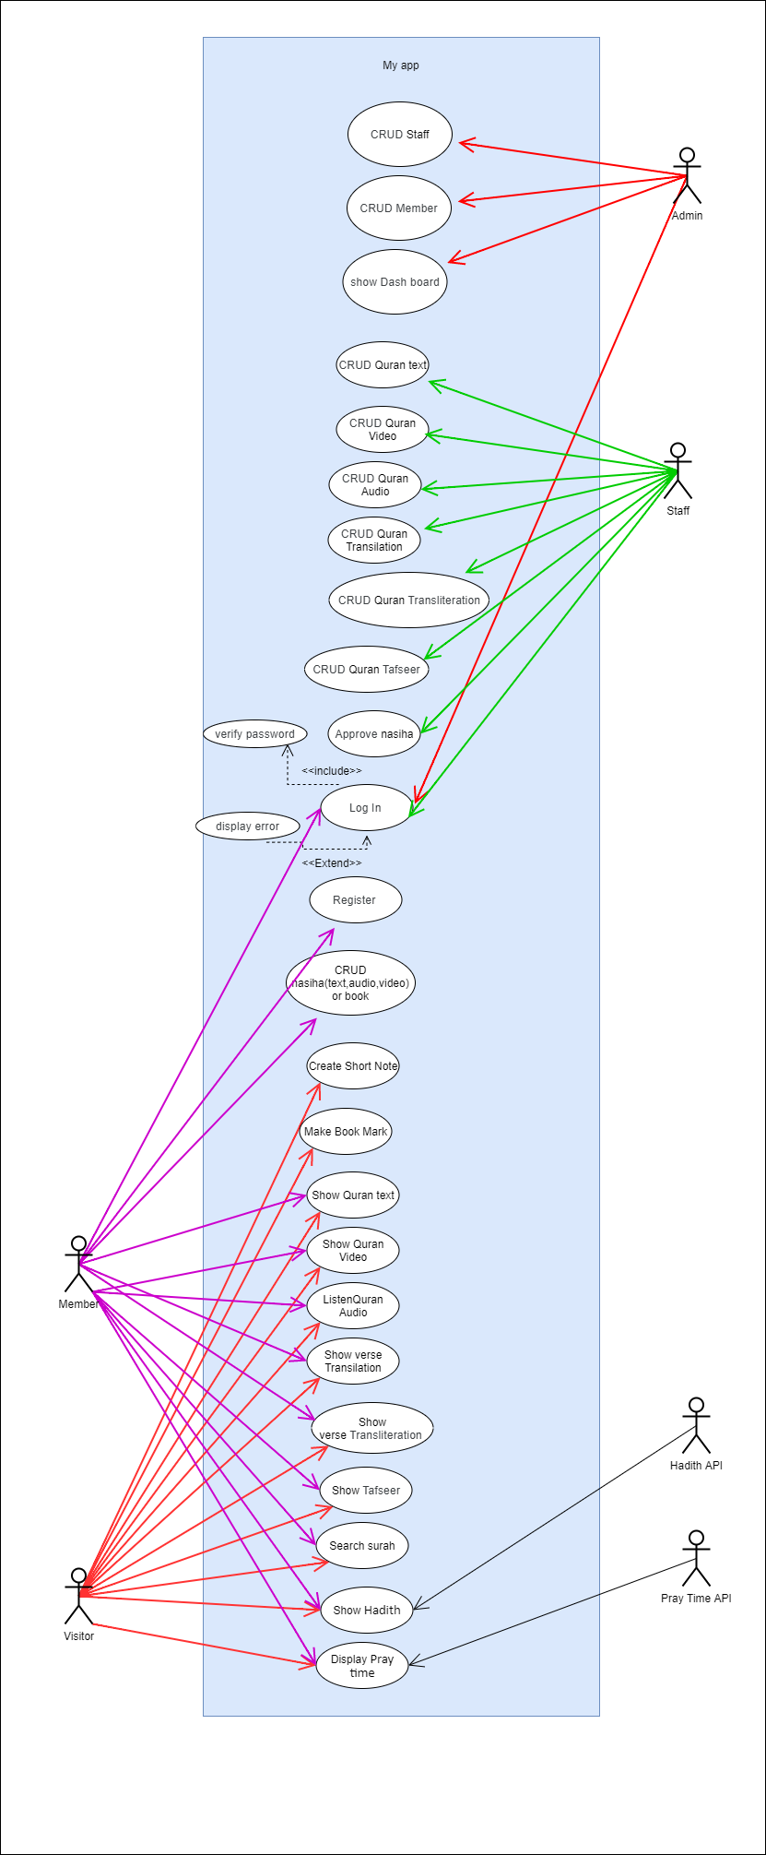

* 1. Use Case Diagram of system.

# **3.4 USE CASE SPECIFICATION (Description)**

A requirement specification is a documented requirement, or set of documented requirements, to

be satisfied by a given material, design, product, service, etc. It is a common early part of engineer-

ing design and product development processes, in many fields.

## 3.4.1 USE CASE :Registration (REQ_11)

|  |  |
| --- | --- |
| Name of Use case | **Registration (REQ_11)** |
| Brief description | This use case will be used to allow the end-users Register  to the system |
| Preconditions | The end-users must have Email |
| Characteristic of Activations | The execution depends on the user’s demand |
| Flow of events | -The users must Enter their Username, Email, Password, Confirm Password  -The users press the Register button. [A-1: cancel] [A-2: Login]  -The system will validate username and password, Confirm Password, Email.  [E-1: Invalid or already exist Email username and password]  -The system will Register the user to the system. |
| Alternative flow | A-1: cancel  The system will cancel the Register.  A-1: Login  The system will Redirect to Login page. |
| Exception flow | • E-1: Invalid username and password  The system will display error message to re-enter the user-  name and password. |
| Limitation | (Username, Email, Must be unique)  The password must be at least 8 characteristics.  Username must be more than 3char and less than 30 char |

## 3.4.2USE CASE :Login

|  |  |
| --- | --- |
| **USE CASE :Login** | |
| Use case ID | **(REQ_12)** |
| Brief description | This use case will be used to allow users (Admin , Staff and  End-Users(member)) enter to the system. |
| Preconditions | The users (Admin, Staff, and End-Users) must have username  and password to access in the system. |
| Actors | Admin , Staff and End-Users(member) |
| Flow of events | • The users Enter their Email and password on the login page.  • The users press the login button. [A-1: cancel] [A-1: Register]  • The system will validate username and password.  [E-1: Invalid Email and password]  • The system will allow the users enter the system. |
| Alternative flow | A-1: cancel  The system will cancel the login button.  A-1: Register  The system will Redirect to Login Register. |
| Exception flow | • E-1: Invalid Email and password  The system will display error message to re-enter the user-  Email and password. |
| Limitation | (Email, must be unique)  The password must be at least 8 characteristics. |

## 3.3.3USE CASE : Manage Users

|  |  |
| --- | --- |
| **USE CASE : Manage Users** | |
| Use case ID | **(REQ_13)** |
| Brief description | This use case will be used to allow Admin to manage users (staff, members) by make CRUD operation |
| Preconditions | The Admin and staff must login first |
| Actors | Admin |
| Flow of events | * Admin select manage user (staff or member) on the dashboard page. The system displays options of Staff and End-Users * Admin select manage Staff or End-Users * Admin select create, read, update, delete button to CRUD Staff and End-Users account * Admin press OK button. [A-1: Cancel] * This use case will finish; the system will display massage success |
| Alternative flow | A-1: cancel This system cancels to CRUD Staff and End-  Users account process. |
| Exception flow | - |
| Limitation | No limitation |

# **3.4 ACTIVITY DIAGRAM**

Activity diagrams are a technique to describe procedural logic, business process, and work flow. In

many ways, they play a role similar to flowcharts, but the principal difference between them and

flowchart notation is that they support parallel behavior. notation is that they support parallel behavior.

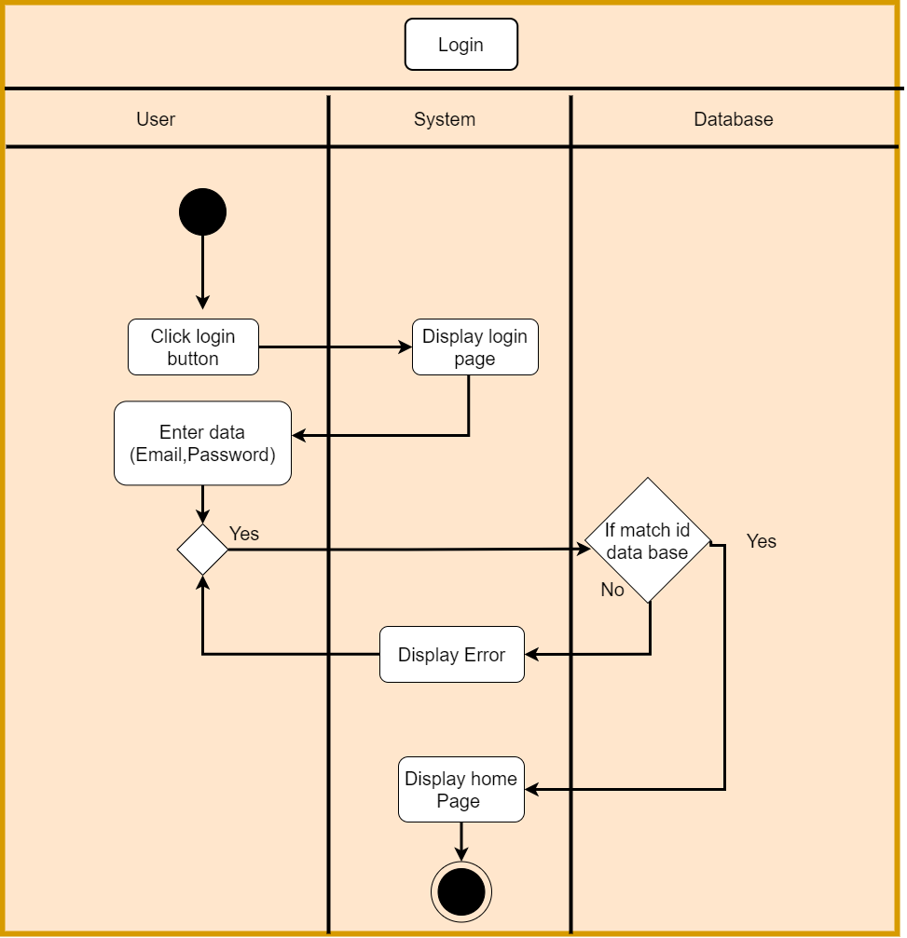

3.4.1 Activity diagram of Login

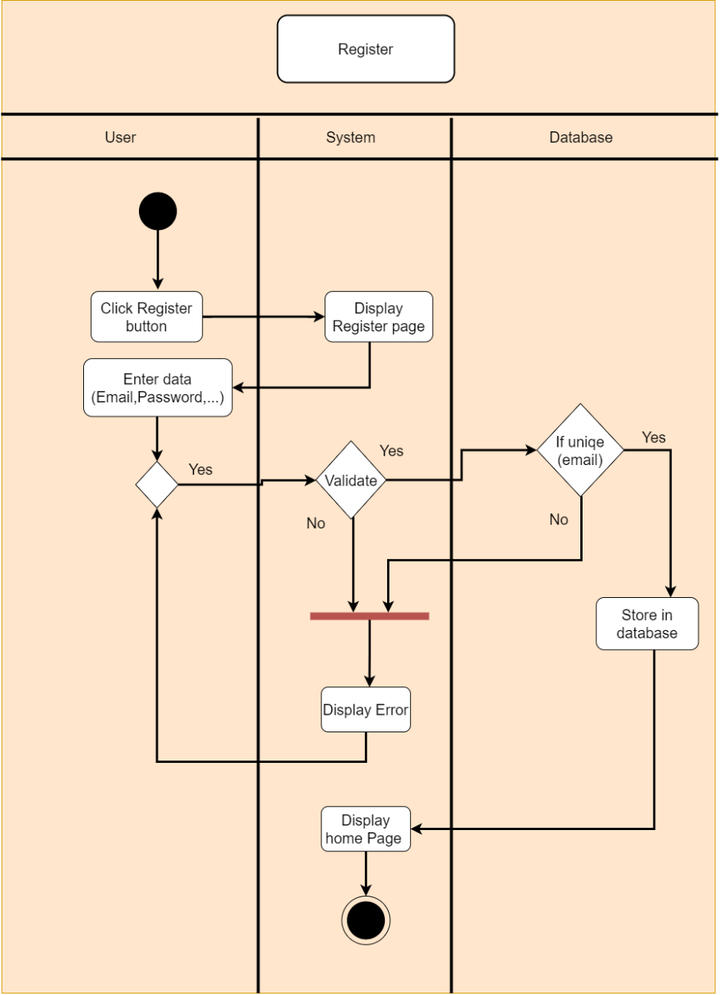

3.4.2 Activity diagram of Registration

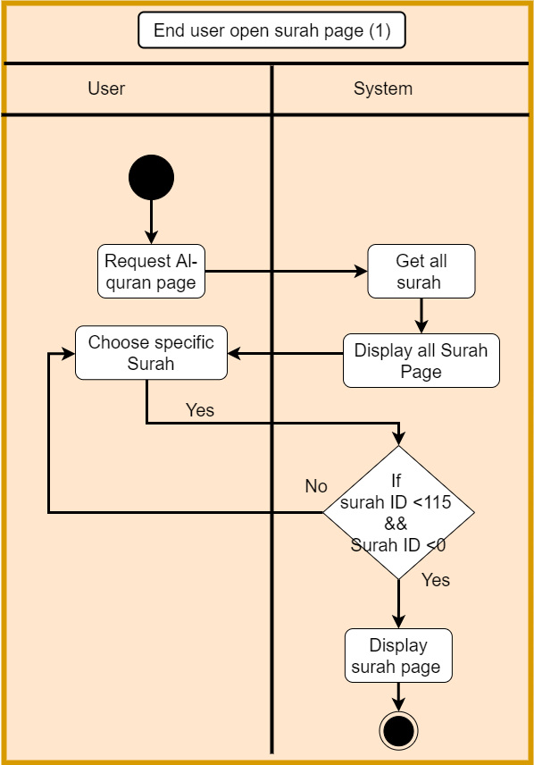

3.4.3 Activity diagram of End user open surah page

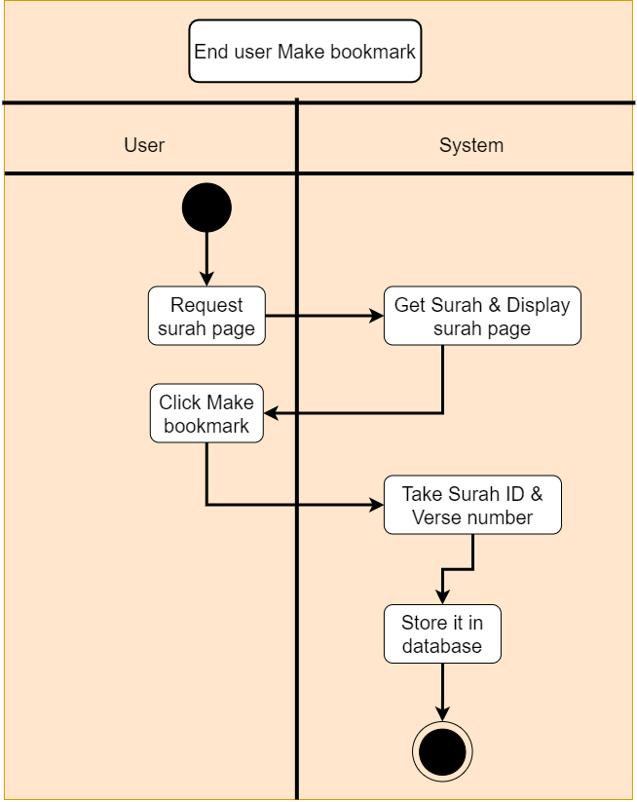

3.4.4 Activity diagram of End user Make Bookmark

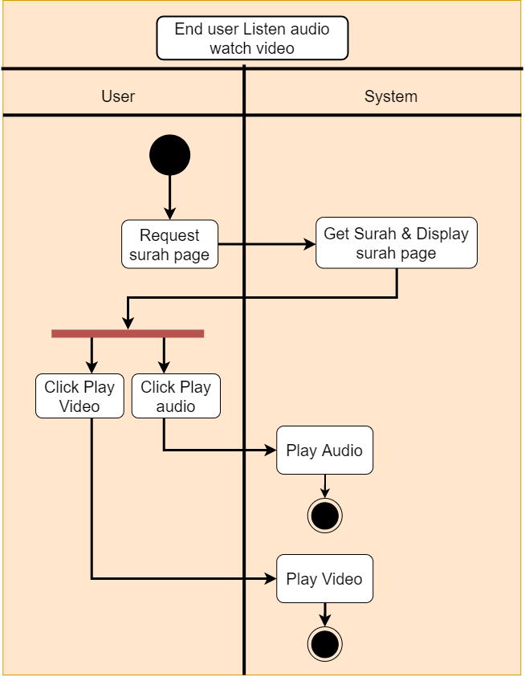

3.4.5 Activity diagram of End user Listen audio watch video

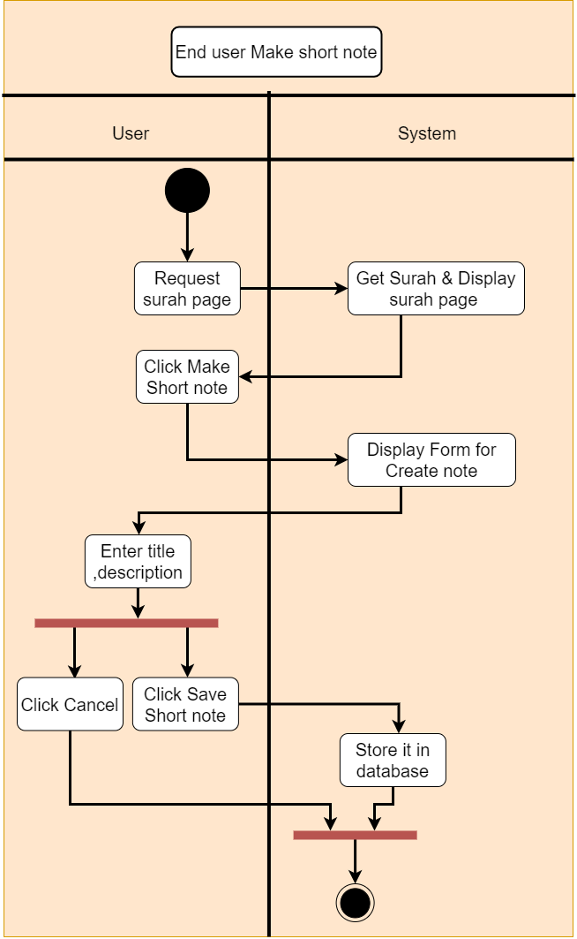

3.4.6 Activity diagram of End user Make short note

3.4.7 Activity diagram of End user in Surah page

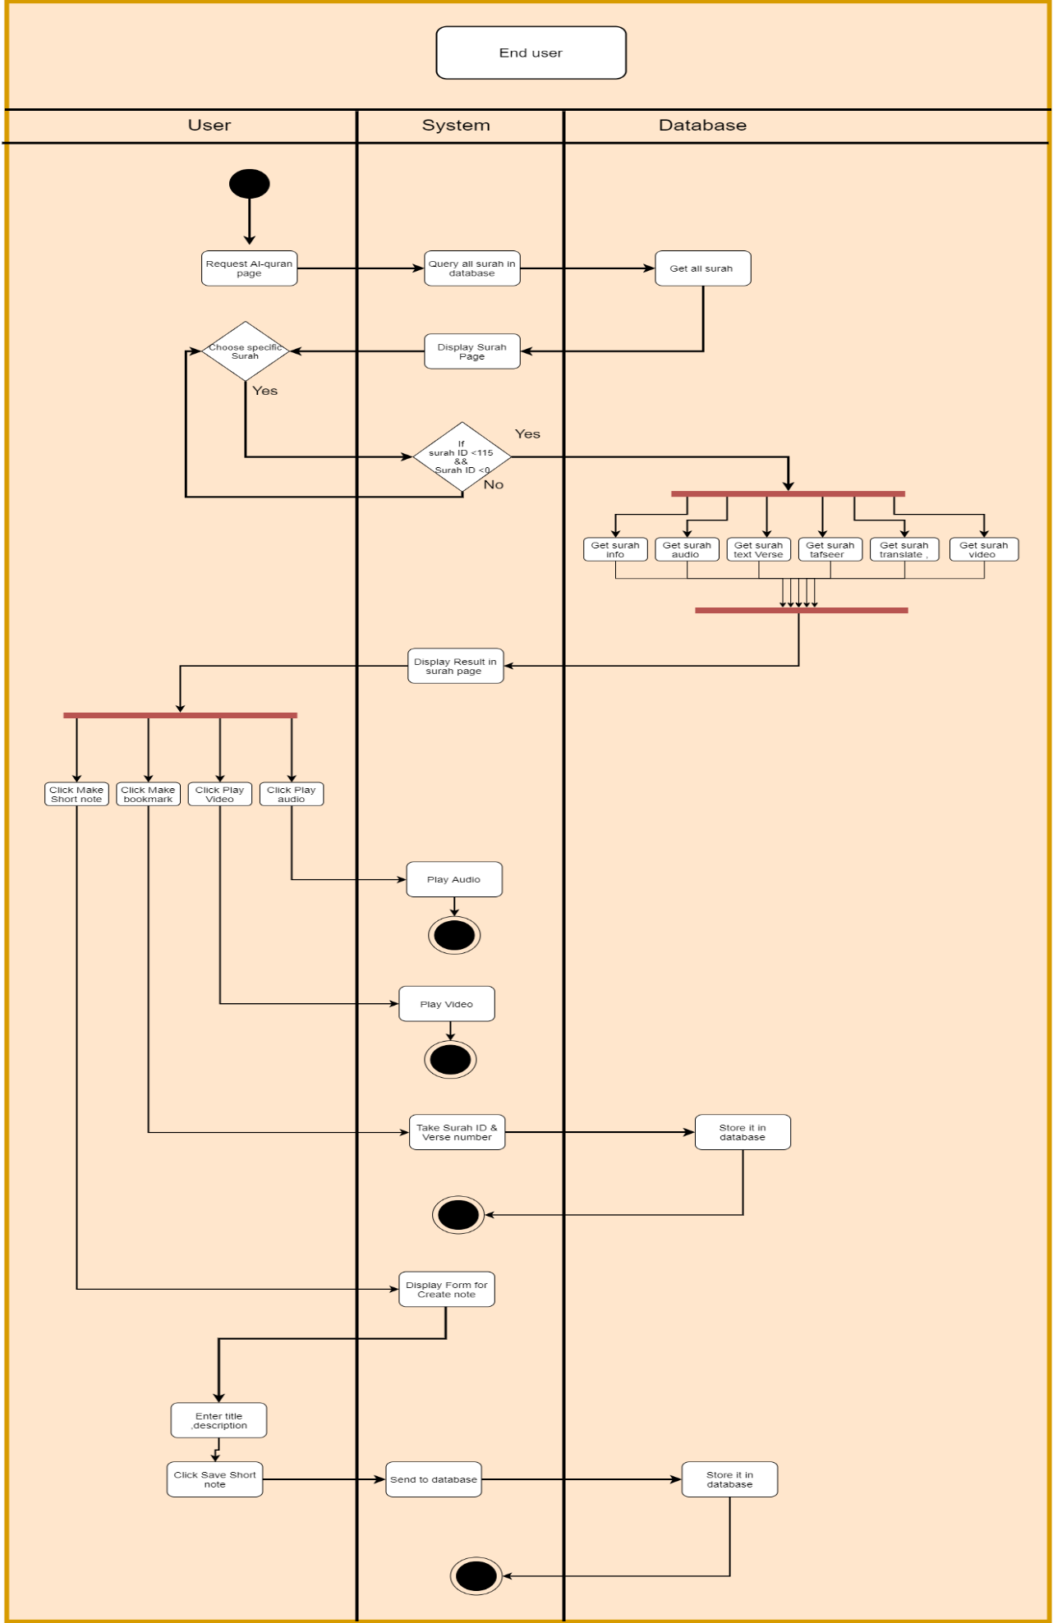

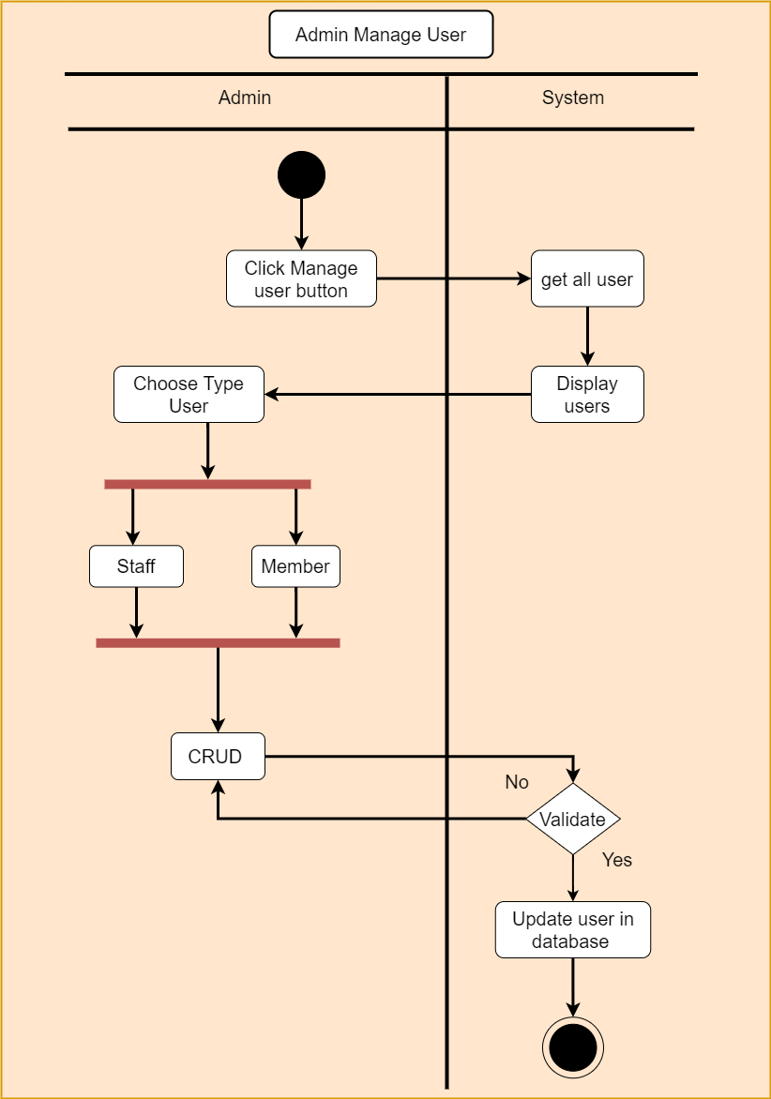

3.4.8 Activity diagram of Admin Manage user

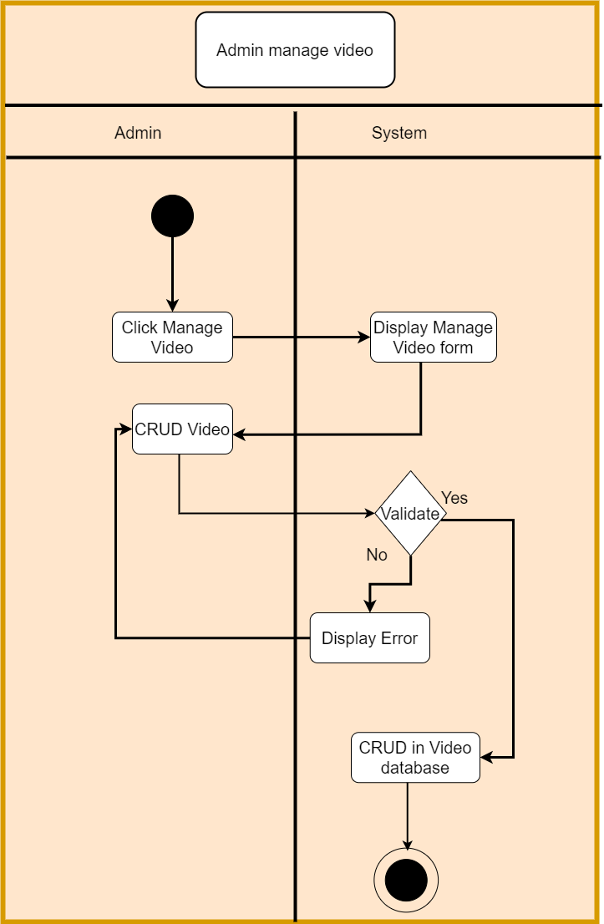

3.4.9 Activity diagram of Admin Manage Video

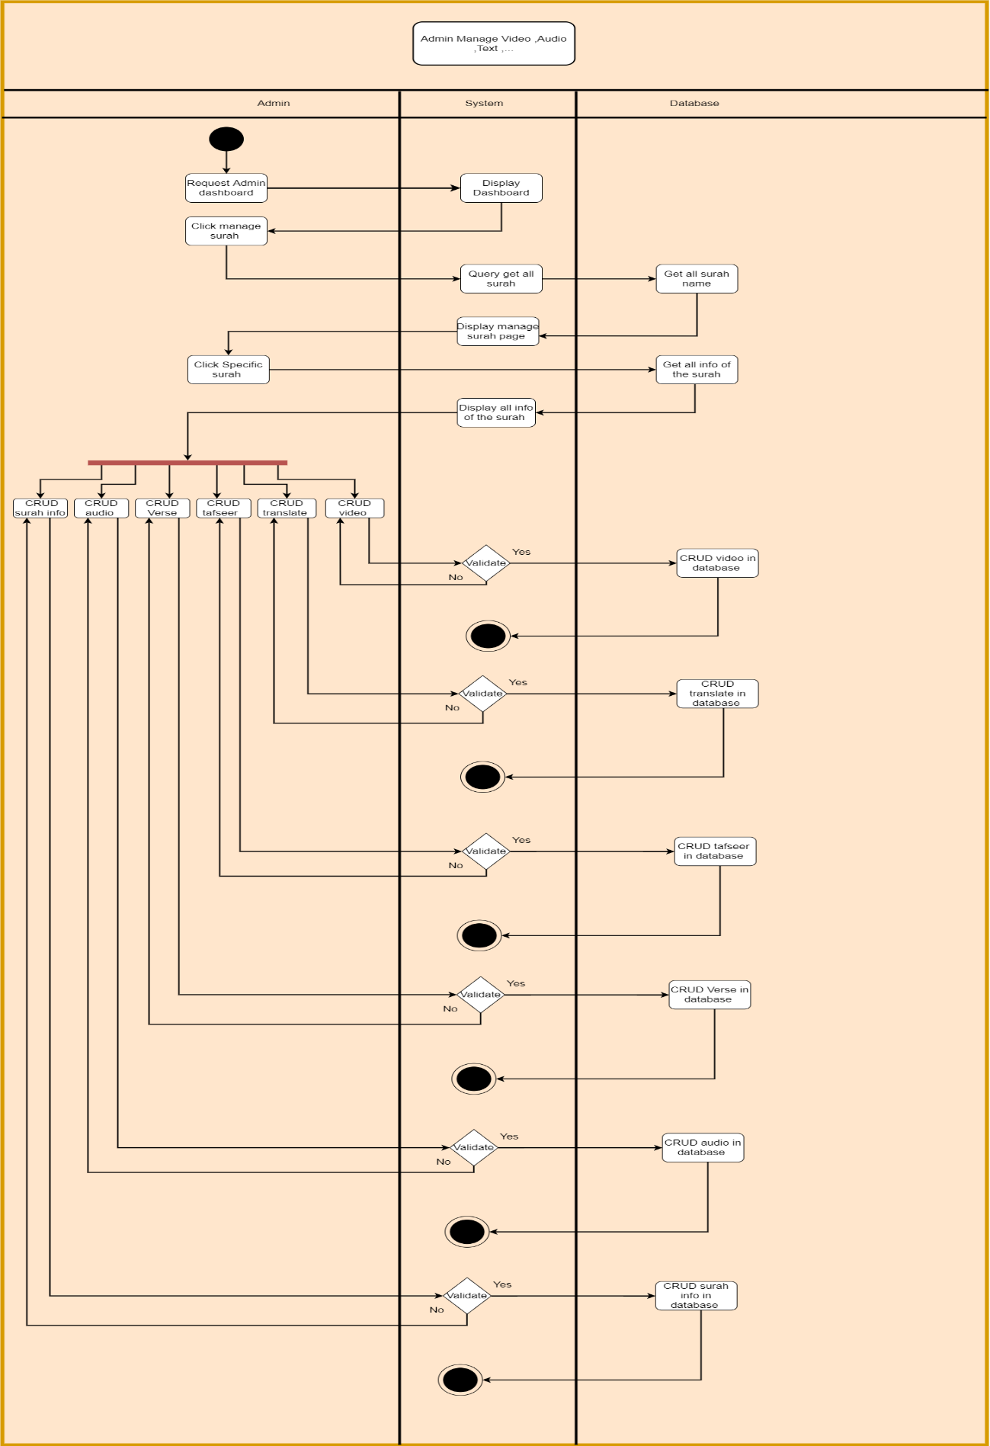

3.4.10 Activity diagram of All Admin Activity

# **3.5 SEQUENCE DIAGRAM**

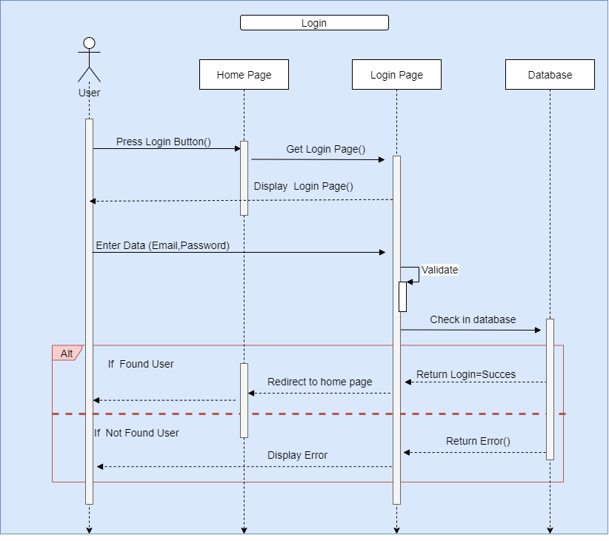Sequence diagram of massive open online course is interaction diagrams describe how groups of objects collaborate in some behavior. The UML defines several forms of interaction diagram. Developer use sequence diagrams when developer wants to look at the behavior of several objects within a single use case. Sequence diagrams are good at showing collaborations among the objects. The useful forms of interaction diagrams are communication diagrams, for showing connections and timing diagrams for showing timing constraints.

3.26 Sequence diagram of End-Users Login

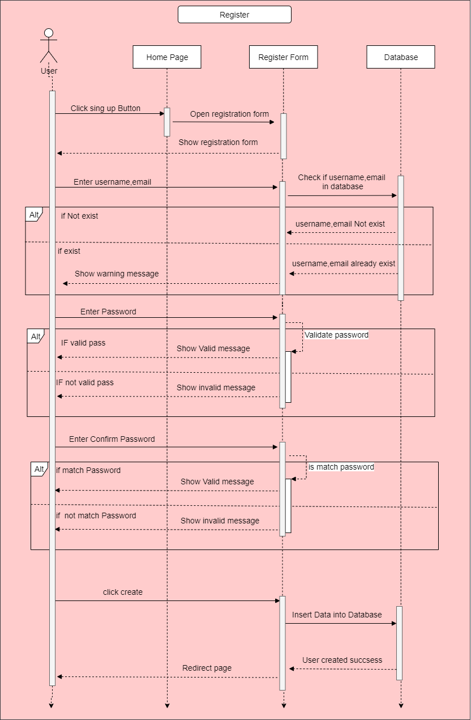

3.26 Sequence diagram of End-Users Register

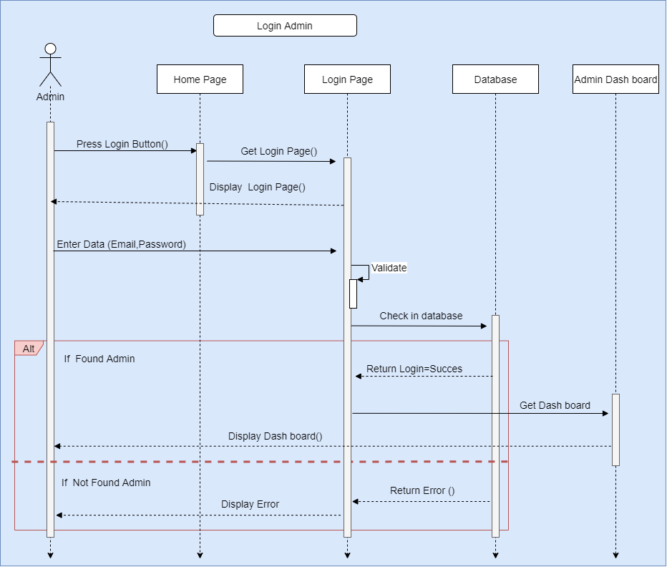

3.26 Sequence diagram of Admin Login

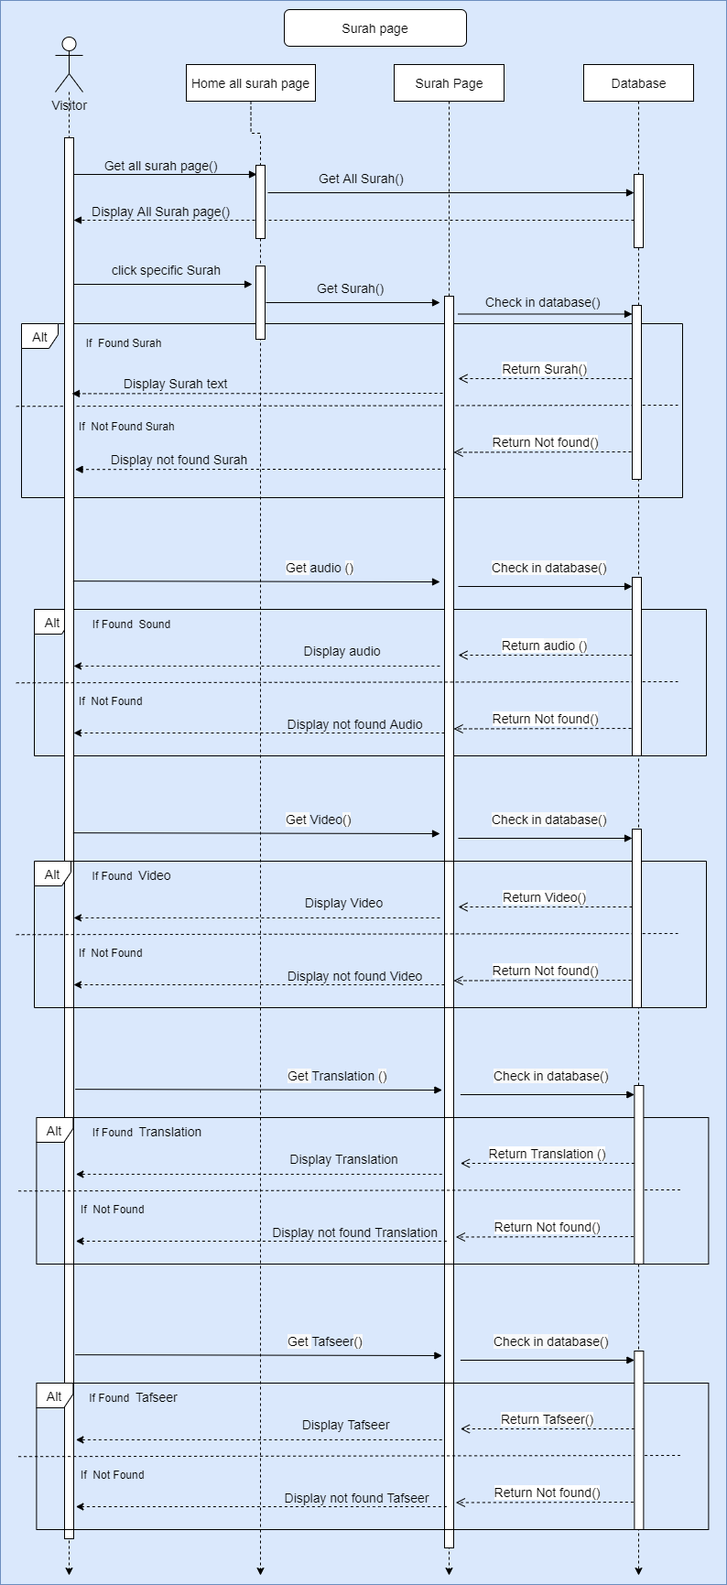

3.26 Sequence diagram of what can end user in surah page

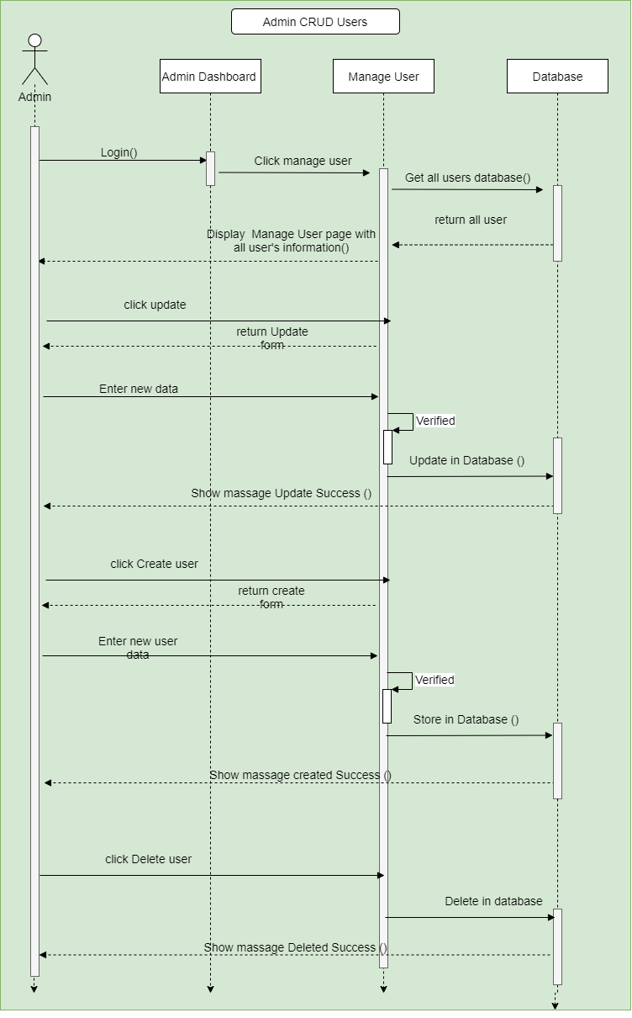

3.26 Sequence diagram of Admin CRUD User

### 

3.26 Sequence diagram of Admin CRUD Tafseer

### 

3.26 Sequence diagram End user Add short note

### 

3.26 Sequence diagram End user Add Bookmark

# 

# **3.6 CLASS DIAGRAM**

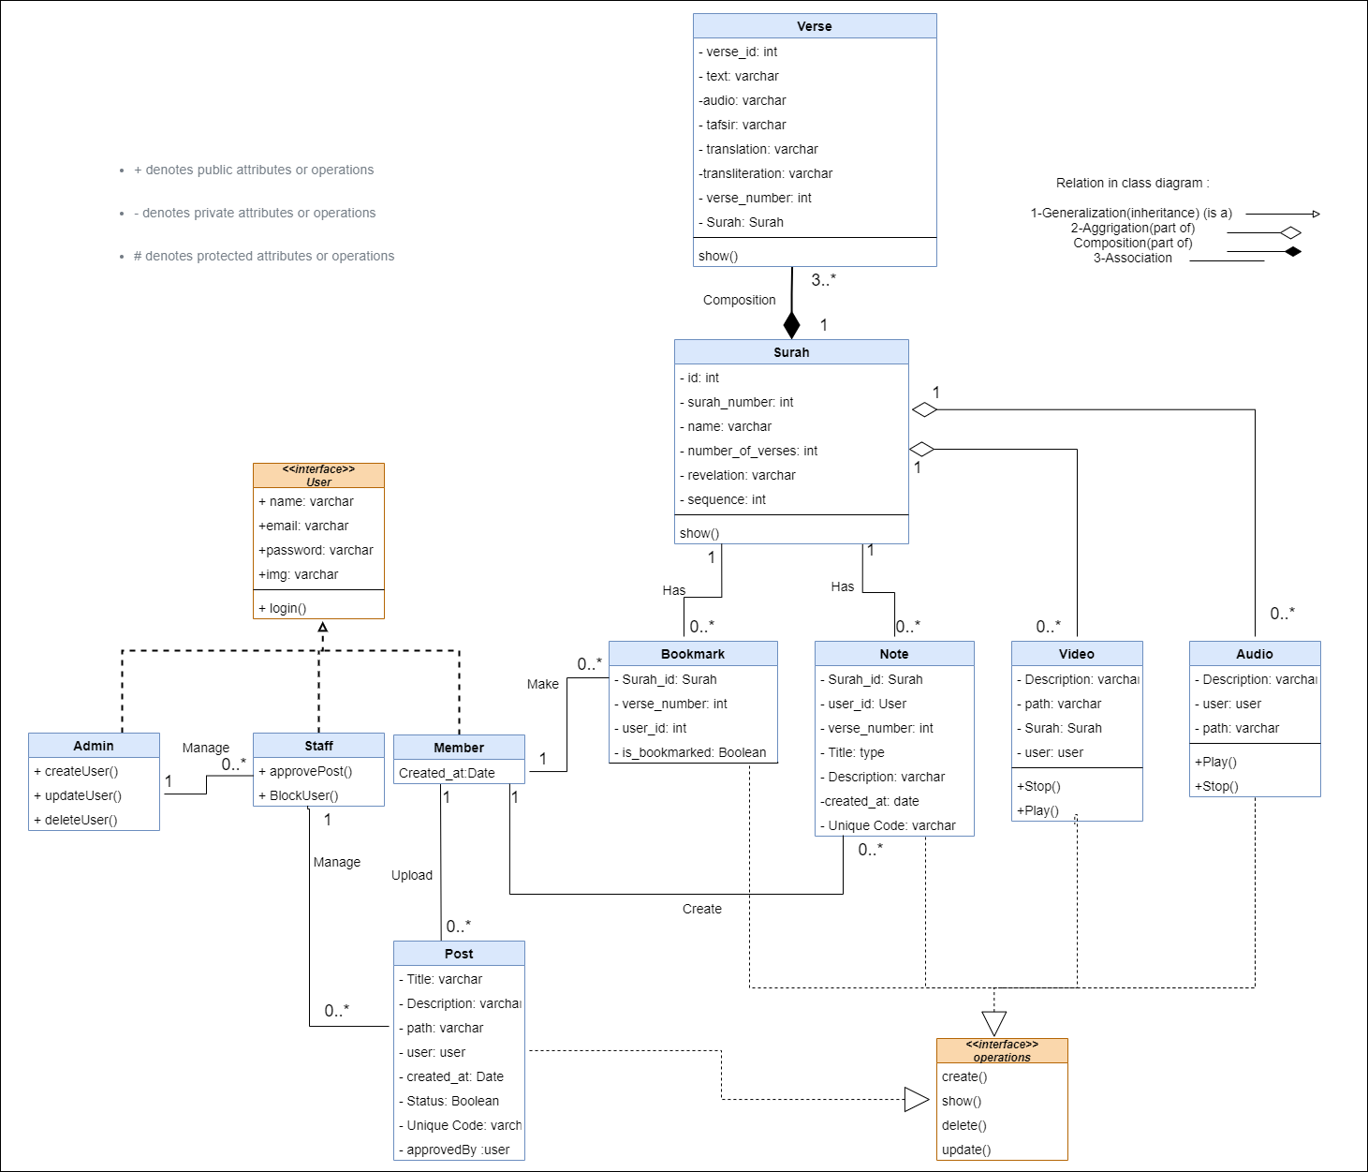3.26 Class diagram of the system

## Database:

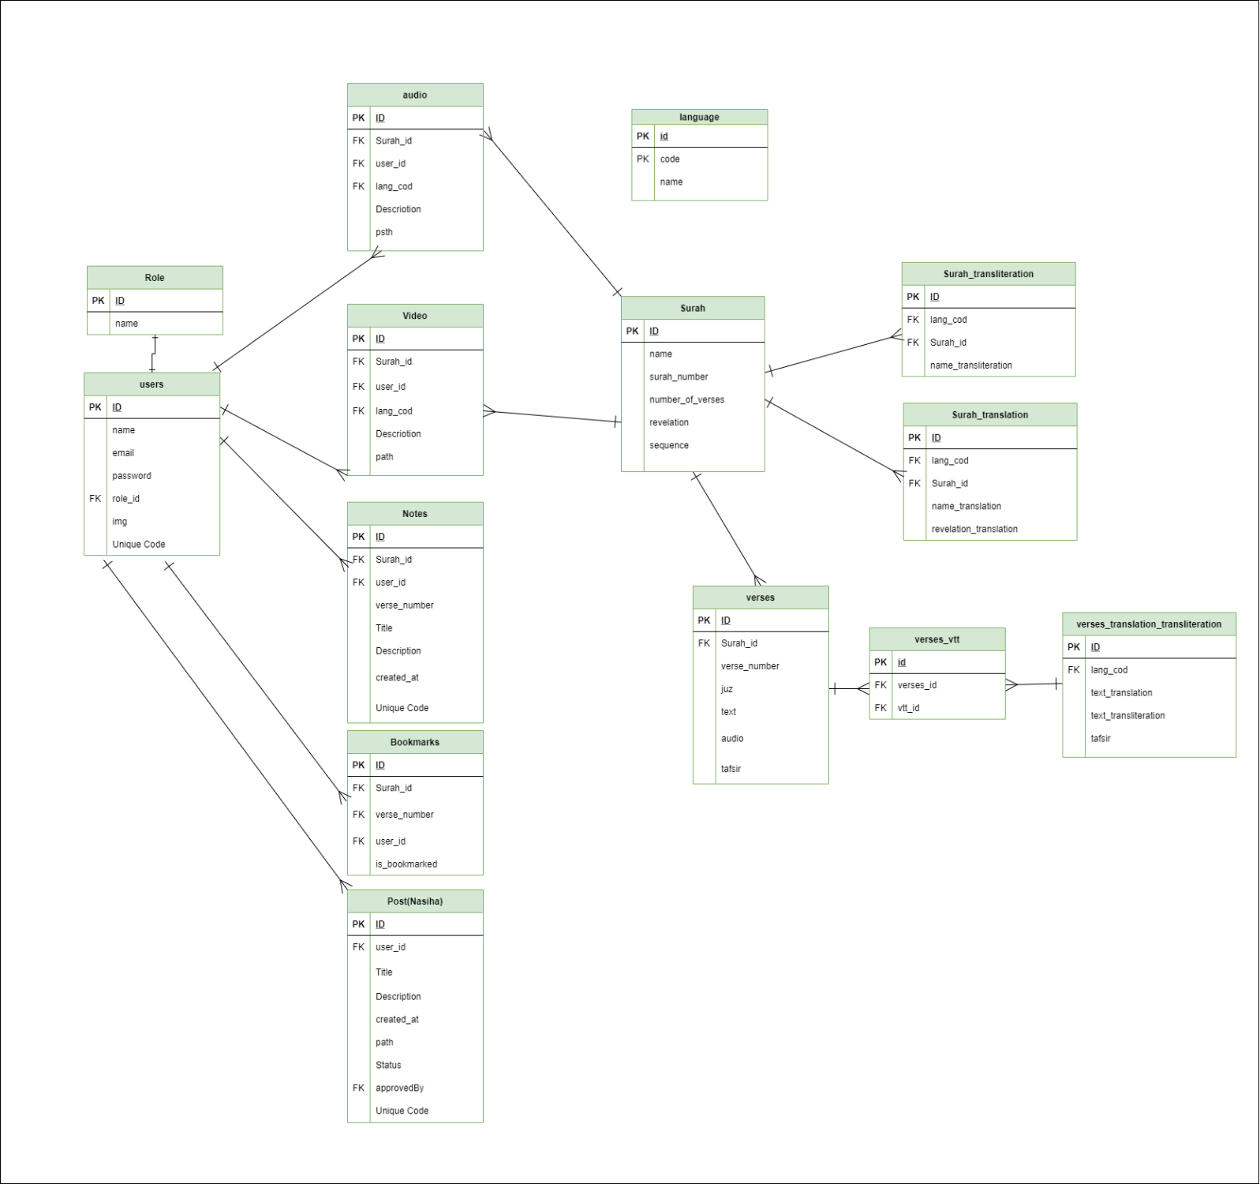

## 3.6.1 USER INTERFACE

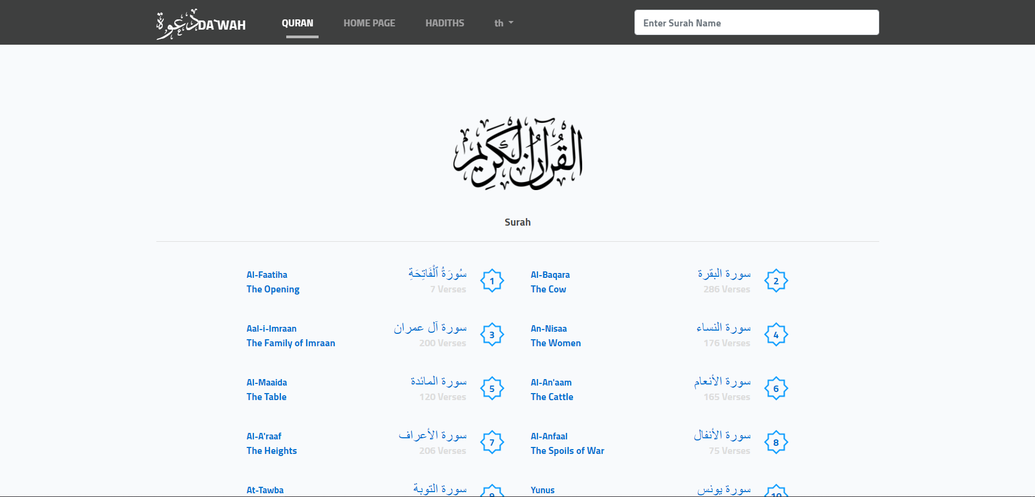

3.Use interface of All Surah

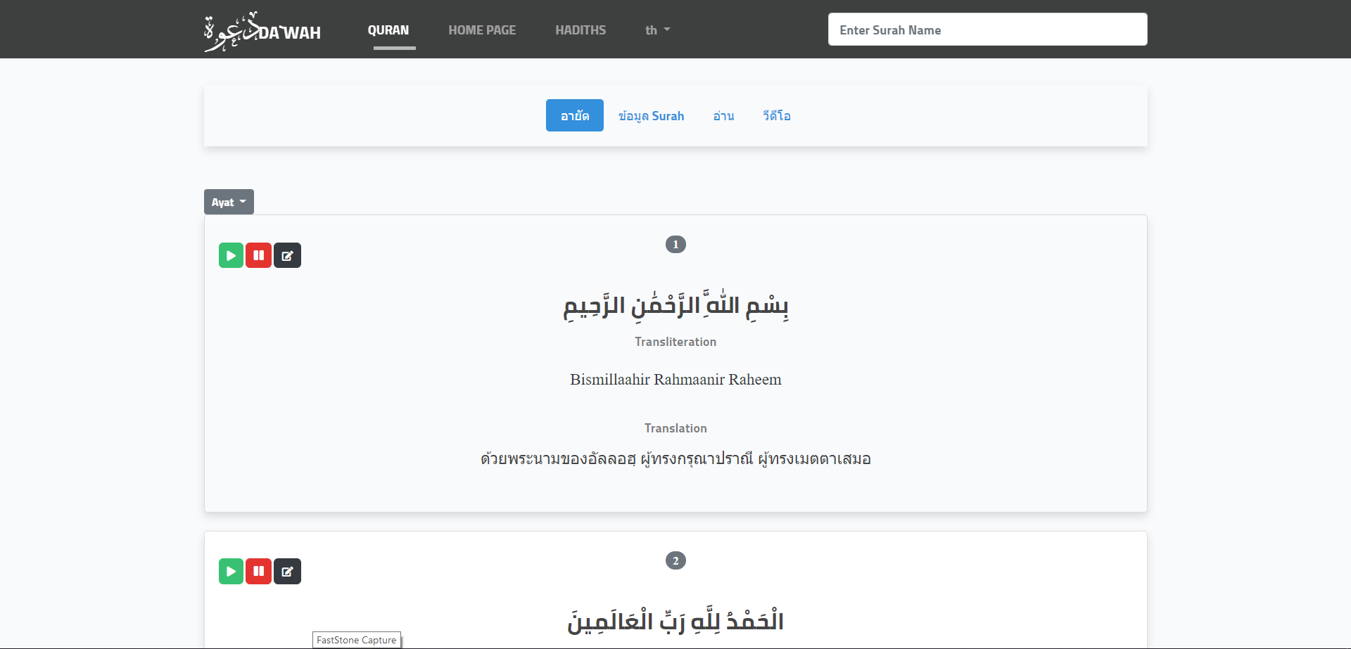

3.Use interface of Surah Page

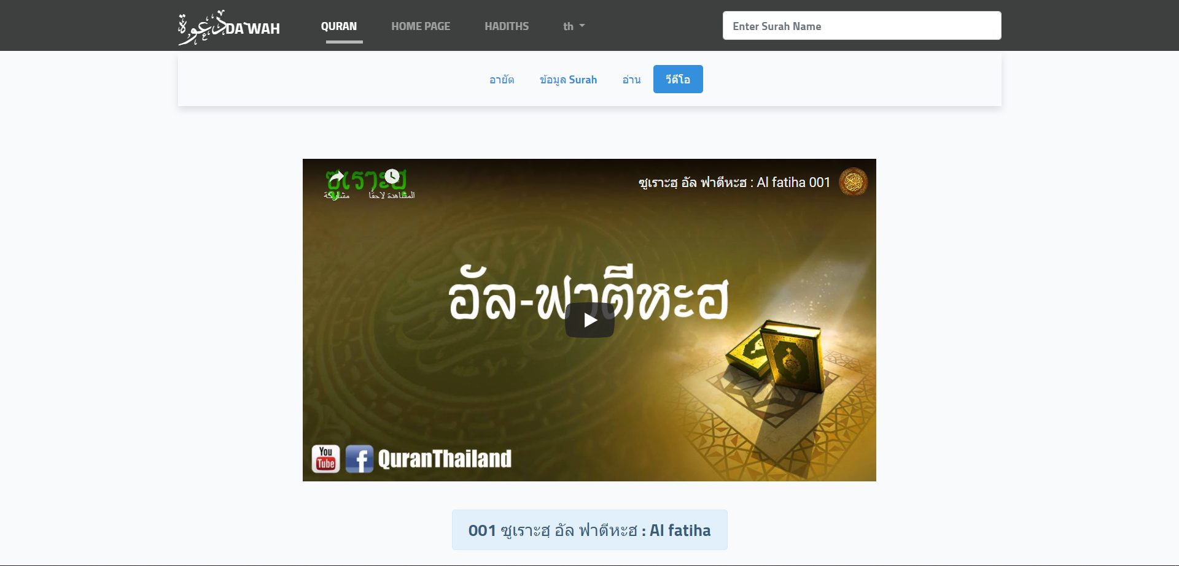

3.Use interface of Quran Video

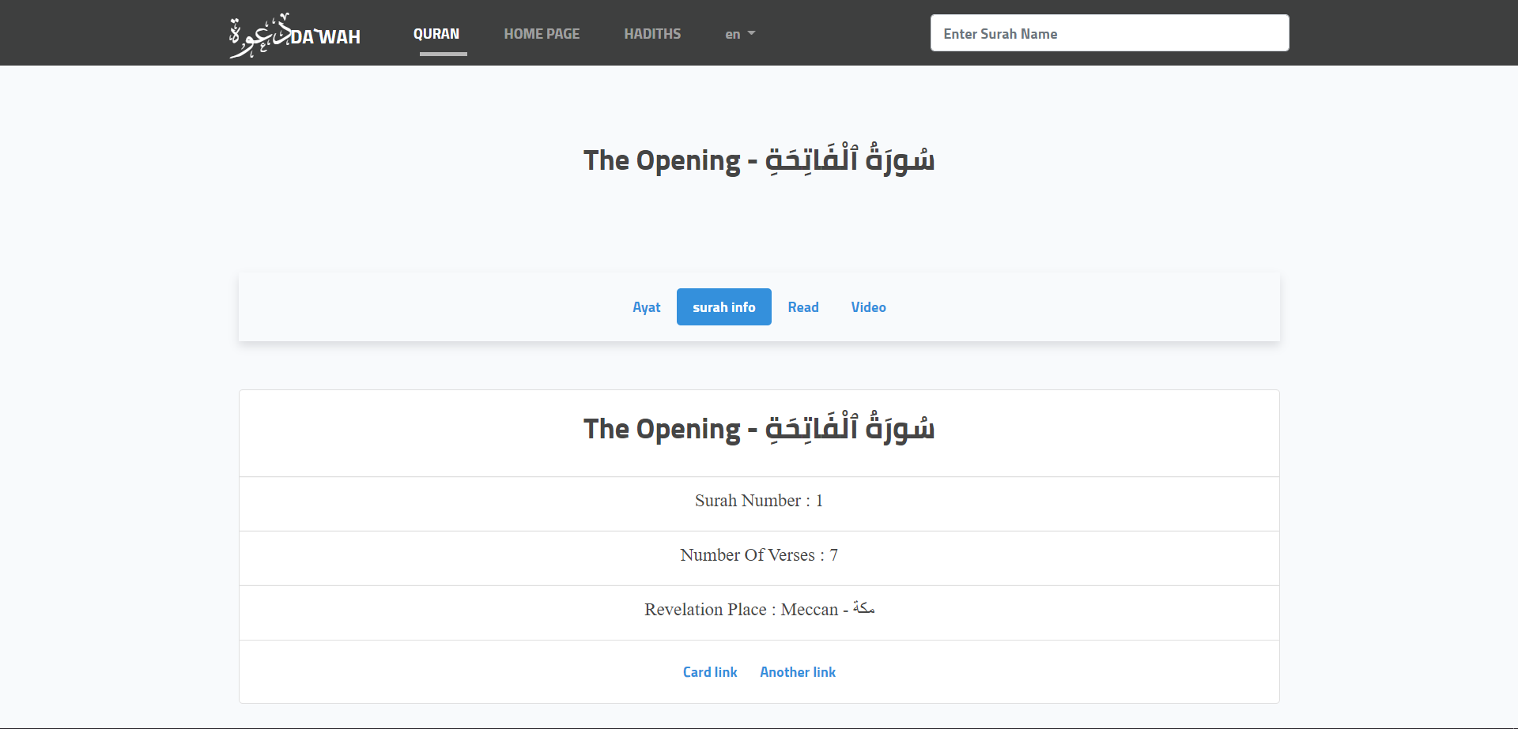

3.Use interface of Surah info

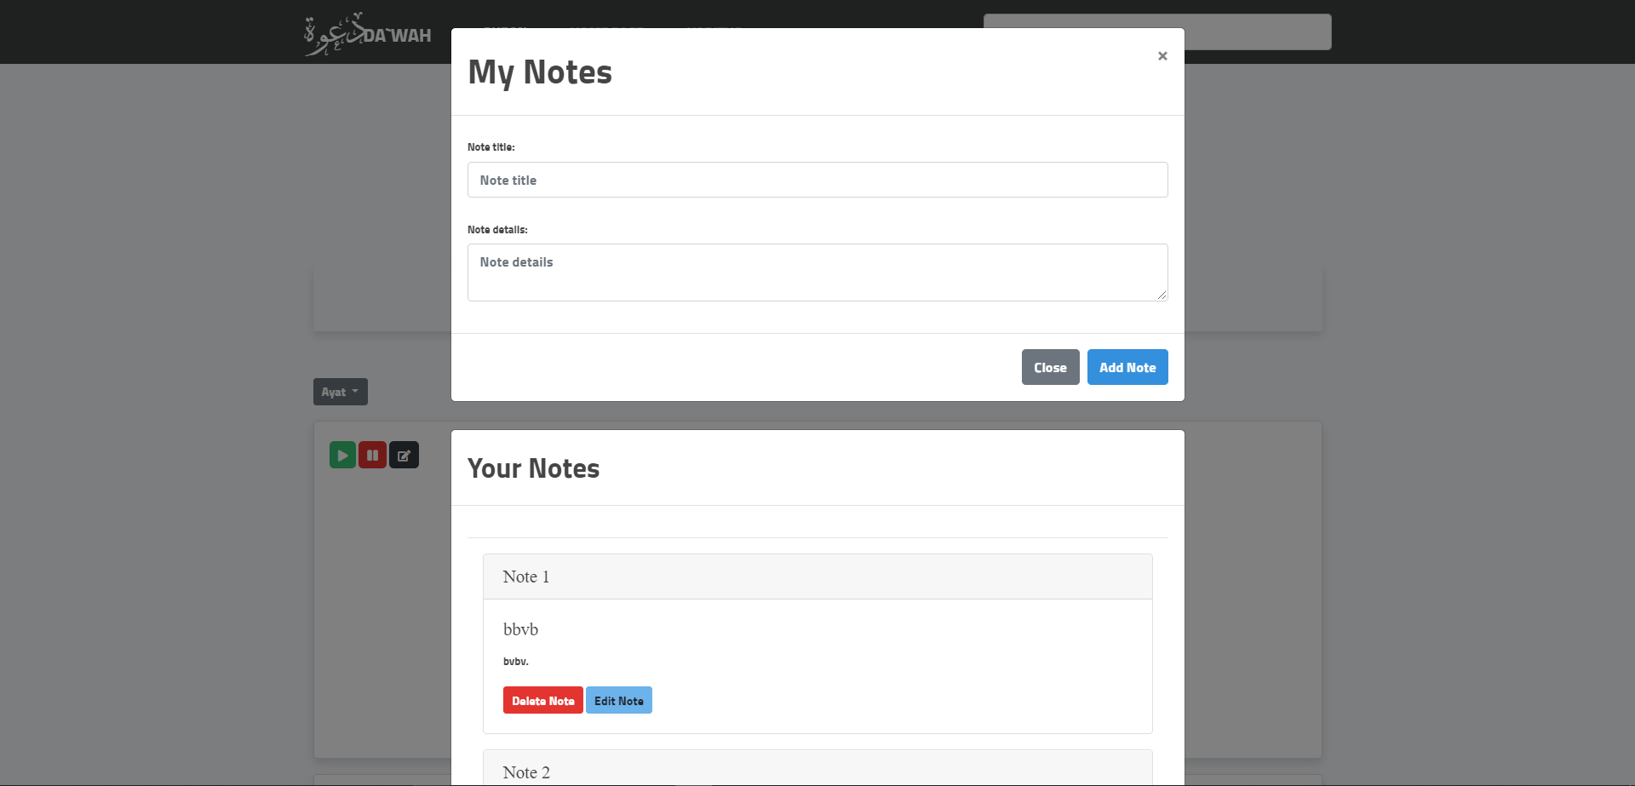

3.Use interface of Add short note

# **3.7 ARCITICTURE**

We can scale our server vertical or horizontal

Vertical means powerful server and more store but it’s so expensive

Horizontal by buy many servers and put each service in the server

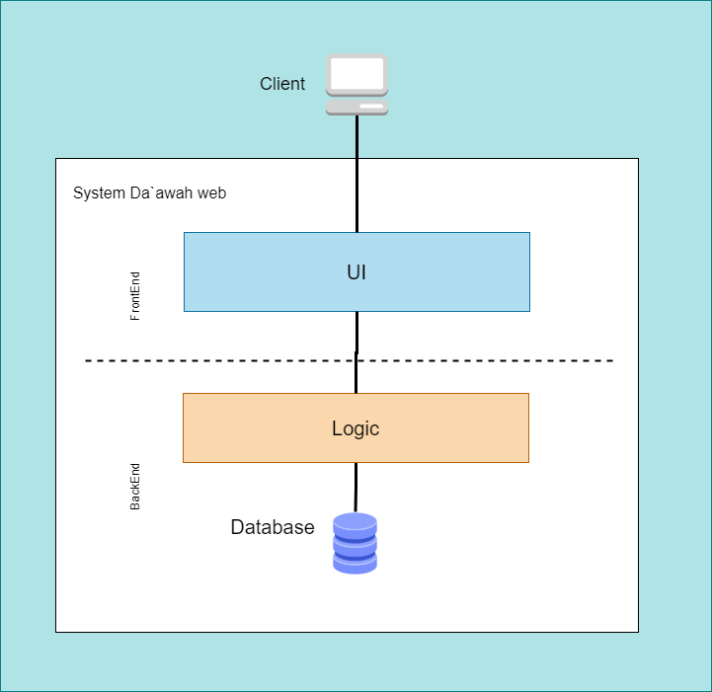

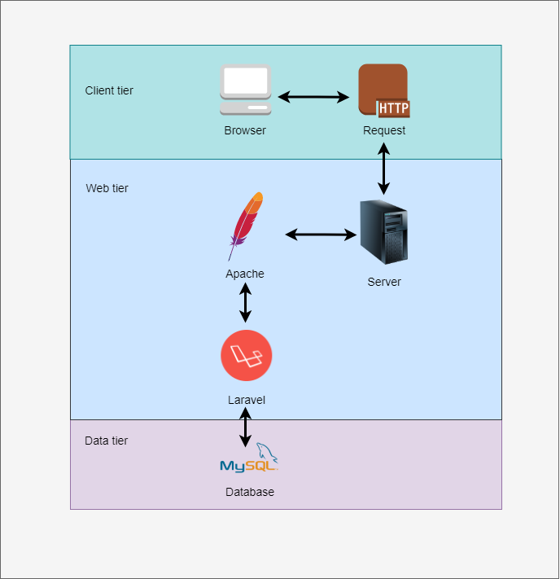

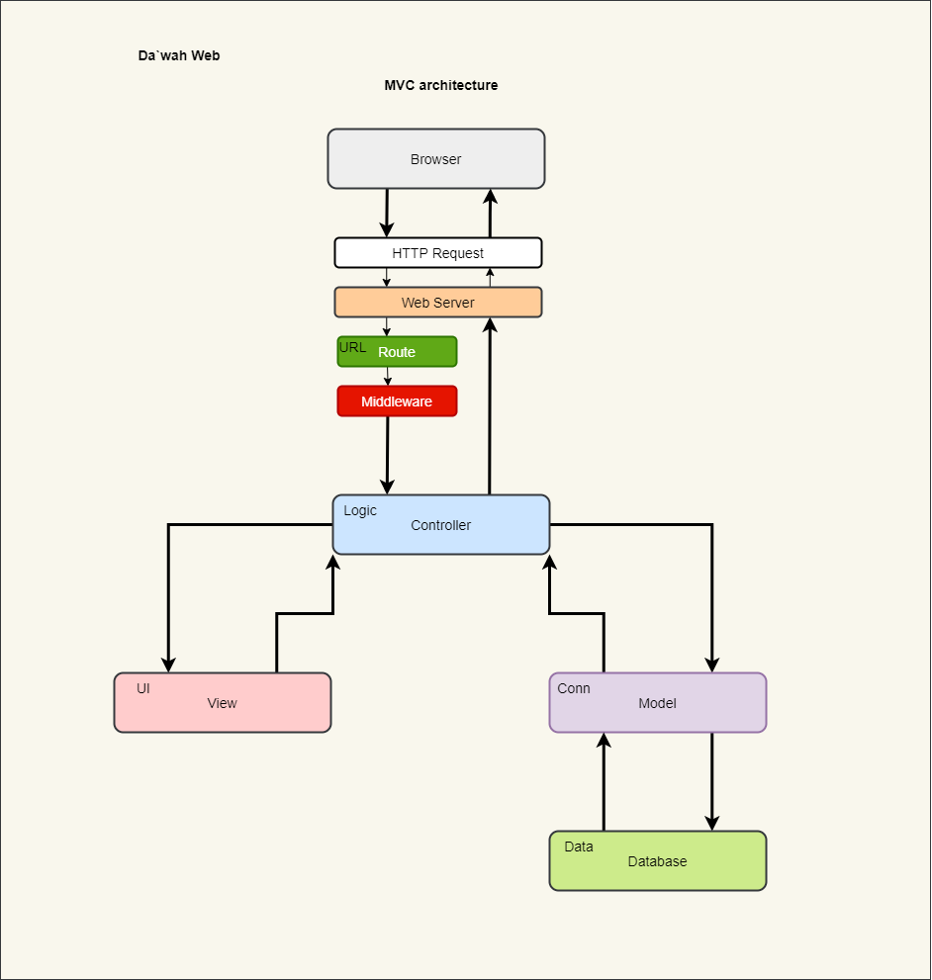

3.MVC Design Patterns