The phonetics and phonology of depressor consonants in Gengbe

1. Introduction

It is often the case that a binary phonological contrast, for example [+/-voice] in onset consonants, is realized via differences in multiple phonetic correlates (Wright 2004). Cues related to the voicing of onset consonants, for instance, may include (but are not limited to) Voice Onset Time (Lisker & Abramson 1964), formant transitions (Stevens & Klatt 1973), f0 contour of the following vowel (Chistovich 1969), and fundamental frequency (f0) register of the following vowel (Shimizu 1989). In the present work, we probe the connection between the feature [+voice] in onset consonants and lowered f0 in subsequent vowels, a relationship observed in many unrelated languages (Bradshaw 1999; Tang 2008). Though voicing-f0 interactions can occur with coda consonants—as in Vietnamese and some Tibeto-Burman languages (Maran 1973; Matisoff 1973), for instance—we focus on the interaction between onset consonants and f0 in Gengbe, a Gbe language spoken in southern Togo and Benin.

Consonants that trigger f0 lowering are generally called “depressor consonants”, and have been studied in a variety of other languages but not systematically in Gengbe. Two effects are discussed here. First, depressor consonants in Gengbe trigger f0 register lowering of Low (L) tone, meaning that L is lower across the entire vowel after a depressor consonant than after other consonants. This register effect is seen in some High (H) tone contexts as well. Second, depressor consonants in Gengbe can allow initial f0 lowering of H tone in some phonological, morphophonological, and syntactic contexts. This results in a contour effect, where f0 is low at the onset of the vowel and rises across the time-course of the vowel. This contour effect differs across morphological domains in that different sets of consonants act as depressors in nouns and in verbs (where different environments produce the contour effects). While only voiced obstruents act as depressors in nouns, voiced obstruents and sonorants act as depressors in verbs. This aligns with observations from other languages: differential treatment of onset types as depressors is attested in Ewe (Bradshaw 1999) and in Zina Kotoko (Odden 2007), for instance.

As no prior discussion of these effects in Gengbe exists, this paper presents a thorough description of the depressor effects that have been observed in Gengbe thus far. The data were collected during 18 months of fieldwork with a native speaker consultant. Acoustic analysis is included where possible, in order to illustrate the phonetic effect of depressor consonants on f0 in following vowels.

Our ultimate goal is to produce a thorough description and analysis of depressor effects in Gengbe, and doing so will necessitate taking into account phonetic, phonological, morphophonological, and syntactic factors, at a minimum. Here, however, our focus is on the phonetics and phonology of Gengbe depressor consonants, and so it is important to be clear about what we mean when we refer to phonetics and phonology. The distinction we aim to highlight is this: a phonetic depressor effect is one wherein f0 is lowered but a new tonal category is not created, such that L after a depressor consonant has a lower fundamental frequency but is still L; a phonologization of that effect yields a new tonal category. This hinges on the distinction between f0 and tone, which is described by Yip (2002:5) as follows: "f0 is an acoustic term referring to the signal itself…. Tone…is a linguistic term. It refers to a phonological category that distinguishes two words or utterances." The distinction between those effects that are phonetic and those that have been phonologized is not always straightforward, and our understanding of depressor effects in Gengbe is under development. To understand whether phonologization of depressor effects in Gengbe is in progress, however, we must first develop an understanding of the depressor effects that exist in the language at present. That is the goal here, and doing so helps suggest important types of data to elicit in future.

The remainder of the paper reads as follows. Section 2 provides relevant background on depressor consonants and tone in Gbe languages. Section 3 discusses the research aims and methodology employed in the current study. Section 4 discusses f0 effects in nouns (Section 4.1) and verbs (Section 4.2). Section 5 concludes the paper.

1. Background on depressor consonants

Previous research indicates that voiced obstruents—and sonorants, albeit less commonly—can act as depressor consonants (Ohala 1973; Bradshaw 1999; Tang 2008), meaning that they can trigger lowering (or depression) of f0 in adjacent vowels. Relevant for this discussion is the vowel immediately following a depressor consonant onset. Depressor effects fall into two broad categories. F0 register effects—schematized below in Fig. 1a—are those that perseverate across the entire vowel, as in Japanese (Oglesbee 2008). F0 contour effects, schematized in Fig. 1b, are localized to the left edge of the vowel, following the consonant constriction release. This results in a rising pitch pattern, as in English (Lea 1973; Oglesbee 2008).



*1a. 1b.*

**Figure 1. Schematized representation of f0 register depressor effect (1a, in the left panel) and f0 contour depressor effect (1b, in the right panel). T represents a voiceless obstruent and D represents a voiced obstruent**

Evidence for a link between [+voice] in consonants and f0 lowering in subsequent vowels has been found in many languages (Bradshaw 1999; Tang 2008), and a relationship between voiced obstruents and tone may also exist (Yip 2002:5). In a tone language where lowered f0 on a vowel already serves as a crucial cue for L tone, co-opting f0 lowering as a redundant cue for the feature [+voice] leads to complications in the phonological system. This conflict may lead to distributional restrictions: Thai, for instance, disallows voiced stops in the onsets of high tone syllables (Perkins 2011); in Kera, limitations on obstruent voicing and tone produce a situation where the full Low-Mid-High tonal contrast is only available in syllables with sonorant onsets (Pearce 2005); and in Ewe, a language closely related to Gengbe, Ansre (1961) analyzes the tonal system as having a ‘Non-High’ toneme that is realized as L after a voiced obstruent and Mid (M) after a voiceless obstruent, a claim that we will revisit in Section 4.

These distributional restrictions hold true synchronically, but it is also worth considering their diachronic development. What might phonologization of a phonetic depressor effect look like? One process—dubbed ‘Tonal Bifurcation’ and outlined in Hyman (2013)—is outlined in Fig. 2. In the first stage of Tonal Bifurcation (Fig. 2a), an f0 contour effect (as discussed earlier for English) is present in a language with two register tones (H and L). The next stage of the process (Fig. 2b) involves innovation of a contrasting Rising (LH) tone due to realization of H tone syllables as LH following voiced onsets. This occurs in languages like Ewe and Gengbe (Ansre 1961; Bole-Richard 1983). In the final stages of this process—seen in languages like Nguni and Shona (Downing 2009), and illustrated in Fig. 2c—the voicing distinction has been lost in favor of a tonal distinction.

|  |  |
| --- | --- |
| 1. tá vs. dá | [+voice] manifests phonetically as a redundant f0 cue on the left edge of the vowel |
| 1. tá vs. dǎ | Voiced obstruents phonologically trigger Rising rather than level High tone |
| 1. tá vs. dǎ | Voicing contrast is lost, contrasting lexical tone remains |

**Figure 2. Illustration of tonal bifurcation (adapted from Hyman 2013).**

Gengbe exhibits the pattern illustrated in Fig. 2b: it retains a voicing contrast that results in the realization of underlying H tone with a rising pitch pattern in some contexts. We are not the first to note such an interaction in the Gbe languages. Westermann (1928) illustrated the presence of a non-lexical distinction between Low and Mid tone in Ewe, and—as noted previously—Ansre’s (1961) study of Ewe tone concludes that the language has two tonemes, High and Non-High, with the latter realized as Low after a voiced obstruent and Mid after a voiceless obstruent. Smith (1968) and Stahlke (1971) both take on the task of formalizing this interaction, focusing on the various morphophonological processes that interact with the realization of Low and Mid tone as well as some differences found across Ewe dialects. But Stahlke rejects the analysis of Mid tone as non-underlying, arguing instead for instances of predictable, lexically specified, and floating Mid tones in Ewe. Bole-Richard (1983) notes that the link between rising pitch patterns and voiced obstruents also holds for Gengbe. The myriad interactions shown in previous Ewe literature are not systematically investigated therein, however, and so our study aims to begin doing so.

Ewe is known for its typologically irregular treatment of sonorants as depressor consonants in some phonological and morphophonological contexts, earning it a slot in Bradshaw’s (1999) study of depressor effects under the section detailing ‘problem cases’. Bradshaw analyzes the depressor effect as an interaction between L tone and the privative feature [L/voice]. This is generally a property of voiced obstruents. In order to account for inclusion of sonorants as depressors in languages like Ewe, Bradshaw proposes that while sonorants are generally underspecified for [L/voice] this is not always the case and that their phonological patterning language-internally can reveal whether or not this is so (Bradshaw 1999: 169-170). As discussed in Section 4, Gengbe does exhibit interactions between sonorants and a rising pitch pattern, like Ewe. Although the details of the pattern differ from Ewe, under Bradshaw's analysis this would suggest that sonorants in Gengbe, as in Ewe, are not underspecified for [L/voice]. Note that another element of Bradshaw’s analysis is that the feature [L/voice] can render an onset transparent to L tone spreading and may also serve as the source for the L tone that spreads onto neighboring vowels. This is not investigated here but, given the other similarities between Ewe and Gengbe, it should prove valuable to investigate in the future.

In this paper we use the term ‘depressor consonant’ as a cover term for the onsets that participate in the various pitch-lowering processes found in Gengbe—that is, for both voiced obstruents and for sonorants, in instances where they cause either register or contour effects. Some of the effects outlined may be indicative of a phonologization process—in particular, those contexts where an underlying /H/ tone mandatorily surfaces as [LH], or a Rising tone. These should prove valuable in a future discussion of how phonetic effects may become phonologized, but the goal here is to present a clear overview of the depressor effects found in nominal and verbal domains. We turn now to a review of methods and aims.

1. Methods and Aims

The present study surveys phonetic and phonological aspects of Gengbe depressor consonants with a focus on probing the differences between nouns and verbs in realizing such effects. The data here are from a single native speaker of Gengbe who is in his fifties and is from Batonou, Togo, and were gathered in elicitation sessions conducted weekly from August 2014 to June 2016.

Those items which were subjected to acoustic analysis were recorded in randomized order. All items were embedded in carrier sentences: nouns appeared in the frame *Kòfí bé ____ kèà* "Kofi said ____ again," and verbs appeared in the frame *ṹsùà ____ vɔ̀* "The man ______ed." Recorded were made in a sound-attenuated booth (WhisperRoom Model # 6084), annotated using Praat (Boersma & Weenink 2016), and measured using Prosody Pro (Xu 2013), a script which automates the taking of acoustic measurements. A random sub-sample of the data was hand-checked to ensure validity.

Measures reported here are for time-normalized f0: each vowel was divided into ten equal portions and a mean f0 measure was calculated for each portion. This method facilitates cross-token comparison. Note that vowel length in Gengbe is not contrastive, although we will see that allophonic lengthening does occur in some environments. That said, in the data that follow we have indicated Rising tone as a series of L and H on identical adjacent vowels rather than on a single vowel (i.e. *àá* rather than *ǎ*). This is a stylistic choice. It does not indicate a phonemically long vowel.

1. F0 Contour Effects

As noted, an underlying H tone in Gengbe is mandatorily realized as LH in some contexts. In sections 4.1 and 4.2 below, we present an overview of the onset types and environments that produce LH tone in nouns and verbs respectively. The most notable difference between the two is that sonorants do not act as depressor consonants in nouns, but do in verbs.

* 1. LH tone in nouns

Most nouns in Gengbe are monosyllabic, with a lexically determined L tone nominal prefix *è-* or *à-*. In this environment, when H tone is preceded by a syllable with L tone, the surface realization of H is determined by the consonant that precedes it. Depressor consonants in this environment are followed by LH, while other consonants are followed by H. That H and LH are both realizations of the H toneme is evinced by the numerous tonal minimal pairs included in Table 1. In these minimal pairs, L contrasts with H following voiceless obstruents (Table 1 a-c) and sonorants (Table 1 d-f). Following voiced obstruents, however—as in (Table 1 g-i)—L contrasts with LH. Recall that there is no phonemic vowel length contrast in these minimal pairs: what distinguishes them is the tone of the final syllable.

**Table 1: Tonal minimal pairs**

|  |  |  |  |  |  |  |
| --- | --- | --- | --- | --- | --- | --- |
|  | **L** | **Gloss** | **H** | **Gloss** | **LH** | **Gloss** |
| **a)** | èk͡pɛ̃̀ | *‘whistle’* | èk͡pɛ̃́ | *‘cough’* |  |  |
| **b)** | èkɔ̀ | *‘neck’* | èkɔ́ | *‘sand’* |  |  |
| **c)** | ɑ̀tɔ̃̀ | *‘nest’* | ɑ̀tɔ̃́ | *‘apple’* |  |  |
| **d)** | èɲĩ̀ | *‘cow’* | èɲĩ́ | *‘bee’* |  |  |
| **e)** | èmɔ̃̀ | *‘corn mill’* | èmɔ̃́ | *‘way’* |  |  |
| **f)** | ɑ̀l̃ɛ̃̀ | *‘stupidity’* | ɑ̀l̃ɛ̃́ | *‘sheep’* |  |  |
| **g)** | ègɑ̀ | *‘metal’* |  |  | ègɑ̀ɑ́ | *‘chief’* |
| **h)** | èdɔ̀ | *‘sickness’* |  |  | èdɔ̀ɔ́ | *‘work’* |
| **i)** | ɑ̀dɔ̃̀ | *‘squirrel’* |  |  | ɑ̀dɔ̃̀ɔ̃́ | *‘beak’* |

Since H and LH tone are in complementary distribution here, we consider H and LH tone allotones of the same H toneme. The data in Table 1 conform to the process Bradshaw (1999) describes as L tone spreading from the initial L tone realized on the nominal prefix over the voiced obstruent (with [L/voice]) and onto the following vowel, a process that does not occur in nouns with voiceless obstruents and sonorants onsets lacking this feature.

There are several things to note about the phonetic realization of H and LH as illustrated by the above data. First, LH tone is associated with vowel lengthening. Average duration of vowels after voiced and voiceless obstruents—calculated over 66 items in each category, for a total of 264 token—is shown in Fig. 3. Duration is of course affected by factors such as speaker and speaking rate, but in these data vowels with LH tone (shown in the bottom bar on the chart) are longer than other vowels by approximately 60ms.

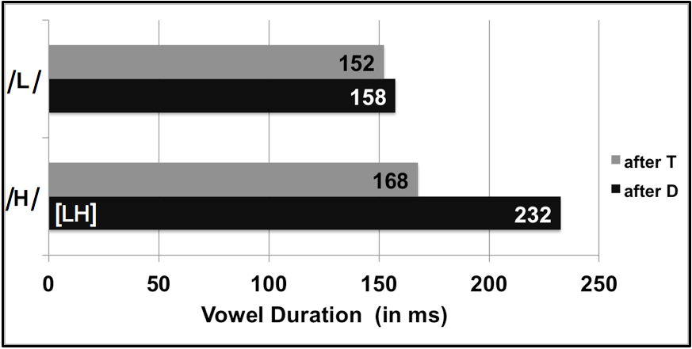

**Figure 3. Average duration of vowels after voiced (black) and voiceless (gray) obstruents in nouns. Underlying H is longer after voiced than after voiceless obstruents. T represents a voiceless obstruent and D represents a voiced obstruent**

We can also look at the time-normalized f0 tracks of these vowels, shown in Fig. 4. Here, gray lines represent vowels after voiceless obstruents (referred to as ‘T’ in the key) and black lines represent vowels after voiced obstruents (referred to as ‘D’ in the key). Solid lines represent L tone, and dotted lines represent H (after voiceless obstruents) and LH (after voiced obstruents). Note the presence of what looks like an f0 register effect in Low tone: L after voiced obstruents is approximately 20 Hz lower than after voiceless obstruents, and this difference perseverates across the entirety of the subsequent vowel. The dashed lines, meanwhile, illustrate the robust f0 differences between H and LH, which is realized as a contour effect.

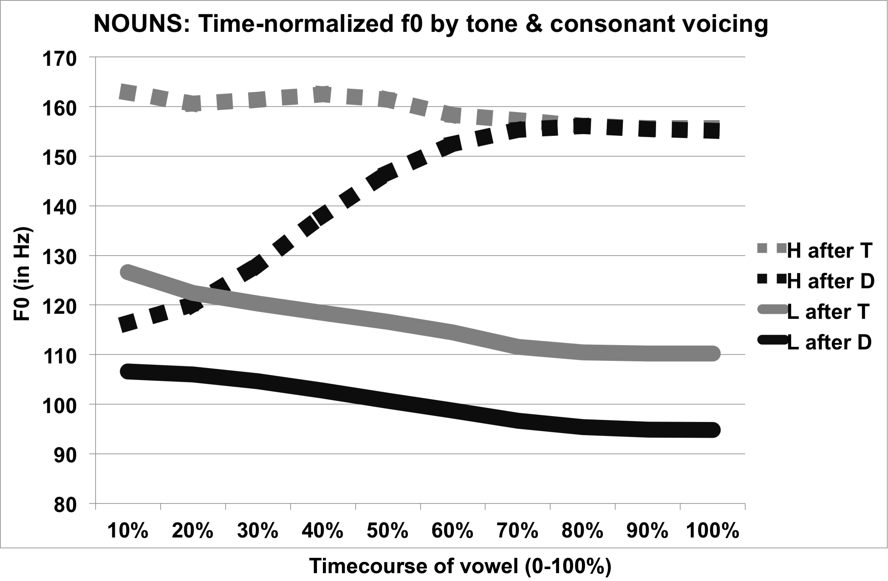

**Figure 4. Time-normalized f0 tracks of High (dotted lines) and Low (solid lines) tones after voiced (black lines) and voiceless (gray lines) obstruents in nouns. H follows voiceless obstruents and LH follows voiced obstruents.**

Means and standard deviations are included in Table 2; commentary follows.

**Table 2: Means and standard deviations (in Hz) for the ten timepoints included in time-normalized f0 tracks shown in Figure 4.**

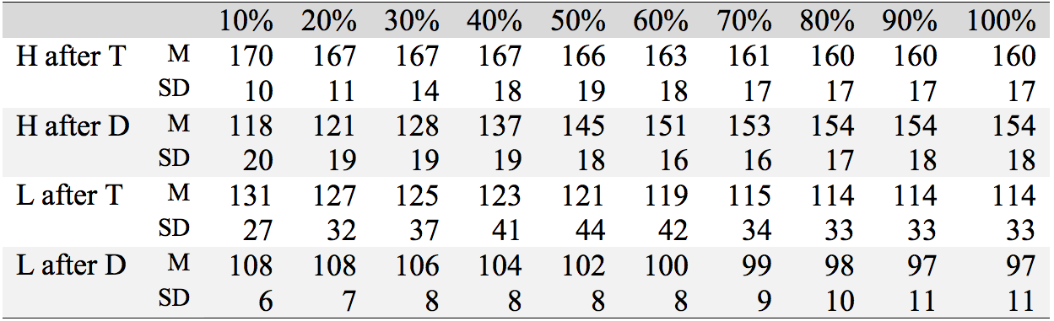

The L tone difference illustrated in Fig. 4 conforms to Ansre’s (1961) analysis of Ewe, which claims that there are two realizations of the Non-High toneme: Low after a voiced obstruent and Mid after a voiceless obstruent. But is this a phonetic effect as discussed above for Japanese (Oglesbee 2008) or is this a phonological effect as in Ewe? Unlike Ewe, neither previous Gengbe literature nor our elicitation has provided evidence for Mid tones that are not phonologically conditioned, nor have we discovered lexical Mid tones or floating morphological Mid tones in Gengbe. The appearance of the phonetically lower Low after a voiced obstruent, in other words, is regular and predictable in Gengbe, whereas that is not always the case in Ewe. For the time being, then, we analyze this register lowering as a purely phonetic effect.

As a side note, f0 register lowering is not limited to L tone contexts. As discussed more thoroughly in Section 4.2, there are contexts in Gengbe where High tone is realized as H rather than as LH after voiced obstruents. In these instances, shown in Fig. 5, we again see what looks like register lowering of f0. High tone is realized with higher f0 after voiceless obstruents than after voiced obstruents. Note here that the pitch range for H tone in Fig. 5 is comparable to the pitch range in L tone in Fig. 4 above, but this is most likely a result of final lowering—a topic to be investigated in future work.

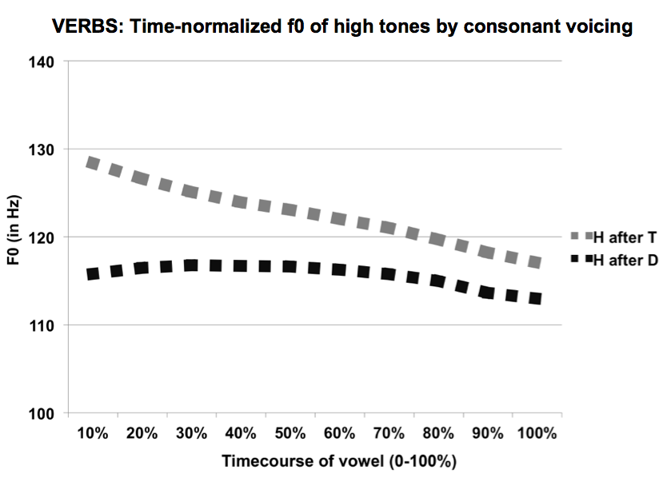

**Figure 5. Time-normalized f0 tracks of level High tones after voiced (black) and voiceless (gray) obstruents in verbs. H is lower following voiced obstruents.**

At this time we do not have a firm answer on whether register f0 lowering is a phonetic or phonological effect in Gengbe. The data may support an analysis in Gengbe that parallels that adopted for the L toneme in Ewe—that is, an analysis that posits two allotones for the L toneme (in Fig. 4) and two allotones for the H toneme (in Fig. 5)—but this is a question we can not answer yet.

For now, we leave the topic of f0 register effects and turn back to the LH tone in Gengbe. The f0 contour effect in nouns—which manifests as a Rising pitch pattern in Table 1 (g-i), is shown to have longer duration than H in Fig. 3, and displays a >50 Hz f0 difference localized to the left edge of the vowel in Fig. 4—is tied to the tone of the preceding syllable, not just preceding L tone nominal prefixes. In nominal compounds, for instance, word-medial nominal prefixes are deleted. If this means that the target H tone syllable is preceded by a surface H, as in (1), or a surface LH, as in (2), no f0 contour effect occurs. Rather, underlying H surfaces as H even after voiced obstruents.

(1) ɑ̀ɲĩ́g͡bɑ̃́ + è**dɔ̀ɔ́** → ɑ̀ɲĩ́g͡bɑ̃́**dɔ́**

*‘earth’ ‘work’ ‘earth work’*

(2) èg͡bèé + ɑ̀v**ũ̀ṹ**  → èg͡bèé**vṹ**

*‘bush’ ‘dog’ ‘bush dog’*

This interaction is important, for it helps to define the phenomenon as morphophonological in the sense that depressor consonants are not the source of the L tone (as is argued for in Bradshaw 1999 for some depressor effects). Rather, depressor consonants allow L tone to spread over them from the preceding vowel. Using preceding L tone nominal prefixes as an illustrative environment, we present the list of Gengbe onsets that nouns treat as depressors in Table 3. This includes all voiced obstruents—stops in (a-d), affricates in (e), fricatives in (f-i), and the retroflex [ɖ] in (j).

**Table 3: List of Gengbe depressor consonants in nouns.**

|  |  |  |  |  |  |  |  |
| --- | --- | --- | --- | --- | --- | --- | --- |
|  | Onset | Noun | Gloss |  | Onset | Noun | Gloss |
| **a)** | [b] | ɑ̀bɔ̀ɔ́ | *‘arm’* | **g)** | [z] | èzɑ̃̀ɑ̃́ | *‘night’* |
| **b)** | [d] | èdɔ̀ɔ́ | *‘work’* | **h)** | [β] | èβɑ̃̀ɑ̃́ | *‘spear’* |
| **c)** | [g] | ègɑ̃̀ɑ̃́ | *‘bigness’* | **i)** | [ɦ] | èɦɑ̀ɑ́ | *‘group’* |
| **d)** | [g͡b] | èg͡bĩ̀ĩ́ | *‘buttocks’* | **j)** | [ɖ] | èɖìí | *‘dirt’* |
| **e)** | [d͡ʒ] | èd͡ʒɑ̃̀ɑ̃́ | *‘bow’* | **k)** | [gl] | ɑ̀glòó | *‘joy’* |
| **f)** | [v] | ɑ̀vɔ̀ɔ́ | *‘cloth’* | **l)** | [ɦj] | èɦjɛ̃̀ɛ̃́ | *‘poverty’* |

Table 4, meanwhile, presents the consonants that do not act as depressors in Gengbe nouns. These include voiceless obstruents, as in (a-f), and sonorants, as in (g-l). By contrasting Table 3 items (k-l) with Table 4 items (m-o), we can also see that the second member of an onset cluster is disregarded when calculating depressor effects in nouns. In other words, it is C1 in a C1C2 onset cluster that determines how an underlying H is realized in Gengbe nouns—clusters that begin with a depressor, as in Table 3 items (k-l), pattern with other onset depressors. Clusters that do not, as in Table 4 items (m-o), pattern with the other non-depressor onsets. Note that only liquids and glides may appear as C2 in consonant clusters in Gengbe. Bradshaw (1999)'s analysis of sonorants as unspecified for [L/voice] may prove useful here. While it is beyond the scope of the present work, investigation of this possibility will prove valuable in future work.

**Table 4. Non-depressor consonants in Gengbe nouns**

|  |  |  |  |
| --- | --- | --- | --- |
|  | Onset | Noun | Gloss |
| **a)** | [t] | ɑ̀tí | *‘tree’* |
| **b)** | [k] | èkú | *‘death’* |
| **c)** | [k͡p] | èk͡pɑ́ | *‘fence’* |
| **d)** | [ɸ]/[p] | ɑ̀ɸɑ́/ɑ̀pɑ́ | *‘shout’* |
| **e)** | [f] | ɑ̀fí | *‘here’* |
| **f)** | [s] | èsɔ̃́ | *‘horse’* |
| **g)** | [m] | èmṹ | *‘mosquito’* |
| **h)** | [n] | ɑ̀nɑ̃́ | *‘bridge’* |
| **i)** | [ɲ] | èɲĩ́ | *‘bee’* |
| **j)** | [l] | èló | *‘crocodile’* |
| **k)** | [w] | èwɔ́ | *‘corn flour’* |
| **l)** | [j] | ɑ̀jɑ́ | *‘air’* |
| **m)** | [kl] | ɑ̀kló | *‘flat boat’* |
| **n)** | [fj] | èfjɔ́ | *‘monkey* |
| **o)** | [wl] | èwlí | *‘shout’* |

While the pattern seen in verbs—shown next, in Section 4.2—differs, depressor consonants in nouns are limited to voiced obstruents. Sonorants do not act as depressors in nouns, and they are disregarded in C1C2 clusters, indicating that it is the featural specification of C1 that is relevant for this process. Furthermore, LH tone in nouns is triggered by L tone in a preceding syllable. When preceded by H or LH tone, as in nominal compounds, underlying H surfaces as H even after voiced obstruents, so this phenomena requires an external L tone to trigger spreading. This contrasts with the verbal pattern, which is outlined in the next section, where we will see that the occurrence of depressor effects is based on syntactic position.

* 1. LH tone in verbs

Verbs differ phonologically from nouns in several ways. First, more onset types (sonorants and voiceless obstruent-liquid sequences) act as depressors in verbs. In addition, LH tone surfaces not after a preceding L tone vowel, but after a preceding phrase boundary. We begin by presenting data motivating the claim that verbs are sensitive to initial phrase-boundaries, then use the structural positions in which LH tone manifests to illustrate the onset types that act as depressors in the verbal domain. Data are drawn from three contrasting syntactic situations: predication vs. citation, plural imperative vs. singular imperative, and reduplication with vs. without a pre-posed logical object.

In predication, as shown in (3), even when the preceding vowel has L tone and even following voiced obstruents, as in (3b), the H tone verb is not realized as LH. In citation forms, however—shown in the examples in (4)—there is no overt subject present. Here we see that what surfaced as H in the examples in (3) is still realized as H after voiceless obstruents (4a) but as LH after voiced obstruents (4b) and sonorants (4c).

(3) Predication (overt subject)

a. mũ̀ **k͡pɔ́** ǹtísì b. mũ̀ **bú** ǹtísì c. mũ̀ **ɲɑ̃́** gɔ̃̀mɛ̃̀d͡ʒèd͡ʒèé-ɑ́

1SG see lime 1SG lose lime 1SG know beginning-the

*‘I saw a lime.’ ‘I lost a lime.’ ‘I know the beginning.’*

(4) Citation (no overt subject)

a. **k͡pɔ́** b. **bùú** c. **ɲɑ̃̀ɑ̃́**

see lose know

*‘to see’ ‘to lose’ ‘to know’*

The examples in (4) illustrate that the verbal domain differs from the nominal domain in both the context and onset types that are required for the realization of LH. As we saw in section 4.1, the context that produces LH tone in nouns is morphophonological, in the sense that it results when an underlying H surfaces after a depressor consonant preceded by a Low-toned syllable. The context that gives us LH in verbs is syntactic, however. In addition, both the voicing and obstruency of an onset is relevant in the nominal domain where only voiced obstruents act as depressors. In the verbal domain, however, it appears that only voicing matters: here, as shown in (4b) and (4c), both voiced obstruents and sonorants act as depressors.

The same observations made in (3-4) hold for overt and non-overt subjects in imperatives. Plural imperatives, which require the overt L tone subject *mĩ̀*, as in (5), exhibit no depressor effect. Singular imperatives, on the other hand, lack overt subjects, as in (6), and we see the same depressor effect shown in (4) in citation form.

(5) Plural imperative (overt subject)

a. mĩ̀  **tú** èɦɔ̃̀tɾú

2PL close door

*‘Close the door, you all!’*

b. mĩ̀ **vɑ́**

2PL come

*‘Come, you all!’*

c. mĩ̀ **lé** ṹsù-ɑ̀

2PL arrest man-DEF

*‘You all arrest the man!*

(6) Singular imperative (no overt subject)

a. **tú** èɦɔ̃̀tɾú b. **vɑ̀ɑ́** c. **lèé** ṹsù-ɑ̀

close door come arrest man-the

*‘Close the door!’ ‘Come!’ ‘Arrest the man!’*

Bradshaw (1999) analyzes the singular imperative in Ewe as formed by a prefixed L tone morpheme that docks with the vowel only when the onset is voiced. Since our data suggests the trigger of LH is present in citation form as well as the singular imperative, we describe the phenomenon in terms of an initial syntactic boundary (possibly an initial L boundary tone) rather than a morphological affix. It is possible still that the L tone is a morphological affix, although with the two situations described (as well as reduplication data below), we posit a single positional explanation rather than three independent L tone morphemes.

When a verb is reduplicated, the logical object, normally following the bare verb, is moved to precede the reduplicated verb. Where there is such pre-verbal information, there is no depressor effect, as in (7), and where there is no preverbal material, we again see the depressor effect, as in (8). Note that sonorants are still considered depressors here despite the fact that in (7-8) we are deriving nouns from verbal roots. If we are to assume that category-changing derivation processes are done in the lexicon, this introduces an as-yet unsolved mystery as to the nature of the relevant property that determines which set of onsets counts as depressors. For now we can tentatively define the distinction as derivation from underlying nominal or verbal roots.

(7) Reduplication (pre-posed object)

a. èlɑ̃̀ **fɑ**́~fɑ́ b. èlɑ̃̀ **vo**́~vó c. ɲɔ̃́nũ̀ **jɔ́**~jɔ́

meat cool~NOM meat decay~NOM woman call~NOM

*‘cooling meat’ ‘decaying meat’ ‘calling a woman’*

(8) Reduplication (no pre-posed object)

a. **fɑ**́~fɑ́ b. **vòó**~vó c. **jɔ̀ɔ́**~jɔ́

cool~NOM decay~NOM call~NOM

*‘cooling’ ‘decaying’ ‘calling’*

We analyze this process in terms of syntax rather than morphology or phonology for the following reasons. As noted before, we do not posit tonal morphology that affects these three processes independently, although we leave open the possibility. We also do not see a clear path to a phonological explanation in terms of (prosodic) word-initial position. If we were to explore this possibility, we would need to describe the verbs in (3), (5), and (7) as non-initial. Pronouns in (3) and (5) can—and have in the case of Ewe (Duthie 1996)—been analyzed as clitics, however, full NP subjects also fail to trigger LH tone in following predicates, for example *ènɔ̃̀ã̀ bé* ‘mother said,’ suggesting that the right environment for LH tone in verbs has to do with phrase position (possibly utterance-initial position) rather than word position. As of yet, we leave the term ‘phrase-initial position’ purposefully vague. The importance of syntactic position in tone rules is well established (Snider 2014), but we leave the definition of such positioning to future syntactic work.

The data in (3-8) indicate that depressor consonants in the verbal domain include voiced obstruents and sonorants; and, phrase-initial position, rather than a preceding L tone vowel, is the trigger for LH tone. The data in (9-10) present verbs with initial consonant clusters, using the citation form as illustration, though reduplication and imperative data were also investigated. (9) reveals that consonant-liquid clusters act as depressors, regardless of the identity of C1; (10) reveals that consonant-glide clusters do not. It is again valuable to note that liquids and glides are the only consonants that can serve as C2 in a consonant cluster in Gengbe. The crucial data points here are (9a) where a voiceless onset-liquid cluster shows a depressor effect and (10a) where a voiceless onset-glide cluster does not. We resist the urge here to speculate about syllable structure based on these verbal data since the difference between C2 liquids and glides in the verbal domain does not hold in the nominal domain, as illustrated previously in Table 4 (m-n).

(9) Consonant-liquid clusters in Gengbe Verbs

a. **klòó** b. ŋlɔ̃̀ɔ̃́ c. glòó

*‘to fade’ ‘to fold’ ‘to boast’*

(10) Consonant-glide clusters in Gengbe Verbs

a. **fjɔ́** b.ljàá c. ɦjɛ̃̀ɛ̃́

*‘to teach’ ‘to climb’ ‘to need’*

Taking all of these data together, then, verbs differ from nouns (or more specifically verbal roots differ from nominal roots) in that single onset sonorants act as depressors for the former, but not the latter. Furthermore, C1 determines whether or not a depressor effect emerges in nouns and consonant-liquid sequences fail to act as depressors if C1 is not a voiced obstruent. Yet in verbs, regardless of the identity of C1, consonant-liquid but not consonant-glide clusters act as depressors. Finally, LH tone in verbs is triggered in phrase-initial position rather than by preceding L tone vowels. A breakdown of the onset types that pattern as depressors in the nominal and verbal domains is given in Fig. 6, where a shaded box indicates that a depressor effect obtains in that environment: in other words, depressor effects occur after voiced obstruents—still represented with a capital D—in both nominal and verbal domains. Note that a noun consisting of a H tone syllable with Nasal-Glide (NG) onset has yet to be elicited and is marked ‘n/a.’

|  |  |  |  |  |  |  |  |  |  |
| --- | --- | --- | --- | --- | --- | --- | --- | --- | --- |
|  | **T** | **TL** | **TG** | **D** | **DL** | **DG** | **N** | **NL** | **NG** |
| **Nouns** |  |  |  |  |  |  |  |  | n/a |
| **Verbs** |  |  |  |  |  |  |  |  |  |

***Figure 6. Summary of onsets considered depressors by nouns and verbs (T=Voiceless Obstruent, D=Voiced Obstruent, N=Sonorant, L=Liquid, G=Glide)***

In this survey, we have presented a brief overview of the phonetic, phonological, and morphological contexts in which we can, on the surface, observe f0 register and f0 contour lowering. This overview is preliminary, and is intended to inform future investigation.

1. Summary

Our preliminary research on Gengbe has highlighted relevant observable phenomena as well as mysteries in need of further investigation. We have shown two types of observable effect. The f0 contour effect occurs when an underlying H follows specific depressor onsets (a category which differs based on whether a root is nominal or verbal) and is realized with a Rising pitch pattern. It is realized phonetically through both lengthening (by about 60ms) and f0 lowering (by about 50Hz at the left edge of the vowel). There is also an f0 register effect, wherein an underlying L is realized as lower following a voiced obstruent (by about 20 Hz across the duration of the vowel). We have shown that register f0 lowering is also present in some verbal contexts when an underlying H surfaces as H (rather than LH) after a voiced obstruent.

In the contexts investigated in this study, we find that nominal and verbal roots differ both in the onset types that are followed by LH and in the contexts that trigger this Rising pitch pattern. Nominal roots in Gengbe treat voiced obstruents in C1 position as depressors, revealed as such when preceded morphologically by a L tone syllable. C2 consonants do not alter this effect in nouns. Verbal roots, on the other hand, treat both voiced obstruents and sonorants as depressors, revealed as such when placed in phrase-initial position. Unlike nouns, C2 liquids—but not glides—are also followed by LH in these verbal contexts.

Although this study is preliminary and there is much work to be done on Gengbe, it is our expectation that further investigation of the behavior and identity of depressor consonants in the many Gbe languages will prove a rich ground for the study of tonal bifurcation and the phonologization of tone.

**REFERENCES**

Ansre, Gilbert. 1961. *The tonal structure of Ewe.* The Kennedy School of Missions of The Hartford Seminary Foundation: Hartford, Connecticut. (Masters Thesis.)

Boersma, Paul & Weenink, David. 2016. Praat: doing phonetics by computer [Computer program]. Version 6.0.14

Bole-Richard, Rémy. 1983. *Systématique phonologique et grammaticale d’un parler Ewe: Le Gen-Mina du Sud-Togo et Sud-Bénin*. Paris: Editions L’Harmattan.

Bradshaw, Mary M. 1999. *A crosslinguistic study of consonant-tone interaction.* Ohio State University, Columbus, Ohio. (Doctoral dissertation.)

Chistovich, L. A. l969. Variations of the fundamental voice pitch as a discriminatory cue for consonants. *Soviet Physics-Acoustics* l4. 372-378.

Downing, Laura J. 2009. On pitch lowering not linked to voicing: Nguni and Shona group depressors. *Language Sciences* 31(2). 179-198.

Duthie, Alan S. 1996. *Introducing Ewe Linguistic Patterns*. Accra: Ghana Universities Press.

Hyman, Larry M. 2013. Enlarging the scope of phonologization. In Yu, A. (ed.), *Origins of sound change: Approaches to phonologization*, 3-28. Oxford: Oxford University Press.

Lea, Wayne A. 1973. Segmental and suprasegmental influences on fundamental frequency contours. *Consonant types and tone* 1. 15-70.

Leben, William R. 1973. The role of tone in segmental phonology. *Consonant types and tone* 1. 115-150.

Lisker, Leigh & Abramson, Arthur. 1964. A cross-language study of voicing initial stops: acoustical measurements. *Word* 20(3). 384-422.

Maran, La Raw. 1973. On becoming a tone language: A Tibeto-Burman model of tonogenisis. *Consonant types and tone* 1. 97-114.

Matisoff, James A. 1973. Tonogenesis in southeast Asia. *Consonant types and tone* 1. 71-95.

Odden, David. 2007. The unnatural tonology of Zina Kotoko. Tones and Tunes 1. 63-89.

Oglesbee, Eric N. 2008*. Multidimensional stop categorization in English, Spanish, Korean, Japanese, and Canadian French.* Indiana University, Bloomington. (Doctoral dissertation.)

Ohala, John. J. 1973. The physiology of tone. *Consonant Types and Tone* 1. 1-14.

Pearce, Mary. 2005. Kera tone and voicing. *UCL Working Papers in Linguistics* 17. 61-82.

Perkins, Jeremy. 2011. Consonant-tone interaction and laryngealization in Thai. In presentation, 21st Annual Conference of the Southeast Asian Linguistics Society (SEALS 21). 11-13.

Shimizu, Katsumasa. 1989. A cross-language study of voicing contrasts of stops. *Studia Phonologica* 23. 1-12.

Smith, Neil. 1968. Tone in Ewe. *MIT Research Laboratory in Electronics Quarterly Progress Report* 88. 293-305.

Snider, Keith. 2014. On establishing an underlying tonal contrast. *Language Documentation & Conservation* 8. 707-737.

Sprigge, R. G. S. 1967. Tone in the Adangbe dialect of Ewe. *Collected Language Notes* *(No.8).* University of Ghana, Legon.

Stahlke, Herbert F. W. 1971. *Topics in Ewe phonology*. University of California, Los Angeles. (Unpublished doctoral dissertation.)

Stevens, Kenneth & Klatt, Dennis. 1973. Role of formant transitions in the voiced-voiceless distinction for stops. *The Journal of the Acoustical Society of America* 55(3). 653-659.

Tang, Katrina E. 2008. *The phonology and phonetics of consonant-tone interaction*. University of California-Los Angeles. (Doctoral Dissertation.)

Westermann, Diedrich. 1928. *Evefiala or Ewe-English Dictionary*. Berlin: Deitrich Reimer (Ernst Vohsen). Reprint 1973.

Wright, Richard. 2004. A review of perceptual cues and cue robustness. *Phonetically based phonology*, 34-57.

Xu, Yi. 2013. ProsodyPro — A Tool for Large-scale Systematic Prosody Analysis. In Proceedings of Tools and Resources for the Analysis of Speech Prosody (TRASP 2013). Aix-en-Provence, France. 7-10.

Yip, Moira. 2002. *Tone*. Cambridge: Cambridge University Press.