On the Acquisition of European Portuguese Liquid Consonants by L1-Mandarin Learners

Chao Zhou, University of Lisbon

Maria João Freitas, University of Lisbon

Adelina Castelo, University of Lisbon

The present study aimed to investigate the developmental patterns of acquisition of the European Portuguese liquid consonants by L1-Mandarin speakers, and to examine the prosodic effect on L2 phonological acquisition. Fourteen L1-Mandarin learners participated in a picture-naming task and results showed that the alveolar lateral was produced accurately in branching/non-branching onset, while it was frequently vocalized in coda; the palatal lateral was produced as a Mandarin palatalised lateral nearly half of the time; the tap was acquired in coda before onset and the repair strategies were context-dependent: in non-target-like realisations, it was articulated as an alveolar lateral in onset but accommodated in diverse ways in coda (epenthesis, deletion, segmental repair); the uvular rhotic was acquired fairly well due to the L1-L2 allophonic overlap. Our results suggest that the degrees of difficulty in L2 segmental learning vary as a function of the distance between L1 and L2 categories and the syllable constituency effect observed in the acquisition of the Portuguese alveolar lateral and the tap could be attributed to L2-to-L1 allophonic category mapping and L1 phonotactic restriction, respectively.

1. Introduction

Novel liquid consonants are notoriously problematic for L2 learners. However, for an extended period of time, the acquisition of L2 liquids has been only explored within a limited number of language-pairs, such as native speakers of East Asian languages acquiring the English approximant (e.g. Aoyama et al. 2004, Brown 1998) or L1-English learners studying the French and Spanish rhotics (e.g. Colantoni & Steele 2007; 2008, Face 2006, Steele 2009, Waltmunson 2005).

The Chinese learners’ struggle with the European Portuguese (EP) liquids has long been reported in the literature, while our current understanding of this difficulty is still far from being complete. Previous studies either drew their conclusions on the basis of pedagogical observations (e.g. Batalha 1995, Espadinha & Silva 2009, Martins 2008) or only studied a subset of the EP liquids (Oliveira 2016). The present study hence seeks to make both empirical and theoretical contributions by expanding on prior research in several ways. First, the acquisition of all four EP liquids (/l/, /ʎ/, /ɾ/ and /ʀ/) was elicited through an experimental task (picture-naming). Second, the L2 phonological acquisition of EP liquids was accessed across prosodic contexts (syllable and word-level positions), which has been widely shown to shape both L1 (e.g. Fikkert 1994, Freitas 1997) and L2 phonological acquisition (e.g. Waltmunson 2005, Colantoni & Steele 2008). Third, the experimental findings were discussed in the light of the current L2 speech learning models.

The paper is organized as follows: first, we review several theoretical frameworks, which account for difficulties in L2 speech from different perspectives. In section 3, the phonetic and phonological characteristics of the EP and Mandarin liquids are discussed, followed by a summary of previous studies on the acquisition of EP liquids by Chinese learners. Section 4 introduces the current study, including research questions and methodology. Results are presented and discussed in Section 5 and we offer conclusions in Section 6.

* 1. Accounts for L2 speech learning difficulties

One of the central goals of studies on L2 phonological acquisition is to elucidate and predict difficulties in acquiring a novel sound structure, for instance, phonological features, syllabic constituents, segments, to mention a few. Numerous studies have converged on the idea that the divergence between the leaners’ output and the target form can be usually attributed to cross-linguistic influence (CLI), the interaction between learners’ previously acquired language(s) and the target language (see Major 2008 for a general review). So it comes as no surprise that CLI constitutes a core feature of most L2 speech models (see Colantoni et al. 2015 for a general review).

The well-known Speech Learning Model (SLM; Flege 1995)[1] postulates that CLI manifests itself first in perception and whether learners are able to acquire a novel segment is contingent on whether she/he can perceive the sound accurately, under the influence of pre-existing L1 allophonic categories. In particular, the SLM posits that the relationship between L1 and L2 sounds exists on a continuum ranging from “identical” over “similar” to “new”. For simplicity, let us consider three prototypical scenarios for the moment: (i) Identical sounds are easy to learn as they are exactly the same as L1 sounds and a straight transfer from L1 to L2 will result in target-like performance; (ii) New sounds are those L2 sounds that do not resemble any L1 category and, compared to identical sounds, new sounds require extra-learning of some novel aspects, but notable L1 interference is not expected due to a high degree of L1-L2 disparity; (iii) Similar sounds are the most difficult since they are different but close enough to be regarded as “instantiations” of L1 categories. In the last scenario, it is very likely that the L1-L2 category equivalence will block the formation of a new L2 category, as learners will rely on a L1-L2 composite category to process the novel sound, an example being the acquisition of English /l/ and /ɹ/ by L1-Japanese learners. According to the SLM, learning the English /l/ is expected be more demanding than /ɹ/ for Japanese learners, since [l] is perceptually closer to the Japanese category /ɾ/ (Iverson et al. 2001). This was borne out in a longitudinal study where greater improvement for English /ɹ/ than English /l/ was found both in perception and production by L1-Japanese learners (Aoyama et al. 2004).

On the other hand, some theories highlight that L2 speech difficulties may stem from CLI in articulation (Honikman 1964, Zimmer & Alves 2012). In production, a speaker’s task is to retrieve the stored phonological representation of the indented lexical entry and decode the abstract phonological representation into articulatory gestures (phonetic implementation). As stated in Articulatory Setting Theory (AS; Honikman 1964), each language has its own articulatory settings, which are instantiated by cross-linguistic difference in terms of tongue rest position (Gick et al. 2004, Wilson & Gick 2014), and CLI is expected when L1 and L2 articulatory settings do not resemble. Supporting evidence can be found in Święciński (2013), where an examination using electromagnetic articulography showed that Polish beginners of English do not display a substantial difference of tongue position between L1-Polish and L2-English production, while the difference exists for advanced learners. These results indicate that learners still articulate an L2 sound within L1 articulatory settings before mastering novel gestures and/or gestural coordination.

In addition to CLI, according to the L2 speech model proposed in Colantoni & Steele (2008), universal phonetic constraints may also give rise to speech learning difficulties. Numerous studies have demonstrated that, in the development of a novel category, learners do not master it equally in all positions (e.g. Colantoni & Steele 2008, Westmunson 2005). Cross-linguistic evidence was reported in Colantoni & Steele (2008), where L1-English learners acquired both the Spanish /ɾ/ or the French /ʁ/ faster in intervocalic onset than in word-internal coda position. The onset-coda asymmetry was argued to be effected by the universal salience of syllable onset in terms of learnability and accessibility. Moreover, Colantoni & Steele also observed that English native learners did not acquire simultaneously all the phonetic properties (voicing, place and manner of articulation), involved in the realization of the French uvular rhotic. The manner of articulation, which is considered phonetically salient, was present earlier in learners’ production than were the place and voicing features, revealing once again that difficulties in L2 speech learning may be attributed to phonetic constraints on production.

* 1. Liquid consonants in ep and in Mandarin

EP comprises four segments in the class of liquids, two laterals /l/, /ʎ/ and two rhotics /ɾ/, /ʀ/ (Mateus et al. 2016).

The EP /l/ exhibits two allophonic variants, an alveolar lateral [l] in non-branching/branching onset and a velarised [ɫ] in coda (Mateus & Andrade 2000, Mateus et al. 2016). Both acoustic and articulatory studies show that the EP /l/ carries a certain degree of velarisation, evidenced by low F2 formant values, irrespective of syllable position and adjacent context (Andrade 1998, Marques 2010, Oliveira et al. 2011). Recently, Rodrigues et al. (2019) reported that, despite the fact that the F2 values of the EP /l/ is consistently low, in support of the idea that /l/ is velarised across syllable contexts, the F3 values are relatively higher in coda than in onset, which can be regarded as an acoustic correlate of a different degree of velarisation, justifying the allophonic alternation of the EP /l/. In terms of distribution, /l/ can occupy all syllable (singleton, complex onset and coda) and word-level (word-initial, word-medial and word-final) positions.

The other lateral, /ʎ/, is palatal and can only occur in intervocalic onset position. An MRI-based articulatory study revealed that the realization of the EP /ʎ/ requires a complete contact of the tongue blade and/or pre-dorsum with the alveolo-palatal region (Teixeira et al. 2012), in contrast to the traditional description that it is articulated at the dorso-palatal zone (Sá Nogueira 1938, apud Mateus & Andrade 2000).

The EP /ɾ/ is a tap, articulated with a very rapid tongue tip movement against the alveolar ridge. Although there was no register on the allophonic variation of /ɾ/ in the traditional descriptions (Mateus & Andrade 2000), an acoustic study revealed that its phonetic realization varies depending on the syllable position and on the adjacent segmental context (Silva 2014). In particular, in onset position, it is mostly a tap, while in coda it could be produced as a tap, an approximant or a fricative, hinging on the following consonant. Moreover, the occurrence of tongue tip closure and of the vocoid (supporting vowel) is favoured before a stop and the fricative variant is more common when the following consonant is also a fricative. In word-final position, the EP /ɾ/ is often produced as a voiceless fricative (Jesus & Shadle 2005). With respect to the distribution, it can occur in all syllable and word-level positions, except word-initially.

The EP /ʀ/[2] is most often realized as a fricative with the place of articulation ranging from the velar to the uvular region and can be either voiced or voiceless (Rennicke & Martins 2013, Rodrigues 2015, Pereira 2020). It only occupies non-branching onset, either word-initially or word-internally.

The Mandarin inventory includes two liquid consonants, /l/ and /ɻ/. Comparable to EP, the Mandarin /l/ is also an alveolar lateral. Regarding distribution, /l/ occurs exclusively in non-branching onset. The exact phonetic nature of the Mandarin rhotic, which is allowed both in onset and in coda (branching onset is not legitimate in Mandarin), has been an ongoing debate since it has been argued to be a retroflex approximant [ɻ] (Duanmu 2005, Lin 2007, Zhu 2007), a post-alveolar fricative [ʐ] or a retroflex vowel [əʳ] (Duanmu 2007). A recent study in which both ultrasonic image and acoustic analyses were performed on the Mandarin rhotic revealed that both retroflex approximant and post-alveolar fricative were possible allophonic variants, subject to inter-speaker difference (Xing 2019).

Additionally, it is worth noting that Mandarin comprises a palatalized lateral [lj] and a velar fricative /x/, which may play a role in L2 phonological acquisition of the EP liquids. [lj] is phonetically very similar to [ʎ] and [lj] was used as repair strategy for /ʎ/ by L1-English learners of Portuguese (Oliveira et al. 2016). It is thus very likely that L1-Mandarin learners will fail to discern the difference between [ʎ] and [lj] reliably. The Mandarin /x/ may be realised either with velar or glottal place of articulation (Lin 2007). The velar allophone [x] coincides with one of the possible variants of the EP /ʀ/ (Rennicke & Martins 2013, Rodrigues 2015, Pereira 2020). This overlap might facilitate the acquisition of the EP /ʀ/ (produced as [x]) and at the same time could lead to the segmental replacement with [h] in L2 production.

* 1. Previous studies on EP liquids by Chinese learners

In the literature, it has been long reported that Chinese learners find Portuguese liquid consonants effortful. Among the first to register the deviant production of the EP liquids by Chinese learners in the classroom setting, Batalha (1995) found that Chinese learners tend to vocalize the word-final lateral (/l/ → [w]) and to confuse [ʎ] with [l]. In the case of /ɾ/, they may replace it with the lateral in onset position or delete it word-finally. In addition to all these deviant realizations, Martins (2008) also reported the interchangeable use between [ɾ] and [ʁ] for target /ɾ/.

Oliveira (2016) tested the perception and production of the EP word-initial consonants by L1-Cantonese learners in the laboratory. Her results showed that /l/ was correctly produced 74.1% of the cases and it was most often realized as [n] when the target was not produced. The production accuracy of /ʀ/ reached 40.5% and the use of [l] was the most prevalent repair strategy.

The brief review on previous studies suggests that Chinese learners may have difficulty with all EP liquids; however, the relative degree of difficulties and the underlying reason for such difficulties is still far from being clear. In the present study, we aim to contribute to the current understanding of this L2 speech learning difficulty by testing the production of EP liquids by L1-Mandarin learners across prosodic contexts and discussing the experimental findings in the light of the L2 speech theories presented in Section 1.2

1. The present study
   1. Research question

The current study has three goals. Firstly, we intend to investigate the L2 acquisition of all four EP liquids, /l/, /ʎ/ /ɾ/ and /ʀ/, by L1-Mandarin learners through an experimental production task. Secondly, we aim to test the prosodic position effect on the L2 phonological acquisition of these four categories. Finally, we attempt to contribute to the ongoing discussion on the explanatory factors for L2 speech learning difficulty. To achieve these goals, the study is designed to answer the following research questions (RQ).

RQ1. How well do L1-Mandarin learners produce the EP liquid consonants, /l/, /ʎ/ /ɾ/ and /ʀ/?

RQ2. Is the Chinese learners’ production of EP liquids constrained by prosodic positions?

RQ3. What are the explanatory factors for Chinese learners’ deviant production of the EP liquids?

* 1. Method
     1. Participants

Fourteen L1-Mandarin, L2-English learners of ep aged 19 to 20 participated in the current study. All participants were enrolled in the third year of university-level Portuguese Language and Culture course. They come from different regions in China but all have Mandarin as their dominant language and have studied English since primary school (mean learning time = 14 years). These participants started to learn Portuguese when they entered university, which was, in all cases, after the age of 17. Before coming to Portugal, they studied ep in a formal classroom setting for two years and, at the moment of being recruited, they had been attending the Portuguese language course at the University of Lisbon for two months, where they all were assigned to B1-level[3]. No participant reported any hearing or speech impairment.

* + 1. Stimuli

The stimuli consisted of 52 EP disyllabic or trisyllabic real words. All 42 test words were controlled for liquid type (four EP liquids), stress (all liquids in stressed syllable), syllable (singleton onset, onset cluster and coda) and word-level positions (word-initial, word-internal and word-final). Ten distractors were intermixed with the test words. All stimuli were nouns or adjectives in order to achieve a transparent relationship between the stimuli and the graphic representations. The entire stimuli list can be found in Appendix A.

* + 1. Experimental task

A picture-naming task was performed to elicit L2 production of the ep liquids across prosodic contexts. During the task, the participants were presented with pictures representing each stimulus in a random order on a computer screen via PowerPoint. The task was self-paced and took about 3 to 5 minutes. The motivation for adopting a picture-naming task rather than a word reading task, which is widely used for L2 production studies, was to avoid the orthographic influence (e.g. Hayes-Harb & Masuda 2008, Escudero & Wanrooij 2010).

Subject to the limited vocabulary size of the participants, a familiarisation task was performed a week before data collection. During the familiarisation phase, all participants were given a word list containing all stimuli with their written forms in Portuguese, in Chinese and their corresponding pictures (see some examples in Appendix B), which were used later in the picture-naming task, and they were required to memorize all the words on the list.

Participants were tested individually in a quiet room. They were told that they would see a series of pictures on the computer screen and were asked to articulate the word represented by each picture as clearly as possible. Their productions were recorded using *Praat* (Boersma & Weenink 2016) on a laptop, at an audio sampling rate of 44.1 kHz.

* + 1. Data analysis

After data collection, all sound files were imported into the program *Phon* (Rose & Brain 2014), where the segmentation and the phonetic transcription were performed through an auditory analysis, combined with a visual analysis of acoustic cues present in the wave form and spectrograms by the first author, a native Mandarin, advanced L2 Portuguese speaker trained in acoustic analysis. All coding was then carefully checked by the second author, a phonetically trained native EP linguist. The tokens in which two authors disagreed were sent to a third trained EP native phonetician. Two tokens were excluded from data analysis due to ambiguity. To determine the role of prosodic position effect on the outcome of target versus non-target production, a series of generalized logistic mixed models were run using lme4 package (Bates et al. 2015) in R (R core team 2019), with syllable position or word-level position as a fixed effect. Each model included random intercepts for participant and stimuli, as well as random slope for participant. All *p*-values were generated via likelihood ratio tests.

1. Results and discussion

The accuracy rates were summarized with respect to the syllable (Figure 1) and word-level positions (Figure 2). The repair strategies employed by participants are presented in Table 1.

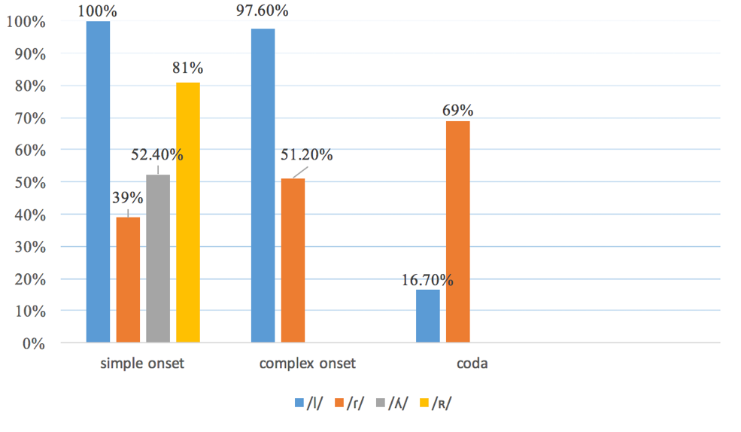

Figure 1. The accuracy rate of EP liquids produced by L1-Mandarin learners across syllable positions

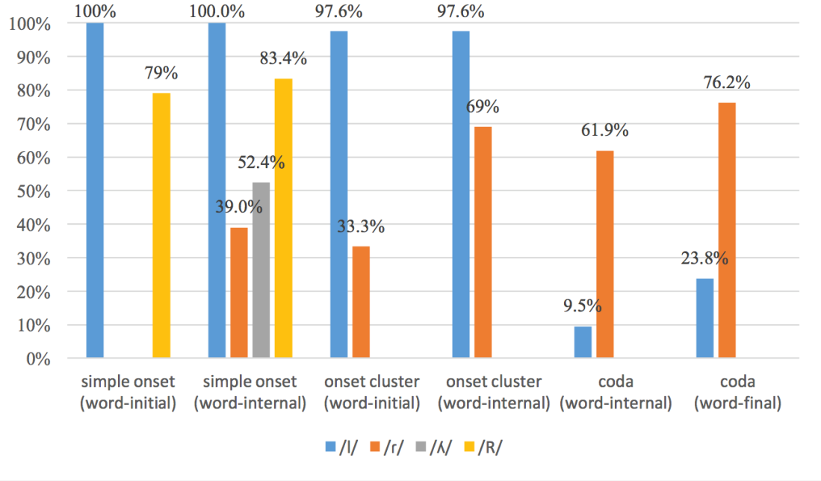

Figure 2. The accuracy rate of EP liquids produced by L1-Mandarin learners across word positions

|  |  |  |  |
| --- | --- | --- | --- |
|  | CV | CCV | CVC |
| /l/ | - | - | [w] (77.3%) deletion (6%) |
| /ʎ/ | [lj] (42.8%) [l] (4.8%) | - | - |
| /ɾ/ | [l] (61%) | [l] (48.8%) | [ɾə] (8.3%) [ɻ] (8.3%) [l] (7.2%)  deletion (3.6%) metathesis (3.6%) |
| /ʀ/ | [h] (19%) | - | - |

Table 1 – Repair strategies used by L1-Mandarin learners for target EP liquids across prosodic positions

Results demonstrated that in non-branching onset the ep /l/ was accurately produced in all cases (accuracy rate: 100%). This high accuracy can be attributed to the fact that the L1 Mandarin likewise comprises an alveolar lateral, which seems to bear no detectable difference from the ep /l/. Consequently, as predicted by slm (identical scenario), the reuse of the L1 lateral will lead to target-like L2 performance. In contrast to what was reported in Oliveira (2016), the participants in the present study did not confuse the lateral with [n] in syllable onset. This difference might be explained by the distinct dialectical profiles of the participants between two studies. The participants in Oliveira (2016) were speakers of Cantonese, in which /l/ and /n/ may be freely substituted for each other at initial position (Avery and Ehrlich 1987, Ho 1994), whereas no Cantonese speaker was recruited for the present experimental task.

A major difficulty with /l/ was detected in coda (accuracy rate: 16.7%), where learners performed substantially worse than in non-branching onset (χ2(1) = 28.349, *p*<0.0001). When failing to produce the target, learners mainly vocalised it as [w] (77.3% of the time), in line with previous studies (Batalha 1995, Martins 2008). The difference between word-medial and word-final position did not reach significance (χ2(1) = 0.043, *p*=0.8363). The velarised lateral [ɫ] seems to constitute a persistent challenge for L1-Mandarin learners since the [ɫ]-vocalization has also been attested in their L2 production of English (He 2014). Several explanations are plausible. The first one concerns cli on L2 perception (slm; Flege 1995). Guan & Kwon (2016) performed a perceptual transcription experiment testing how Russian consonants are categorized by monolingual L1-Mandarin listeners and their results showed that the velarised lateral was categorized as a /w/-like category. Accordingly, it is very likely that the ep [ɫ] is perceptually identified as /w/, presumably due to low F2 values. If this were the case, /w/ would be stored in the L2 lexicon and be retrieved consequently in production. Alternatively, the vocalisation of /l/ in coda might stem from articulatory imprecision (Honikman, 1964), since the realization of [ɫ] stipulates both a coronal and a dorsal gesture, whose coordination is entirely novel to L1-Mandarin speakers. He (2014) speculated that, before mastering this novel gestural coordination, L1-Mandarin learners might only preserve the dorsal gesture, which precedes the coronal gesture in the realization of [ɫ] (Sproat & Fujimura 1993), resulting in alveolar contact loss. It is worth noting that the perceptual and articulatory explanations are not mutually exclusive as it has been shown experimentally that the articulatory and acoustic cues, whether in combination or in isolation, are sufficient for triggering lateral-vocalisation (Recasens & Espinosa 2010). This cross-modalities force may elucidate the wide distribution of [ɫ]-vocalisation, such as in synchronic variation (e.g. Recasens & Espinosa 2005; 2010), diachronic sound change (e.g. Graham 2017), L1 phonological acquisition (e.g. Freitas 1997) and L2 speech learning (He 2014).

It comes as a surprise to us that the accuracy rate of producing /l/ reached 97.6% in branching onset, a syllable structure missing in learners’ L1 Mandarin, since prior research on L2 English suggested that L1-Mandarin learners many times accommodated the illicit branching onsets through epenthesis or deletion (Chen 2003, Enochson 2014). The lack of structural modifications in the acquisition of ep /l/ in branching onset might be due to the fact that learners produced a complex sound, rather than a canonical onset cluster. Complex sounds are structurally distinct from onset clusters as two elements in a complex sound are associated to a single skeletal position, whereas each segment of a canonical branching onset has its own projection at the skeletal level (Selkirk 1982). Therefore, realising two consecutive consonants as a complex sound is structurally less demanding and it has been argued to be a strategy employed by children before the branching onset becomes available in their phonological system (Freitas 2003). This possibility can be tested in further studies that measure the duration of the ep obstruent + /l/ clusters produced by L1-Mandarin learners across different proficiency levels. If using the complex sounds were indeed an intermediate stage in the phonological acquisition of ep, a significant difference in terms of cluster duration would be attested between beginners and advanced learners. Another plausible explanation for high accuracy of /l/ in branching onset concerns learners’ experience with another L2, English. All participants in the current study have started to learn English around age six and reported having spoken English for 14 years on average. This long-term exposure to English, where branching onsets are common, might have lead the participants to overcome the L1 structural restriction, thus facilitating the acquisition of the onset clusters of another non-native language. The positive L2 influence during the phonological acquisition of an L3 has been reported in an increasing number of studies (e.g. Tremblay 2007, Llama et al 2010).

With respect to the palatal lateral /ʎ/, the participants produced it correctly 52.4% of the time. The use of [l] for the target /ʎ/, a repair strategy observed in the literature (Batalha 1995, Martins 2008), was rather rare in the present study (merely two tokens). Instead, our prediction in Section 3 was borne out since the participants resorted to their L1 category [lj], which might stem from cli in perception or articulation. The palatal lateral [ʎ] has been shown to contain a glide-like cv (consonant to vowel) transition, a perceptual cue leading to glide-like interpretation (Colantoni 2004). The close perceptual distance between [ʎ] and [lj] thus might give rise to an equivalence between two categories during the construction of a novel sound category (similar scenario in slm), resulting in the use of /lj/ in the L2 speech. On the other hand, the articulatory imprecision might also be responsible for the use of [lj] for the target /ʎ/ (Honikman 1964), since the gestural differences between [ʎ] and [lj] are rather subtle: [lj] is higher than [ʎ] at the middle of the tongue and the tongue tip during the realization of [lj] is more anterior than that of [ʎ] (Wong 2017). Accordingly, before acquiring target-like gestural coordination, learners might still articulate the target palatal lateral in an L1-like manner. Again, the perceptual confusability and articulatory imprecision may work in tandem contributing to learners’ difficulty with the ep /ʎ/.

The ep /ɾ/ in non-branching onset was the most problematic novel structure for L1-Mandarin learners (accuracy rate: 39%). When failing to produce the target tap, the participants uniformly turned to [l], presumably due to the perceptual similarity between [ɾ] and [l] (similar scenario in slm). Although the L2 perception of the ep /ɾ/ was not tested in the current study, the perceptual confusability between [ɾ] and [l] has been attested in the acquisition of Spanish by L1-Mandarin learners (Chih 2013). Accordingly, it is plausible that the ep tap might be stored as an L1-L2 composite category (/l/-/ɾ/) in the L2 lexicon, the activation of which will lead to the alternation between [l] and [ɾ] in speech production. In the case of the intervocalic /ɾ/, the articulation-based account seems to be less probable as, articulatorily speaking, [t] is also quite close to the tap (Ladefoged & Johnston 2011), but it was not used by the participant in the present study.

/ɾ/ was produced more accurately in coda (accuracy rate: 69%) than in non-branching onset (χ2(1) = 9.87, *p*=0.002). No significant difference in terms of production accuracy was found between word-internal and word-final coda (χ2(1) = 0.01, *p*=0.92). The onset-coda asymmetry in L1-Mandarin learners’ acquisition of the ep /ɾ/ (coda > onset) is in opposition to the one usually reported in the literature (onset > coda; e.g. Colantoni & Steele 2008, Westmunson 2005), where the syllable onset was considered to be salient in terms of accessibility and learnability (Carlisle 1998). To our best knowledge, the preference for syllable coda over onset is novel to the L2 speech learning literature; however, it has been attested in the L1 phonological acquisition of Hebrew rhotic (Cohen 2015). The fact that the Hebrew rhotic displays less allophonic variation (more phoneme consistency) in coda than in onset leads Cohen to postulate that the phoneme consistency accelerates the develop of Hebrew rhotic in coda. The consistency-based explanation does not remain plausible in the case of the acquisition of the ep tap, because it manifests more allophonic variations in coda than in onset (Silva 2014). Alternatively, the higher production accuracy of the ep /ɾ/ in coda might be due to the Mandarin phonotactic restriction. As we argued in the last paragraph, the acquisition of /ɾ/ seems to be hindered by its closest L1 category /l/; nevertheless, this L1 interference is only restricted to onset because /l/ is not licensed syllable-finally in Mandarin, which only allows nasals and a retroflex approximant in coda (Lin 2007), implying that Mandarin speakers might experience less L1 interference in coda position during the acquisition of the ep tap. The impact of L1 phonotactic constraint was evidenced by the diverse repair strategies (segmental replacement, epenthesis, deletion, metathesis) for the target /ɾ/ in coda, in comparison with onset.

The participants produced more target-like [ɾ] in branching (accuracy rate: 51.2%) than in non-branching onset (accuracy rate: 39%), although this difference is not significant (χ2(1) = 0.52, *p*=0.47). The predictor “word-level position” was found to have a significant effect (χ2(1) = 4.55, *p*=0.033), indicating that the production accuracy was higher in word-medial (accuracy rate: 69%) than in word-initial branching onset (accuracy rate: 33%). Nevertheless, we attribute this word-level prosodic effect to an artefact of our experimental set-up, where the word-initial onset clusters are composed of a bilabial voiceless stop plus a tap ([pɾ]ato “dish”, [pɾ]eto “black” and [pɾ]enda “gift”), while two of the three word-internal onset clusters consist of a dental stop and a tap (es[tɾ]ada “road”, em[pɾ]esa “company” and qua[dɾ]ado “square”). In particular, we reason that the L1 interference which affects the L2 production accuracy was blocked in word-medial sequences [tɾ] and [dɾ], which are never mispronounced by the participants, due to an articulatory constraint. In particular, comparable to other syllable position (e.g. non-branching onset), L1-Mandarin learners often realised the target tap as [l] in branching onset, due to cli; however, such segmental repair in word-medial clusters would result in [dl] and [tl], which are consonantal sequences rarely attested cross-linguistically (Hallé & Best 2007) and the languages that currently allow these clusters are becoming less tolerant with them. For instance, Portuguese only has [tl] clusters in few words (e.g. a[tl]ético; Mateus & Andrade 2000) and the tendency to avoid [tl] through rhotacism (e.g. A[tɾ]ético) was observed in Brazilian Portuguese (Cristófaro-Silva 2003) and in Angolan Portuguese (Miguel 2018). Therefore, it is likely that the relatively high accuracy of [ɾ] in word-internal onset clusters is due to the fact that the L1 interference (the use of [l]) cannot be applied to sequences [dɾ] and [tɾ]. Future studies are suggested to take the articulatory constraint *[dl]/[tl] into consideration when selecting test stimuli.

The ep /ʀ/ was accurately produced 80% of the time. The predictor “word-level position” did not have a significant effect (χ2(1) = 0.65, *p*=0.42). The phonetic variants produced by the participants were quantified in Table 2, reminiscent of the production of the French /ʁ/ by L1-Mandarin learners (Steele 2002). This cross-linguistic evidence indicates that learners do not master all phonetic features simultaneously. In particular, they first target the manner feature, which is considered to be more salient, in comparison with place and voicing features (Colantoni & Steele 2008) and realize the ep /ʀ/ exclusively as a fricative. The only repair strategy attested was the production of [h], which could be explained by cli. According to the prediction in Section 3, it seems that the ep /ʀ/ was processed by Mandarin speakers as the L1 category /x/, which alternates freely between [x] and [h] (Lin 2007). On the one hand, the velar realisation overlaps with possible variant of the ep /ʀ/; on the other hand, the glottal realisation was regarded as a deviant production.

|  |  |  |  |  |
| --- | --- | --- | --- | --- |
| /ʀ/ | [χ] | [x] | [ʁ] | [h] |
|  | 43% | 28% | 10% | 19% |

Table 2. Phonetic variants of the ep /ʀ/ produced by L1-Mandarin learners

1. Conclusion

The current study contributed with new experimental data to the literature on novel liquids acquisition. Results showed that not all ep liquids are equally difficult, which is mediated by the relationship between L1 and L2 categories, as predicted by the slm. Moreover, this paper has shown that the phonological development of /l/ and /ɾ/ was conditioned by syllable position, while the word-level position does not seem to play a decisive role. We reason that the syllable position effect stems from the relationship between L1 and L2 allophonic categories, in the case of /l/ and from the L1 phonotactic restriction, regarding /ɾ/. Future research should include a larger group of L1-Mandarin learners across different proficiency levels to gain a better understanding on how L2 phonological representations develop over time. Furthermore, both perceptual and production tasks are needed in order to reveal how different speech modalities interact in the L2 speech learning.

Abbreviations

EP- European Portuguese

CLI- cross-linguistic influence

SLM - Speech Learning Model

AS - Articulatory Setting Theory

RQ – Research Question

References

1. Other perception-based L2 models, such as the Perceptual Assimilation Model-L2 (Best & Tyler 2007) and the Automatic Selection Perception Model (Strange 2011), are not revisited here because they do not make explicit assumptions on L2 production.
2. Some researchers analysed the EP uvular rhotic as an underlying /ɾ/ word-initially and /ɾɾ/ word-internally (e.g. Mateus & Andrade 2000). The debate on the nature of the EP underlying rhotic is beyond the scope of this study. However, studies on L1 phonological acquisition suggest that there seems to be two rhotics in the EP phonological inventory since the Portuguese children processed these the alveolar and the uvular rhotic differently. For instance, they tended to use a lateral ([+continuant]) for the target alveolar tap but a stop ([-continuant]) for the target uvular /ʀ/ (Amorim 2014, Costa 2010).
3. According to European Framework for language assessment (Common European Framework of Reference, a definition of different language levels written by the Council of Europe), Level A corresponds to low proficiency, level B, intermediate proficiency and level C, advanced proficiency.