Integration of the negative existential into the standard negation system:
The case of Nanaic languages
Sofia Oskolskaya (Institute for Linguistic Studies, RAS), Natalia Stoynova (Russian Language Institute, RAS & NRU Higher School of Economics)
Abstract: The paper deals with the use of negative existentials in the system of standard negation in different Nanaic varieties (a sub-group of Tungusic languages). Three different types of integration of negative existentials into standard negation constructions are discussed: 1) “converb + negative existential”; 2) “present/past indicative finite verb + negative existential”; 3) a series of constructions in which the negative existential functions as a pleonastic negative marker. While the first construction is attested in almost all Nanaic varieties, the others are less widespread. For each construction under discussion we propose a possible grammaticalization path. All the constructions refer to stage B>C in Croft’s cycle. We argue that in some aspects the first construction goes beyond Croft’s cycle.
Keywords: negative existentials, standard negation, Tungusic languages, Nanai, Ulch, grammaticalization.

1. Introduction
The paper deals with the use of negative existentials in the system of standard negation in different “Nanaic” varieties, a sub-group within the Tungusic family, including Nanai and some other closely related varieties (see Map 1).
According to Veselinova (2013: 107), negative existentials (NegEx) are special markers used in negative existential predications like “There are no mice in the basement,” while standard negation (SN) is a negation of declarative sentences with an overt verb predicate (see Miestamo 2005: 39–45).
In Nanaic, the negative existential can function as an element of some standard negation constructions. These standard negation constructions vary across Nanaic languages. The most widespread one is a past tense construction, illustrated in (1):
- Naikhin Nanai
n’oani naj sori-i-wa-ni xāli=dā ičə-m=də̄ aba-ni
3sg human fight-prs-acc-3sg when=emph see-cvb.sim.sg neg.ex-3sg
‘He has never seen people fighting.’ (Avrorin 1986: 154, text)
As shown in (1), it consists of the simultaneous converb of the lexical verb (ičə-m ‘seeing’) and the negative existential (aba). An optional element of the construction is the particle =dA. It has an emphatic meaning in its proper use (see Avrorin 1961: 264), but within the SN-construction the import of its meaning seems to be lessened.
This construction is attested in most Nanaic varieties, and it reveals notable differences in different varieties. Its possible diachronic development seems to be non-trivial. We include some comparative data on this construction, which can shed light on its grammaticalization from the NegEx-construction.
In some of the Nanaic varieties, other SN-constructions with negative existentials are also attested. These cases basically agree with the expected cross-linguistic patterns of NegEx-evolution.
The paper is organized as follows. Section 2 gives some background information on the Nanaic sub-group. In Section 3, we present the data and methodology of the study. Section 4 describes the standard negation systems and negative existentials attested in Nanaic languages. In Section 5, we provide analysis of the most widespread SN-construction with the negative existential (see example 1), based on the comparative data of different Nanaic varieties. In Section 6, we discuss other, less frequent constructions. Finally, Section 7 contains a brief summary.

2. Nanaic varieties within the Tungusic family
According to the classification of Tungusic languages in Doerfer (1978), they form a Central-Western Tungusic subgroup comprising Nanai (iso-code gld), Ulch (iso-code ulc), Orok (iso-code oaa) and Hezhe (also known as Kili, glottocode kile1243). It constitutes the Central Tungusic group together with the Central-Eastern Tungusic languages: Oroch (iso-code oac) and Udihe (iso-code ude).
The general name “Nanaic languages” in a broad sense includes Nanai, Ulch, Orok and, in some classifications, also Hezhe. These varieties are spoken in the Russian Far East and in the North East of China. In the paper, we discuss the Amur Nanai dialects: Naikhin and Dzhuen (the Middle Amur sub-group), Sikachi-Aljan (the Upper Amur sub-group), Gorin (the Lower Amur sub-group), Bikin Nanai and Kur-Urmi (which are also sometimes attributed as Nanai dialects), and the Hezhe and Ulch languages (see Map 1).
Hezhe and Bikin Nanai are nearly extinct, while Amur Nanai dialects as well as Kur-Urmi are endangered; furthermore, Ulch is severely endangered. See Gerasimova (2002), Sumbatova and Gusev (2016), and Kalinina and Oskolskaya (2016) on the current sociolinguistic situation.
Besides the Central Tungusic languages there are the Manchu-Jurchen and Northern branches (see Map 2). The Manchu-Jurchen branch comprises Jurchen (iso-code juc), Manchu (iso-code mnc) and Xibe (iso-code sjo). The Northern branch comprises Even (iso-code eve), Evenki (iso-code evn), Negidal (iso-code neg) and Oroqen (iso-code orh). Data of the Manchu-Jurchen and Northern branches are not discussed in the paper.

3. Data and methodology
Our data come from different sources. The information on Hezhe, Bikin Nanai and Kur-Urmi is taken from grammar descriptions and published texts (Zhang et al. (1989) and Zhang (2013) for Hezhe, Petrova (1967) and Tsumagari (2009) for Orok, Sem (1976) for Bikin Nanai, and Sunik (1958) for Kur-Urmi). The data on Naikhin, Sikachi-Aljan, Dzhuen and Gorin dialects, as well as the Ulch data, were collected during our fieldtrips to the Russian Far East in 2015–2017. Some information was received through elicitation tasks of several types: 1) We asked speakers to translate Russian negative sentences into their native languages (Nanai or Ulch). 2) Then we asked them to judge some sentences in their own language, which we constructed ourselves, using the negative form we were interested in. 3) We also asked speakers to estimate negative forms derived from various verbal lexemes, to give a pair of sentences with the negative form and to explain their meanings.
- Examples of the elicitation tasks:
a. Researcher (in Russian): How do you say “He didn’t write a letter”?
Speaker (in Naikhin Nanai): N’oani bičxə-wə əčiə niru-ə-ni.
3sg letter-acc neg.pst write-conneg-3sg
b. Researcher: Is it a correct Nanai sentence: N’oani bičxə-wə niru-mi aba.
3sg letter-acc write-cvb.sim.sg neg.ex
Speaker (in Russian): Yes, you can say it this way.
c. Researcher: Is it a correct Nanai expression: niru-m=də aba?
write-cvb.sim.sg=emph neg.ex
Speaker: Yes, it is.
Researcher: Could you give an example with this expression? What does it mean?
Speaker: N’oani bičxə-wə niru-m=də aba.
3sg letter-acc write-cvb.sim.sg=emph neg.ex
Speaker: It means ‘He didn’t write a letter at all.’
Some parts of our research were based on the Nanai and Ulch text collections, consisting of our own field records (different Amur dialects, Ulch), Ulch texts collected by V. Gusev, S. Toldova, E. Kalinina and N. Sumbatova in 2007–2010 in Ulchsky District (Khabarovsk Krai, Russia), and Nanai and Ulch published texts from Avrorin (1986) and Sunik (1985).

4. Standard and existential negation in Nanaic

4.1 Standard negators
The majority of modern negative forms and analytic constructions attested in Nanaic varieties go back to a construction with the dedicated negative verb *ə- and the non-finite form of the lexical verb, marked with the connegative suffix -(r)A. Within the Nanaic subgroup, this construction is attested in its initial form only in Orok (3).
- Orok
a. tari nari e-si-ni ŋennee
that man neg.aux-prs-3sg go.conneg
‘He doesn’t go.’ (Tsumagari 2009: 13)
b. tari nari ec-ci-ni ŋennee
that man neg.aux-pst-3sg go.conneg
‘He didn’t go.’ (Tsumagari 2009: 13)
In (3), the negative verb *ə- takes the finite form (with reference to the present in (3a) and the past in (3b)), marked with person-number inflection, and the lexical verb ‘to go’ takes the uninflected connegative form.
In all other varieties the negative verb *ə- has undergone a further development. Different frozen TAM-forms of *ə- have been grammaticalized to a range of negative particles. Synthetic negative verb forms attested in Nanaic also go back to the analytic construction with *ə-.
The resulting inventories of standard negators in Nanaic languages are quite rich and heterogeneous. In this Section, we focus on the present and past tense negative paradigm, since the constructions with NegEx, which are discussed in detail in the paper, belong exactly to these domains. The data on the main past tense negators, except those containing negative existentials, are summarized in Table 1. The constructions with EN markers are discussed separately in Section 5.
The first negative construction with reference to the past contains the special past negative particle əčiə and the connegative form of the lexical verb. The particle əčiə goes back to the past tense form of the negative verb *ə-; cf. (4) from Naikhin Nanai:
- Naikhin Nanai
əǯi agǯa-o-so, əčiə bu-də-ni=əmdə
proh believe-imp.2pl neg.pst.cop die-conneg-3sg=quot
‘Don’t believe him, he has not died.’ (text, Naikhin, our field data)
Unlike in (3b) from Orok, in (4) the former past tense form of the negative verb is frozen; it does not take person-number markers, they (optionally) attach to the connegative form of the lexical verb.
The second past tense form is synthetic. Here, the connegative and the past tense form of the negative verb constitute synchronically a single verb form; cf. (5):
- Kur-Urmi
…kera-du-i bəjə bi-wə-n=xəj sa-o-rā-čin…
edge-dat-1sg person be.prs-acc-3sg=what know-imps-conneg-pst
‘It was unknown that there are people who live nearby.’ (Sunik 1958: 145, text)
A structurally similar synthetic form is used with reference to the present (6). It goes back to the combination of the connegative and the present tense form of the negative verb.
- Ulch
uj=də tị-wa sā-ra-sị
who=emph this-acc know-conneg-neg.prs
‘Nobody knows it.’ (text, Bulava, our field data)
Table 1. Inventory of standard negators in Nanaic languages
 | Naikhin Nanai | Gorin Nanai | Bikin Nanai | Sikachi-Aljan | Kur-Urmi | Hezhe | Ulch | Orok
PRESENT
synthetic form  e.g., sā-ra-sị  know-conneg-neg.prs | yes | yes | yes | yes | yes | yes | yes | no
negative verb + V-CONNEG  e.g., e-si-ni ŋennee  neg.aux-prs-3sg go.conneg | no | no | no | no | no | no | no | yes
PAST
əčiə(l) V-CONNEG  e.g., əčiə bu-də-ni  neg.pst.cop die-conneg-3sg | yes | yes (‘not yet’) | no | marginal | yes | no | (‘not yet’) | no
synthetic form  e.g., sa-o-rā-čin  know-imps-conneg-pst | yes | yes | yes | no | yes | yes | no | no
negative verb + V-CONNEG  e.g., ec-ci-ni ŋennee  neg.aux-pst-3sg go.conneg | no | no | no | no | no | no | no | yes

Outside the present and past paradigms, some other negative forms and constructions are used. Most of these also contain elements that go back to the former negative verb. For instance, in Amur Nanai varieties, there is the negative particle əm. It is the negative verb, frozen in a form of its simultaneous converb. In modern Amur Nanai, it is used as a component of analytic negative non-indicative forms with the auxiliaries ta- ‘do’ and bi- ‘be’:
- Naikhin Nanai
mī əm ənə-rə bi-mčə-i
1sg neg go-conneg be-sbjv-1sg
‘I would not go.’ (elicitation)

4.2 Negative existentials
The most widespread negative existential in Nanaic varieties is aba (the majority of Amur varieties, Bikin Nanai, Kur-Urmi). Other negators are attested in Ulch (kəwə), Gorin Nanai (kəukə) and Hezhe (anči); see Table 1. Kəukə and kəwə are cognates, while aba, anči and kəukə (kəwə) are not related to each other. All these negators have very similar behavior in NegEx-functions in all the varieties.
Table 2. Negative existentials in Nanaic varieties
 | NegEx-marker | use in SN-constructions
Amur Nanai (except Gorin), Bikin Nanai, Kur-Urmi | aba | yes
Gorin Nanai | kəukə | no
Ulch | kəwə | yes
Orok | ana | no
Hezhe | anči | ?

The range of their uses is wider than the existential proper; however, it basically agrees with cross-linguistic generalizations on negative existentials. Table 3 illustrates the list of functions of aba in Naikhin Nanai. The list is based on the cross-linguistic study on negative existentials by Veselinova (2013). The further description in this section is also based on the Naikhin data. In the other varieties under discussion, the picture is similar. In Ulch and Gorin Nanai, in which the word aba is absent (see Table 2), the word kəwə~kəukə has the same range of uses and the same structural properties, as aba. We do not have enough information about the use of negative existentials in Orok and Hezhe.
Table 3. Functions of aba in Naikhin Nanai: A typological profile (based on Veselinova 2013: 118–119)
function name | short description | aba
neg.ex | Negation of existence | yes
neg.loc | Negation of location | yes
neg.poss | Negation of possession | yes
no | The negative existential is also used as a short answer ‘no’ | yes
pro-sentence | The word used has the same propositional content as the preceding proposition (V or not?) | ?yes
disappear | The negative existential is related to ‘disappear’ | (yes), abana- ‘to disappear’ – the derivate from aba
absent, away, gone | The negative existential is also used with any of these senses | no
lack | The negative existential also has the sense ‘lack’ | no
dead | The negative existential also has the sense ‘dead’ | no
destroy | The negative existential also has the sense ‘destroy’ | no
nothing | The negative existential also has the sense ‘nothing’ | no
none | The negative existential is also a negative indefinite pronoun | no
without | Use of the negative existential as a pre-/postposition meaning ‘without’ or as a privative marker | no
neg.emphatic | The use of the negative existential produces an emphatic statement | no
not_noun | Use of negative existentials as a negator for nominal constituents | no
not_be | The negative existential is a general negative copula | ? (negative existentials can function as a negative copula among other items)
co-occurs with ‘be’ restricted | The negative existential may be used to negate the copula verb | no
+ classification | There are different negative existentials depending on the semantic properties of the noun phrase: animate, human, age | no

Structurally, aba is an item of a mixed nature. In many ways it behaves as a morphologically reduced noun. The syntactic structure of the NegEx-construction is similar to the structure of the possessive noun phrase. Aba occupies the position after the subject-noun and agrees with it in person and number, as well as the head-noun referring to a possessee; cf.:
- Naikhin Nanai
mədur-səl aba-či ≈ mədur-səl xasar-či
dragon-pl neg.ex-3pl ≈ dragon-pl wing-3pl
‘Dragons do not exist’ (lit. ‘the absence of dragons’) ≈ ‘wings of dragons’ (elicitation)
In NegEx contexts, aba takes person-number markers according to the person-number of the subject of non-existence in most of the varieties. The person-number marker is optional for the 3sg context. See Oskolskaya & Stoynova (2015) for more detail on aba in Amur Nanai dialects.

5. The construction CVB.SIM + NegEx in different Nanaic varieties
In this section, we discuss in detail a past tense standard negation construction, consisting of the negative existential and a converbial form of the lexical verb. This SN-construction with NegEx is the most widespread in Nanaic varieties. For each particular variety (Sections 5.1–5.4), we give information on its status within the past negative paradigm and on its competition with other past negators. We also describe some formal properties of this construction with a special focus on the degree of its formal cohesion: the presence/absence of the person/number inflection on the NegEx, the number marking of the converb, and the presence/absence of the emphatic particle. In Section 5.5 we compare the data from different Nanaic varieties and formulate a hypothesis on the evolution path of the construction under investigation.

5.1 Naikhin Nanai (the Middle Amur sub-group of dialects)
In the Naikhin dialect of Nanai, the default way to express standard negation with a reference to the past is the past negative particle əčiə together with a verbal form with the connegative suffix -(r)A; see example (4). The standard negation construction with the negative existential aba, which is of interest in this section, is also attested (see example 1). In Avrorin’s grammar of “Standard Nanai” (based mostly on the Naikhin variety), it is mentioned briefly as one of very marginal past tense negative constructions (1961: 108).
Our consultants allowed its use in special contexts such as an emphatic one: ‘he did not do it at all.’ However, there are no examples of CVB.SIM + NegEx construction in our texts collected since 2007. In the texts collected by Beljdy and Bulgakova (2012) in 1980–2006, only one occurrence is attested. In the texts collected by Avrorin (1986) in the middle of the 20th century, we found few occurrences (13 uses).
Generally, a reduced form of the converb (-m) is used in all the sources. Sometimes it is palatalized as -m'. The allomorph -mi occasionally occurs as well. The suffix -m/-m'/-mi is used irrespective of number, which is not typical for the use of the simultaneous converb in its main function (i.e., as the head of a dependent clause). Thus, one can assume that this converb has been grammaticalized to a special unchangeable form which is specific for this negative construction. However, the plural converb form with -mAri (or reduced -mAr) is still allowed by some speakers in the case of the plural subject; cf. (9):
- Naikhin Nanai
buə ǯobo-mar(i)(=da) aba-(pu)
1pl work-cvb.sim.pl=emph neg.ex-1pl
‘We didn’t work.’ (elicitation)
In the texts, all 13 examples refer to a singular subject and have the -m/-mi converb form. Among them, only one example has a full form with -mi.
The particle =dA is optional. However, most of the examples attested in texts (except for two) contain this particle. Interestingly, modern speakers of Naikhin Nanai, which do not use the construction actively, interpret the particle =dA during elicitation as a proper emphatic particle rather than as a neutral part of the construction as it is in other Nanaic varieties where this construction is common (e.g., in Sikachi-Aljan dialect):
- Naikhin Nanai
n’oani soŋgo-m=da aba
3sg cry-cvb.sim.sg=emph neg.ex
‘She didn’t cry at all!’ (elicitation)
The negation marker aba can agree with the subject in person and number. But this agreement is optional (see example (10), in which the 3sg marker -ni is omitted): in the texts, person-number affixes are omitted in all three attested examples with 1st and 2nd person subject and in two examples (out of ten) with 3rd person subject.
In the data elicited from modern speakers, it is quite difficult to determine factors that influence the choice of the CVB.SIM + NegEx construction instead of the əčiə-construction, which is a more common negator. In his grammar Avrorin (1961: 108) postulates “a slight modal component” in the semantics of the CVB.SIM + NegEx construction. Avrorin’s text data give the impression that the construction in question is (or was) likely to be used in perfect contexts (e.g., in the experiential meaning (11) or in the case when the result of a negated action is still important for the point under consideration (12)). Note that there is no affirmative perfect form and no other dedicated negative perfect form in Naikhin Nanai.
- Naikhin Nanai
n’oani naj sore-e-wa-ni xāle=dā ičə-m=də̄ aba-ni
3sg person fight-prs-acc-3sg when=emph see-cvb.sim.sg=emph neg.ex-3sg
‘He has never seen fighting people before (lit. he is absent while seeing fighting people)’ (Avrorin 1986: 154, text)
- Naikhin Nanai
əǯi-ni sənə-m=də̄ aba
husband-3sg wake.up-cvb.sim.sg=emph neg.ex
‘Her husband hasn’t woken up (lit. her husband is absent while waking up)’ (Avrorin 1986: 209, text)
The verbs, attested in texts in a CVB.SIM + NegEx construction, are states, as in (11), atelic processes, and achievements, as in (12), which is important for further discussion (see Section 5.5).
Therefore, it seems that initially the əčiə-construction and the CVB.SIM + NegEx construction were distributed as the most common negator with a past tense reference (the əčiə-construction) and a special perfect negator (the CVB.SIM + NegEx construction). Nowadays, Nanai speakers gradually shift into Russian. In this sociolinguistic situation, the more marginal CVB.SIM + NegEx construction is used rather scarcely. If CVB.SIM + NegEx is a perfect negator, then the small number of its uses in Avrorin’s texts (collected before the language shift) is not surprising either: these are narratives, mostly legends and folktales, in which perfect contexts are very rare.

5.2 Sikachi-Aljan Nanai (the Upper Amur sub-group of dialects)
In the Sikachi-Aljan dialect of Nanai (at least in the data from one speaker who was asked), the construction cvb.sim + ne is a neutral means of past negation. An alternative construction with əčiə (cf. Naikhin Nanai) is accepted in elicitation tasks, but it is not used in practice.
Our data on Sikachi-Aljan are very poor and come mostly from elicitation received from one speaker. According to these data, the construction cvb.sim + ne basically has the same morphosyntactic features as in Naikhin Nanai: 1) the non-palatalized reduced singular converb suffix -m is the preferred one, but other variants (plural -mAr, palatalized -m’/-mAr’, full markers -mi/-mAri) are also accepted, 2) the emphatic particle =dA as well as person-number markers on aba can be omitted but usually they are not; cf. the only available text example:
- Sikachi-Aljan Nanai
golǯon=də ewača-mar=da aba,
stove=emph fire-cvb.sim.pl=emph neg.ex
sea-goj=da xaj=də ul’si-mar=da aba
eat-cvb.purp-refl.sg=emph what=emph boil-cvb.sim.pl=emph neg.ex
‘{There is nobody at home}, (the sister) has not fired the stove, she has not cooked dinner.’ (text, Sikachi-Aljan, our field data)

5.3 Kur-Urmi
Our data for Kur-Urmi come from a short grammatical sketch and seven texts published in Sunik (1958). Although these data are obviously not enough to get a complete picture of the use of aba, it is possible to make some observations.
The construction CVB.SIM + NegEx is one of the basic past tense standard negators in Kur-Urmi:
- Kur-Urmi
ē-wa=da wā-m=da aba-ni
what-acc=emph kill-cvb.sim.sg=emph neg.ex-3sg
‘He didn’t catch anything.’ (Sunik 1958: 134, text)
Alternative means of past negation include a synthetic past tense form (see example (5)) and the analytic construction with the negative particle əčə, like the construction in example (4).
There are also other past tense negative constructions with aba similar to the construction in question but with the present/past indicative form instead of the mi-converb. They will be discussed in Section 6.3.
In the texts (Sunik 1958, ca. 9700 words), 20 uses of SN-markers with a reference to the past were found in total. According to these preliminary data, the construction CVB.SIM + NegEx seems to be the main past tense negative form: it occurs eight times with a diverse range of verbs (wā- ‘to kill,’ ičə- ‘to see,’ mədələ- ‘to match a bride,’ nōdače- ‘to spread out,’ xarxe- ‘to twist,’ mora- ‘to cry,’ m’ækora- ‘to bow’). The synthetic negative form occurred six times; however, four of them are passives of two particular verbs: sa- ‘know’ and ičə- ‘see’ (cf. example (5) above). The construction with the indicative past tense form + aba was attested four times (also one use with the present tense form was found). No text examples of the analytic construction with əčə mentioned by O. P. Sunik in the grammatical sketch are attested in texts. See Table 4.
Table 4. Kur-Urmi: SN-constructions with reference to the past in the texts (Sunik 1958)
 | N of uses
CVB.SIM + NegEx | 8
PST + NegEx | 5
synthetic negative form | 6 (restricted to two verbs)
əčə-construction | n/a

The construction in question has the same structure as in Amur Nanai: it consists of the simultaneous converb, the particle =dA and the negative existential aba. The simultaneous converb on the whole may have different suffixes for singular and plural subjects: -mi and -mAri. However, as Sunik points out, the suffix -mi often occurs with plural subjects also (Sunik 1958: 94). For the past negative construction, Sunik gives the reduced converb suffix -m for all forms irrespective of number (cf. təːči-m=də aba-su sit-cvb.sim.sg=emph neg.ex-2pl ‘you didn’t sit’). All the text examples have singular subjects. So, we do not know whether the plural form -mAr(i) can be used in this construction in Kur-Urmi.
In seven text examples (out of eight), the reduced form of the converb -m and the emphatic particle =dA are attested. The only one example with the full suffix form -mi does not contain =dA:
- Kur-Urmi
mədələ-mi aba-i
ask.in.marriage-cvb.sim.sg neg.ex-1sg
‘I didn’t ask (her) in marriage.’ (Sunik 1958: 127, text)
The person-number marking of the negative existential is optional; it is attested in seven out of eight examples. One occurrence refers to the 1sg subject (example (15)). All the other occurrences, including the one without a person marking, refer to 3sg subjects.

5.4 Ulch
In Ulch, the negative existential marker is kəwə. The standard negation construction under consideration is V-m(i)~mər(i)(=də) kəwə-(PERS):
- Ulch
tatočị-xa, tara ịkzamịn-tị ŋənə-m=də kəwə-ni
study-pst then exam-dir go-cvb.sim.sg=emph neg.ex-3sg
‘She studied, but she did not go to pass the exam.’ (text, Bulava, our field data)
This construction is used as the most common past tense negator in a wide range of contexts, while other constructions expressing standard negation with reference to the past are quite numerous but much less frequent; cf. Table 5:
Table 5. Ulch: the inventory of past tense negators (frequency in texts)
negator | N of uses (%) | semantic nuances
CVB.SIM(=də) kəwə | 86 (78%) | neutral
əčəl V-NEG | 10 (9%) | ‘not yet’
V-PST kəwə | 6 (5%) | emphatic
əŋdə V-NEG | 5 (5%) | emphatic
other markers | 3 (3%)
total amount | 110 (100%)

The emphatic particle =dA is optional. In our text sample, it is attested in 55% of uses (47 uses).
The negative existential kəwə in SN-construction optionally takes person-number markers. In the grammatical sketch by Petrova (1936: 65), the following distribution is outlined: the person-number marker is used for 1st and 2nd person, and it is not used for 3rd person. Data from contemporary texts, presented in Table 6, show the following picture: a) the person-number marker is optional for all persons and numbers, b) it is more probable for 1st (or non-3rd) person contexts, and c) it is less probable for 3sg contexts.
Table 6. Ulch: Person-number markers on kəwə in SN-construction
 | kəwə-PERS.NUM | kəwə | 2-tailed exact Fisher test
1SG | 16 | 9 | 1st person vs. 3rd person: significant, p=0.0066
1PL | 6 | 0 | 1st person vs. 3rd person: significant, p=0.0066
3PL | 7 | 8
3SG | 14 | 26 | 3sg vs. other: significant, p=0.0169

In the majority of uses, the form of the converb is reduced (-m, -mAr, not -mi, mAri), but this is a general feature of Ulch converbs.
The converb tends to be used in the singular form (-m) both in singular and plural contexts. However, uses of the plural form (-mər) are also attested (in plural contexts). The choice of the plural versus the singular form of the converb in plural contexts correlates with the presence versus absence of the plural number marker on kəwə. Table 7 shows the text data for uses with reference to the plural subject (the correlation is statistically significant, two-tailed exact Fisher-test, p=0.0139):
Table 7. Ulch: CVB.SIM + NegEx with plural subjects: The singular vs. plural form of the converb
 | CVB.PL (-mAr) | CVB.SG (-m)
kəwə unmarked | 5 | 3
kəwə-PERS.NUM | 1 | 12

Therefore, the plurality of the subject tends to be marked in the construction only once, either on the converb or on the negative existential, but not on both components.

5.5 CVB.SIM + NegEx past tense negative construction and its grammaticalization across Nanaic varieties
A summary on formal features of CVB.SIM + NegEx in different Nanaic varieties is given in Table 8.
Table 8. CVB.SIM + NegEx past tense negative construction across Nanaic varieties
 | Kur-Urmi | Sikachi-Aljan | Naikhin | Ulch
CVB.SIM + NegEx | one of the preferred past tense negators | preferred past tense negator | rare, mostly in perfect contexts | preferred past tense negator
past tense negators in competition with CVB.SIM + NegEx | əčə V-CONNEG, V-PST NegEx, synthetic form | (əčiə V-CONNEG) | əčiə V-CONNEG, synthetic form | əčəl V-CONNEG, V-PST NegEx, əŋdə V-CONNEG
negative existential | aba | aba | aba | kəwə
use of plural converb suffix -mAr(i) | not attested, the paradigm is given with singular -mi | allowed, but singular -mi occurs more often | allowed, but singular -mi occurs more often | allowed, but singular -mi occurs more often
use of emphatic particle =dA | optional, =dA is omitted rarely | optional, =dA is omitted rarely | optional, =dA is omitted rarely | optional, =dA is omitted in half of the occurrences
person-number marking of negative existential | optional, omitted rarely | optional, omitted rarely | optional, omitted rarely | optional, rarely omitted for 1st person subjects, preferably omitted for 3sg subjects

We can make the following observations on the basis of these comparative data:
1) The CVB.SIM + NegEx construction has a different status within the sn-system in different varieties. In some of them, it is the neutral preferred one; in others it is rare and tends to be used in specific contexts. Our synchronic data seem to reflect different stages of the diachronic process of the integration of ne into the SN-system:
- degree of integration into sn system (low ←→ high)
(Gorin, Dzhuen, Hezhe) – Naikhin – Kur-Urmi – Sikachi-Aljan, Ulch
2) An overt person-number marking of NegEx is attested in all varieties under consideration, though it is optional. Thus, the NegEx retains its morphosyntactic status, being used as part of the SN-construction, and it does not change into a frozen item. The most regular rules of omission are attested in Ulch, where CVB.SIM + NegEx is a default past tense negator (i.e., where it is the most integrated into the sn-system).
3) The emphatic particle =dA can be estimated to be a full part of the construction for all varieties, except for Ulch. Maybe this is one of the factors that enable its full grammaticalization into a default past tense negator in Ulch. In all the other varieties, an additional step is expected to take place for the complete grammaticalization process, namely, the desemantization of =dA (or otherwise the loss of this particle in the negative construction).
4) The converb tends to be used in the frozen singular form in spite of the subject number in all varieties in question. It is evidence of some degree of grammaticalization.
We can propose the following considerations on the grammaticalization path of the CVB.SIM + NegEx construction. On one hand, these data can be analyzed in terms of the so-called Croft’s cycle. Croft (1991) proposed a cyclical model of the evolution of standard negation markers from negative existentials, based on synchronic cross-linguistic data. This cycle comprises three stages, which are presented in Table 9:
Table 9. Negative-existential cycle (Croft 1991)
 | existential negative predication | standard negative predication
type A | SN marker | SN marker
type B | negative existential | SN marker
type C | negative existential | negative existential

These types are not equally frequent in the languages of the world: according to Veselinova (2016: 147), type C is poorly represented in comparison to types A and B. Moreover, a lot of languages display stages with variation of types A > B, B > C and C > A, and stages with variation can be diachronically stable (see Veselinova 2016: 158).
The Nanaic data display a transition from type B to type C. Similar cases are described by Croft as a “gradual substitution … in only part of the verbal grammatical system” (1991: 10) (here the past tense form). However, our data do not make it clear whether this construction has really substituted a past standard negation construction or if it functions in a different way and takes a special place in the negation system, which has nothing in common with a potential process of substitution.
A possible hypothesis is that this construction emerges as a counterpart to an affirmative imperfective construction with the verb bi- ‘to be,’ attested in the majority of Nanaic varieties; cf.:
- Naikhin Nanai
xon’=da nūči-du-i xupi-məri bi-či-pu
how=emph little-dat-refl.sg play-cvb.sim.pl be-pst-1pl
‘We used to play when we were young.’ (elicitation)
The parallel between these two constructions is evident:
- the symmetry of literal readings:
‘to be V-ing’ ~ ‘to be absent V-ing’
- structural symmetry:
CVB.SIM bi- ‘X exists while V-ing’
CVB.SIM(=dA) aba ‘X does not exist while V-ing’
However, they can be considered as real counterparts only at some previous stage of grammaticalization, not on a synchronic level. The first difference between the affirmative construction and the negative one is aspectual. The function of the affirmative construction CVB.SIM bi- is imperfective: it marks habitual or progressive events (18). The negative construction CVB.SIM(=dA) aba, in contrast to the affirmative one, has no special imperfective semantic nuances in any of the Nanaic varieties (see the discussion and examples in Sections 5.1–5.4). It can refer to both perfective and imperfective events.
One more difference is that the negative construction is restricted to a single TAM-form, while the affirmative one can be used in various tense and mood forms (in the past and present tense forms, in the imperative, etc.).
Moreover, the only negative form, CVB.SIM(=dA) aba, which refers to the past, is structurally equivalent with the affirmative present tense form, not the past tense one, as expected. In the affirmative construction, TAM is consistently expressed by the corresponding form of the existential verb bi- ‘be’. The negative existential aba- in the negative past tense construction CVB.SIM(=dA) aba formally corresponds to the present tense form bii-, not to the past tense form biči- (20). If the negative construction were parallel with the affirmative one, one would expect the present tense form of NegEx (aba) not in past contexts, but in present ones (a)–(b), and in past contexts, the past tense form of the NegEx (aba biči-) would be expected (c)–(d). The last form is not really attested in the construction at all.
- Naikhin Nanai
a. xupi-mər=də aba-pu
play-cvb.sim.pl=emph neg.ex-1pl ~
‘we did not play’ (expected: *‘we are not playing’)
- xupi-məri bi-i-pu
play-cvb.sim.pl be-prs-1pl
‘we are playing / we play regularly’ (elicitation)
c. *xupi-mər=də aba bi-či-pu
play-cvb.sim.pl=emph neg.ex be-pst-1pl
expected: *‘we were not playing’
d. xupi-məri bi-či-pu
play-cvb.sim.pl be-pst-1pl
‘we were playing / we played regularly’ (elicitation)
The asymmetry between the affirmative construction and the negative one is shown schematically in Table 10.
Table 10. The negative CVB.SIM + NegEx vs. the affirmative CVB.SIM + ‘be’
 | affirm | neg
‘present’ | CVB.SIM be-PRS | —
‘past’ | CVB.SIM be-PST | CVB.SIM NegEx-PRS

So, for the negative construction we have to postulate the reinterpretation from present to past. The possible way of such a semantic shift is via perfect contexts, which are intermediate between present ones and past ones. The most affected verb classes are probably states and atelic processes with the reading ‘entry to state / process’ in the past tense form. While used in the perfect context, the past tense form of such a verb has a meaning which is pragmatically very close to that of the present tense form (‘he has seen’ ≈ ‘he can see now,’ ‘he has cried out’ ≈ ‘he is crying now’). The same is true under negation (‘he has not seen’ ≈ ‘he cannot see now,’ ‘he has not cried out’ ≈ ‘he is not crying now’). This provides an opportunity for a semantic shift of the CVB.SIM + NegEx construction. Hypothetically, at first, through the implication, the present tense ‘he cannot see, he is not crying now’ undergoes reinterpretation as a past tense form in the perfect context: ‘he has not seen, he has not cried out’; here it is being generalized to all past tense contexts. Another verb class that probably triggers the shift from the present tense to past tense readings is that of achievements. The momentary event cannot have a proper progressive reading in the present tense. While affirmatives are likely to take the prospective reading in this case (‘he wake.up.prs’ > ‘he is about to wake up’), the perfect reading is a more natural option for negatives (‘he wake.up.neg.prs’ > ‘he has not waken up’); cf. the reconstruction of the shift for the verb ‘to see,’ as in (11) above, and for the verb ‘to wake up,’ as in (12).
- ‘he cannot see now’ > ‘he has not seen’ > ‘he did not see’
#‘he is not waking up’ > ‘he has not waken up’ > ‘he did not wake up’
The predisposition to perfect contexts and the range of verbs attested in Naikhin Nanai, in which the CVB.SIM + NegEx construction has the most restricted usage, supports the idea of such a shift. For more detail on the hypothesis, see Oskolskaya & Stoynova (2017).
If it is true and the CVB.SIM + NegEx construction emerges as a counterpart to some affirmative construction and subsequently loses connection with it, then it differs from examples of the B>C type, described in Croft (1991). In accordance with the logic of Croft’s cycle, it does not fulfill any gap in the SN-system, because it does not substitute an existing part of the negation system; see the discussion of similar cases attested in some Slavic and Polynesian languages in Veselinova (2014; 2016).

6. Other SN-constructions with negative existentials

6.1 Bikin Nanai
The picture attested in Bikin Nanai differs radically from the picture described in Section 5 for the other Nanaic varieties. The past tense construction CVB.SIM + NegEx is completely absent in this variety. However, the negative existential aba is involved in the SN-domain even more than in other varieties.
The data on this nearly extinct dialect are very restricted; the short description below follows the sketch (Sem 1976) and reflects the data of a couple of texts from the same book.
The negative existential aba is used in Bikin Nanai as a pleonastic element with all verbal negation forms, except prohibitives, as shown in (23):
- Bikin Nanai
xuə=də ab čik-si
plank.bed=emph neg.ex fit-prs.neg
‘(He) does not fit in the plank-bed!’ (Sem 1976, text 2)
In sn-constructions, aba behaves as a frozen form (i.e., as a particle): a) it takes no inflection markers, and b) it induces no morphological/syntactic changes in the initial negation construction. In sn-use, it can have a reduced form ab, as in (23) above.
According to Sem (1976), aba is optional with synthetic negation forms (such as in (23)), and it is an obligatory part of analytic forms with auxiliaries bi- ‘be’ (24) and oda- ‘do, become’ (25). However, both in synthetic forms and in analytic ones, aba is not the only negator, but a pleonastic one; cf. the same affix PRS.NEG in (24) and (25).
- Bikin Nanai
Bi abā ənə-ə-si bi-mcə-i
1sg neg.ex go-conneg-neg.prs be-sbjv-1sg
‘I would not go.’ (Sem1976: 76)
- Bikin Nanai
āba ənə-ə-s’i oda-ǯam-b’i
neg.ex go-conneg-neg.prs do-fut-1sg
‘I won’t go.’ (Sem 1976: 76)
Possible preconditions for a more intensive expansion of aba in Bikin Nanai in comparison to other Nanaic varieties are shown in the following.
1) In Bikin Nanai, aba reveals morphological reduction already in NegEx-function. Unlike its equivalents in other varieties, the Bikin Nanai marker completely loses person-number markers, not only in SN-construction but also as a negative existential proper (Sem 1976: 51); cf. (26) and (8):
- Bikin Nanai
xədun=də aba
wind=emph neg.ex
‘There is no wind’ (Sem 1976: 51)
2) The second explanation is related to the fact that Bikin Nanai lacks one of the main SN-markers used in Amur varieties (i.e., the particle əm; see Section 4). The Amur Nanai analytic forms with əm and the Bikin Nanai analytic forms with aba are quite similar, both structurally and paradigmatically, though they are not completely parallel with each other (cf. (24) from Bikin Nanai and (7) from Amur Nanai). Thus, we can say that aba in Bikin Nanai in some sense takes the vacant place of the absent əm and fulfills a paradigmatic gap in the system.
In Croft’s (1991) classification, the Bikin Nanai negation system would be an example of the intermediate type B>C: reinforcement. The additional negative item aba in Bikin Nanai “reinforces” the existing standard negative construction. From this point of view, it can also be considered in terms of Jespersen’s well-known double negation cycle (Jespersen 1917; cf. Auwera 2009; 2010). Synthetic forms (with optional aba) and analytic ones (with obligatory aba) present two different intermediate stages of the cycle:
- neg1 – neg1+(neg2) – neg1+neg2 – (neg1)+neg2 – neg2
synthetic forms analytic forms
This reinforcing function is probably obtained by the negative existential via its use as a no-answer; see Section 3 (i.e., the double negative constructions aba + V.NEG go back to such structures as ‘No, X does not V’).
We can hypothesize the following grammaticalization path. At first, aba comes to the analytic sub-paradigm of the SN-system—probably supported by the analogy with Amur Nanai əm-constructions in the course of the language contact. Then the process of aba-integration also affects synthetic SN-forms—due to the analogy with analytic ones. This likely diachronic sequence is exactly reflected in the position within Jespersen’s cycle: the older analytic aba-forms are already obligatory and the younger synthetic ones are still optional; see also van der Auwera et al. (this volume) on the intertwining of cyclical processes.

6.2 Ulch
In Ulch, two marginal standard negation constructions with the negative existential (kəwə) are used together with the main CVB.SIM + NegEx construction (cf. Section 5.4). They are not mentioned in the short surveys of Ulch grammar by Petrova (1936) and Sunik (1985). However, they are attested (in relatively few cases) both in texts collected by Sunik (1960–1970s) and in our sample of modern texts. The first construction is used with reference to the present or future, and its structure is “the present tense affirmative form (+ the emphatic =dA) + the negative existential kəwə.” The second one is used with reference to the past, and it is structurally parallel with the first one: “PST + (=dA) + kəwə”; cf. below:
- Ulch
nat mimbə tunč-i-n=də kəwə
3pl 1sg.acc touch-prs-3sg=emph neg.ex
‘{There are lots of animals here.} However they will not attack me!’ (text, Bulava, our field data) — PRS + kəwə
- Ulch
uj=də pansa-xa-n=də kəwə nambat
who=emph ask-pst-3sg=emph neg.ex 3pl.acc
‘Nobody asked them!’ (text, Bulava, our field data) — pst + kəwə
The uses of both constructions illustrated in (28) and (29) seem to be more emphatic than the uses of default present/past tense negators (≈ ‘even not V,’ ‘still not V’). However, we do not have enough data to describe their semantics in detail.
The existential kəwə is used in the constructions without any person-number marking.
These two constructions (at least on a synchronic level) can be described as symmetric negators in Miestamo’s terms (2005): “affirmative + NegEx.” It is very atypical for standard negation systems in Nanaic languages (as well as other Tungusic languages): most of the forms are asymmetric.

6.3 Kur-Urmi
Kur-Urmi also displays two standard negation constructions with the basic present or past tense form + the negative existential (aba):
- Kur-Urmi
ēma fud’im-nə-ni wa-i-t=da aba
what beauty-acc-3sg kill-prs-3pl=emph neg.ex
‘They aren’t killing any girl.’ (Sunik 1958: 141, text)
These constructions are not mentioned in the grammatical sketch by Sunik (1958). On the basis of five examples found in the texts, we can assume that the negative existential aba cannot take person-number markers, unlike aba in the construction cvb.sim + aba. Person-number markers may be attached to the main verb (see example (30)).
All available text examples comprise the emphatic particle =dA. The past tense construction and the present tense one are structurally symmetric to each other.

6.4 Naikhin Nanai
In the texts (Avrorin 1986), we also found one example in which aba is used together with an affirmative finite verb, forming a standard negation construction:
- Naikhin Nanai
ǯōk-či močo-go-j aba
house-dir come-rep-prs neg.ex
‘I won’t come back home.’ (Avrorin 1986: 192, text)
This construction is similar to the Ulch and Kur-Urmi constructions described in Sections 6.2 and 6.3.
The impression is that in Naikhin Nanai, this construction (if it exists at all) is much more marginal in comparison to Ulch and Kur-Urmi. It is notable that: a) it is attested only once in our quite large text sample, and b) it is not mentioned in the very detailed grammar by Avrorin.

6.5 Summary: Possible paths of grammaticalization
As was shown in this section, aba and kəwə can be used in the standard negation system beyond the CVB.SIM + NegEx construction in Kur-Urmi, Bikin and Naikhin dialects and Ulch. The case of Bikin differs from the other ones, and it was discussed in detail in Section 6.1. Kur-Urmi and Ulch display similar constructions: the affirmative finite verb form + NegEx. One occasional example of such a construction is also attested in Naikhin Nanai. For an overview of these constructions, see Table 10; for their geographical distribution, see Map 4.
The diachronic development of such constructions presumably implies a reinterpretation of a rhetorical question-answer or self-correction structure:
- Ulch (=(28))
nat mimbə tunč-i-n=də(?) kəwə
3pl 1sg.acc touch-prs-3sg=emph neg.ex
lit. ‘Will they attack me? No.’ or: ‘They will (probably) attack me… No.’
Such a path of evolution implies that the negative existential does not enter into the SN-system directly, but through the use in the no-answer or pro-sentence function (the same assumption was proposed for Bikin Nanai above, for Sino-Russian pidgin in Veselinova (2016: 155–156), for Palenquero, a Spanish-based creole, in Croft (1991: 21), who cites Schwegler (1988), and for Swahili varieties in Bernander et al. (this volume)).
The hypothesis is supported by Ulch data. All Ulch constructions of this type occur in emphatic contexts, and this agrees with the hypothesis on the origin from some rhetorical structure. In Kur-Urmi, these constructions seem to be used in neutral contexts (however, there are too few text examples available to make confident conclusions).

7. Summary and concluding remarks
Table 12 presents a brief overview of negative existentials across Nanaic varieties.
Table 12. Negative existentials in standard negation system across Nanaic varieties
variety | NegEx | CVB.SIM + NegEx past tense SN-construction | other SN-constructions with NegEx
Hezhe | anči | n/a | n/a
Orok | ana | n/a | n/a
Dzhuen Nanai (Amur) | aba | n/a | n/a
Gorin Nanai (Amur) | kəukə | n/a | n/a
Bikin Nanai | aba | n/a | attested in all SN-constructions: (ab) NEG.PST, (ab) NEG.PRS, ab NEG.PRS o-/bi-
Naikhin Nanai (Amur) | aba | marginal, perfect contexts | (PRS aba)
Sikachi-Aljan Nanai (Amur) | aba | default past tense sn-negator | n/a
Kur-Urmi | aba | one of the main past tense sn-negators | pst/prs aba
Ulch | kəwə | default past tense sn-negator | PST/PRS kəwə

Negative existentials attested in Nanaic varieties are lexically different (aba, kəwə~kəukə, anči, ana) but structurally similar (they all behave syntactically as reduced nouns, such as ‘absence, no-existence’). Some of them reveal similar patterns of evolution into standard negators. The following options are attested:
a) negative existentials with only proper uses: Hezhe (see, however, footnote 4 in Section 1), Orok, Gorin Nanai, Dzhuen Nanai;
b) negative existentials which are integrated into one standard negation construction: Naikhin Nanai, Sikachi-Aljan Nanai;
с) negative existentials which form several standard negation constructions: Kur-Urmi, Ulch;
d) negative existentials, which are used consistently in the whole standard negation system: Bikin Nanai.
See the scale of integration of negative existentials into the SN-system in (33):
- Hezhe, Orok, Gorin Nanai, Dzhuen Nanai – Naikhin Nanai, Sikachi-Aljan Nanai – Kur-Urmi, Ulch–Bikin Nanai
All the patterns b)–d) present the intermediate type B > C of Croft’s cycle of NegEx-evolution (1991): that is, no systems with a total replacement of “old” SN-markers with “new” NegEx-markers (type C) are attested across Nanaic varieties. The pattern d) (Bikin Nanai) placed on the right edge of the scale (33) is not the case either. This system presents the reinforcement subtype of B > C: though ne is attested across the whole SN-paradigm, it does not replace the old SN-markers, being used together with them within one and the same SN-construction. This result fits well in cross-linguistic generalizations, as proposed in Veselinova (2016). According to Veselinova’s data, the intermediate type B > C is well attested in the languages of the world: 14.9% in the worldwide sample and 26.7% in the sample of Uralic languages, which are geographically and structurally close to Tungusic. In contrast, type C is twice as rare: 7.9% in the world-wide sample (only attested in Dravidian and Polynesian); see Veselinova (2016: 150).
The SN-constructions with the negative existential attested in Nanaic varieties are of three types:
a) The cross-Nanaic type construction CVB.SIM + NegEx. It is attested in four out of eight varieties (Naikhin Nanai, Sikachi-Aljan Nanai, Ulch, and Kur-Urmi). They reveal different degrees of expansion of this construction, from a very marginal one (Naikhin Nanai) up to the default one (Ulch, Sikachi-Aljan Nanai). According to our assumption, the negative existential is involved in this construction directly from its proper uses and overall preserves its initial morphosyntactic properties (‘X did not V’ is lit. ‘the absence of X while doing V’). Originally, it could function as a negative counterpart to the imperfective affirmative construction with the verb ‘to be’ (lit. ‘X is present while doing V’).
b) The Ulchaic-type construction PRS/PST + CVB.SIM + NegEx. It is used in only two varieties (in Ulch and in Kur-Urmi, also sporadically attested in Naikhin Nanai). There is no clear evidence of its diachronic development. One of the possible assumptions is that this construction goes back to the rhetorical question-answer or self-correction structure (‘Does he V?! – Oh no!’; ‘He does V… Oh, no!’). In this case, the negative existential is integrated into the SN-system not directly but via an intermediate stage of the no-answer or the pro-sentence.
c) The Bikin-type series of constructions, which is specific to Bikin Nanai. In this dialect, the negative existential is used in the whole negative paradigm. In this case, the negative existential completely loses the initial morphosyntactic structure and semantics in the SN-function and becomes a bleached, frozen and phonetically reduced particle.
In (34), we present a scale that shows the degree of expansion of the negative existential into the domain of standard negation for each type of the constructions under consideration.
- (NegEx proper) – CVB.SIM + NegEx – PRS/PST + NegEx – Bikin-type constructions
The variation across ne evolution patterns reveals a slight correlation with the current geographic distribution of Nanaic varieties (see Map 3). The construction CVB.SIM + NegEx is attested in neighboring Kur-Urmi, Sikachi-Aljan and Naikhin varieties, as well as in Ulch. The absence of such a construction in Dzhuen and Gorin corresponds to the hypotheses on the origin of populations speaking these dialects. The Gorin population is supposed to have come from Siberia along the Bureya and Amgun Rivers, Maltseva (2009: 135). The area of Bolon Lake where the Dzhuen population lives used to be a contact area of the Siberian and Amur Tungusic peoples; see Maltseva (2009). The origin of the Dzhuen and Gorin Nanai speakers could influence the grammar structure of their varieties. It might also explain the absence of the construction CVB.SIM + NegEx in Dzhuen and Gorin.
Thus, we observed the use of negative existentials in the system of standard negation in different Nanaic varieties: Ulch, Amur Nanai dialects, Bikin Nanai and Kur-Urmi. Three different types of integration of negative existentials into standard negation constructions have been discussed: 1) The cross-Nanaic type construction “converb + negative existential,” 2) the Ulchaic-type construction “present/past indicative finite verb + negative existential,” and c) the Bikin-type series of constructions in which the negative existential functions as a pleonastic negative marker.
We proposed possible grammaticalization paths of the constructions in question. All the constructions refer to the same stage (B > C in Croft’s cycle), which is cross-linguistically very widespread. At the same time, these constructions, all attested within a very small genetic group, demonstrate very different ways of reaching this stage. The most interesting case is the first, converbial construction. We argue that this construction in some aspects goes beyond Croft’s cycle. According to our hypothesis, it integrates into the SN system “legally,” being a counterpart to an affirmative imperfective construction with the existential verb. Later, it loses the initial connection to the affirmative construction and changes its tense-aspect properties. Other constructions with use of a NegEx marker in a SN system could evolve with the reinterpretation of rhetorical questions and no-answer structures.

Abbreviations
1, 2, 3 — 1st , 2nd , 3rd person; acc — accusative; conneg — connegative; cvb — converb; dat — dative; decaus — decausative; dir — directive; emph — emphatic; ex — existential; fut — future; neg.ex — negative existential; neg — negative; num — numeral; pers — personal; pl — plural; prs — present; pst — past; purp — purpose; refl — reflexive; sbjv — subjunctive; sg — singular; sim — simultaneous; sn — standard negation.

References
Auwera, Johan van der. 2009. The Jespersen cycles. In Gelderen, Elly van (ed.), Cyclical change, 35–72. Amsterdam: John Benjamins.
Auwera, Johan van der. 2010. On the diachrony of negation. In Horn, Laurence R. (ed.), Expression of Negation, 73–101. Berlin: Mouton de Gruyter.
Auwera, Johan van der, Olga Krasnoukhova & Frens Vossen. 2019. Intertwining the negative cycles. In Hamari, Arja and Ljuba Veselinova (ed.), The Negative Existential Cycle from a historical-comparative perspective (Studies in Diversity Linguistics 99), 1–41. Berlin: Language Science Press.
Avrorin, Valentin A. 1961. Grammatika nanajskogo jazyka [Nanai grammar], vol. 2. М.: Nauka.
Avrorin, Valentin A. 1986. Materialy po nanajskomu jazyku I foljkloru [Materials on the Nanai language and folklore]. Leningrad: Nauka.
Beljdy, Raisa A. & Bulgakova, Tatiana D. 2012. Nanajskije Skazki [Nanai folktales]. Norderstedt: Verlag der Kulturstiftung Sibirien, SEC Publications.
Benzing, Johannes. 1955. Die tungusischen Sprachen: Versuch einer vergleichenden Grammatik. Mainz: Akademie der Wissenschaften und der Literatur.
Bernander, Rasmus, Maud Devos & Hannah Gibson. The Negative Existential Cycle from a historical-comparative perspective. In Arja Hamari & Ljuba Veselinova (eds.), The Negative Existential Cycle from a historical-comparative perspective. Berlin: Language Science Press.
Croft, William. 1991. The evolution of negation. Journal of Linguistic 27. 1–27.
Doerfer, Gerhard. 1978. Classification problems of Tungus. In M. Weiers (ed.), Beiträge zur nordasiatischen Kulturgeschichte, 1-26. Wiesbaden: Harrassowitz.
Gerasimova, Anna N. 2002. Nanajskij i ul’čskij jazyki v Rossii: sravnitel’naja xarakteristika sociolingvističeskoj situacii [Nanai and Ulch in Russia: comparative characteristics of the sociolinguistic situation]. Jazyki korennyx narodov Sibiri 12. 246–257.
Hölzl, Andreas. 2015. A typology of negation in Tungusic. Studies in Language 39(1). 118–159.
Hölzl, Andreas. 2017. Kilen: Synchronic and diachronic profile of a mixed language. A talk given at 24th LIPP Symposium “Language in Contact. Yesterday — Today — Tomorrow,” München, June 21-23, 2017.
Kalinina, Elena Ju. & Sofia A. Oskolskaya. 2016. Nanajskij jazyk. [Nanai]. In Vida Ju. Mixal’čenko (ed.), Jazyk i obščestvo. Ènciklopedija [Language and Society. An Encyclopaedia], 293–296. Moscow: Azbukovnik.
Maltseva, Olga V. 2019. “Taiga” and “River” Components in the Nanai Socio-Tribal Organization at Lake Bolon, the Lower Amur. Archaeology, Ethnology & Anthropology of Eurasia 47/2. 131–139.
Miestamo, Matti. 2005. Standard negation: the negation of declarative verbal main clauses in a typological perspective. Berlin: Mouton de Gruyter.
Nurse, Derek. 2008. Tense and Aspect in Bantu. Oxford: Oxford University Press.
Oskolskaya, Sofia A. & Stoynova, Natalia M. 2015. Evoljucija pokazatelja ekzistencialjnogo otricanija v nanajskom jazyke [The evolution of negative existential in Nanai]. UralAltaj 1(24). 59–76.
Oskolskaya, Sofia A. & Stoynova, Natalia M. 2017. Two scenarios of integration of negative existential into the standard negation system: The case of Nanai “aba” (Paper presented at International workshop "The Negative Existential Cycle from a historical-comparative perspective. Stockholm, 4–5 May 2017).
Petrova, Taisia I. 1936. Uljčskij dialekt Nanajskogo jazyka [The Ulch dialect of Nanai]. M.: Uchpedgiz.
Petrova, Taisia I. 1967. Jazyk orokov (Uiljta) [The language of Oroks (Uilta)]. Leningrad: Nauka.
Schwegler, Armin. 1988. Word-order changes in predicate negation in Romance languages. Diachronica 5. 21–58.
Sem, Lidia I. 1976. Očerki dialektov nanajskogo jazyka. Bikinskij dialect [Sketches on Nanai dialects. The Bikin dialect]. Leningrad: Nauka.
Sumbatova, Nina R. & Valentin Ju. Gusev. 2016. Ul’čskij jazyk [Ulch]. In Vida Ju. Mixal’čenko (ed.), Jazyk i obščestvo. Ènciklopedija [Language and Society. An Encyclopaedia], 513–515. Moscow: Azbukovnik.
Sunik, Orest P. 1958. Kur-urmijskij dialekt. Issledovanija i materialy po nanajskomu jazyku [The Kur-Urmi dialect: explorations and materials on the Nanai language]. Leningrad: Nauka.
Sunik, Orest P. 1985. Uljčskij jazyk. Issledovanija i materialy [The Ulch language: explorations and materials]. Leningrad: Nauka.
Tsumagari, Toshiro. 2009. Grammatical Outline of Uilta. Journal of the Graduate School of Letters 4. 1–21.
Veselinova, Ljuba. 2013. Negative existentials: A cross-linguistic study. Italian Journal of Linguistics 25(1). 107–145.
Veselinova, Ljuba. 2014. The Negative Existential Cycle Revisited. Linguistics 52(6). 1327–1389.
Veselinova, Ljuba. 2016. The negative existential cycle viewed through the lens of comparative data. In Gelderen Elly van (ed.), Cyclical Change Continued, 139–187. Amsterdam: John Benjamins.
Zhang, Paiyu. 2013. The Kilen language of Manchuria. PhD Thesis. Univeristy of Hong Kong, Hong Kong.
Zhang, Yanchang, Xi Zhang, and Shuyan Dai. 1989. The Hezhen Language. Changchun: Jilin University Press.
Map 1. Nanaic languages
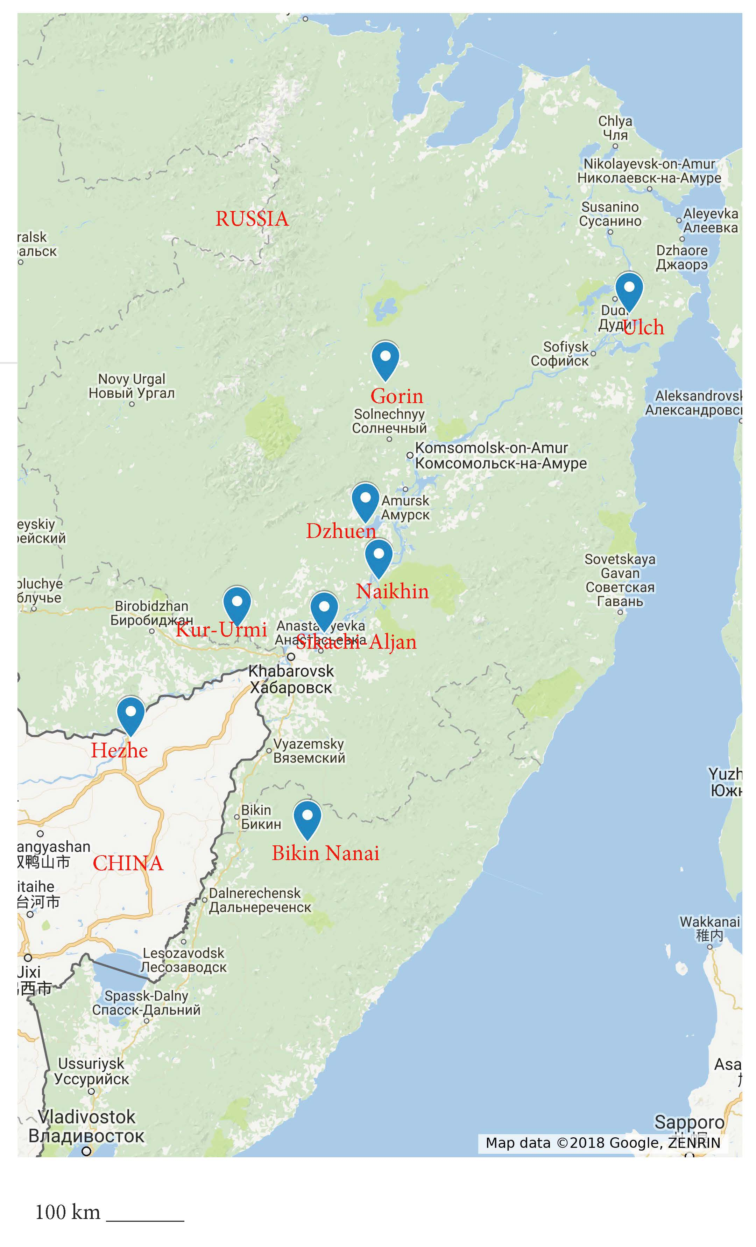
Map 2. Geographic location of the Tungusic varieties (compiled by E. Koile)
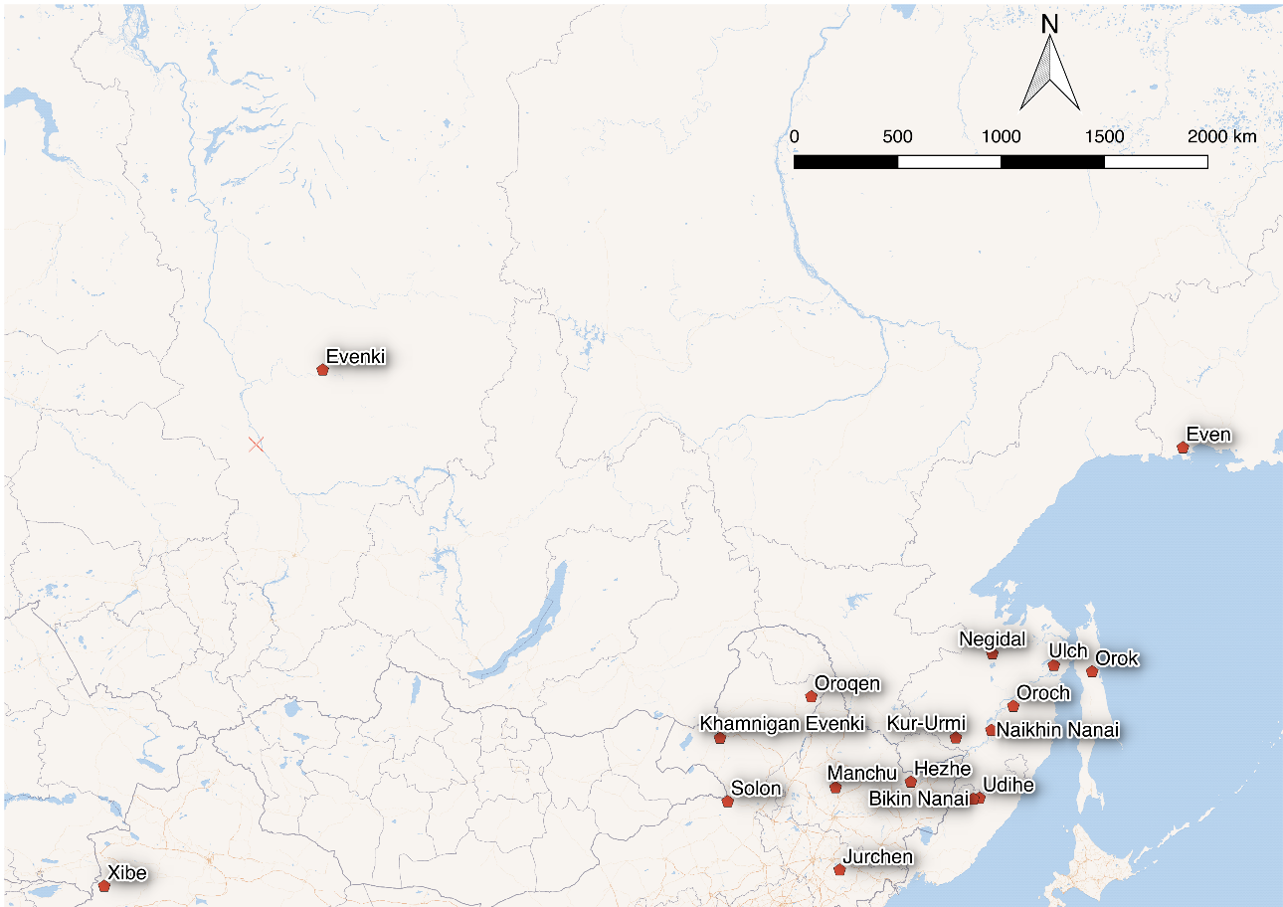

Map 3. Use of CVB.SIM + NE construction in Nanaic languages
red dots — the construction is attested
blue dots — the construction is absent
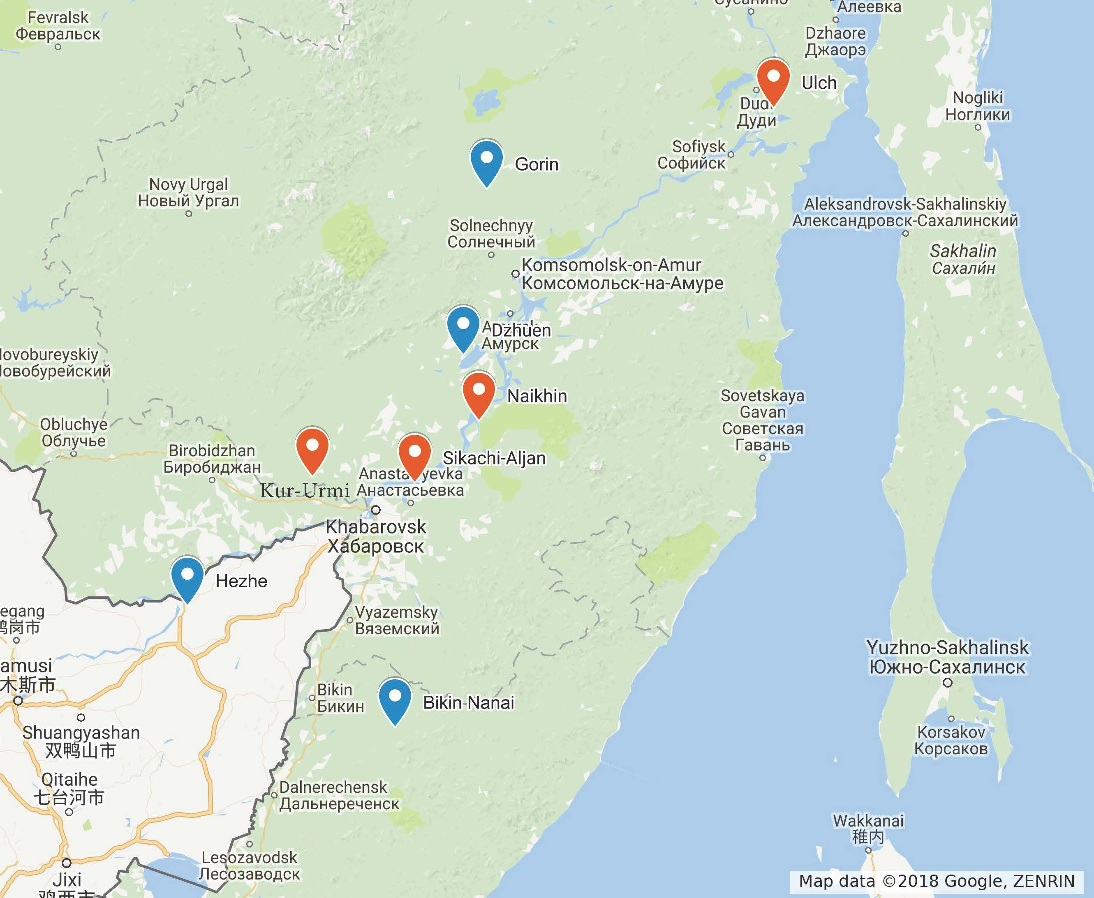

Map 4. Use of SN-constructions with NE (except for CVB.SIM + NE construction)
blue dots: other SN-constructions with NE are absent
red dots: pst/prs + ne construction (note: it is attested only once in Naikhin Nanai data)
brown dot : (ne) pst/prs.neg; neg prs.neg aux constructions

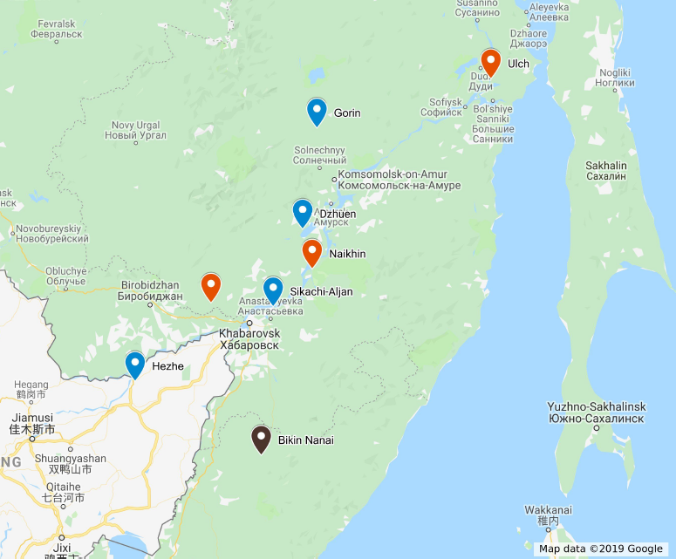

Index of languages
Ulch – (iso) ulc
Nanai – (iso) gld
Orok – (iso) oaa
Kili – (glottolog) kile1243
Oroch – (iso) oac
Udihe – (iso) ude
Jurche – (iso) juc
Manchu – (iso) mnc
Xibe – (iso) sjo
Even – (iso) eve
Evenki – (iso) evn
Negidal – (iso) neg
Oroqen – (iso) orh
Coordinates for dialects from GoogleMaps:
Naikhin 49.279633, 136.475953
Sikachi-Aljan 48.751548, 135.647484
Dzhuen 49.853811, 136.250359
Gorin 51.291015, 136.590935
Bikin 46.539895,135.358349
Kur-Urmi 48.79962, 134.2543

The research was funded by the Russian Foundation for Basic Research as part of research project 16-34-01015-OGN. We are grateful to Ljuba Veselinova and Arja Hamari for their valuable comments to the first versions of the paper. All mistakes are ours.
The “simultaneous converb” is one of the central non-finite verb forms. In its main use, it refers to an event that is simultaneous with the event of the main clause (i). (i) Naikhin Nanai ele-se-māri ičə-ǯi-či stand-ipfv-cvb.sim.pl see-res.prs-3pl ‘They are standing and watching.’ Outside the negative construction with aba, this converb has no negative meaning. The negative converb is derived with a negative suffix -(r)A and a negative particle əm (see example (ii) below), which is different from the SN-construction with aba presented in example (1). Negative forms of converbs are not discussed in the article. (ii) Naikhin Nanai Mi bičxə-wə əm niru-ə-mi akpaŋ-go-xam-bi. 1sg letter-acc neg write-conneg-cvb.sim.sg lie.down-rep-pst-1sg ‘I went to sleep without writing a letter (~ I did not write a letter and went to sleep).’ (elicitation)
The genetic affiliation of Hezhe is a question of many debates, because this variety shares different linguistic features with different Tungusic groups, so that it can refer to the Nanaic, Udiheic, Manchu-Jurchen and Northern (which includes Even, Evenki and Negidal) branches, according to different classifications; see Hölzl (2017). As Hezhe has some features common with the Nanaic varieties, we decided to include some basic information on negation in Hezhe in our research.
The suffix -(r)A is assumed to be etymologically related to one of the TAM-suffixes and to the marker of the non-simultaneous converb. It is described as the “aorist suffix” in the proto-Tungusic reconstruction by Benzing (1955: 124 ff., 146). In the modern Nanaic varieties, these three types of use can be strictly distinguished by their phonological form and syntactic properties. This explains why they can be regarded as three different markers.
Analytic constructions with the negative verb are more widespread in Northern Tungusic languages. For a more general picture of standard negation in Tungusic languages, see, e.g., Hölzl (2015).
Zhang (2013) includes examples in which the NE-marker is used in the prohibitive construction. However, we do not have enough data for a detailed discussion.
The experiential meaning is indicated by the use of an adverb xāle=dā ‘never.’ As Nanai lacks a special affirmative perfect form, the context is the only evidence for the perfect use of the form in question.
The data sample used for Ulch consists of oral texts that we collected in 2017 (about 4600 words) and by V. Gusev, S. Toldova, L. Kalinina and N. Sumbatova in 2007–2010 in Ulchsky District (Khabarovsk Krai, Russia, about 11,000 words).
We do not have any 2nd person context in our sample.
In fact, we also need more accurate comparative data on the possibility of omission of person-number markers in NegEx-proper uses for each variety.
In fact, the use of the singular form of the converb in plural contexts is also sporadically attested outside this construction.
Type A implies the use of one construction for both existential and negative predications, while in type C existential negative and standard negative predications are expressed by different constructions containing the same negative existential.
Neutralization of aspectual distinctions is common under negation, see Miestamo (2005).
In the present tense, a standard negator is used, see Section 4.1.
Similar developments are observed in Bantu languages; see Nurse (2008: 148).
In Amur Nanai, the person-number marker is optional in this context (see above). In Bikin Nanai, it never occurs.
Aba in this case is hardly just a negator like English no (cf. English sentence “No, I would not go.”), because it takes an internal syntactic position; cf. example (24), where aba goes after the subject, and example (iii), where aba is in the beginning of the sentence: (iii) Bikin Nanai Āba, f'iktə-s īlə d'id-ə-cən. no child-2sg here come-conneg-neg.pst ‘No, your child did not come here’ (Sem 1976: 52)
These are CVB.SIM + kəwə for the past and the synthetic form V-CONNEG-PRS.NEG-PERS for the present; see Sections 4 and 5.4.

