LangSci user guide for authors

# Submit a manuscript

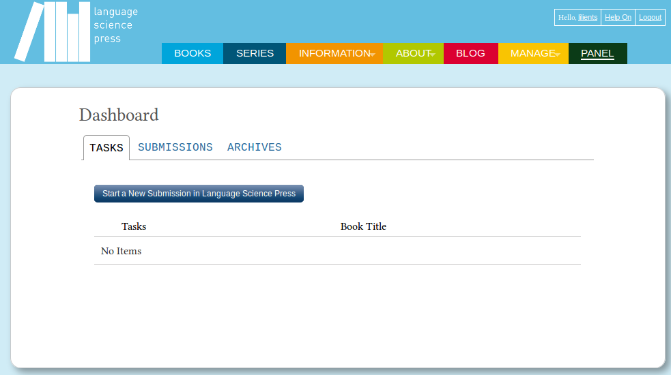

Click start a new submission in Language Science Press to hand in your manuscript.   
In the next five steps you can upload your file and give some additional information:

1. **Prepare** – check terms and checklist, give some general information about the document
2. **Upload** – hand in your file/s
3. **Catalog** – add metadata, like title and abstract
4. **Next Steps** – finish the submission

**Attention!** When uploading check the type of the document in File Contents. Be sure to add a title at the second step. Click complete at the third step or the upload will be aborted.