LangSci user guide for editors

Using Open Monograph Press with Language Science Press

Content

Start a Submission 2

Handle a Submission 3

Review 3

Conversion 3

Catalog 4

Editorial 4

Production 5

# Start a Submission

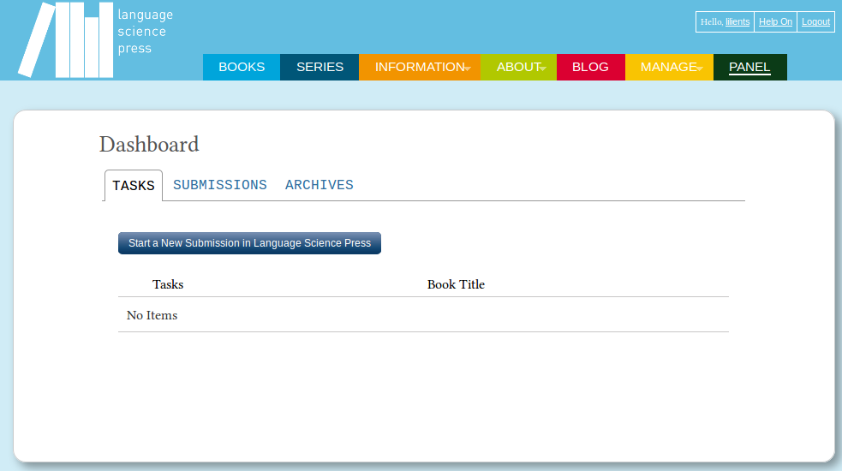

Click start a new submission in Language Science Press to hand in your manuscript.   
In the next five steps you can upload your file and give some additional information:

1. **Prepare** – check terms and checklist, give some general information about the document
2. **Upload** – hand in your file/s
3. **Catalog** – add metadata, like title and abstract
4. **Next Steps** – finish the submission

**Attention!** When uploading check the type of the document in File Contents. Be sure to add a title at the second step. Click complete at the third step or the upload will be aborted.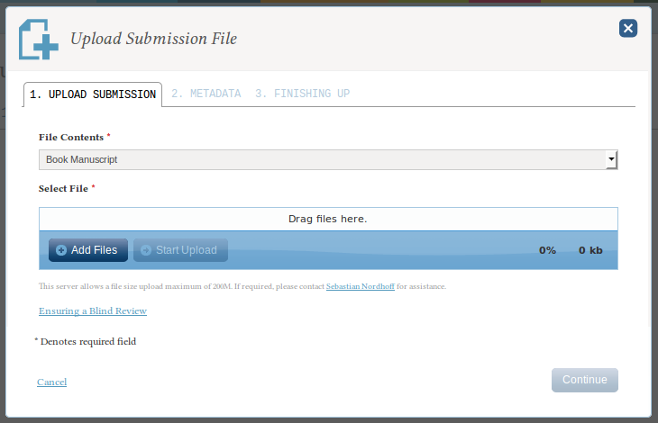

# Handle a Submission

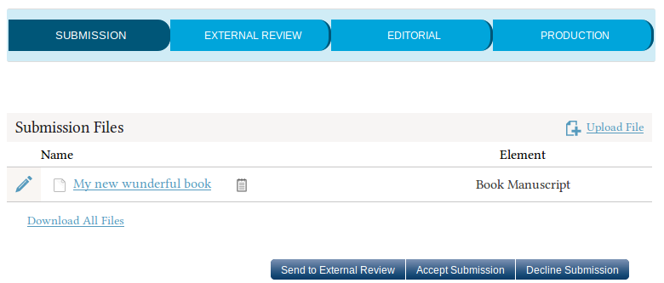New submissions appear in your panel as open tasks. Click the task to start. Now you can see the file and download it:

To start the review send choose Send to External Review. To skip the review and go directly to the editorial choose Accept Submission.

# External Review

Start the review by adding reviewers. You can select an existing reviewer, create a new one or select an existing user and give him the reviewer role.

\\cedis20\home$\slilienthal\Eigene Dateien\My Pictures\revision.PNGOnce the reviews are in, inform the author, send him the reviews and ask him to do the revision. Upload the revision to Files with incorporated revisions.

To complete the review choose your decision: Accept Submission or Decline Submission.

# Conversion

External from OMP: convert the document to LaTeX. Use the script provided at the author section of the webpage under langsci-press.org/information/forAuthors (username and password: doc2tex).

# Catalog

\\cedis20\home$\slilienthal\Eigene Dateien\UserGuide\img\catalog.jpg

Open the Catalog and add the metadata of the book. Write “forthcoming” at prefix. Add all available data.

**Attention!** When checking the checkbox at the top of the page (Create a catalog entry for this book based on the metadata below.) the book will appear in the catalog as forthcoming with the description you added, but without any files.

# Editorial

The Editorial starts with the proofreading of the document. Add a proofreader under Participants > add (choose the user group proofreader).

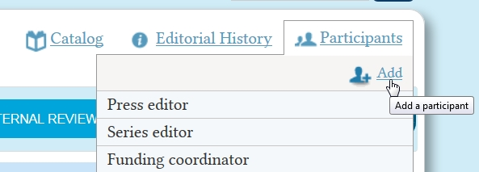

Upload the proofread document to Proofread Files. \\cedis20\home$\slilienthal\Eigene Dateien\My Pictures\proofread-files.PNG

Inform the author about the suggestions by the proofreader; ask him to do the revision. Upload the revised file to Proofread Files.

\\cedis20\home$\slilienthal\Eigene Dateien\My Pictures\typeset-files.PNGThe next step in the editorial is the typesetting. Assign a typesetter (choose the user group typesetter) and upload files to Typeset Files. Inform the author to check the document.

Finish the editorial by clicking Sent to Production.

# Production

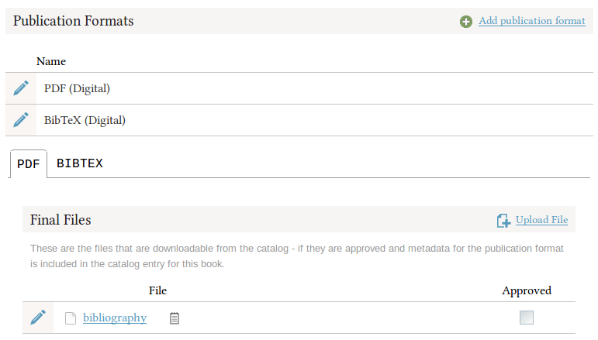There are two publication formats: PDF and BibTeX. Upload the book as pdf and its bibliography as a bibtex file.

By checking the approved checkbox, the file appears in the catalog.

Now you can complete the catalog entry (if you haven’t done it yet):

* Remove the prefix “forthcoming”
* Add the publication date at the PDF section in the catalog entry. 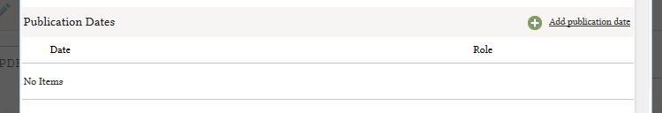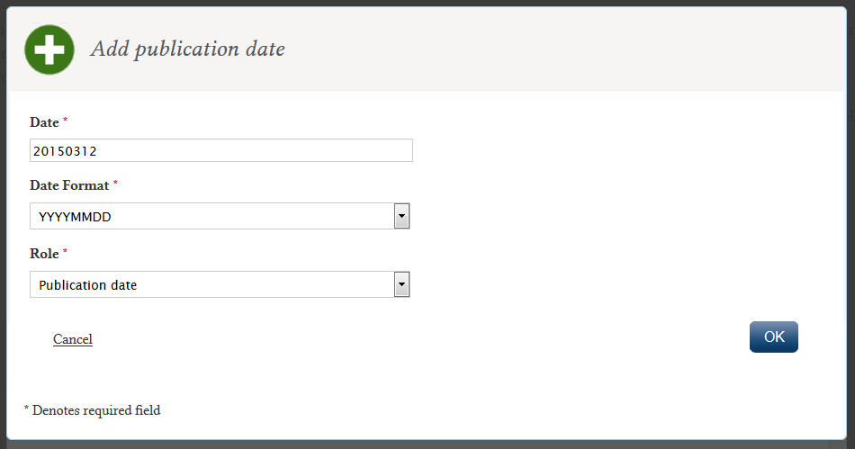

Your book is published. Hurray!